Skip’s Place
2025 CSA Explanation & Agreement:
The following outlines the shared commitment between you the CSA member and Skip’s Place as your Farm.

Please fill out the CSA contract on the last page. Return by email/mail.
(Due by Aril 8th for discount). Sign-ups close April 25th at midnight.

What is a CSA?
A Community Supported Agriculture (CSA) program in its most basic form is a vegetable subscription. Members pay in the beginning of the season to secure a share. Skip’s Place then provides members with a weekly subscription of vibrant, fresh, nutritious vegetables straight from the farm.
But a CSA is more than that; it is a way for people to connect directly to their food system beyond an exchange of funds for goods. By taking part in Skip’s Place CSA, you are voting with your dollar and saying yes to clean, local food for you and your family. You are saying yes to sustainable growing practices that leave the land better than it was found. And you are saying no to food grown irresponsibly with harsh chemicals. You are helping to grow happy veggies, healthy bodies, and empowered minds. For this I offer you the utmost gratitude and appreciation.

The Share:
-Is a variety of produce (generally 6-12 items) that changes weekly based on harvest times.
-Increases in quantity/ variety as summer progresses (Peak months: July, August, September.)

Growing Practices:
-Sunshine, water, soil, love.
-More on growing practices, click Here or go to https://skipsplace.net/growing-practices

Shared Risks of a CSA:
No New England farm is immune to the effects of mother nature's wrath (as we were so kindly reminded these past few years.) I aim to be proactive not reactive and to take steps to mitigate and minimize risks before they become problems. I do my best to provide you with an abundant weekly share and to amend as appropriate to give you the full value. If the quantity is significantly affected a certain week due to unpredictable factors despite my best efforts, please remember that as a CSA member you are agreeing to share not only the plentiful harvests but also the risk of crop failure with Skip’s place. If this problem persists across multiple weeks, we can discuss compensation as I want you to maintain your faith in me and in Skip’s Place as an honest business that values your continued support and interest in our food systems.

CSA Share Type and Payment Options:
Share Type | Total | Ideal For | # Wks | Cost Options: * | Pay By:
Full  Share | $680 | 3-4 people | 13 wks | 1. 5% off paid-in-full by 4/8 ($646)  2. Full price after April 8th. | Venmo  Check
Biwkly  (*Full only) | $435 | 3-4 people | 7 wks | 1. 5% off paid-in-full by 4/8 ($413.25)  2. Full price after April 8th. | Venmo  Check
Half  Share | $350 | 1-2 people | 13 wks | 1. 5% off paid-in-full by 4/8 ($332.50)  2. Full price after April 8th. | Venmo  Check
Delivery | - | - | - | Not offered this season

Picking Up:
Pick up Day | Time | Location
Tuesday Neighborhood pick up: (from coolers) | 6pm-8pm | 36 Anthony Rd (the driveway)  North Reading, MA
Delivery: Not offered this season. |  | Not offered this season.
Make up day- Text/email 3 days ahead so I don’t over harvest. ** | as needed basis. | 36 Anthony Rd (driveway)  North Reading, MA

*Email me you need to set up a payment plan.
**If you anticipate missing > 5 pick up days, please consider setting up someone to pick up veggies on your behalf.

Other things to note:
- Pick up within the time frame and properly store/ wash produce before use.
- Please be respectful of the pick-up location hosts’ property and neighbors.
- Bring Skip’s Place bag every week (get at first pick up or re- use last year’s.)
- Unplanned missed pickups are donated that week to prevent food waste.
- Feeling sick? Stay home. Contact me and we will figure something out.

Anticipated Start Date: June 24th
Anticipated End date: September 16th
These dates are subject to change. You will be notified via email of the exact date about 1 month in advance.

Skip’s Place
growing happy veggies, healthy bodies, and empowered minds
Please fill out the following Contract and return via email (skipsplace9@gmail.com) or mail to:
Sarah Schipelliti 14 Kearsage Street Tewksbury, MA 01876

Name: | Phone #:
Town of Residence: | Email:
Top 3 Favorite Veggies:
Allergies (NOT dislikes):
CSA Options: (circle one)  (All pick-ups on Tuesdays 6-8pm from coolers.)  Full: (3-4 people)  - No Discount: $680  - 5% off Paid in full by 4/8/24: $646  ________________________________________________________________________________  Biweekly *Full Share only  - No Discount: $435  - 5% off Paid in full by 4/8/24: $413.25  ________________________________________________________________________________  Half: (1-2 people)  - No Discount: $350  - 5% off Paid in full by 4/8/24: $332.50 | 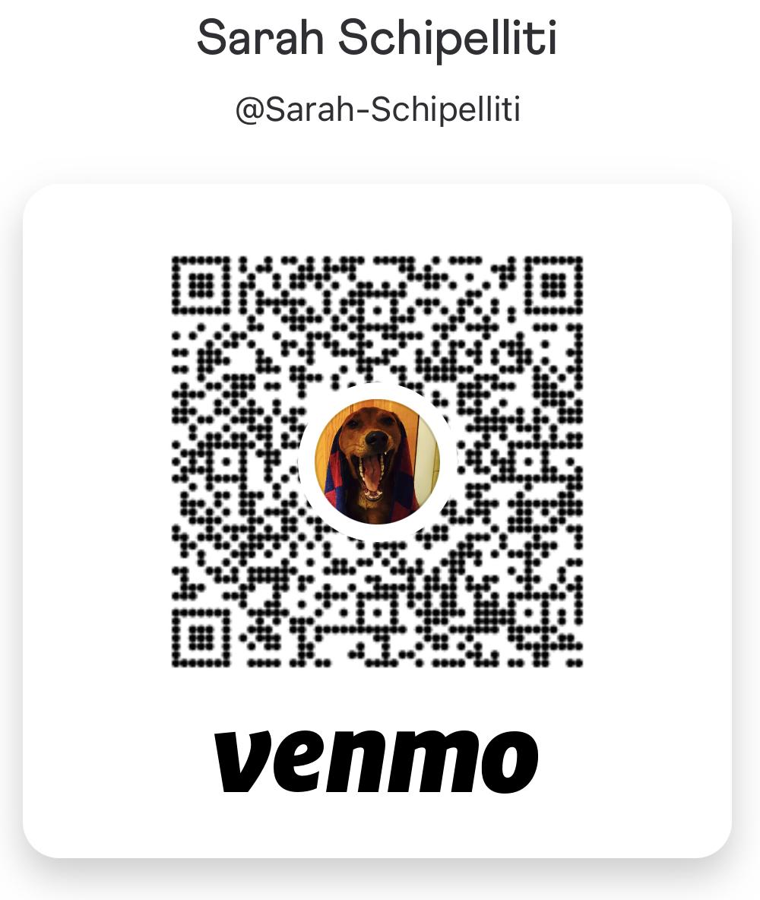  Payment: (circle one)  - Scan here or search ‘Sarah Schipelliti’ (put ‘ ’ as the comment.)  - Make check out to Sarah Schipelliti
 | Delivery: Not offered this season
 | Email me (skipsplace9@gmail.com) if you need to set up payment in installments.
Circle one:
- I will be re-using last year’s CSA bag.

- I need a new CSA bag (no charge).
Any pick-up dates you know you will need to miss or reschedule? List them here:

By signing and dating below either by typed, electronic, or handwritten signature, I agree to the purchasing of a CSA share and will act in accordance with the 2025 CSA Explanation and Agreement. I agree to pay according to the CSA options/ payment options listed.
Signature: Date:

Communicating With Your Farmer
The best way to communicate with me is via text (978-764-8381), next best is email (skipsplace9@gmail.com.) I do my best to respond as soon as I’m able. I’d love any feedback. I welcome questions, conversations, musings!

