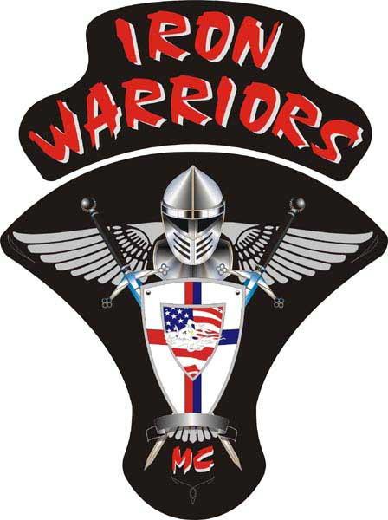
President:Lee “Bling” Lozo
Vice President:Ben “Aero” Laswell
Secretary:Rhonda “Twister” Johnson
Treasurer:Jeff “Adam Henry” Hanley
Sergeant at Arms:Rhonda “Twister” Johnson
Member at Large/Web Master:Ben “Aero” Laswell
Road Captain:Various

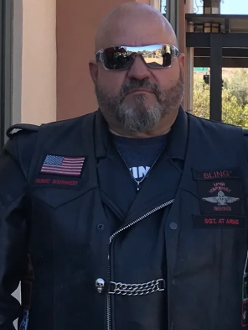

BLING, President
Happy December everyone, where has the year gone?
2022 has turned out to be a great year with a lot of riding with some of the best people I have ever known, we have a close group which makes get togethers all that much better. The colder weather is upon us so the opportunity to break out the bikes are not as frequent as they have been, remember, if you are going to be letting your bike sit for a few months pull that battery, get it on a trickle charger and get some fuel treatment in the tank.
I am already anticipating some great opportunities for hearty riding in 2023. To kick off the new year we will be holding our 2nd annual New Year kickoff party at Twisters house on January 21st. This meeting is mandatory and will count towards 1 meeting and 1 ride to kick off the year. Certainly, if you want to ride let me know, I am always up for a chilly January ride, otherwise cage it, hike it, bus it, just make it safe. The kickoff party will again feature the white elephant gift exchange (if anyone has a question about what this is let me know) and will be potluck, I will be sending out a sign-up sheet so everyone can pick something to bring, Tink, you already know . As always B.Y.O.B.
There are going to be great opportunities to ride in 2023, I know that Aero and I will be doing a couple more camping runs, it is always great fun so, before you even need to ask, you are invited! We have Nationals coming up in Boise in June, make your plans early so we can have a good group to ride up and enjoy the excellent hosting from our Boise family. Dues need to be turned in at our kickoff party in January so make sure to have cash or a check with you so Adam Henry can get that into the treasury.
Finally, I want to throw out a few honorable mentions and offer thoughts and prayers.
- Nick Baker lost his wife Denise, we also lost Steve “Chopper” Stedtfeld, you will both be missed friends, R.I.P.
- Our friend and brother Joe is dealing with some medial issues in the family, thoughts and prayers go out.
- ET has a new addition to her family and is a grandmother for the first time, is it still too soon for the “G” word to be thrown around?
- LT and his bride Secret are expecting a new addition, can’t wait to get that little one in IWMC gear
- Aero is getting dangerously close to getting his pilot’s license so we can do a few quick Vegas trips
- Tink, as always, volunteering to make the world a better place

I wish everyone a happy and safe holiday season, I.W.F.F.I.W.
Lee “Bling” Lozo
Prez.

.

For our merchandise to purchase, please go to our website: https://ironwarriorsdesertsouthwest.com where there are pictures, pricing and ordering instructions.
Thanks!

