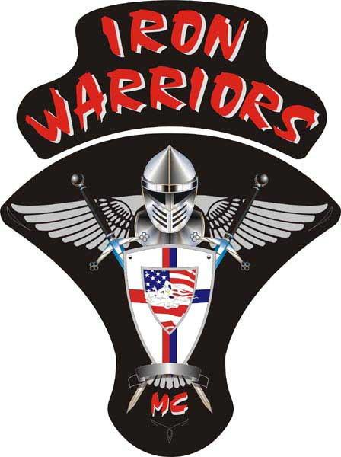

President:
Lee “Bling” Lozo
Vice President:
Ben “Aero” Laswell
Secretary:
Rhonda “Twister” Johnson
Treasurer:
Jeff “Adam Henry” Hanley
Sergeant at Arms:
Rhonda “Twister” Johnson
Member at Large/Web Master:
Ben “Aero” Laswell
Road Captain:
Various

HERE COMES THE HEAT!

With the warm summer heat kicking in it is very important to remember: HYDRATE, HYDRATE, HYDRATE!!! I know that we are getting ready for our April meeting at Aero and Sammy’s house, so, if you are going to ride, head on a swivel and be safe. I have been called away to Missouri. I will be flying out of LAX on Saturday, April 10th and will not be back until Wednesday, April 21st. So, unfortunately, I will be unable to attend the meeting. I would have worked around the meeting if there was any way possible but this time it was just unavoidable. I value every single time that I get to see my brothers and sisters and greatly regret any time that I must miss the opportunity. Maybe we can all meet in Vegas for a weekend and we can have Aero show us how to properly play blackjack. He is studying up on his skills. Have a great meeting, enjoy the great company, and have a few for me.

IWFFIW

Bling

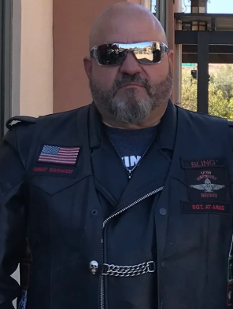
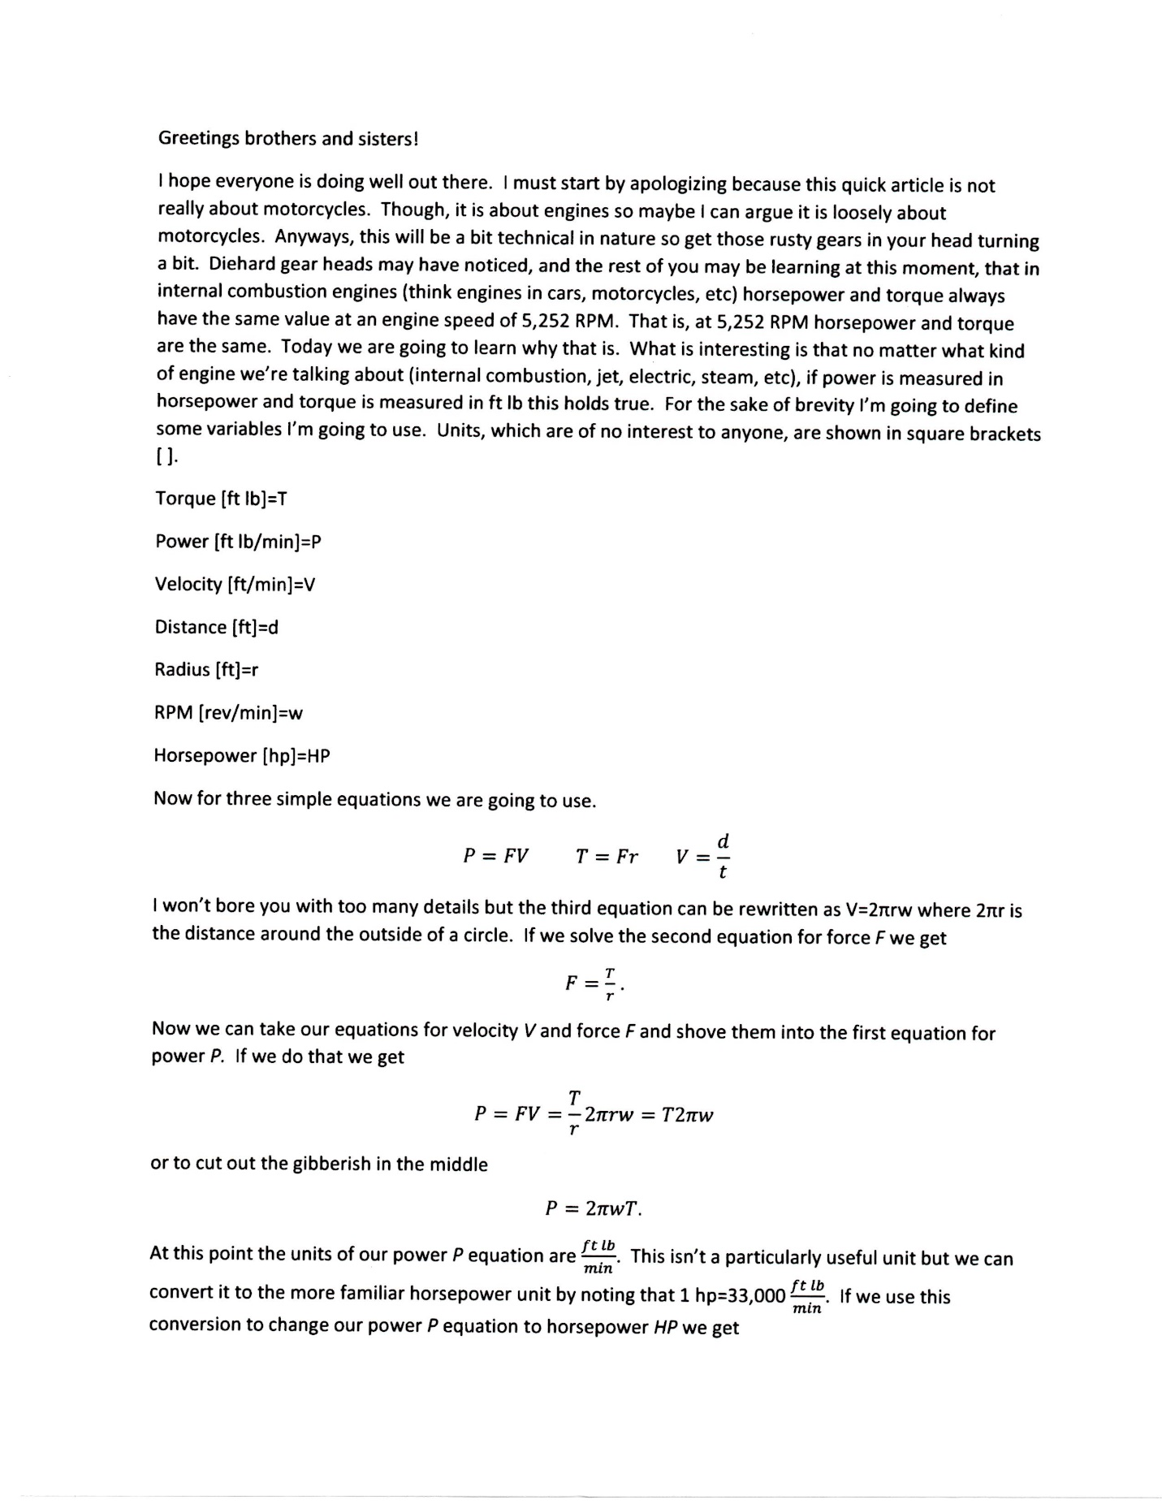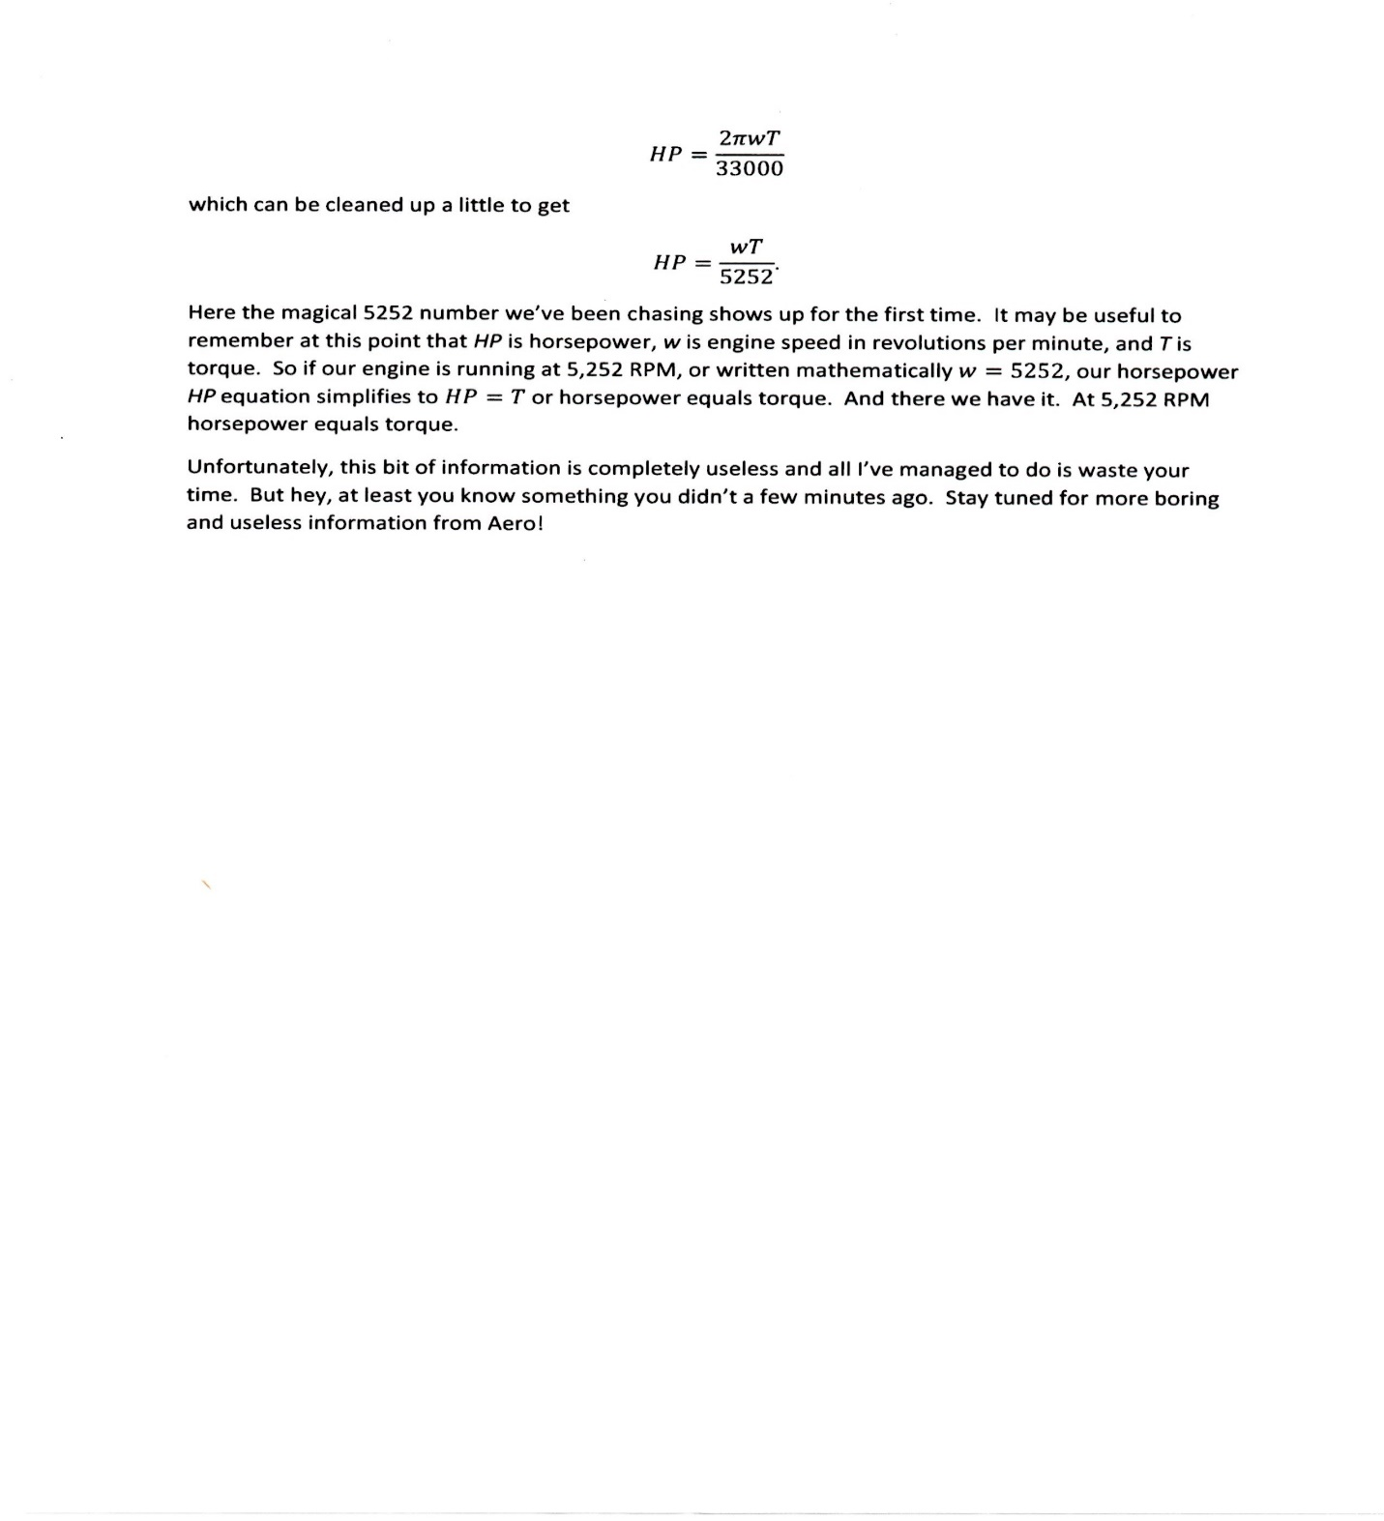
See, I told you we have a rocket scientist in our chapter ;)

For our merchandise to purchase, please go to our website: https://ironwarriorsdesertsouthwest.com where there are pictures, pricing and ordering instructions.
Thanks!

