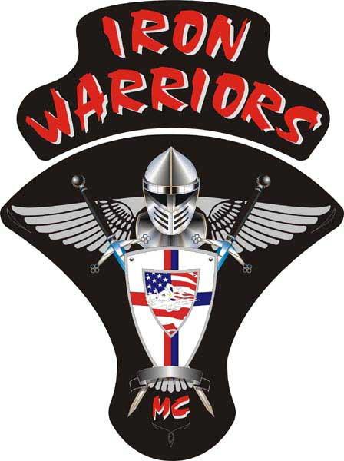
President:Lee “Bling” Lozo
Vice President:Ben “Aero” Laswell
Secretary:Rhonda “Twister” Johnson
Treasurer:Jeff “Adam Henry” Hanley
Sergeant at Arms:Rhonda “Twister” Johnson
Member at Large/Web Master:Ben “Aero” Laswell
Road Captain:Various

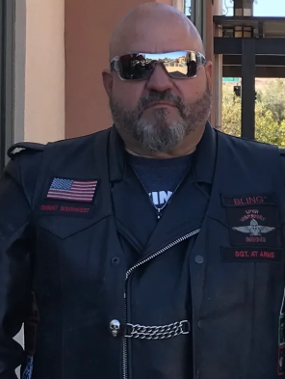

BLING, President

WOW! This year has flown by and the holidays are upon us again. I am excited to finish the year strong. It was a great summer with a lot of riding taking place. Of course, there is never enough time to get out on the bike and just leave the real world behind but it has certainly been a great summer. My youngest, Brandon, came out this summer before going back to school and was finally able to meet Aero. We knew that camping was the way to go so we loaded up our bike and headed for Mohave Narrows by Victorville, CA, which has a nice park with camping by the lake. This was our first camping trip, and by our first camping trip I mean Brandon and I . This is a regular occurrence with Aero and I, but it was special to say the least.

Brandon took to Aero quickly and we all l did some quality riding, grilled dogs, tossed the football around a bit, and ate s’mores…Success!!! Brandon cannot stop talking about getting his first bike and being an Iron Warrior. Really cool when the younger generation thinks that what we stand for is something they wand to be a part of.

Although a good riding year, there was a lot of freaky weather that Arizona and California riders do not always have to concern themselves with. There has been a lot more rainfall than usual and some interstates and highways have fallen victim by washouts and flooding. Myself, Aero and ET headed out for our face-to-face at LT’s home in August and ran into some pretty harsh rain over the summit about 75 miles west of Phoenix. We stopped somewhere before the summit and Aero threw his rain hear on just in case. Good thing he did because it let loose! The funny thing about that? We were dousing our clothing with cold bottled water because it wo hot not even 3 hours earlier, then it was long sleeves and outerwear because it was cold and wet. Great times with friends and family!!!

Make sure and keep posted on what it is going on in the 1%-er world and stay vigilant when you are out and about. There have been some incidents, Smiley passed them on to the club, so when out riding solo let’s do what we can to keep ourselves and the public safe by not wearing indicators about our LEO affiliation until this mess quiets down. I just want everyone to stay safe so we can enjoy each othere for a long time to come. Our 2nd Annual New Year Kick Off Party is coming quickly so let’s start coming up with some great ideas for venue so we can all get together and celebrate friends and family.

Bling

I.W.F.F.I.W.

Well, what a summer it has been! With the temperatures in southern California finally dipping below 90, it is starting to feel like fall. And with the onset of fall I thought it would be fun to recap the happenings of the summer.
For me, “summer” started in February when Bling and I took a trip to Death Valley for some motorcycle camping. We left Palmdale on Saturday February 19 and had an easy ride through the southern Mojave up to Trona, California. Palmdale to Trona is a wasteland of 2-lane roads and quintessential desert riding. It went by fast. Trona is a ghost town hanging on by a thread, and if it weren’t for the borax mined from the nearby Searles Valley it would have folded years ago. But, surprisingly, Trona was absolutely packed with people heading into Death Valley for the weekend. Bling and I decided we’d save a few miles by taking the Trona-Wildrose Road from north of Trona into Death Valley but without having been down the road recently we didn’t know its condition.
Pluses: Could cut an hour and a half off our ride. Super cool and super sketchy washed out road to ride. The end of the road pops us out right by the camp ground.
Minuses: Donkeys. The road could be washed out. Incredibly narrow and pot-holed.
Fortunately, our gamble to take the road less traveled paid off. We made it to Wildrose Campground and grabbed the last remaining campsite.
After setting up camp we rode down into “civilization” and saw the Mesquite sand dunes, the lowest point in North America (282 ft below sea level) at Badwater Basin, and Dante’s Overlook. It was dark by the time we started making our way back to Wildrose and besides the sweet twisty-turny roads the main concern was donkeys. Damn donkeys all over the road at night. And they don’t give two shits about who is on “their” roads. Bastards don’t move for anyone.
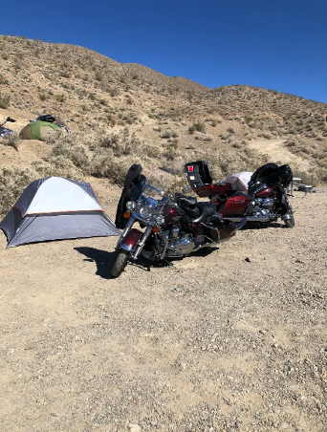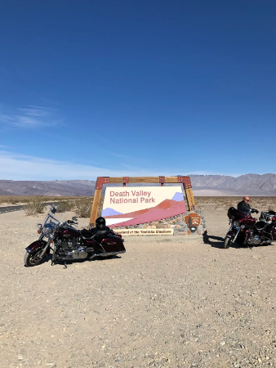
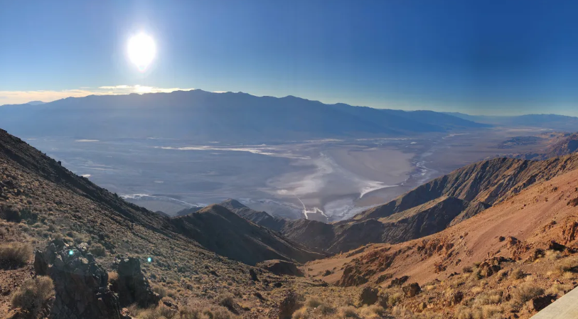
A few weeks later Evil-T, myself, and Bling hit the road again for another early spring camping adventure. On Friday April 1st we headed into the Angeles National Forest to check out the Monte Cristo Campground. Located an easy half-hour drive from Palmdale, the Angeles National Forest is a prime riding and camping destination.
Jax and Jemma blessed us with their presence and besides the very chilly evenings a good time was had by all. My memory of Friday evening is a bit blurry but I seem to remember Evil-T giving up and sleeping in her car while yours truly toughed it out in a hammock under the stars.
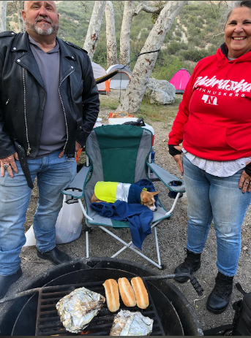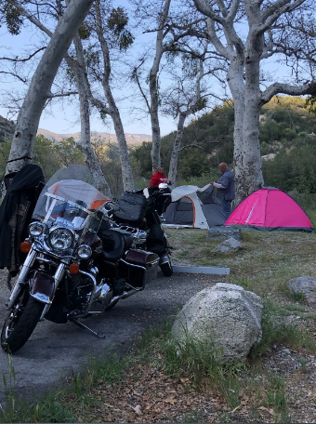
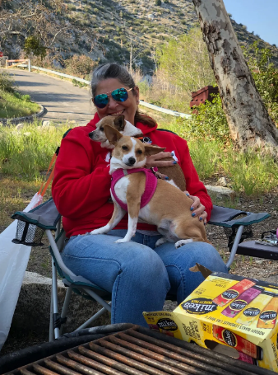

By this point in the year (late April), we were all primed for poor decisions and we didn’t disappoint ourselves. We made a quick camping excursion out to Mojave Narrows State Park near Victorville. In the unlikely event anyone is reading this far I will go on the record (and I believe Bling has my back) and say that everything was Evil-T’s fault (sorry ET). Bling and I were perfectly content riding down to Crestline for a few libations. Evil-T insisted on meeting us back at the camp site. The next few hours are, again, a bit blurry but I do recall something about trains and pennies. I suspect it was fun based solely on how crappy ET was feeling the following morning.
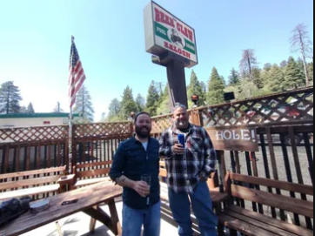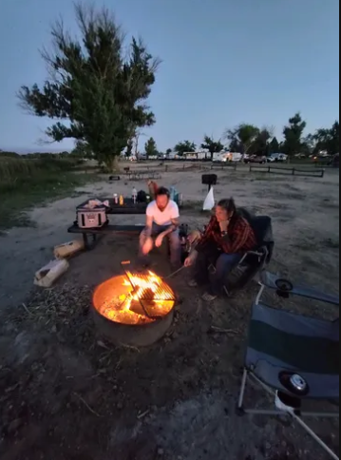

After drying out for a few weeks I had the pleasure of meeting Adam Henry and his better half Anitra down in Simi Valley for the Ron Helus Ride for The Blue. The Ride for The Blue was founded in 2015 to honor all law enforcement agencies throughout Ventura County. In 2019 the ride was renamed to honor Sgt. Ron Helus who was lost in the line of duty a year before. Despite being late to the ride it was great to see Anitra (and Adam Henry I guess).
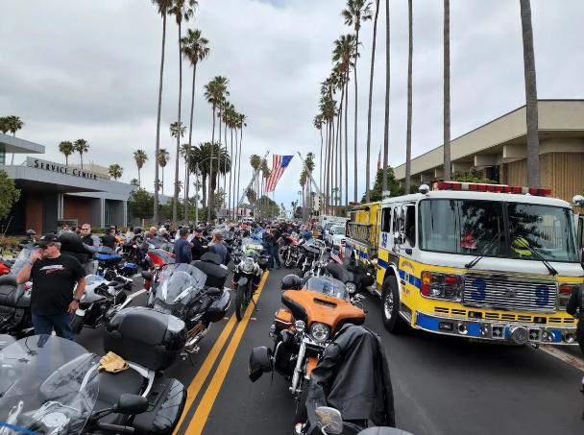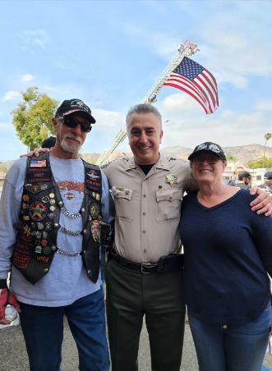
Jim bun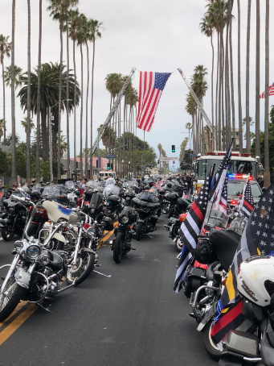
Next up in the summer that seems to never end was a quick ride up to Boise for the Western Regional Conference. It was a quick one day up, one day there, and one day back to Palmdale. But it was an absolutely beautiful ride the entire way and I can’t wait to do the same ride in 2023 for the National Conference.
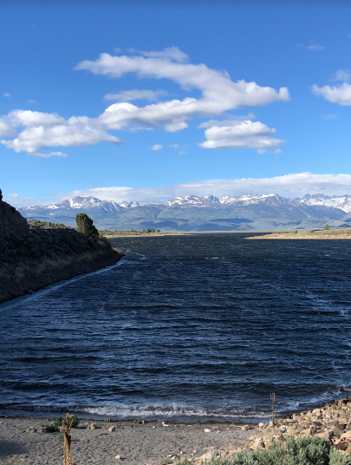
The weekend following the Regional Conference in Boise I met up with Bling and Evil-T and we headed east to Phoenix for our monthly meeting. While there we had the good fortune of meeting LT and his wife Secret, two recent transplants from River City via somewhere in Texas. First impressions matter and first impressions were good: I think they will be a good addition to our Chapter. Despite Mother Nature’s best efforts, we even managed an awesome ride into the Superstition Mountains without rain.
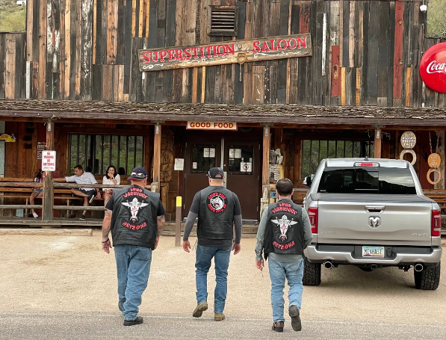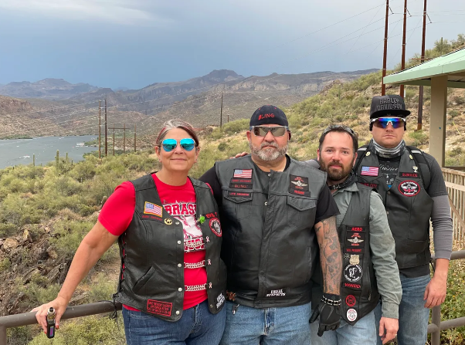

Continuing my full-throttle summer, a few weeks later I was blessed to accompany Bling and his son Brandon on their father-son camping trip to Mojave Narrows. Bling and Brandon met me in Palmdale and we made the quick ride over to Victorville. Despite being hot as crap it was a nice ride. That evening we did all the compulsory camping activities – played football, roasted dogs and marshmallows, committed a felony, etc. Good times.
The following morning we attempted to ride out to the Rim of the World Highway. The ride was largely successful but unfortunately the Rim of the World was closed south of Crestline. After that it was back home and back to reality.
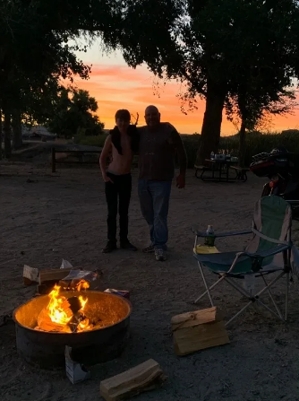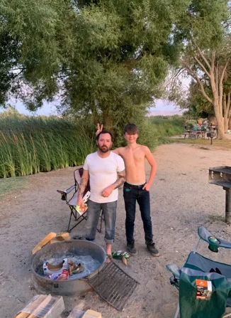
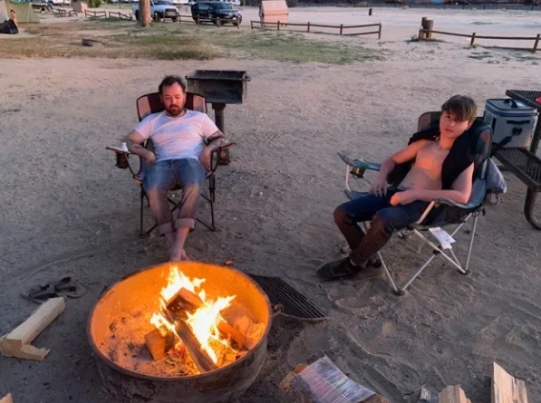

Well hot damn. I started this article thinking I hadn’t really done much this summer. Once again my Brothers and Sisters have proven me wrong. Cheers to a great summer and here’s to a great winter, looking forward to a great 2023!

PS. Before I forget, this happened too
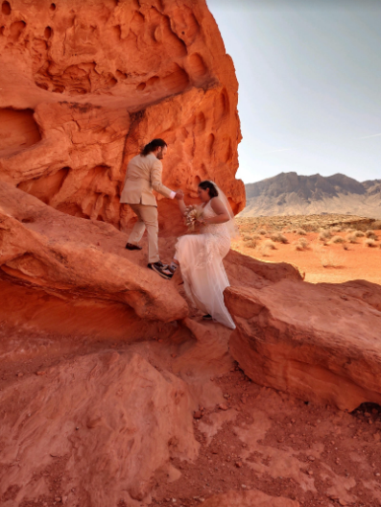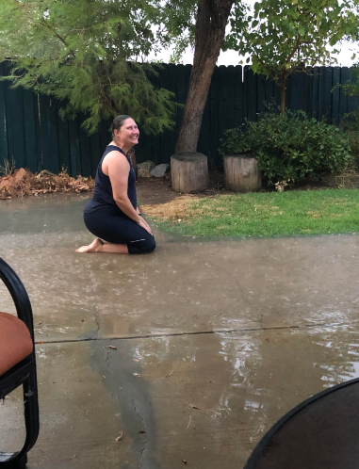
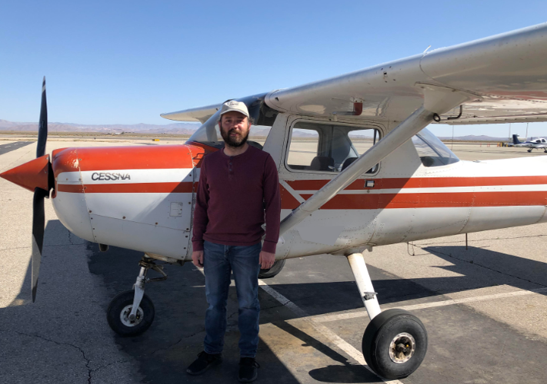

For our merchandise to purchase, please go to our website: https://ironwarriorsdesertsouthwest.com where there are pictures, pricing and ordering instructions.
Thanks!

