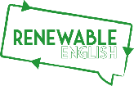Vocabulary
Connect the picture to the word.

Landfill

Single-use plastic

Microplastic

Upcycle

In the supermarket

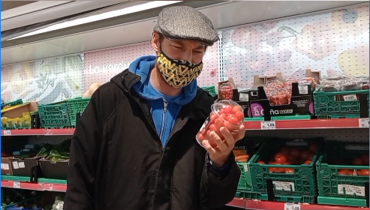
What do you remember from the video?

Plastic Facts T/F

Watch the video and answer True(T) or False (F)
- A plastic bottle will be around for about 100 years.
2. More than 40 percent of plastic is used just once, then tossed.
3. More than 6.3 billion tonnes of plastic waste has been generated. Around 20% of that has been recycled, 5% burnt, and 75% sent to landfill.

Interview Questions

For the full interview check our YouTube page.

1)What is Kids Against Plastic? And when was it founded?

It’s an__________ and was founded in _________

2) To be plastic clever, which are the 4 main items of plastic we need to reduce/remove?

1.

2.

3.

4.

3) What inspired Amy and

her sister to start K.A.P?

A) Renewable English’s inspiring classes.

B) A project based around the UN’s sustainable development goals.

C) They saw some rubbish at the beach.

4) Other than the 4 main plastics, what extra item do plastic clever schools think about?

5) What type of hat does Harry say he wants to get from kidsagainsplastic.co.uk?

A) A trendy top hat.

B) A fabulous fez.

C) A fancy trucker’s hat.

My Planet Promise

Write your planet promise below. Remember to send it in to the socials.

I,………….., promise ….………………………………………………………………………

- CHALLENGE YOURSELF
- Make a video:
- Upcycle something old and send us your video.
- OR
- Go on a litter pick with some friends, show us how much you picked up
- Things to consider:
- Don’t forget your gloves.

@Renewablenglish
Renewable English
Renewable English
@RenewableEnglish

