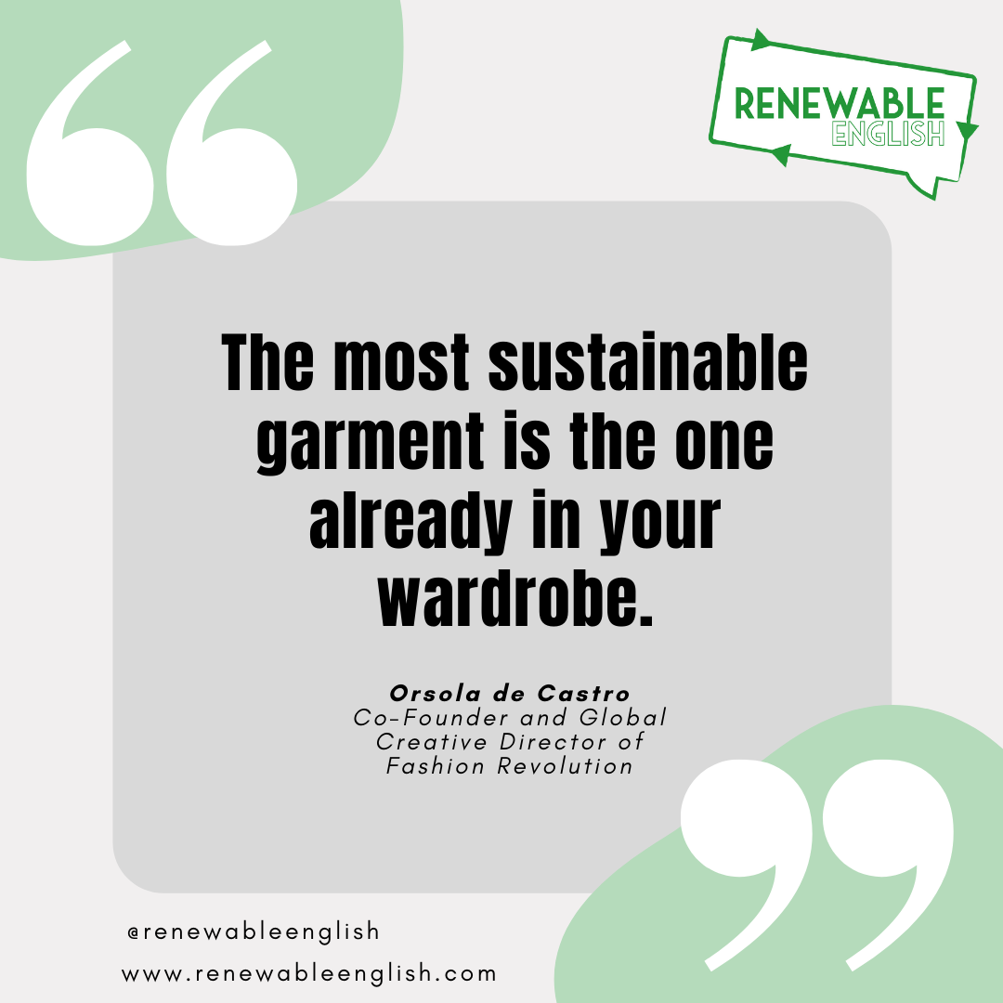

Fashion Vocabulary
Connect the word to its definition!

Fast Fashion A Tiny Piece of plastic

Second-hand Rubbish on the floor

Synthetic Fibres Rubbish in the ocean

Consumer A plastic you use only once

Fashion UnFun Facts T/F

Watch the video and answer True(T) or False (F)

1. The fashion industry is responsible for 5% of carbon emissions.​
Source: UN Environment, 2019 ​
​
2. Fashion is responsible for up to 35% of microplastic that flows into the ocean.​
Source: The State of Fashion, McKinsey 2020​
3. It takes 7,000 litres of water to make​
a pair of jeans and 2,700 to make a T-shirt​
Source: Greenpeace​
4. 9% of industrial water pollution comes ​
from the treating and dyeing textiles.​
Source: Greenpeace

Interview Questions

For the full interview check our YouTube channel

1. What was Cherie’s job in fast fashion?

Creative Director

Marketing executive

Buyer

2. What did she feel she was creating?

Amazing clothes

Waste

A better planet

3. Why is fast fashion bad for the planet?

She says fast fashion is bad for the planet because………

4. What are her top tips to help people stay away from fast fashion?

My Planet Promise

Write your planet promise below. Remember to send it in to the socials.

I,………….., promise ….………………………………………………………………………

www.renewableenglish.com

@Renewablenglish
Renewable English
Renewable English
@RenewableEnglish

