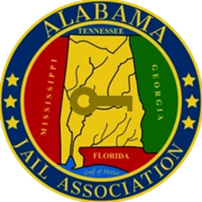
Save the Date!
Alabama Jail Association 2026 Fall Conference
October 6 – 9, 2026
Island House Hotel Orange Beach, AL
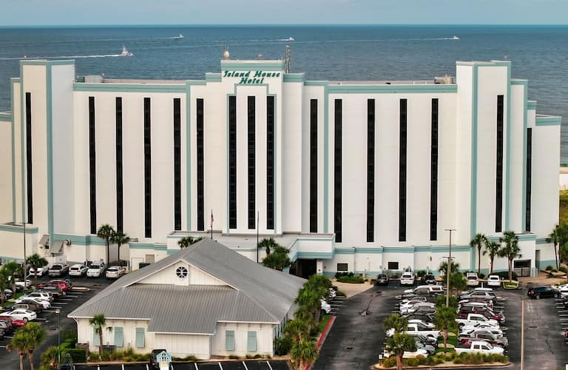
26650 Perdido Beach Blvd.
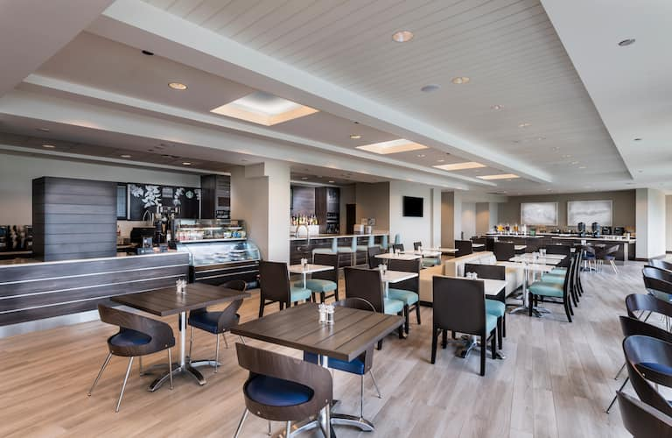

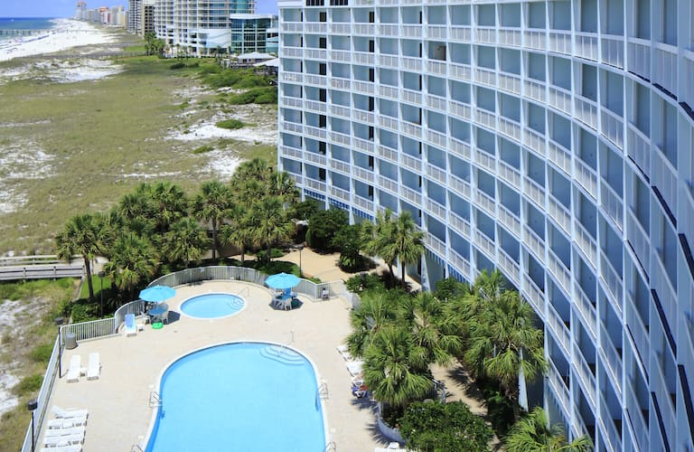
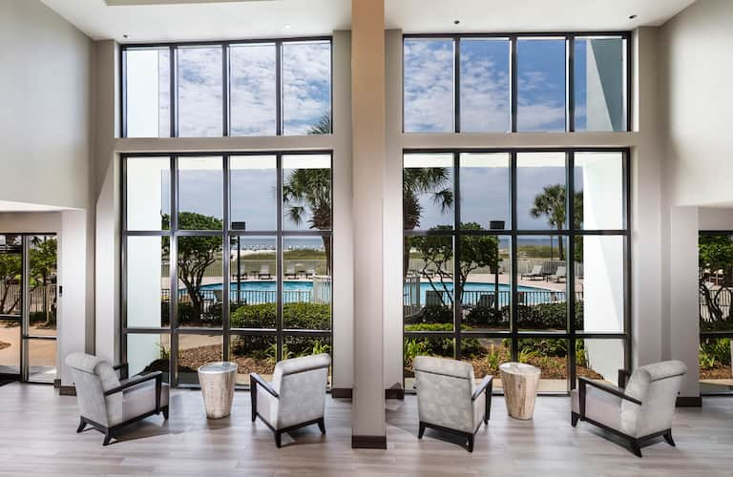

Early Bird registration will open July 1, 2026 and is open to members only.
Hotel booking link with group rate will be posted to the website July 1, 2026

