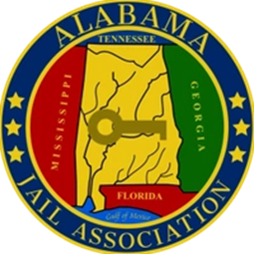
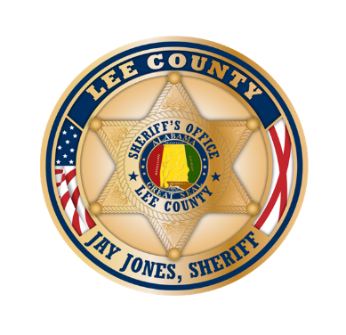
Save the Date!
Alabama Jail Association 2025 Symposium
June 9 – 10, 2025
Hosted by: Lee County Sheriff’s Office

Opelika Al.

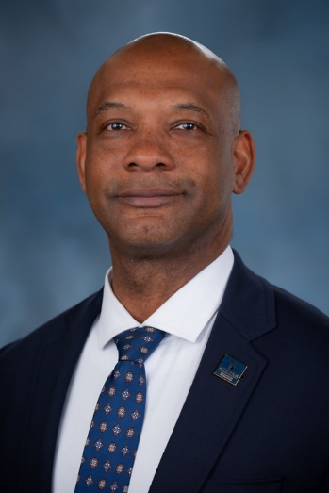
Topic: The Dangers of Effective Leadership in Law Enforcement and Corrections

Presenter Dr. Clarence Stewart and Dr. Clarence J.C. Stewart, IV
Dr. Stewart is the Auburn University's Assistant Vice President for Campus Safety and Compliance. He previously served as Assistant Police Chief for the City of Auburn, building on a 20-year career with the Auburn Police Department that began in 2003.
A graduate of the FBI National Academy, Dr. Stewart earned his Ph.D. in Adult Education from Auburn University in 2021, along with two degrees from Troy University. His research centers on emotional intelligence, employee satisfaction, and law enforcement burnout. Guided by the philosophy “Taking care of people,” Dr. Stewart is committed to the well-being of those he serves, blending leadership, scholarship, and community engagement.
Join us for an essential training opportunity open to all levels of jail staff. Enhance your skills, stay informed on the industry’s best practices, and network with fellow professionals. All training materials included in tuition cost.

Training Details:
Tuition Cost: 75.00 for Alabama Jail Association Members (validation through the Alabama Jail Association) and 100.00 for non-members
Date: June 9-10, 2025

Location: Bennie G Adkins Meeting Center 205 S 10th St, Opelika, AL 36801

There will be other Special Guest Speakers (TBA)

