June Training Symposium  When  June 29 – 30, 2026  Where  Bennie G Adkins Meeting Center  205 South 10th Street Opelika, AL 36801  Join us for an impactful training event focused on leadership development, accountability and tactical readiness within the corrections environment. Class will begin @ 0800 hours each morning.    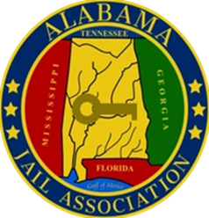  www.alabamajailassociation.com | Alabama Jail Association  Training Event  Registration Cost  75.00 AJA Member  125.00 Non-Member  Instructors  Dr. Stewart  Lt. Greg Summer  Training topics  - Critical Incident Leadership  - Training, Coaching and Mentoring Staff  - Decision Making Under Stress  - Building a Culture of Accountability  - Hostage Negotiation  - Taser VR Scenario Based Training  Hosted by:  Lee County Sheriff’s Office  Lunch will be provided on June 29th

