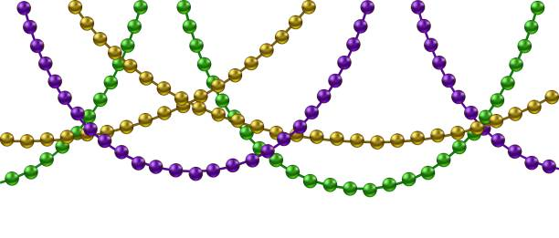

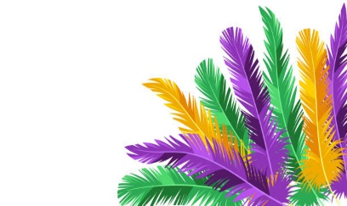
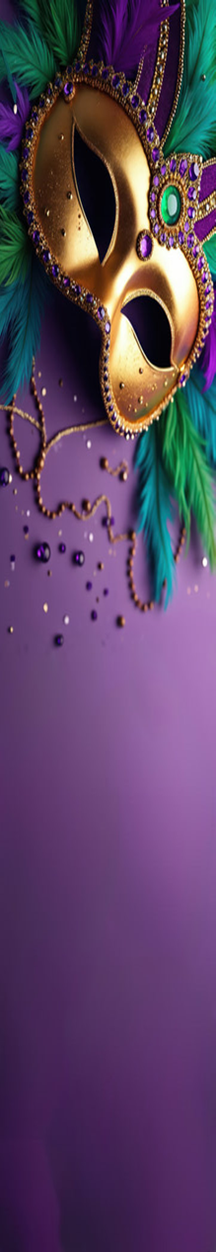
The French Quarter
May have Bourbon Street,
But our Mardi Gras Party
Is going to be hard to beat!
Grab your beads and masks
And Let the Good times Roll,
a night of fun is good for the soul!


It’s time to jazz it up!
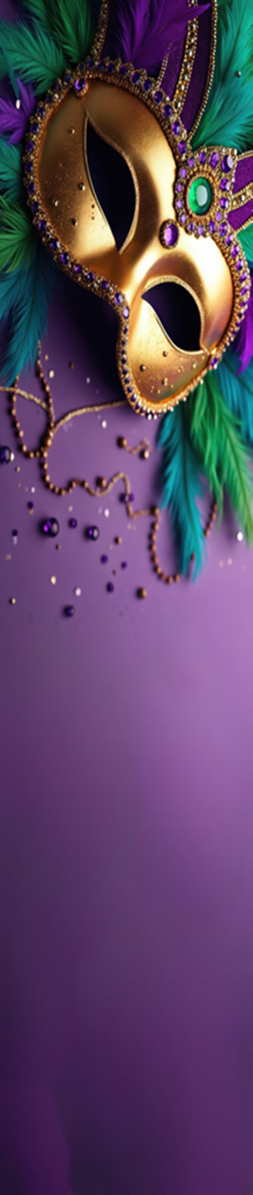
Join us Thursday evening
At 6:30 Pm for
The Presidents Mardi Gras Dinner

Mardi Gras Party & Karaoke

Immediately following

7:30 – 11:00


