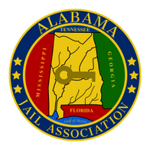
Alabama Jail Association
June Training Symposium
Dates: June 29 – 30, 2026
(June 29th – full day of training, June 30th 1/2 day of training)
Location: Bennie G Adkins Meeting Center
205 South 10th Street
Opelika, AL 36801
Hosted by: Lee County Sheriff’s Office
Training Topic: Critical Incident Leadership, Training/Coaching/Mentoring Staff, Decision Making Under Stress, Building a Culture of Accountability, Hostage Negotiation, and Taser VR Scenario Based Training
AJA Member: Yes__________
No__________
*Membership will be verified by The Alabama Jail Association

Name: ________________________________________
(Please PRINT)
Agency:


Member Payment = 75.00

Non-Member Payment = 125.00

On-site Registration = 150.00
Email address:
For Office Use Only:
Payment Received:

Date: _________________________

Check # _______________________

On-line payment ________________
Title:

