Alabama Jail Association
3rd Vice President Candidates

- Parker Crosby – Elmore County Sheriff’s Office

- Stephanie Harwell – Hueytown Police Department

- Sonja Pritchett – Montogmery County Sheriff’s Office

- Jamie Manning – Autauga County Sheriff’s Office

Parker Crosby – Elmore County Sheriff’s Office
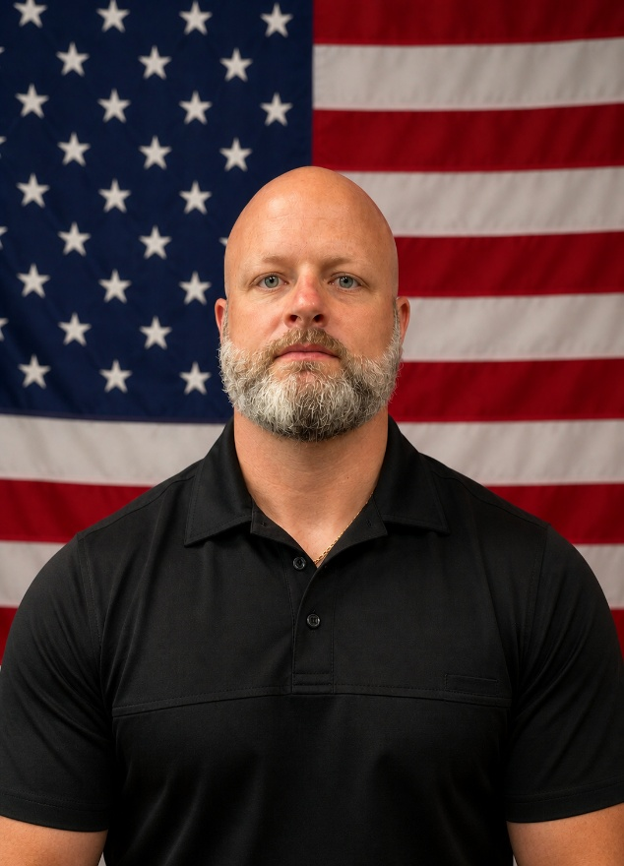
My name is Parker Crosby, and I began my law enforcement career in 2005 with the Millbrook Police Department. During my time there, I worked my way up through the ranks, serving as an Investigator before being promoted to Corporal within the Investigative Division. Those early years helped shape my foundation in leadership, accountability, and investigative work.
In 2010, I joined the Elmore County Sheriff’s Office, where I was selected to serve in the Narcotics Division as a Drug Task Force Agent. For the first two and a half years, I worked undercover operations, targeting street-level narcotics and illegal firearms trafficking. That experience taught me discipline, situational awareness, and the importance of protecting our communities from the ground up.
During my time with the Sheriff’s Office, I have also been a member of the Special Operations Unit, where I have served as an Assistant Team Leader since 2020. In addition, I am a certified Firearms Instructor, Cell Extraction Instructor, Less Lethal Instructor, Basic SWAT Instructor, and Explosive Breacher. These roles have allowed me to train and mentor other officers while maintaining a high standard of readiness and professionalism.
In late 2024, after assisting with operations at the county jail, I felt called to serve on the corrections side of the Sheriff’s Office. With the upcoming retirement of the Warden in 2025, I approached the Sheriff about the opportunity to step into that role. After spending time learning from the outgoing Warden, I assumed the role of Warden in 2025.
Since taking on this position, I have developed a deep respect for corrections and the professionals who work in it every day. I am committed to strengthening the jail through training, leadership development, and accountability. I believe in empowering officers with the skills they need to grow and succeed, not just in their current roles, but throughout their careers.
I firmly believe that every officer should strive to be the kind of officer they would want to supervise, and every supervisor should be the kind of leader they would want to work for. That belief continues to guide how I lead and serve every day.

Stephanie Harwell – Hueytown Police Department
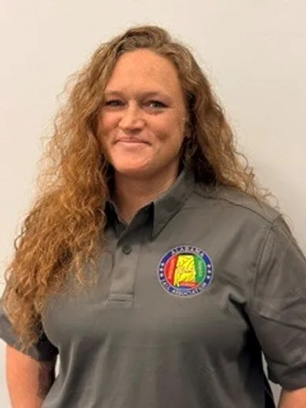

Since 2021, I have served as a Corrections Officer for the City of Hueytown, where I work closely with inmates, court personnel, and department leadership to support safe and effective correctional operations. My responsibilities include inmate advocacy, collaborating with the court department, and assisting in the development and revision of jail policies and procedures to improve operations and compliance standards.
In 2025, I earned a bachelor’s degree in criminal justice with a concentration in corrections, further strengthening my knowledge and leadership within the corrections field. Throughout my career, I have remained committed to professionalism, service, and improving outcomes for both the community and the individuals I serve.

With more than 25 years of experience as a first responder, I have dedicated my career to public safety, emergency medical services, and corrections. I am a licensed Advanced EMT, CPR Instructor, and EMT Basic Instructor, committed to training and mentoring future emergency service professionals and correctional officers.

Sonja Pritchett – Montgomery County Sheriff’s Office
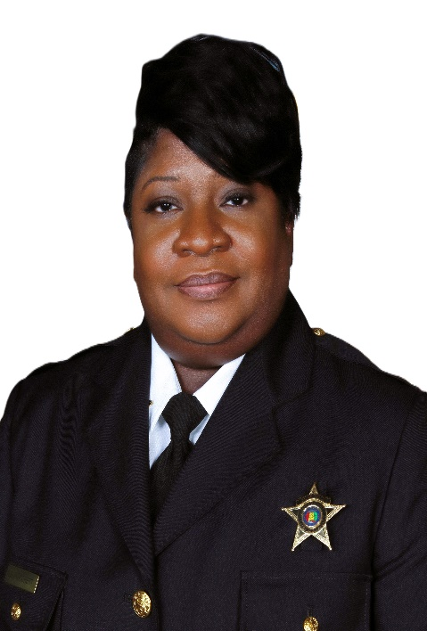

Colonel Sonja Pritchett started her career with the Montgomery County Sheriff’s Office in 2006 and has served as a servant leader for 20 years in the correctional profession. Colonel Pritchett was appointed director and earned a master’s degree in organizational leadership with a concentration in Criminal Justice in October 2019.
Colonel Pritchett is directly responsible for overseeing the daily operations of the jail, which includes Courts Coordination, Compliance with regulations and standards set by the law, and budget management. Additionally, Colonel Pritchett oversees inmate health care, rehabilitation and education. Since her promotion, Colonel Pritchett has expanded training for the correctional personnel and increased programming and services for the men and women confined within the facility.

Jamie Manning – Autauga County Sheriff’s Office

