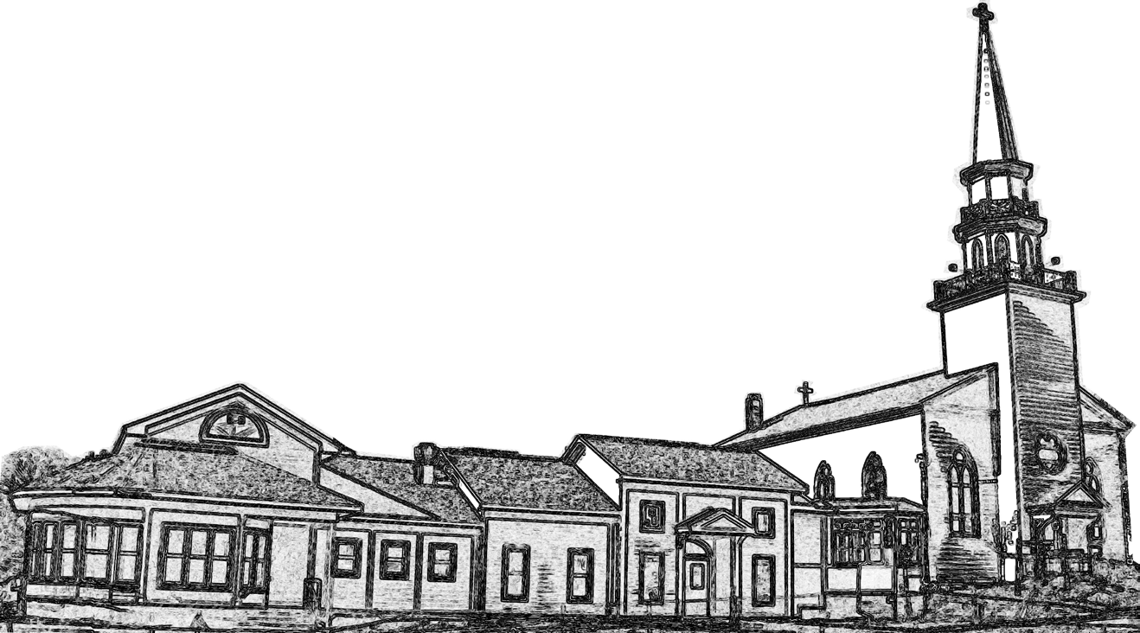

**CHRIST CHURCH**

**CONNECTIONS**

**Christ Church** Manlius, New York

VOLUME XXXV, ISSUE 10 NOVEMBER 2022

**Don’t listen to the world. Listen to the world.**

Is that title a typo? No, not at all! We Christians use the word “world” to refer to two different things. First, there’s the human world. Work, family, responsibilities, culture, government - things humans do when they get together. Second, there’s the physical world. The planet Earth, the planets in their courses, or (as my Greek professor liked to call it) the “mud-ball,” from animals to distant stars: physical Creation.

November is a good time to consider this important difference. On the one hand, our culture is ramping up. Mid-term elections are coming up very soon. The holiday season seems like it’s already begun. Colds are here with a vengeance, and many of us have used too many sick days to take a day off for ourselves or to stay home with our sick kids. Even in November, the month of thankfulness, our culture continues to be about go go go, do do do, now now now.

On the other hand, however, the world is falling asleep. Most of the leaves have fallen, and there are great mounds of them on the sides of neighborhood roads. Daylight is getting shorter and dimmer. We may have some nice, warm days, but it’s getting colder, and sitting in front of a warm fire with a blanket pulled up around our necks is sounding nice and nicer.

We humans are social animals. Our society influences us deeply. We want to interact with others, vote our conscience, and travel to new places. But we are also animals, and our bodies are in tune with the natural changes of the world. We may not hibernate like bears, but do quite a bit of nesting as the days grow colder. Life is, in part, balancing these two worlds.

This November, however, we’ll be facing a lot of energy: political debate, the fervor of getting ready for the holidays, and the worry of covid. Do not forget, however, Jesus’ call to rest. Do not forget the psalmists’ plea to look at the natural world and to see joy in it. Do not forget that we were not created to live in little boxes but with the wide world all around us. And do not forget to stop and love Jesus wherever you find him - or wherever he finds you.

|  |  |  |
| --- | --- | --- |
| **Service Times**  **Sundays**  8:00 and 10:15 am  **Centering Prayer**  Wednesday 9:00 am  **Clergy and Staff**  **Rector** Tim Hannon  **Parish Administrator**  Deirdre Popp  **Choir Master** Shawn Hebert  **Organist** Deborah Cunningham  **Christian Ed. Director**  Rebecca Russel  **Sexton** Peter Winkler  **Vestry**  **Members**  Doug Allen (*Outreach*)  Jeff Amack (*Finance*)  Michael Bull (*Property*)  Craig Byrum (*Hospitality*)  Carmen Denny (*Pastoral Care*)  Suzanne Mitchell (*Worship*)  Jean Regan (*Education*)  Jim Tifft (*Communications*)  Amy Trail (*Resource Dev.*)  **Wardens**  Candy Wilhite  Mollie Mills  **Treasurer**  Anne Whyte  **Clerk**  Lori Gibson |  | **General Office Hours**  Monday - Wednesday  9 am to 1 pm  Thursday  8 am to 12 pm  **Fr. Tim’s Office Hours**  **Monday** 2 to 3 (at Cafe Kubal)  **Tuesday** 11 to 1  **Thursday** 10 to 2  **And by appointment**  **Prayer Chain**  If you need prayer, contact the church office or one of the following members:  The Rev. Tim Hannon, Michael Bull, Jim Whilhite, Marjorie Edwards, Rebecca Russell  **Upcoming Events**  November 4: First Friday Dinner  November 6: Daylight Savings Time ends; set your clocks back!  November 6: All Saints’ Day  November 9: CC Afternoon Book Group  November 19: Christmas Mart 9 a.m.-3 p.m.  November 19: Christmas Mart Luncheon 11 a.m. -2 p.m.  November 22: Vestry Meeting  November 23: Office closed  November 24: Thanksgiving Day; Office closed |

**Vestry Voices**

Growing up as a cradle Episcopalian, I have always felt at home in the Episcopal church. The hymns and liturgy have always shaped my faith and been a part of who I am today. I taught Sunday school when I was in high school and at different times through my life and learned a lot about the church, the Bible, and our liturgy. My parents were always involved with their church and honestly there were stories I heard over the years that made me hesitate to get involved, even though showing up for worship was so important to me. There was the story about the choir director who told all the women in the choir that they were either a bird, a horse, or a cow and proceeded to label each of them. Needless to say, many women quit the choir that year. As a result of these and many other stories, I stayed on the sidelines convinced I was a “Mary” who wanted only to listen and worship God. I was mostly interested in relationships and having time for people. God had a bigger plan! At some point at Christ Church, I decided to ask about joining the altar guild, a nice behind the scenes ministry. I was in awe the first time I stepped onto the altar area and learned about handling sacred things. Spending time in this quiet, beautiful space with another member of the guild and preparing the church for services was a way I could be a small part of telling God’s story and serving the parishioners. Before I could blink, I became the sacristan & leader of this ministry and a “Martha”! Discovering that I could be both a “Mary” and a “Martha” was news to me! It all has been a huge blessing and I honestly never could have dreamed I would serve on the vestry as well! God has a plan for everyone and I encourage you to step forward and prepare to be surprised and blessed!!

- Suzanne Mitchell

**November First Friday Dinner**



October was such fun! Thanks to all who made it a truly happy and friendly time. And now…. November is in sight with cool evenings and the desire for comforting meals. Please join us on Friday, November 4!

Here’s what we plan for the dinner:

Old fashioned Beef Stew 🙚 Acorn Squash 🙚 Waldorf Spinach Salad 🙚 Crusty homemade bread 🙚 Caramel Turtle cake (OH MY GOSH…IT LOOKS UNBELIEVABLE!)

Reservations ([rhebert694@earthlink.net](mailto:rhebert694@earthlink.net), 315-632-4388, Ron & Rene Hebert) are needed by Nov. 2nd and then just show up around 6 PM for these treats! Bring your own place settings and beverage. Dinner is planned for 6:45 PM. Cost is only $10 per person and children are $5. Family maximum is $30.

Christ Church Volunteers Doing Good Work…. Again!

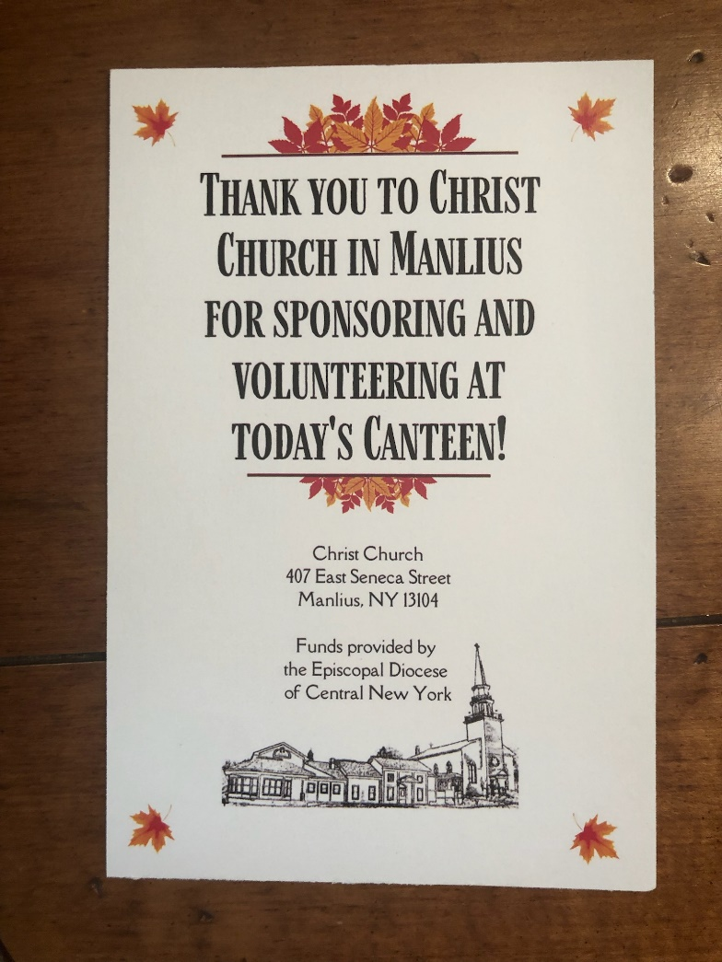As we know, our mission statement at Christ Church is to “transform ourselves and our community through the unconditional love of Jesus Christ.” We are endeavoring to do just that through our many outreach projects. This is especially true with our new relationship with Clear Path for Veterans. The Diocesan Ministry Grant that was awarded to us has helped in making that relationship a reality.

On October 5, volunteers from Christ Church stepped forward to devote their time and effort to serve at Clear Path’s Canteen. The Canteen is a weekly luncheon, provided free of charge to veterans. On that day, Christ Church treated over 250 veterans to lunch. Not only did we sponsor the luncheon, but our team of sixteen (usually there are less than ten volunteers) prepared food, waited on tables, served food and beverages, washed dishes etc. All of this was done while interacting with the guests.

Special thanks to our Christ Church team of Nell, Anabel, and Will Bartkowiak, Claudia Byrnes, Donna Cameron-Carter, Eileen Emerson, Lori Gibson, Father Tim Hannon, Rene and Ron Hebert, Mollie Mills, Oxana Panol, Deb and Jim Tifft, Candy Willhite, and Peter Winkler.

The next project we’ll be involved with is to work with Clear Path in establishing The Place for Reflection. Spiritual wellness is one of the dimensions of health that is a part of Clear Path’s programming. Stay tuned for more details.

In the meantime, check the bulletin boards in Crosby Hall for more pictures of our volunteer team.

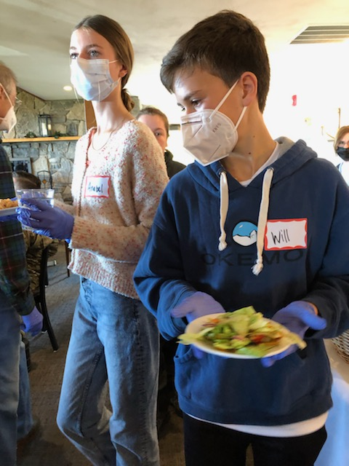

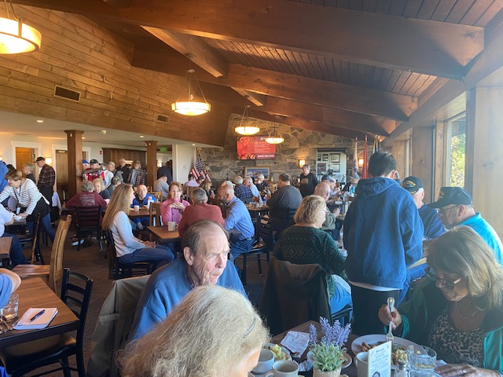

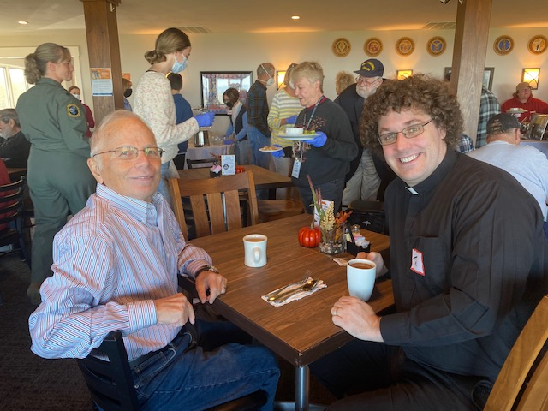

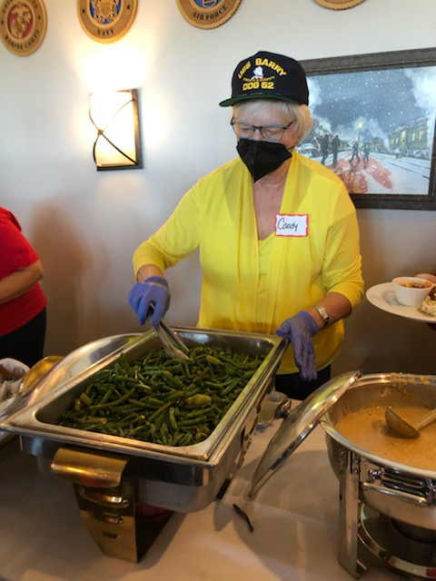

**On Being Anglican**

*The following is a new column for the newsletter about Anglican identity. We Anglicans (which includes Episcopalians) often say that we’re “Catholic-lite” or just a corner of the Church Universal that grew up in Britain. We have, however, a pretty distinct character, identity, and theology. Please join Father Tim in meditating on this identity!*

One of my favorite parts of the Eucharistic Prayer is something called the “institution narrative.” This is where we remember Jesus at the last supper telling his disciples to remember him through the breaking of the bread and the drinking of the wine. “Take, eat”, we remember Jesus saying, “this is my body, which is given for you. Do this for the remembrance of me.” And so, as well, with the wine.

As Anglicans, we come to Communion in many different ways. Some of us insist that the wafer and the wine become the *literal* body and blood of Jesus Christ; others say they are a symbol for our community (the Church) in the loving presence of Jesus; and some of us say that we have no idea what “happens”, only that we are brought closer to one another and to God in receiving the Elements. You don’t need to believe something about the Eucharist to receive it; you just need to come to the altar rail with an open heart for how the Holy Spirit will transform you.

Personally, I believe the bread and wine become the literal Body and Blood of Christ. Many people ask me why I believe this. Frankly, I don’t know why, exactly. Often, it’s said that Anglicans believe in “consubstantiation” while Roman Catholics believe in “transubstantiation”, but these terms refer to a medieval worldview that is completely outdated. For me, it’s about intimacy. The center of my own faith is the Eucharist (and art, but I’ll save that for a different column), where Jesus and I become one. For me, it’s not a symbol, not a chance to remember, not just an image of how God loves me, but the literal fullness of Love entering into my identity as a human being.

That’s me. How about you? What do you think of the Eucharist? How do you meet Jesus there? How are you equipped for discipleship and ministry? How are you brought, by the Eucharist, into a fuller love of God and of your neighbor?

✠✠✠

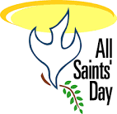**All Saints’ Day**

We will be celebrating All Saints’ Day on Sunday, November 6. If you have names of those who have died who you would like remembered on that day, please submit them to the office no later than October 31.

|  |  |
| --- | --- |
|  | **Teaching Series: What’s an Episcopalian?**  The Church is blessed with a great variety of ways to live as disciples of Jesus Christ - but what does it mean to be an Episcopalian? What are our particular gifts, traditions, and identity?  Join Father Tim at 9:10 on Sunday morning in the community room to discuss the historical, theological, and ministries that are our heritage. All are welcome to bring their questions and expertise to the table! The series will conclude on November 6th.  · November 6th – **Open Conversation** – It’s always fun to share our experiences of the church and our relationship with God. This session is an open time to ask questions and listen to others’ stories. |
| **Adult Forum - Nuts and bolts of the Anglican Communion**  **November 13th to 27th**  We've had some great conversations in our “What's an Episcopalian?” adult forum. We had a lot of questions, too, and many of them circled around the question: “What actually *is* the Anglican Communion?” The Anglican Communion, and the Episcopal Church, are highly organized to do great work, but they can often feel amorphous, full of intricate details, or just far away. These are great topics, and so we'll be holding a November adult forum (from the 13th to the 27th) on the following topics:   * Nov. 13th: How does the Anglican Communion work? - Justin Welby, the “global south, and the joys of a multicultural church. * Nov 20th: How does my local church work? - vestries, committees, and how meetings can be part of doing God's work in the world! * Nov. 27th: How does the Episcopal Church work? - non-US countries that are part of the Episcopal Church and what the presiding bishop can (and can't) do.   Join us for any or all for some awesome discussion. | |

**Christianity and Voting**

*Living our Christian discipleship in all walks of life, even in the voting booth. Father Tim’s meditation on how to live the Christian life in the public square.*

How do we, as Christians, vote? For many Christians, that’s an easy question: it is more “Christian” to support a Republican candidate or a Democratic position. Some Christians in our country and in the world align their faith with a certain political position. And so the question “How do we Christians vote” is pretty easy to answer.

I hope it’s hard for you, though. I hope you struggle with it. I hope that you look at the candidates and the propositions, local and national, and wonder how you can best live your discipleship in Jesus Christ in a world so wracked with division, anger, and fear.

A few of my friends who are professed atheists complain that we should keep religion out of politics. In a sense, I think they’re right. We live in a country of religious freedom, and we shouldn’t enact policy based purely on the fact that it’s important to our faith. Other religions may think differently. On the other hand, Christians cannot separate their call and life as disciples of Jesus Christ from their actions in the world. Part of the Christian call is moral.

And so how do we Christians vote? How do we do the hard work and take the responsibility of living in a democracy as faithful Christians? Pray. Even if you’ve known who you’re voting for since 2020 or earlier, pray. Grab a BCP and pray through some of the prayers that begin on 810 and especially the prayer for our country (pg 820) and the prayers that follow. Join with others and pray your fear, your hope, even your full heart. Pray in the voting booth. Pray that evening after you vote, and the following day, and the day thereafter. And be open, throughout it all, to receive from others the frustration, anxiety, anger, or joy in their hearts. Receive these things with grace, love, and compassion.

✠✠✠

**Turkeys for Eastside Food Pantry**



As has been our tradition for the last several years, we will be having a collection to support the purchase of Thanksgiving turkeys for Grace Church in cooperation with the Eastside Food Pantry. As many of you know, our parish regularly worked with the Grace Church pantry until they merged with the ecumenical effort at the Eastside Pantry located at University Methodist Church. We now maintain that connection by helping with the annual purchase of turkeys. If you would like to donate to this effort, please make your checks out to **Christ Church and write Turkeys** in the memo line. Donations may be either placed in the collection plate or mailed to church from October 30th until November 13th. Thank you for your consideration!



**69th Christmas Mart** **and Art Show**

Saturday November 19, 9 AM – 3 PM with take-out luncheon from 11-2

We are happy to host the 69th Christ Church Christmas Mart and Art Show. This is a longstanding Christ Church tradition and one of the major fundraisers for our church. In keeping with our commitment to community outreach, 10% of our profits will be donated to the FM Food Pantry.

Here are some of the ways that you can be a part of this great holiday tradition:

* **Contribute an item to the Silent Auction.** Local merchants can donate goods or services. Parishioners can donate items such as nicer quality holiday decorations, quilts, furniture, china, tickets (Symphoria, SU basketball, etc). Contact Amy Trail if you have something to donate. If possible, we would like to know what is being donated by the end of October.
* **Be a Mart Sponsor.** This is a great way to contribute if you are unable to be here on the day of the Mart. Make your check out to Christ Church with “Christmas Mart Sponsor” in the memo section. Checks can be either placed in the collection plate or mailed or dropped off at the church office. If you wish to be acknowledged in the program, please let us know of your donation by November 4.
* **Donate items for the gift basket raffle.** We need larger baskets, bottles of wine, craft beer, chocolate, gourmet food items, baking supplies, etc. Children’s items such as books, crafts or toys are also a big hit. Bring items to the church office on or before Sunday November 13 or contact Deirdre Popp, Lori Gibson or Kathy Byrum.
* **Contribute to the Bake Sale.** Bring your pies, breads, cakes, cookies, jams, etc. to Crosby Hall by Friday evening, November 18. (We can also accept items before the Mart opens on Saturday morning, but it is easier to have everything priced and ready if we have the items on Friday.) We are unable to accept any food that requires refrigeration. The Health Department requires us to keep a list of who donated each food item. Please attach a note with your name and contact information when you drop off your goodies. (This information is not given to customers, just kept on file for the Health Department.) If your food item contains nuts or other common food allergens, please label it accordingly. For baked goods, donors are asked to either wrap or place items in zip lock bags. If you have questions, please contact Lori Gibson or Jean Regan.
* **Create boxwood trees and homemade centerpieces**. We will be assembling these in Crosby Hall on Wednesday November 16 from 3-6 PM.
* **Help us with set up/clean up.** Set up will be on Thursday November 17, 9 AM – noon and Friday November 18, 9 AM – 4PM. You do not need to stay the whole time, even just an hour or two helps! Take down/clean up will be Saturday November 20, 3-5 PM. In previous years, we have had lots of helpers in the clean-up crew, which made this task remarkably quick and easy. We are hoping for the same this year!!
* **Help us during the Mart, 9AM-3PM.** We need cashiers as well as people to greet visitors and hand out programs. You can sign up for a half-day or all day if you wish. If you volunteer for the whole day, I will make sure you get a lunch break and that you are assigned different tasks in the morning and afternoon.
* **Invite your friends and neighbors to join us!** Take this opportunity to get some Christmas shopping done, enjoy some nice holiday music, visit with Santa and take home a delicious lunch.

Sign up sheets for all of the above are in Crosby Hall.

Please note that for the safety of our both our guests and volunteers, we will be following whatever CDC recommendations are in place at the time regarding masking.

Thank you for helping to make this year’s Mart a success!

✠✠✠

Daylight Savings Time ends on November 6. Please be sure to set your clocks back by one hour.

**The CC Afternoon Book Club**

Welcome to the Christ Church (CC) Afternoon Book Club! I’m thrilled to facilitate this new initiative.



Wednesday November 9, at 3:30, we will meet in the community room to discuss, The Lincoln Highway, by Amor Towles.

The Manlius Library will be pulling books for our book club. We are called the CC Afternoon Book Club in their system. The Lincoln Highway will be available October 9.

Please let me know if you are interested in book club, and if you think you can attend our November meeting.

Donna Cameron-Carter

[Dcarter3@twcny.rr.com](mailto:Dcarter3@twcny.rr.com)

Text: 315-243-5180

✠✠✠

**Have some news? Let us know!**

A church is not a building, it’s a community! Christ Church is a loving, joyful community that loves to eat together, worship together, and share our lives and calls from God in Jesus Christ together. For the past two years, our community has been spiritually together but, too often, physically apart. We took a break (for very good reasons!) from doing those things that pull our lives together: from sitting down with each other on First Fridays to Coffee Hour after church. In some ways, we’ve lost touch with the lives of one another.

Thankfully, we’ve got the Holy Spirit bringing us together, and this very newsletter can help! Is there some exciting news you have? Do you have any thanksgivings to raise up? Do you have a story about how you’ve seen God in the world recently? Send them to the newsletter! In this “new world” of live streaming and online church, this tried and true newsletter is another great way to connect!

✠✠✠

**Christ Church Outreach Programs**

Christ Church’s Outreach Committee helps us connect with several community organizations so that parishioners can donate time, talent, money, or products to those who need them. Short-term drives will be announced in the bulletin and newsletter, and in church. The following are long-term drives that will be ongoing for the foreseeable future.

For a complete list of organizations we partner with, please visit christchurchmanlius.org and click on *How to Help*.

**Donations Collected at Christ Church**

**FM FOOD PANTRY**

Donations to the FM Food Pantry is once again accepting donations of non-perishable goods. You can also help by spreading the word about their services.

The FM Food Pantry is available to anyone in our community needing food assistance. With food, gas and other prices continuing to increase, more and more households in the FM community are trying to make ends meet. We are a community resource -- please don't hesitate to contact us! Receiving help with food enables a household to spend limited funds on other essentials. This may be particularly true in the upcoming summer months when families with school age children are not receiving school meals -- the pantry is here to help! We also provide our families with non-food items such as paper products, cleaning supplies, and toiletries and can refer them to other helpful resources. The FM Food Pantry is a friendly, welcoming, and supportive place! If you or someone you know needs food assistance, here's what you need to know about the FM Food Pantry:

* Hours: Tuesdays and Wednesdays 10am-2pm and 5:30-7pm
* Location: 122 E. Seneca St. in Manlius (behind Pavone's Pizza)
* Contact & Info: 315-682-3688,
* [fmfoodpantrycny@gmail.com](mailto:fmfoodpantrycny@gmail.com), [fmfoodpantry.org](http://fmfoodpantry.org/)

**Paper Drive for ABC House:** We are collecting paper products and cleaning supplies for our next-door neighbors at A Better Chance House. Please help support our neighbor scholars with donations of paper products such as paper towels, toilet paper, tissues, and napkins; and with cleaning products such as anti-bacterial wipes and sprays and other cleaning products. There will be a barrel in the narthex to collect them.

**POMPEY LIONS CLUB**

There is a collection box in Crosby Hall to donate old glasses and hearing aids.

**WE RISE ABOVE THE STREETS**

We continue collecting travel size toiletries for We Rise Above the Streets. Please leave your donations in the designated basket in the narthex. You may also continue to make financial contributions thru PayPal: Weriseabovethestreets@gmail.com or sending a check to We Rise Above the Streets, 404 Oak Street, Suite 111, Syracuse, NY 13203.

**Volunteer Opportunities**

For more information about any of the following, please contact the organization below.

**WE RISE ABOVE THE STREETS** seeks people to help serve on Sandwich Saturdays. Sign up by calling 35-491-7164.

**F.I.S.H. (Friends in Service Here)** seeks drivers and dispatchers to help people get to appointments. Please call 315-637-8158 for more information.

**CLEAR PATH FOR VETERANS** seeks people to raise puppies for their service dog program. Contact Melissa Spicer at [melissa@clearpathforvets.com](mailto:melissa@clearpathforvets.com) or call Casey Eberhardt, Puppy Development Coordinator at 315-687-3300. Applications are available online at Clearpathforvets.com.

**MATTHEW 25 FARM** seeks volunteers at their farms in Tully and Lafayette. Their mission is to provide fresh produce for local food shelves and other food distribution. An easy way to donate is to give the proceeds from your returnable bottles and cans and there is now an account for the Matthew 25 Farm at FM Returnables on West Seneca St. For more information about the farm and how to volunteer, go to [www.matthew25farm.com](http://www.matthew25farm.com)

✠✠✠

**Keeping Our Christ Church Family Connected**

**Good News**

Please continue to share your good news! We often share our prayer requests and concerns but sometimes forget to let others celebrate with us. Please feel free to share news of awards, births, school and community plays or musicals in which Christ Church people are participating, articles from the paper which feature Christ Church people, sports team successes, and other happy events. You can share items in our Christ Church Manlius Parishioners Facebook group, send items to the office to be shared in the newsletter, or pin them up on our Good News bulletin board in Crosby Hall.

✠✠✠

**Join us on Facebook!**

Our Facebook page has reminders of parish events, links to the video services, and shared posts from other Episcopal organization (the diocese of CNY, the national Church, etc.) among other things.

<https://www.facebook.com/Christ-Church-Manlius-127512003958671/>

Our Facebook group “**Christ Church Manlius Parishioners**” is a place for us to “gather” and share information that may not fit into the bulletin or newsletters.

**Announcements and Reminders**

**The Rector’s Discretionary Fund** is a special account that is financed by the loose cash offering gathered one Sunday each month and by additional donations from parishioners and others. At Christ Church the **loose plate offering from the first Sunday of each month** is designated for the Rector’s Discretionary Fund. Many churches also include a line item in the budget. The purpose of the Rector’s Discretionary Fund is described in the Episcopal Church Canons as *“to be applied to such pious and charitable uses as the Rector or Priest-in-Charge shall determine.”* Money from this fund is used to assist those in financial need, to support ministry, and to contribute to the work of the wider Church.

✠✠✠

**Delta Sonic Gift Certificates**

We have Delta Sonic gift certificates available for purchase in the church office. The **$12. car wash certificate** ($18.35 value) provides a *Super Kiss Wash* with complimentary second wash within 5 days.

✠✠✠

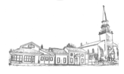Christ Church tee shirts are available for sale at coffee hour and in the office. They come in sizes S, M, L, and XL for $10 and 2XL for $12.



Christ Church now has aprons as well! One size fits all and

are available for $20.

✠✠✠

**Donate by Credit Card**

For members who would prefer to make pledge payments or other donations via credit card, that option is now available. Because of the concerted efforts of our Treasurer, Anne Whyte, anyone choosing this option can access the Hosted Payment Page by going to the church website: [www.christchurchmanlius.org](http://www.christchurchmanlius.org) and pressing the **Donate** button at the bottom of the page. The payment page will have a dropdown list with 7 options including Pledge 2022. These donations will be credited on your quarterly statements just like donations given by check or cash. The processing fee charged by your credit card will be added to your donation.

Of course, those of you who would like to continue to donate via personal check or through Online Banking using Bill Pay may do so. The Finance Committee hopes that one of these three options will be accessible to everyone, especially during this time of social distancing. Any questions can be addressed to Peter Winkler, Financial Secretary, or Anne Whyte, Treasurer. Thank you!

✠✠✠



Christ Church Calendar November 2022

|  |  |  |  |  |  |  |
| --- | --- | --- | --- | --- | --- | --- |
| 30  Holy Eucharist 8 am  Church School 10:15 am  Holy Eucharist 10:15 am  Book Group 7:30 pm Zoom | 31  Mahjong Group 2-4 pm | 1  Rector’s Office Hours  11 am – 1 pm  AA Mtg – PH 11:30 am  St. Margaret’s Craft Guild 1:30-4 pm | 2  Centering Prayer 9:00 am  Alleluia Bells – PH 7 pm | 3  Rector’s Office Hours  10 am – 12 pm  Debbie practice – CC 6m  Cherub Choir – PH 6 pm  Adult Choir – CC 7:30 pm  AA Mtg – PH 7:45 pm | 4  First Friday Dinner 6:15 pm  Office Closed on Fridays | 5  7:45 pm AA Mtg. - PH |
| 6  Holy Eucharist 8 am  Adult Ed. 9:10 am  Church School 10:15 am  Holy Eucharist 10:15 am  Book Group 7:30 pm Zoom | 7  Mahjong Group 2-4 pm | 8  Rector’s Office Hours  11 am – 1 pm  AA Mtg – PH 11:30 am | 9  Centering Prayer 9:00 am  CC Afternoon Book Group – CR 3:30 pm  Alleluia Bells – PH 7 pm | 10  Rector’s Office Hours  10 am – 12 pm  ABC House Board Meeting 7-8 pm – CR  Debbie practice – CC 6 pm  Cherub Choir – PH 6 pm  Adult Choir – CC 7:30 pm  AA Mtg – PH 7:45 pm | 11  Office Closed on Fridays  Diocesan Convention  Parents’ Night Out 6-8 p.m. | 12  Diocesan Convention  7:45 pm AA Mtg. - PH |
| 13  Holy Eucharist 8 am  Adult Ed. 9:10 am  Church School 10:15 am  Holy Eucharist 10:15 am  Book Group 7:30 pm Zoom | 14  Mahjong Group 2-4 pm  Rector’s “Out-of-Office Hours” 2-3 p.m. at Café Kubal | 15  Rector’s Office Hours  11 am – 1 pm  AA Mtg – PH 11:30 am  St. Margaret’s Craft Guild 1:30-4 pm | 16  Centering Prayer 9:00 am  Boxwood Tree making 3-6 p.m. – CH  Alleluia Bells – PH 7 pm | 17  Rector’s Office Hours  10 am – 12 pm  Debbie practice – CC 6 pm  Cherub Choir – PH 6 pm  Adult Choir – CC 7:30 pm  AA Mtg – PH 7:45 pm | 18  Office Closed on Fridays  Newsletter Deadline | 19  Christmas Mart 9 am. – 3 p.m.  Mart Luncheon 11 a.m. -2 p.m.  7:45 pm AA Mtg. - PH |
| 20  Holy Eucharist 8 am  Adult Ed. 9:10 am  Church School 10:15 am  Holy Eucharist 10:15 am  Book Group 7:30 pm Zoom | 21  Mahjong Group 2-4 pm  Rector’s “Out-of-Office Hours” 2-3 p.m. at Café Kubal | 22  Rector’s Office Hours  11 am – 1 pm  AA Mtg – PH 11:30 am  Vestry – CR 7 pm | 23  Office Closed  Centering Prayer 9:00 am | 24  Thanksgiving Day  Office Closed  AA Mtg – PH 7:45 pm | 25  Office Closed on Fridays | 26  7:45 pm AA Mtg. - PH |
| 27  Holy Eucharist 8 am  Adult Ed. 9:10 am  Church School 10:15 am  Holy Eucharist 10:15 am  Worship Cmte 11:30 am  Book Group 7:30 pm Zoom | 28  Mahjong Group 2-4 pm  Rector’s “Out-of-Office Hours” 2-3 p.m. at Café Kubal | 29  Rector’s Office Hours  11 am – 1 pm  AA Mtg – PH 11:30 am | 30  Centering Prayer 9:00 am  Alleluia Bells – PH 7 pm | 1  Rector’s Office Hours  10 am – 12 pm  Debbie practice – CC 6 pm  Cherub Choir – PH 6 pm  Adult Choir – CC 7:30 pm  AA Mtg – PH 7:45 pm | 2  Office Closed on Fridays | 3  7:45 pm AA Mtg. - PH |

|  |  |  |  |  |  |  |
| --- | --- | --- | --- | --- | --- | --- |
| **CHANCEL SCHEDULE – November 2022** | | | | | | |
| Date & Lessons | **8:00**  **Chalice** | **10:15**  **Lector** | **10:15**  **Prayers** | **10:15**  **Chalice** | **10:15**  **Crucifer (+)/Acolyte** | **10:15**  **Ushers/Greeters** |
| **November 6, All Saints Day**  [Daniel 7:1-3,15-18](http://www.lectionarypage.net/YearC_RCL/HolyDays/AllSaintsC_RCL.html#ot1)  [Psalm 149](http://www.lectionarypage.net/YearC_RCL/HolyDays/AllSaintsC_RCL.html#ps1)  [Ephesians 1:11-23](http://www.lectionarypage.net/YearC_RCL/HolyDays/AllSaintsC_RCL.html#nt1)  [Luke 6:20-31](http://www.lectionarypage.net/YearC_RCL/HolyDays/AllSaintsC_RCL.html#gsp1) | Peter Winkler (+) | Sandy Hesler | Lynne Couse | Carla Allen | Shyanne Hesler | Carol Recker-Hughes  Jeff Amack |
| **November 13, Proper 28**  [Malachi 4:1-2a](http://www.lectionarypage.net/YearC_RCL/Pentecost/CProp28_RCL.html#ot2)  [Psalm 98](http://www.lectionarypage.net/YearC_RCL/Pentecost/CProp28_RCL.html#ps2)  [2 Thessalonians 3:6-13](http://www.lectionarypage.net/YearC_RCL/Pentecost/CProp28_RCL.html#nt1)  [Luke 21:5-19](http://www.lectionarypage.net/YearC_RCL/Pentecost/CProp28_RCL.html#gsp1) | Carmen Denny (+) | Doug Allen | Marjorie Torelli | Jean Regan | Gilly Davies | Suzanne Ball  John or Connor Ball |
| **November 20,**  **Christ the King**  [Jeremiah 23:1-6;](http://www.lectionarypage.net/YearC_RCL/Pentecost/CProp29_RCL.html#ot2) [Psalm 46;](http://www.lectionarypage.net/YearC_RCL/Pentecost/CProp29_RCL.html#ps2) [Colossians 1:11-20](http://www.lectionarypage.net/YearC_RCL/Pentecost/CProp29_RCL.html#nt1)  [Luke 23:33-43](http://www.lectionarypage.net/YearC_RCL/Pentecost/CProp29_RCL.html#gsp1) | Peter Geiskopf (+) | Lynne Couse | Chris Denny | Marjorie Torelli | Brian Hebert | Jean Regan  John Stephenson |
| **November 27, Advent 1**  [Isaiah 2:1-5](http://www.lectionarypage.net/YearA_RCL/Advent/AAdv1_RCL.html#ot1)  [Psalm 122](http://www.lectionarypage.net/YearA_RCL/Advent/AAdv1_RCL.html#ps1)  [Romans 13:11-14](http://www.lectionarypage.net/YearA_RCL/Advent/AAdv1_RCL.html#nt1)  [Matthew 24:36-44](http://www.lectionarypage.net/YearA_RCL/Advent/AAdv1_RCL.html#gsp1) | Marjorie Torelli (+) | Ron Hebert | Peter Winkler | Chris Denny | John Henry Davies | Anne Whyte  Mark Hesler |
| **December 4, Advent 2**  [Isaiah 11:1-10](http://www.lectionarypage.net/YearA_RCL/Advent/AAdv2_RCL.html#ot1)  [Psalm 72:1-7, 18-19](http://www.lectionarypage.net/YearA_RCL/Advent/AAdv2_RCL.html#ps1)  [Romans 15:4-13](http://www.lectionarypage.net/YearA_RCL/Advent/AAdv2_RCL.html#nt1)  [Matthew 3:1-12](http://www.lectionarypage.net/YearA_RCL/Advent/AAdv2_RCL.html#gsp1) | Peter Winkler (+) | Deirdre Popp | Shawn Hebert | Lynne Couse | Addie Davies | Kathy Byrum  Craig Byrum |

PLEASE FIND A REPLACEMENT IF YOU CANNOT SERVE AND CALL THE OFFICE BY WEDNESDAY,

to let them know of the change. 315-682-5795.

**MINISTRIES SCHEDULES NOVEMBER 2022**

|  |  |  |  |  |  |
| --- | --- | --- | --- | --- | --- |
| **Ministry** | **11/6** | **11/13** | **11/20** | **11/27** | **12/4** |
| **Counters** | David Hughes and Jeff Amack | Kathy Byrum and Lori Gibson | John Stephenson and Craig Byrum | Travis Newton and Susan Hebert | Becky Walters and David Holder |
| **Altar Guild** | Suzanne Mitchell and Melissa Spicer | Candy Willhite and Susan Orr | Suzanne Mitchell and Suzanne Ball | Linda Albanese and Deb Tifft | Amy Trail and Deirdre Popp |
| **Coffee Hour 8:00** | Pat Barlow | Pete Geiskopf | Lynwood Bennerson | Kim and Bill Jeffery | Tim Byrnes |
| **Coffee Hour 10:15** | Julie and David Holder | Nancy and Tom Winiecki | Jeff and Kristi Amack | Jeanne Kauffman | Kathy and Craig Byrum |

The Parish Hall will be in use by outside groups EVERY:

Tuesday 11:30 am - 1:30 pm Saturday 7:45-9:45 pm

Thursday 7:45-9:45 pm

Please consult the office at 315-682-5795 to get approval for all building use. Thank you.



*November Celebrations*

Birthdays

Becky Walters November 3

Burke Regan November 5

Susan Hebert November 6

Stu Eddy November 9

Nora Newton November 9

David Swanson November 9

Kristi Amack November 12

Dot Kutil November 18

Cathie Swanson November 18

Tim Hannon November 19

Linda Albanese November 22

Brennan Jolly November 23

Lizzie Putelo November 24

John Stephenson November 27

Lynwood Bennerson November 28

Donna Cameron-Carter November 30

Matthew Trail November 30

Anniversaries

Rob and Beth Hughes November 7

Craig and Kathy Byrum November 25



**Christ Church**

**407 East Seneca Street**

**Manlius, NY 13104**

**Change Service Requested**

**________________________________________________________________**

There are two Sunday services with the celebration of the Holy Eucharist at:

8:00 a.m. and 10:15 a.m. with music.

The nursery is available during the 10:15 service.

Links for weekly sermons are posted on the church website and Facebook page and emailed to parishioners.

**___________________________________**

|  |  |
| --- | --- |
| Rector: Reverend Tim Hannon  Phone: (315) 682-5795  E-mail: rector@christchurchmanlius.org | Parish Administrator: Deirdre Popp  Phone: (315) 682-5795  Office Hours: Mon-Wed 8:00-1:00  Thursday 8:00-12:00  Friday closed  Email: church.office@christchurchmanlius.org |

Visit our web site at: http://www.christchurchmanlius.org/

**NEWSLETTER DEADLINE:**

**The deadline for the next issue is**

**Friday, November 18.**

**The next issue will cover the**

**month of December.**

**Please send articles to**

[**newsletter@christchurchmanlius.org**](mailto:newsletter@christchurchmanlius.org)**.**