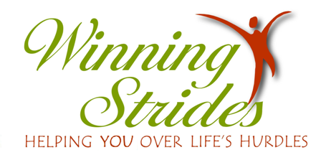

Continuing Education Workshop for the Licensed Professional Counselor

**Friday, September 26, 2025**

**Horse Sense & Clinical Ethics: Staying on the Right Path**

***Come join us at the farm for a fun and fresh approach to continuing education.***

***No riding involved. No prior horse knowledge required.***

**Workshop Description and Information:** Participants will explore ethical challenges and dilemmas that arise in various work settings. With the help of our equine friends, strategies for resolving ethical conflicts will be addressed. Equine assisted learning activities will focus on the elements of the counseling relationship, confidentiality, professional responsibility, and relationships with other professionals, by providing tools for resolving ethical issues. Working as a team, participants will explore ethical challenges to bring about resolution. Participants will learn how to assess their own internal conflicts during therapy sessions and how ethically to determine a course of resolution.

(Elements of the ACA Code of Ethics will be introduced and utilized to provide tools for resolving ethical issues.)

Location of Workshop: 2061 Bethel Road, NE

Conyers, GA 30012

Phone – 770-776-8446 ***Dress for weather and participation in the arena***

**#5.0 Ethics in-person (synchronous) contact hours of continuing education have been approved by the Licensed Professional Counselor Association of Georgia**

**(LPCA CE Approval # 213324511SM-0626)**

**).**

**$150 Fee** includes workshop, materials, and CE Certificate.

No on-site registration - registration must be received one week prior to workshop date. However, you still may be able to attend if space is available up to the day before the workshop. **Space limited to 20 participants.**

9:00-3:00 (Check-in opens at 8:30)

To register: e-mail [susanjung@earthlink.net](mailto:susanjung@earthlink.net) or call 770-776-8446.

**Susan Jung, LPC,** was an elementary school counselor for 37 years and an avid horsewoman all her life. In her private practice at Winning Strides in Conyers, Georgia, she utilizes equine assisted psychotherapy and learning activities for individuals and groups**.**

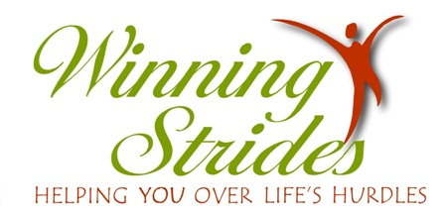

**2061 Bethel Rd., NE Conyers, GA 30012 770-776-8446**

Continuing Education Workshops for the Licensed Professional Counselor

***Horse Sense & Clinical Ethics: Staying on the Right Path***

**Registration Form**

**Name**

**Address**

**City State Zip**

**e-mail address Phone Number**

**License Number**

**Please make checks payable to Winning Strides LLC or go on line at** [**www.winningstrides.net**](http://www.winningstrides.net) **and pay through Pay Pal.**

**Mail to: Susan Jung, LPC**

**Winning Strides LLC**

**2061 Bethel Rd. NE**

**Conyers, GA 30012**