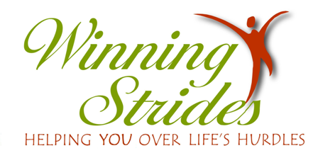

Continuing Education Workshop for the Licensed Professional Counselors
Friday, April 12, 2019

Re-Finding Spirituality in the Midst of Grief – An Equine Assisted Workshop

Come join us at the farm for a FUN and fresh approach to continuing education.
No riding involved. No prior horse knowledge required.

Workshop Description and Information: During this workshop, participants will grow in their ability to help clients lean on their personal spirituality to grieve the various pains and wounds of their lives. Through lively interactive discussions and equine assisted learning activities, they will examine the stages of grief as applicable to numerous life hurts, and begin to recognize that grief often takes a massive toll on a client’s spirituality. They will learn to recognize the spiritual giftedness of each of the stages, and various techniques that they can use to assist clients who are stuck in any of the stages. Participants will learn to assist clients in recognizing the new gifts they may have developed in their grieving process, and use these gifts for continued growth and strength. Finally, participants will examine their own life hurts, and thus grow in their ability to offer compassionate assistance to clients who are grieving.

Location of Workshop: 2061 Bethel Road, NE
Conyers, GA 30012
Phone – 770-776-8446
Dress for the weather and participation in the arena. Closed shoes required.
Please bring your own lunch - no nearby restaurants. Snacks & drinks provided.
Refrigerator & microwave on site.

$125 (by March 31st)
$150 (after March 31st) Fee includes workshop, materials, snacks & drinks, and CE Certificate.
No on-site registration - registration must be received one week prior to workshop date. However, you still may be able to attend if space is available up to the day before the workshop.
Space limited to 20 participants.

9:00-3:00 (Check-in opens at 8:30)

To register: e-mail susanjung@earthlink.net or call 770-776-8446.

Presenters:
Kathryn Byrne, MA, MPM, LPC, is in private practice in Snellville, GA, working with individuals and groups in the areas of grief, depression, anxiety, sexual abuse, and more. She also works at Advantage in Monroe, and at Eastside Hospital’s Behavioral Health unit.

Susan Jung, LPC, CPCS was an elementary school counselor for 37 years and an avid horsewoman all her life. In her private practice at Winning Strides in Conyers, Georgia, she utilizes equine assisted psychotherapy and learning activities for individuals and groups.
CE Core: 5 hours Approval # 8082-19

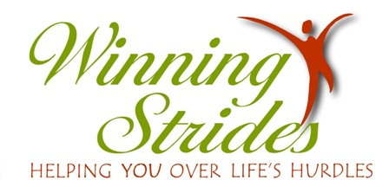
2061 Bethel Rd. NE Conyers, GA 30012 770-776-8446

Continuing Education Workshops for Licensed Professional Counselors

Re-Finding Spirituality in the Midst of Grief – An Equine Assisted Workshop

Registration Form

Name

Address

City State Zip

e-mail address Phone Number

License Number

Please make checks payable to Winning Strides or go on line at www.winningstrides.net and pay through Pay Pal.

Mail to: Susan Jung, LPC
Winning Strides, Ltd.
2061 Bethel Rd. NE
Conyers, GA 30012

