|  |  |
| --- | --- |
| **Transform your phone system into a cost-cutting, sales-driving machine.** JJR COMMUNICATION’S Cloud PBX provides an enterprise-grade VoIP phone system. Delivered from the cloud, it keeps pace with your growth—and propels your business higher. | **Cloud PBX** |

|  |  |  |  |  |
| --- | --- | --- | --- | --- |
| Rich, enterprise-grade calling features | A powerful web-based control panel | Simple management & scaling | Flat monthly rates cut capital costs. No PBX Hardware | 24/7 Tech Support  99.999% Uptime |

Cloud PBX is a complete business communications system and service. With over 40 calling features, Cloud PBX delivers Fortune 500 style capabilities to small and mid-sized businesses. This powerful cloud-based phone system uses a company’s existing data connection and wiring. Best of all, onsite PBX hardware is not required.

**Over 40 calling features let you perform like a big business**

• **Automated attendant** answers and routes every call

• **Hunt groups** ring multiple people at once to help ensure no call goes unanswered

• Use **Outlook** to make calls from your desk phone

• **Unlimited calling** in the U.S.

• Conferencing, call forwarding, music-on-hold (see “Features” section for full list)

**Mobility lets you do your job from any location**

• **Follow Me** automatically forwards calls to mobile phones and other numbers, or rings

multiple numbers at the same time

• Voicemail-to-email helps ensure messages get through faster

• Forward and manage faxes and voicemails just like email messages

**Preserve capital, simplify management**

• Flat per-user monthly pricing cuts capital investment

• No phone system hardware or software to buy

• No wiring to install. Uses your existing data wiring and Internet connection

• Web-based management tool makes moves, adds and changes simple

• More reliable than an on premises phone system

**Phones**

Cloud PBX is powered by Polycom (VVX) and Cisco (SPA) phones designed for office workers, busy managers and front-line staff

• Easy-to-use interfaces, rich audio quality and productivity features

• 2-3 line all-purpose phones, 4, 5 & 6 line professional phones, 12-20 line touch screen phones

• Popular Polycom SoundStation conferencing phones

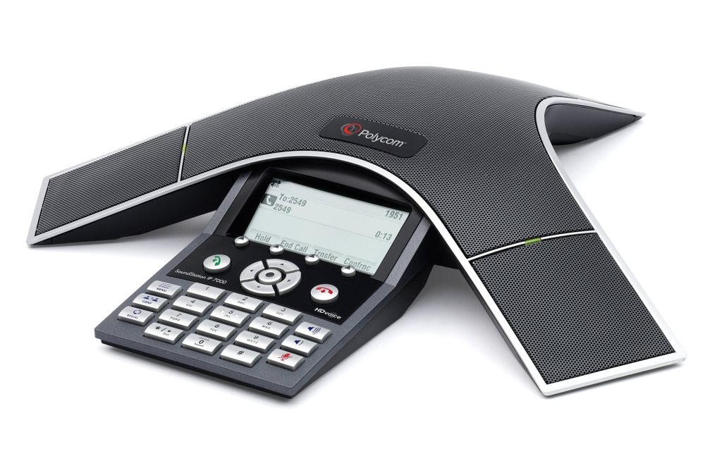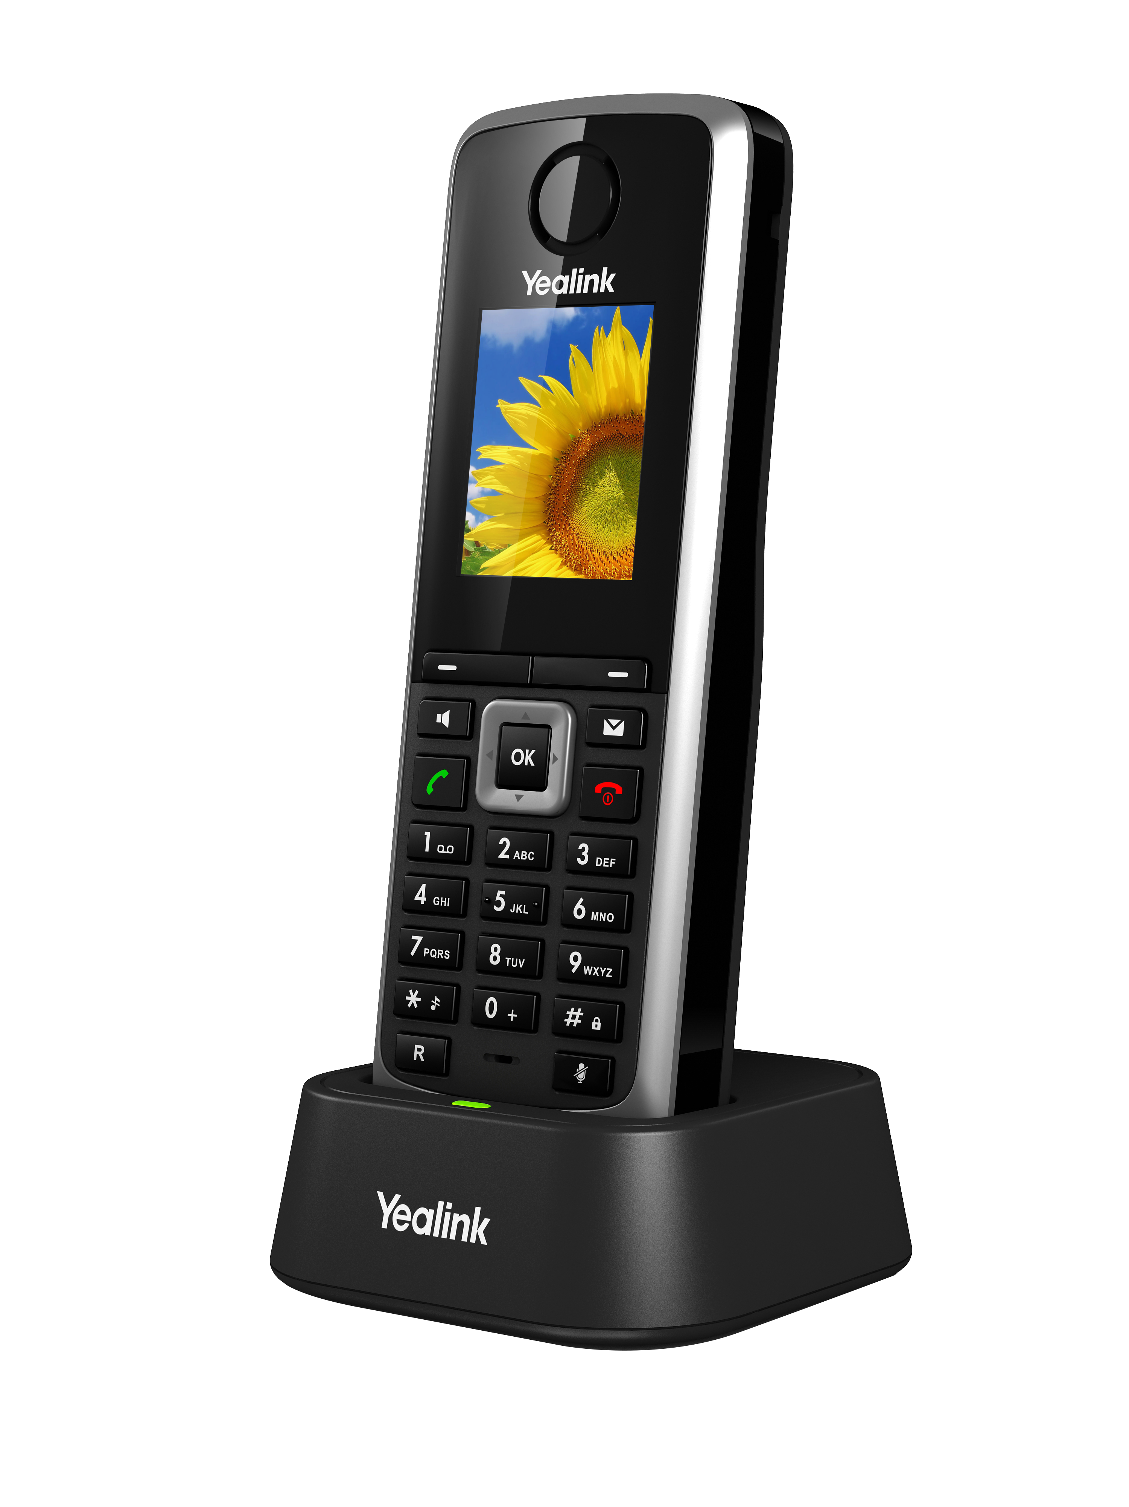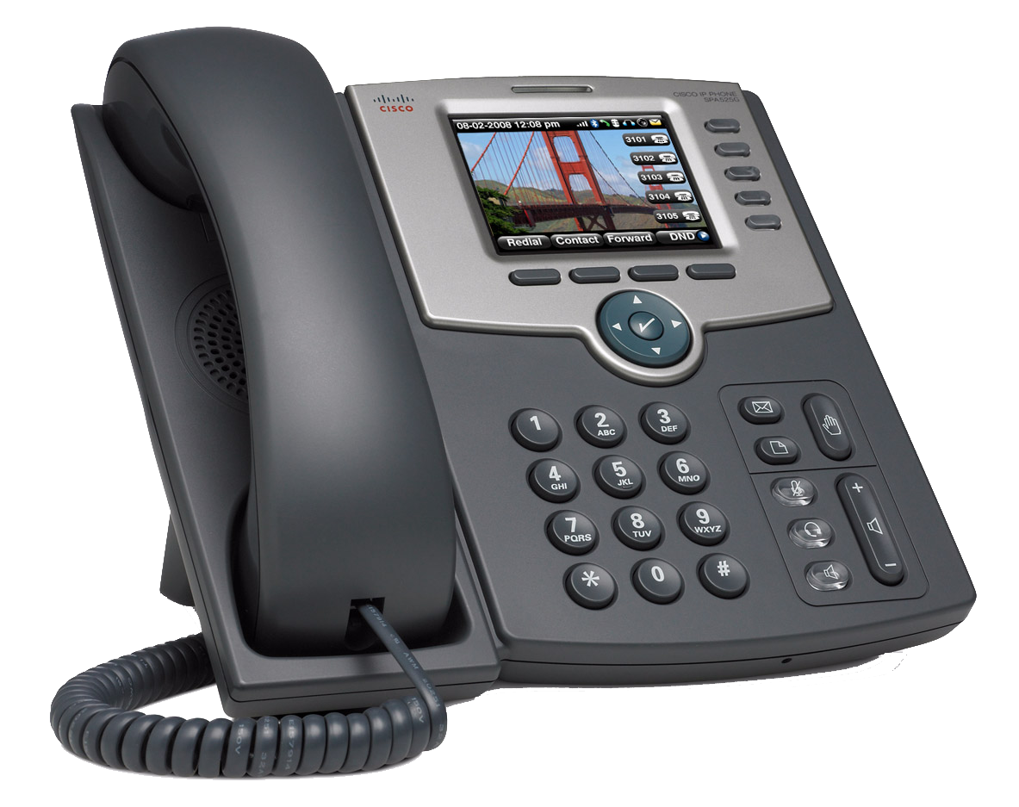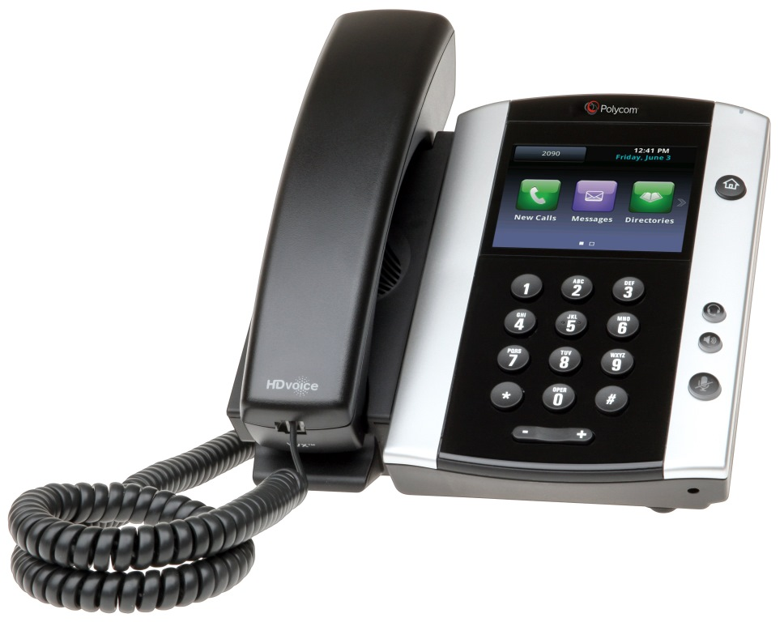

**Polycom VVX**

(2, 6, 12, 16 & 20 line models)

**Yealink T4 series**

(12, 16, & 20 line models)

**DECT Cordless**

**Polycom SoundStation**

Conference Phones

**Cisco SPA**   
(3, 4, & 5 line models)

**Features**

**System Features**

• Voicemail

• Auto Attendant

• Call Routing

• Caller ID

• Follow Me Forwarding

• Custom Hold Music

• Direct Inbound Dialing (DID)

• Message Waiting Indication

• Multi Call Appearance

• Click-to-Call

• Desktop Console

• Hunt Groups

• ACD/Call Queuing

• Daylight Savings Time

• Day/Night/Holiday Switching

**Phone Features**

• Call Forward

• Call Hold

• Call Recording

• Speakerphone

• Call Log

• Call Transfer

• Call Waiting

• 3-way Conferencing

• Do Not Disturb

• Headset Jack (RJ11)

• Mute

• On Hook Dialing

• Auto Answer

• Busy Call Forward

• Directed Call Pickup

• Phone Book (400 Entries)

• Phone Lock/Unlock

• Speed Dial

• Password

• Volume Control

• Administrator Password

• Named Ring Groups

• All Page/Intercom

• Overhead Paging

• Call Park and Pickup

• Inbound Caller Name

• Desktop Softphone

**Get started with Cloud PBX today!**

CALL US

973.432.9837

EMAIL US

Steve@JJRCOMMUNICATIONS.COM

ON THE WEB

www.jjrcommunications.com