s3*’a

■%% '

'-/s



=1

*:tu*

L •*i

'w'--

Is. J'» *•«'

•.V iiSiSs



*mr*

? 4®’7i

**, H'**

•’W

•r>s.

; ‘ .5.



©DUKE Par/tex BR

SEA SCHOOL

Certificate of Training

This will certify that

Clark M. KennedyPaesler

Has successfully completed

Personal Safety & Social Responsibilities

(SEASCH-359)

course as approved by the United States Coast Guard to satisfy the Personal Safety & Social  
Responsibilities competency and training requirements of Section A-VI/1 and  
Table A-VI/1-1 of the STCW Code, as amended 2010, and 46 CFR 11.302(a)(4) and 12.602(a)(4).

Ft. Lauderdale. FL Training Location

May 24. 2018 Date of Completion

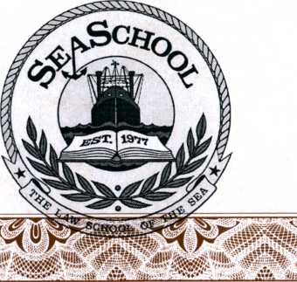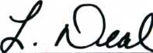

Lucinda Deal Office Manager

Certificate #270578-29

: .'^'v .-i

.null!'

American Superior 02014