F i;®'



SEA SCHOOL

Certificate of Training

This will certify that

i^A%,

a"'

H',}» ^{«|5

s’V"!

*■ lunVit.*

Clark M. KennedyPaesler

Has successfully completed

Personal Survival Techniques

(SEASCH-363)

course as approved by the United States Coast Guard to meet the  
Personal Survival Techniques training and competency requirements of  
STCW Code Section A-VI/1 and 46 CFR 11.302(a)(1) and 46 CFR 12.602(a)(1).

Ft. Lauderdale. FL Training Location

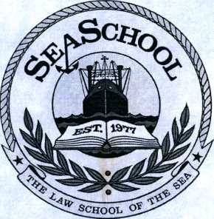

*/Qai^*

Lucinda Deal Office Manager

May 23. 2018 Date of Completion

Certificate #270578-31

© DUKE Par/tex BL



•=>

sfeftSi

"'iiifis



3

v«i^~ '

American Superior 02014

***10***



SEA SCHOOL

Certificate of Training

This will certify that

Clark M. KennedyPaesler

Has successfully completed

Personal Survival Techniques

(SEASCH-363)

course as approved by the United States Coast Guard to meet the  
Personal Survival Techniques training and competency requirements of  
STCW Code Section A-VI/1 and 46 CFR 11.302(a)(1) and 46 CFR 12.602(a)(1).

Ft. Lauderdale. FL Training Location

May 23. 2018 Date of Completion

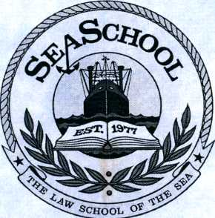

***/QgJl***

Lucinda Deal Office Manager

Cv 1

^ *IS - '■*



-=>

* 'I*

Certificate #270578-31

< ,V c

© DUKEPar/texBL

American Superior 02014

