**Flock of My Son, My Rosary Attached to Your Armor is Protection and Spiritual Strength, with Which You Will Defeat My Adversary and His Hosts of Evil!**

****

**My children, may the Peace of my Lord be with you all, and may my love and protection as Mother Help of Christians be with you always.**

**Flock of my Son, the course of your life is about to change, peace and tranquility will be lost very soon; great events that will completely change your life and daily life are about to happen. The time of my adversary and his emissaries of evil is beginning and what awaits humanity and especially the People of God is repression, persecution, imprisonment, submission, slavery, abuse and death. The New World Order that serves my adversary has already begun to dominate the world, its agenda of tyranny began with the plan of vaccines and vaccination against the existing pandemic; these vaccines are not the solution, but the beginning of the holocaust that will lead to death, transhumanism and implantation of the mark of the beast, to millions of human beings.**

**I ask you, my children, to return to God with all your heart, because only in Him you will find peace, security, trust and solution to all your problems; only God can destroy the traps and deceptions that the emissaries of evil will set for you! The pretext of the pandemic will be used to subdue and enslave humanity; the confinements will make it more severe, because what they seek is to keep humanity submerged in fear and panic, so that it cannot protest; they also seek with the confinements to destabilize the economy of many nations, especially the poorest, in order to exercise over them, dominion and control. Bankrupt nations will be helped by loans, but in order to have access to them, they will have to accept unconditionally the whole agenda of the New World Order. Every subjugated nation will lose its sovereignty, its governments will lose autonomy, and will be ruled by the laws and policies of the New World Order.**

**The Sickle and Hammer will rule over the New World Order, and all those who rise against this regime will disappear. Private property will be lost in nations ruled by the New World Order, and even the parental power of parents over their children, especially the youngest. All will pass to the State, which will dispose of goods of citizens and families. The People of God will walk into exile; only those who have the mark of the beast will be able to buy, sell and enjoy the help and services of the state.**

**My children, from this year onwards, sorrows will begin for mankind, what sadness I feel in my Heart as Mother of mankind, knowing that the immense majority will be lost because they are far from God! The great tribulations are beginning, injustices, deceptions, mistreatments, repressions, submission, slavery, hunger and death, will be the desert that you will have to pass; only if you remain united with God and only if you remain united with God and drawn upon my Holy Rosary, you will be able to overcome these trials. Again I tell you, my Son's flock, do not let go my Rosary because it will give you great victories over the forces of evil; pray in chain with my Rosary and all plans and deceptions of my adversary and his emissaries of evil will roll down. Flock of my Son, my Rosary united with your Armor is protection and spiritual strength with which you will overcome my adversary and his hosts of evil. My children, it is time now to be united in prayer and recollection, because darkness, sin and evil already cover the earth. So, follow my instructions and do not let go my Rosary, so that you may be victorious in all trials.**

**May the Peace of my Lord remain in you, and may my Love and Motherly Protection accompany you always.**

**Your Mother, Mary Help of Christians**

**Make known, my children, the messages of salvation to the whole world.**

**The Flame of Love**

# **Of the Immaculate Heart of Mary**

## What is the Flame of Love?

**The devotion to the Flame of Love of the Immaculate Heart of Mary finds its origin in the revelations of the Lord Jesus Christ and the Virgin Mary to Elizabeth Kindelmann, a Hungarian mother of six, between the years 1961 and 1982. Elizabeth died on April 11, 1985. Through her, the Virgin Mary placed into our hands a new means: The Flame of Love of Her Immaculate Heart.**

**These revelations have been transcribed by Elizabeth in her Spiritual Diary which, together with the Holy Gospels and the Teaching of the Church, is at the root of the spirituality of the Flame of Love Movement.**

**Elizabeth once asked: “What then is the Flame of Love?”**

**Jesus responded: “My Mother’s Flame of Love is for you what the Noah’s Arch was for Noah.”**

**And the Blessed Virgin Mary added: “The Flame of Love of My Immaculate Heart is Jesus Christ Himself!”**

## The Gift of Grace from Our Lady

**"I would like to place in your hands a new instrument, a ray of light... It is the Flame of Love of my heart... With this Flame full of graces that I give you from my heart, ignite all the hearts in the entire country. Let this Flame go from heart to heart. This is the miracle becoming the blaze whose dazzling light will blind Satan. This is the fire of love of union which I obtained from the heavenly Father through the merits of the wounds of my Divine Son." (April 13, 1962)**

**"We will put out fire with fire: the fire of hatred with the fire of love."(December 6, 1964)**

**"My Flame of Love has become so incandescent that I want to spread on you not only its light, but also its warmth with all its power. My Flame of Love is so great that I can no longer keep it within me; it leaps out at you with explosive force. My love that is spreading will overcome the satanic hatred that contaminates the world, so that the greatest number of souls is saved from damnation." (October 19, 1962)**

**"Just as the whole world knows my name, so I want the Flame of Love of my heart performing miracles in the depths of the hearts to also be known." (October 19, 1962)**

**"My little one, I extend the effect of grace of the Flame of Love of my heart over all the peoples and nations, not only over those living in the Holy Mother Church, but over all the souls marked with the sign of the blessed Cross of my Divine Son. Also over those who are not baptized!"(September 16, 1963)**

**"With my Flame of Love, I want to make the home come alive again with love. I want to unite families that are scattered." (August 8, 1962)**

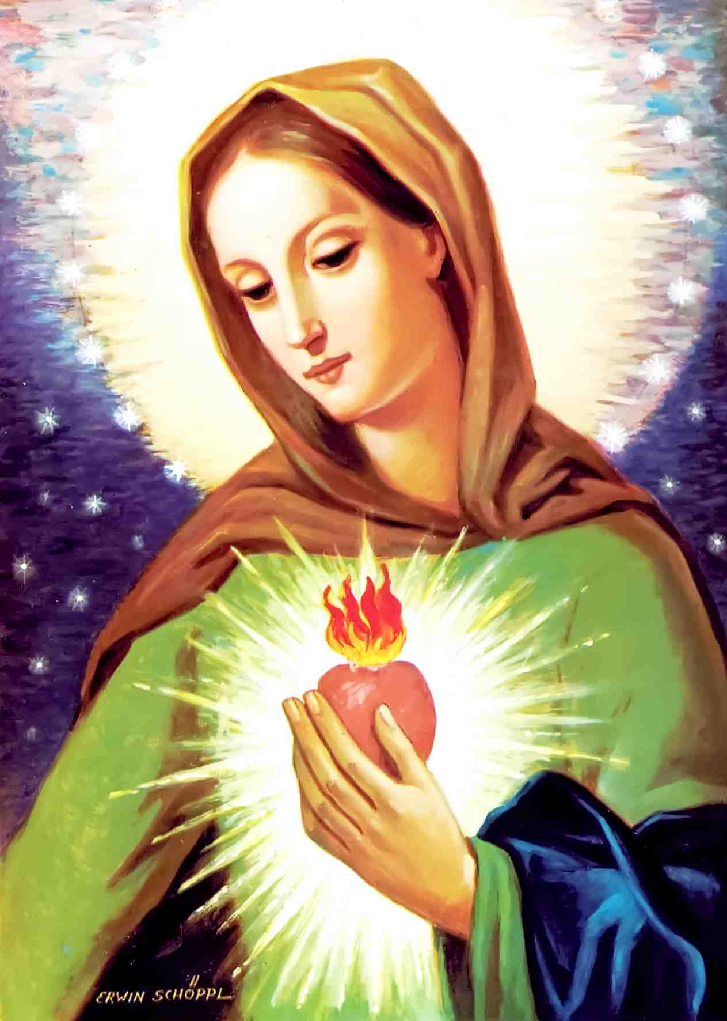

The Flame of Love Prayers

### The Unity Prayer given by Our Lord

**Jesus: "This prayer is a weapon in your hands. By collaborating with Me, Satan will be blinded by it; and because of his blindness, souls will not be led into sin."**

**My Adorable Jesus,  
May our feet journey together.  
May our hands gather in unity.  
May our hearts beat in unison.  
May our souls be in harmony.  
May our thoughts be as one.  
May our ears listen to the silence together.  
May our glances profoundly penetrate each other.  
May our lips pray together to gain mercy from the Eternal Father. Amen.**

### Hail Mary: Addition of the Important Petition

**From Elizabeth's Diary:**

**For a long time, I did not dare to record Our Lady’s petition: "In that prayer which honors Me the most (Hail Mary...), add the following petition: Hail Mary..., pray for us sinners. 'Spread the effect of grace of thy Flame of Love over all of humanity.'"**

**The bishop asked Elizabeth: "Why should we recite the very old Ave Maria differently?"**

**On February 2, 1982, the Lord answered: "It is exclusively thanks to the effective petitions of the Blessed Virgin that the Most Holy Trinity granted the overflowing of the Flame of Love. By it, ask in the prayer with which you greet My Most Holy Mother: "spread the effect of grace of Thy Flame of Love over all of humanity, now and at the hour of our death. Amen." So that, by its action, humanity is converted."**

**The Most Blessed Virgin added: "I do not want to change the prayer by which you honor me; by this petition, I want rather to shake humanity. This is not a new prayer formula; it must become your constant petition." (October 1962)**

**The Hail Mary should be prayed like this:**

**Hail Mary, full of grace, the Lord is with Thee,  
blessed are Thou among women,  
and blessed is the fruit of Thy womb, Jesus.  
Holy Mary, Mother of God, pray for us sinners,  
spread the effect of grace of Thy Flame of Love over all of humanity,  
now and at the hour of our death. Amen.**

**On October 13, 1962 (the 45th anniversary of the final apparition at Fatima), Our Lady revealed to Elizabeth the following message: "My little one, your compassion for the poor souls has so moved my motherly heart that I grant the grace that you sought. If at any moment, while invoking my Flame of Love, any of you pray in my honor three Hail Mary's, a soul is released from Purgatory. During November, the month of the deceased, ten souls will be released from Purgatory for each Hail Mary recited. The suffering souls must also feel the effect of grace of the Flame of Love of my maternal heart."**

### Prayer for the Grace of the Flame of Love

**Most Blessed Virgin Mary, my heavenly Mother!**

**I open my heart to you and with filial love and humble faith, I ask you to kindle in my heart the flame of love of your Immaculate Heart. Give me, my loved ones, the priests and all consecrated people, as well as all people, the graces necessary for them. Help us to persevere in goodness and in godly, virtuous living.**

**We beseech Thee, come to our aid, and flood all mankind with the work of grace of Thy flame of love, now and at the hour of our death. Amen.**

### Prayer for the Propagation of the Flame of Love of the Immaculate Heart of Mary

**With the personal approval of his Holiness Pope Paul VI (November 1973)  
Imprimatur: July 10, 1984 Joseph, Bishop of Augsburg**

**Blessed Virgin Mary, our cherished heavenly Mother, you love so much God and us, your children, that you offer us to your divine Son Jesus on the Cross, to forgive us by our Heavenly Father and to obtain our salvation, so that all those who believe in Him do not perish but obtain the Eternal Life.**

**With a filial confidence, we pray to you, Virgin Mary, that with the Flame of Love of your Immaculate Heart, kindled by the Holy Spirit, you ignite in our languid hearts the fire of a perfect love for God and all the humans, so that together with you, with one heart, we love God and our neighbor.**

**Help us to transmit this holy Flame to all the people of goodwill, so that the Flame of Love extinguishes the fire of hatred everywhere on earth and that Jesus, the Prince of Peace, be the King and the centre of all the hearts in the Sacrament of His Love on the Throne of our altars. Amen.**

### Flame of Love Rosary

#### At the Beginning

**In honor of St. Five Wounds of our Savior, we make the Sign of the Cross † five times in succession.**

#### On the 1st large Bead

**Sorrowful and Immaculate Heart of Mary, pray for us who take our refuge in You!**

#### On the three small Beads

**My God, I believe in You because You are infinitely good.  
My God, I hope in You because You are infinitely merciful.  
My God, I love You because You are kind above all things.**

#### On the small Beads

**Mother, save us, through the Flame of Love of Your Immaculate Heart. (10x)**

#### After each Decade

**Mother of God, spread the effect of grace of Thy Flame of Love over all of humanity, now and at the hour of our death. Amen.**

#### At the End

**Glory be to the Father and to the Son and to the Holy Spirit as it was in the beginning is now and ever shall be world without end. Amen. (3x)**

## The Means of the Flame of Love

**Our Lord and Our Lady have given us several means to put in effect the power of the Flame of Love.**

### Participation in the Sacrifice of Holy Mass

**On November 22, 1962, the Blessed Virgin said: "If you attend a Holy Mass which is not an obligation for you, and if you are in a state of grace before God, I will spread the Flame of Love of my Heart and I will blind Satan during this time. My graces will run out abundantly on the souls for which you offer this Holy Mass. The participation in the Sacrifice of the Holy Mass increases to the highest degree the blindness of Satan."**

### Offering the daily Chores for the Glory of God

**On November 30, 1962, Our Lady said: "Throughout the day also, offer your daily chores for the glory of God! This offering, made in a state of grace, also helps to blind Satan. Live in conformity with my graces so that the blindness of Satan extends more and more and grows increasingly larger. If you make good use of the abundant graces that I bestow upon you, they will make better a multitude of souls."**

### Hour of Atonement on Thursday and Friday

**"My little one, you must consider Thursdays and Fridays as two great days of special grace. These days, those who offer atonement to my divine Son will receive a great grace. During the hours of atonement, the ability of Satan weakens insofar as the atoning souls beg for the sinners." (September 29, 1962).**

**"On Thursday and Friday, I ask you, my daughter, to offer a very special reparation to my Divine Son. This will be an hour for the family to make reparation. Begin this hour with a spiritual reading, followed by the Rosary or other prayers in an atmosphere of recollection and fervor. Let there be at least two or three, because my Divine Son is present where two or three are gathered. Start by making the sign of the Cross five times offering yourselves to the Eternal Father through the wounds of my Divine Son. Do the same at the conclusion. Sign yourselves this way when you get up and when you go to bed, and during the day. This will bring you closer to the Eternal Father through my Divine Son, filling your heart with graces." (April 13, 1962)**

### Adoration in a Spirit of Atonement

**"When someone does Adoration in a spirit of atonement or pays a visit to the Blessed Sacrament, as long as it lasts, Satan loses his power on the parish souls. Blinded, he ceases to reign on souls."(November 6 – 7, 1962)**

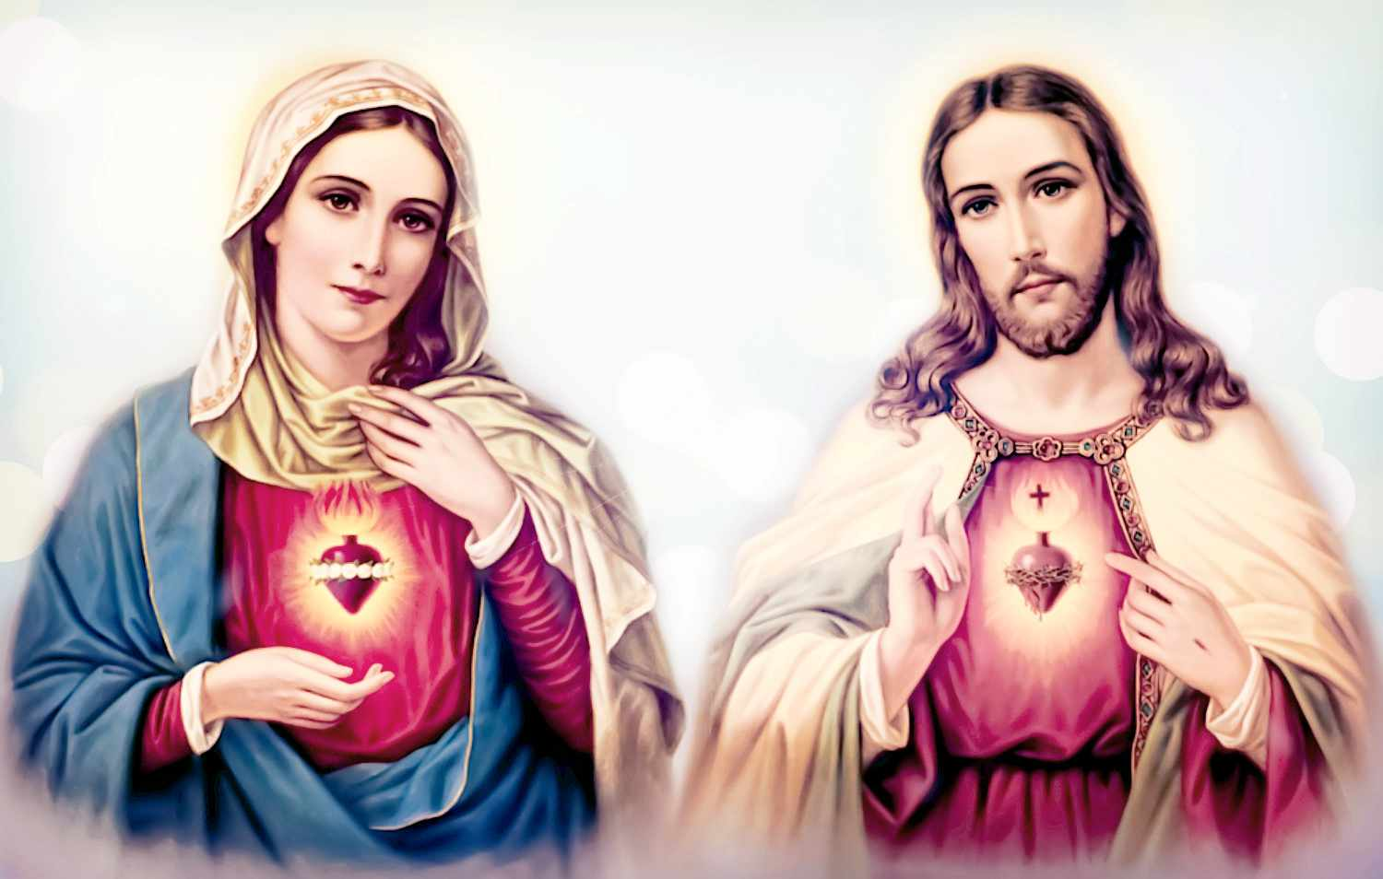

### The Flame of Love and the Dying

**"The more fervently you pray, the more thoroughly will Satan be blinded, and the dying soul will find renewed strength to decide wisely as to her future destiny."**

**"Once the Flame of Love of my heart lights up on the earth, its effect of grace will also spread out to the dying. Satan will be blinded, and through your prayer at the nighttime vigil, the terrible struggle of the dying against Satan will end. Coming under the gentle light of my Flame of Love, even the most hardened sinner will convert."(September 12, 1963)**

**"I want the holy night vigils - by which I want to save the souls of the dying - to be organized in every parish, so there is not even one moment without someone praying in a vigil." (July 9, 1965)**

**Our Lady: "Make sure that not a single minute goes by during the night without prayer. As long as there is someone awake and praying in honor of My Flame of Love, I promise you that not a single dying person in their surroundings will be damned.**

### The Flame of Love and the Souls in Purgatory

**Holy Mary: "My Flame of Love which I desire to spread from my heart over all of you in a greater measure extends even to the souls in Purgatory."**

**The Lord Jesus: "Whoever fasts on Monday on bread and water while referring to the Flame of Love of the Immaculate Heart of Mary delivers the soul of a priest from Purgatory. Also, he who follows that prescription will receive the grace, during the octave following his death, to be delivered from Purgatory by My Mother."(Agenda of Monday)**

**The Blessed Virgin added: "For all those who observe absolute fasting regularly on Monday, they can cease it at 6.00 p.m. But instead, they must pray on the same day a five-decade Rosary for the souls in Purgatory."**

**"When those persons consecrated to God and the faithful keep the Monday fast, they will free a multitude of souls from Purgatory each time they receive Communion during that week, at the very moment they receive the Holy Body of Our Lord Jesus Christ." (August 15, 1980)**

**The Blessed Virgin Mary: "The priests who observe the fasting on Monday release during each Holy Mass they celebrate during that week, at the moment of consecration, innumerable souls from Purgatory. The religious and the laity who observe absolute fasting on Monday, will deliver during that week, every time they receive Communion and at the time they receive the Sacred Body of the Lord, a host of souls from Purgatory." (August 15, 1980)**

**"For those families observing a holy hour of reparation on Thursday or Friday, if someone happens to die in the family, the deceased is freed from Purgatory after a single day of strict fasting observed by any one member of the family." (Let's understand: if he died in a state of grace.)(September 24, 1963)**

**"My little one, your compassion for the poor souls has so moved my motherly heart that I grant the grace that you sought. If at any moment, while invoking my Flame of Love, any of you pray in my honor three Hail Mary's, a soul is released from Purgatory. During November, the month of the deceased, ten souls will be released from Purgatory for each Hail Mary recited. The suffering souls must also feel the effect of grace of the Flame of Love of my maternal heart." (October 13, 1962)**

**The pain of the memory of our sins fertilizes also the souls (August 15, 1964). Even the desire of the salvation of souls contributes to blind Satan (November 30, 1962), because the will of the soul is already love (September 15, 1962).**

"I need you all"

**Mary: "You must strive to participate in the blinding of Satan! I need you, individually as well as collectively. Any delay must be ruled out, for Satan will be blinded to the extent of your participation…**

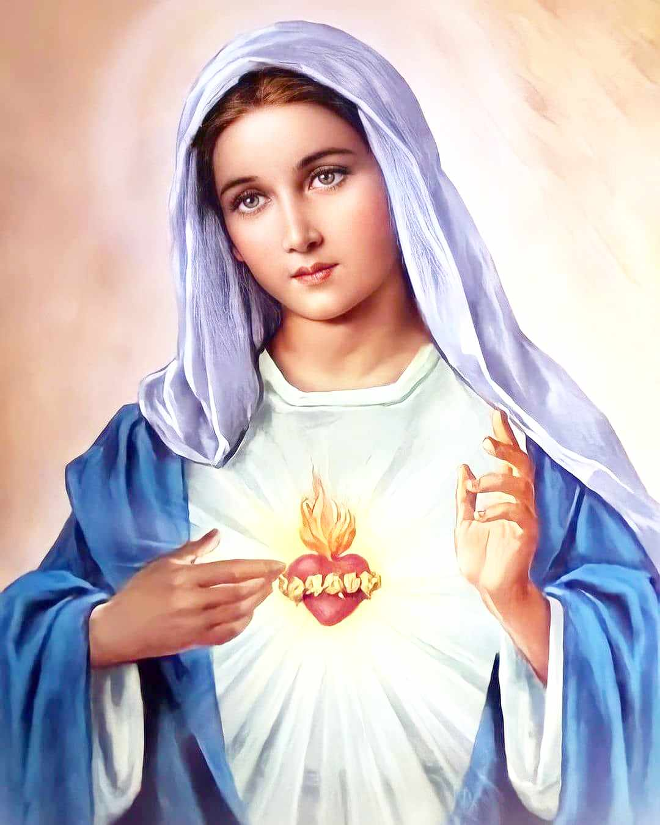**This is a grave responsibility. But your effort will not be in vain. If the whole world is united to Me, the soft light of My Flame of Love will then burn and set the globe aflame. Satan will be humiliated and made incapable of using his power any longer, provided this time of preparation is not indefinitely prolonged! No, do not prolong it! Do not procrastinate in response to My holy requests!"**

**"My daughter, I am providing you with so powerful a grace: the burning Flame of Love from My Heart, that has never before been offered as it is now. Ever since the Word became Flesh, I have not undertaken a greater movement than the Flame of Love from My Heart who rushes to you. Till now, nothing could blind Satan as much. And it is up to you not to reject it, for this rejection would simply spell disaster."**

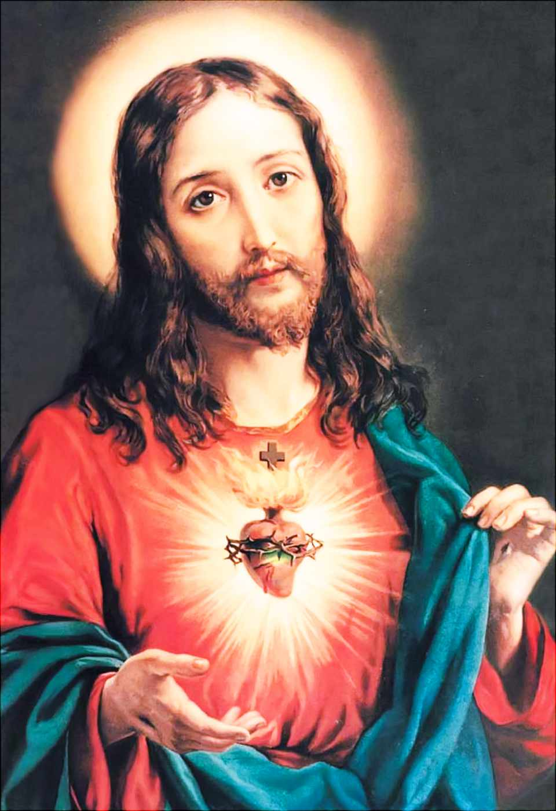**Jesus: "Go beyond your limits! Think of the Three Wise Men who made a superhuman sacrifice. They surely exceeded their usual limits. Above all, the priests must do it, but the other consecrated persons as well and all the faithful..."**

**Mary: "In the tribulation that is about to begin, I will remain with you. I am your Mother. I can and will help you. Soon, you will see My Flame of Love gushing forth everywhere, illuminating the heavens, the earth, and even darkened and slumbering souls. But what sorrow it is for Me to have to watch so many of My children throw themselves into Hell!"**

**Mary: "My children, the arm of My Divine Son is ready to strike. I can barely hold it back. Help Me! If you invoke My Flame of Love, we can save the world together!"**

Request of Jesus to His consecrated Souls

**"Turn to Me and be sacrificed on the sacred altar of inner recollection and martyrdom. Do not forget that this inner martyrdom is My Will and Satan cannot stop it. This battle in the depth of your souls brings about abundant fruit, just as does martyrdom... Set the earth ablaze with your burning desires. Use your sacrifice made from pure love to burn away all sin. Do you not believe this is possible? Just trust Me." (August 7,1962)**

**"You should stand where I put you, firm and full of the spirit of sacrifice... Take upon yourself the Cross that I also have embraced and thus offer yourselves as victims as I have done. Otherwise, you will not have eternal life." (October 4, 1962)**

#### What is the Lord Jesus asking of His beloved priests?

**That they give a good example (December 22, 1963); that they follow the inspirations of the Lord and make souls see the importance of that (January 1, 1964); that they shake the lethargic souls and give raise to courage in souls (April 17, 1962); that they make good use of their time (October 19, 1964); that they allow themselves to be guided by Divine Grace to a sacrificed and apostolic life (November 23, 1962); and that they make adoration and incite the faithful to do the same (July 25, 1963).**

**"Ask My sons to direct souls towards My beloved Mother. They should never give a homily without exhorting the faithful to have a profound devotion for her." (April 17, 1962)**

**"While I was hanging on the Cross, I cried out in a loud voice: 'I am thirsty.' I say these same words to all, especially to the souls consecrated to Me." (August 18, 1964)**

### The Flame of Love and Sinners

**In these messages, the sacred cause of the salvation of souls holds a central position, because the essence and purpose of the action of the Flame of Love is the salvation of souls, their return to God, and their renewal.**

**The Lord Jesus: "Let us have just one thought: the salvation of souls."(May 17, 1963)**

**"Oh, how I long for sinners!" (August 15, 1964)**

**"No soul I have entrusted to the care of My priests ought to be damned." (August 6, 1962)**

**That is why He instructs us: "Let all of you take part in My work of Redemption!"**

**And He also indicates the heavenly instrument: "Hell is swallowing those souls created in the image and likeness of My heavenly Father. They fall into the clutches of Satan. The Flame of Love of My Mother can soothe the sorrow of My Heart." (July 26, 1963)**

**The Blessed Virgin also said: "I want that not one soul be damned. You should want this together with me. For this purpose, I place in your hands a ray of light that is the Flame of Love of my heart."(January 15, 1964)**

**But it also depends on us: "Satan is sweeping souls away in a terrifying way. Why don't you all try your best to stop him and do it as soon as possible?" (May 14, 1962)**

**She added: "You must dedicate yourselves to blind Satan. The coordinated forces of the entire world are necessary to accomplish this. Do not delay because someday you will be called to account for the work entrusted to you, for the fate of a multitude of souls... Satan will be blinded inasmuch as you work against him." (November 27, 1963)**

### The Means to save Souls

**"Sacrifice and prayer! These are your instruments." (July 22-23, 1963)**

**All kinds of sacrifices such as bearing with patience bodily and spiritual sufferings, uniting them to the Passion of Jesus (May 24, 1963), as well as fasting, keeping night vigil (during part of the night), etc. Each one, according to his ability, can practice them at all times and in all places. Even with the offering of our daily work and chores, we can save souls (November 30, 1962).The sorrow of remembering our sins is also fruitful for souls (August 15, 1964). Even the desire for the salvation of souls helps to blind Satan (November 30, 1962), because, "The will of the soul is already love"(September 15, 1962).**

**The Blessed Virgin: "The greater the number of souls who sacrifice and watch in prayer, the greater the power of my Flame of Love on earth will be... Because it is with the power of sacrifice and prayer that the flash of hellish hatred will be overcome." (December 6, 1964)**

**"I will support your work with miracles as never seen before, and that the reparation to my Divine Son will accomplish imperceptibly, gently and silently." (August 1, 1962)**

**And the Lord Jesus: "If you ask for souls, can I refuse your petitions? No. Otherwise, I would be acting against My work of Salvation. I always hear your persevering prayer." (June 24, 1963)**

## Feast of the Flame of Love

**"I ask the Holy Father to make the feast of the Flame of Love on February 2, the feast of Candlemas. I do not want a special feast."(August 1, 1962)**

**Sources:**

[**➥ www.theflameoflove.org**](https://www.theflameoflove.org/survey.html)

[**➥ kath-zdw.ch**](https://kath-zdw.ch/maria/liebesflamme.Elisabeth.Kindelmann.html#Liebesflammen.Apostolat)

**[➥ flameoflove.us](https://flameoflove.us/flame-of-love-prayers/" \t "_blank)**

**[➥ flameoflove.ph](https://flameoflove.ph/messages/" \t "_blank)**