NEWS OF INTEREST

Pennies From Heaven: the monies collected help send children to the camp of their choice (mostly Seneca Hills). Your donations are appreciated and well spent. Other charities are often contributed to as worthy causes from Pennies From Heaven also.

PRAISES AND PRAYER

Please pray for God’s guidance in the future of our church. Please pray for the peace of the world. Pray for the leaders of our country as they earnestly seek peaceful solutions to the problems and crises around the globe. Please pray for our military and police forces and their safety throughout each day. Pray for our public school system. Pray for the mental health of people everywhere. Pray for our mission to Ghana. Pray for all the Christian's who are being persecuted in the world.

Would you like to know what our church has been up to? On the bulletin board in the entryway are the minutes and financial ledgers for each month. Please feel free to copy them and if you have a question, ask any session member or the pastor. We think this is the best way to keep everyone informed.

REMEMBER TO PRAY
FOR OUR MEMBERS AND FRIENDS AT HOME or HOSPITALS

Jen & Marty Gilliland, Mieke Heffern, Susan Hammond, the unspoken request, Ken Timblin, Olivia Foster, Jan Sanners, Robin's mom Betty, Millie & Bill Nolan, Gregg Townsend, Dottie Dillin, Polk Center, Mark Knox, Sandy, Erma, Harry Daye, Virginia Heister, Deb Boyer, Dick & Nancy Kerr, Bonnie, Vicki, Deb Snyder, Dick McNany, Keith Reynolds, Teri and Gary Chisholm, Jewell, John and Chuck Karns, Emma, Megan, Dewayne Doutt, Rick Vaxily, Barb & Bryan Chisholm, Conrad Houk, Nancy & Tom Westcoat, June Mawhinney, Pat Karns, Dennis Martin, Bill Foster, Barb Reaker, Tim Vickers, Michelle Gregory, Dave Allman, Dawson, William Reilly, Harper, Pam Bottomley, Chris Gannon, victims of the storms and all those affected by the Coronavirus, for first responders, hospital staff, the military staff, at-home children, elderly and at-risk persons, the overdose & suicide epidemic, wildfires and firefighters

Polk Presbyterian Church
P.O. Box 1027
Polk, PA 16342
polkpresbyterianchurch.com

CHURCH OFFICE: 814-437-3153

Pastor Larry Myers 412-417-5737
flyfisher@windstream.net

SESSION MEMBERS:

Conrad Houk 814-374-4143
Regina Allman 814-425-1850

Brian Heffern 814-671-2774

Jeff Karns 814-676-5096
Colleen Scurry 814-437-6069
Deb Crum 724-679-9867

IF YOU ARE IN NEED OF ASSISTANCE
PLEASE CONTACT:

FINANCIAL SECRETARY:
Robin Russell 814-437-7038
rrussell@pa.rr.com

SECRETARY:

Anna Aumiller 814-437-3611
aaumiller@neo.rr.com

CLERK OF SESSION:
Wendy Bellin 814-673-9826

Millie & Bill Nolan Karns, Clayton M.
1380 School Rd 5350 Berger Street
Stoneboro, PA 16153 Stop #1360
Moody AFB, GA 31699

Tyler Wood Gracie Stryffeler
c/o Room 718 c/o Room 206
117 University Plaza 117 University Plaza
Youngstown, OH 44502-1208 Youngstown, OH 44502-1208

Dave Burgoyne Jenn & Marty Gilliland
c/o Amy Zemanski 238 W. Washington St.
200 McClelland Avenue Harrisville, PA 16038
Polk, PA 16342

Trevor Wood Zach Stryffeler
369 Sherman St. PO Box 213
Akron, OH 44311 3261 W. State Road
St. Bonaventure, NY 14778
Wendy Bellin
5272 Georgetown Rd
Franklin, PA 16323


Polk Presbyterian Church
Calendar of Events
January 2021

Sunday School at 8:30am

Children Sunday School at 8:30am

Bible Study on Wednesdays at 6:30pm : at the church & via Zoom https://us04web.zoom.us/j/559705244 Meeting ID: 559 705 244 The passcode is 202020

Assisted hearing devices are now available. They are in the secretary's office on the file cabinet. Please mark your name on the box.

Greeting cards are being sent to some of our stay-at-home members during this time of Covid. Please sign the cards with any message you'd like to cheer these folks up with.

Offering to Heifer International has been extended to Jan 24th and individuals can still donate to this ministry.

Donations to the building fund are welcome. Put the donation into an envelop marked Building Donation and drop into collection plate.

Home Communion: If you know anyone who would like to receive communion at home, please let Pastor Larry know who they are.

Lay Speakers: Looking for volunteers to speak at the beginning of the service in the same capacity as Jon Crum does now. If you would like to volunteer, please let Pastor Larry know.

Men's Association are welcoming projects for the elderly or persons who are unable to do projects like painting, lawn mowing, etc. Please let one of the men know if there is anyone in the community that needs this kind of help.

Food Drive: Please place food items in box in the vestibule hallway and it will be taken to the Salvation Army.

Feb 7 - Communion Sunday

Feb 11 at 6:30pm - Session Meeting

Feb 14 after worship service - Lodge Drive By

Feb 16 at 6pm - Shrove Tuesday Pancake Supper

Feb 17 at 6pm - Ash Wednesday Service
Feb 17 at 6:30pm - Bible Study



Polk Presbyterian Church

January 31, 2021
4th Sunday after Epiphany

*Introit Fairest Lord Jesus # 58
Fairest Lord Jesus! Ruler of all nature!
O Thou of God and man the Son!
Thee will I cherish, Thee will I honor,
Thou my soul's glory, joy and crown!

Time for meditation and reflection.

CALL TO WORSHIP Psalm 62:5-8
(L) I will give thanks to the Lord with my whole heart, in the company of the upright, in the congregation.
(P) Praise the LORD!
(L) The fear of the LORD is the beginning of wisdom; all those who practice it have a good understanding.
(P) His praise endures forever.
Purple Booklet

*Praise Hymn In the Name of the Lord # 132

There is strength in the name of the Lord.
There is power in the name of the Lord.
There is hope in the name of the Lord.
Blessed is He who comes in the name of the Lord!

PRAYER OF CONFESSION
Merciful God, forgive us when we are led astray by the physical attractions of this world, we chase after false prophets, or we listen to our selfish desires. Pardon our sins of fear, doubt, hatred or anxiety that open the door for evil to gain a foothold in our lives. Grant us ears to hear those who speak with the authority of God so we might discern the divine truth. Enable the living Word of God to fill our hearts so we too might reflect the authority of our Lord. In the name of Jesus, the Christ, we humbly pray. Amen.

ASSURANCE OF PARDON 1 John 1:6-9
(L) If we say that we have fellowship with him while we are walking in darkness, we lie and do not do what is true;
(P) But if we walk in the light as he himself is in the light, we have fellowship with one another, and the blood of Jesus his Son cleanses us from sin.
(L) If we say that we have no sin, we decieve ourselves, and the truth is not in us.
(P) If we confess our sins, he who is faithful and just will forgive us our sins and cleanse us from all unrighteousness.

*Gloria Patri # 42

SPECIAL by the Congregation How Great Thou Art

CHILDREN'S CHAT

MOMENTS FOR MISSI0N

PRAYERS OF THE PEOPLE Joys and concerns:

Happy Birthday: Lisa Heffern, Regina Allman, Mieke Heffern, Dave Stryffeler

Presbytery Prayers: First Church of the Covenant, Erie, Rev. Chris Weichman, Pastor and Rev. Britney Knight, Assoc. Pastor; Erie - Wayside, Rev. James Bernhardt, Pastor and Rev. Nathan Royster, Assoc. Pastor

THE LORDS PRAYER
Our Father, who art in heaven, hallowed be Thy name, Thy kingdom come, Thy will be done, on earth as it is in heaven. Give us this day our daily bread; and forgive us our debts, as we forgive our debtors; and lead us not into temptation, but deliver us from evil. For Thine is the kingdom, and the power, and the glory, forever. Amen.

HYMN OF PREPARATION Blessed Assurance # 319

RETURNING THANKS TO GOD
*THE DOXOLOGY # 39
*THE PRAYER OF DEDICATION

SCRIPTURE READING: Deuteronomy 18:15-20
Mark 1:21-28
(P) Thanks be to God

SERMON "Functioning with Authority"

AFFIRMATION OF FAITH The Brief Statement of Faith 11.2
We trust in Jesus Christ, fully human, fully God. Jesus proclaimed the reign of God: preaching good news to the poor and release to the captives, teaching by word and deed and blessing the children, healing the sick and binding up the brokenhearted, eating with outcasts, forgiving sinners, and calling all to repent and believe the gospel. Unjustly condemned for blasphemy and sedition, Jesus was crucified, suffering the depths of human pain and giving his life for the sins of the world. God raised this Jesus from the dead, vindicating his sinless life, breaking the power of sin and evil, delivering us from death to life eternal.

*CLOSING HYMN This Is My Father's World # 56

*THE BENEDICTION

*Our Response I Have Decided to Follow Jesus # 454
I have decided to follow Jesus, I have decided to follow Jesus, I have decided to follow Jesus—No turning back, no turning back!

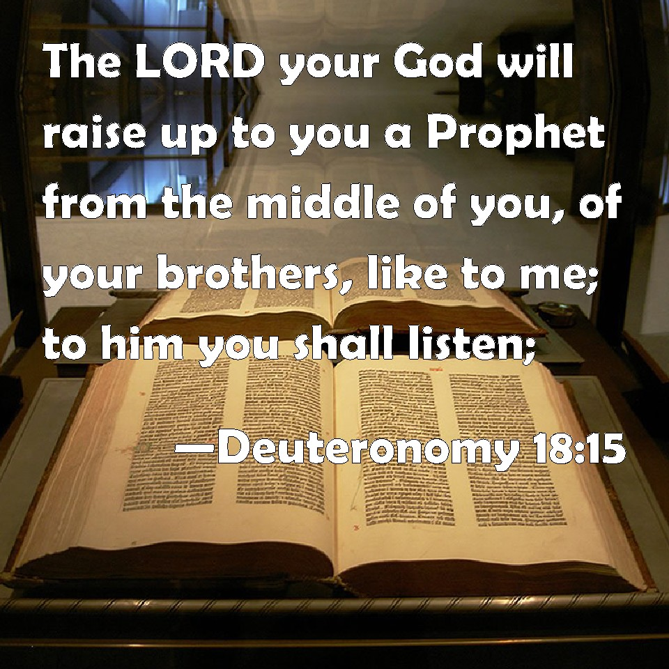

Pastor: Rev. Larry Myers
Elder on Call: Brian Heffern
Music: Debbie Myers
Greeters: Brian & Mieke Heffern

