

Polk Presbyterian Church

2nd Sunday of Christmas

January 5, 2020

Purple Booklet

*The Introit “ Emmanuel ” # 114
Emmanuel, Emmanuel, His name is called Emmanuel; God with us, revealed in us; His name is called Emmanuel.

Time for meditation and reflection.

CALL TO WORSHIP Jeremiah 31:7-9
(L) For thus says the Lord: Sing aloud with gladness for Jacob, and raise shouts for the chief of the nations;
(P) Proclaim, give praise, and say, “Save, O Lord, your people, the remnant of Israel.”
(L) See, I am going to bring them from the land of the north, and gather them from the farthest parts of the earth, among them the blind and the lame, those with child and those in labor, together
(P) A great company, they shall return here.
(L) With weeping they shall come, and with consolations I will lead them back, I will let them walk by brooks of water, in a straight path in which they shall not stumble;
(P) For I have become a father to Israel, and Ephraim is my firstborn.
Purple Booklet
*Praise Hymn The Greatest Thing # 18

PRAYER OF CONFESSION
Loving heavenly Father, forgive us when we become swept up in the hiatus of the commercialization of Christmas and the secular celebrations of the holiday season. Grant us eyes to see the significance of an incarnate baby in a manger, the love displayed on a wooden cross, and the power of an empty tomb. Enable us to accept undeserved grace and dedicate our lives to participating in the divine plan of salvation. In the name of our risen Lord, Jesus the Christ we lift this humble prayer. Amen.

ASSURANCE OF PARDON John 1:10-14
(L) The Word was in the world, and the world came into being through him; yet the world did not know him.
(P) He came to what was his own, and his own people did not accept him.
(L) But to all who received him, who believed in his name, he gave power to become children of God, who were born, not of blood or of the will of the flesh or of the will of man, but of God.
(P) And the Word became flesh and lived among us, and we have seen his glory, the glory as of a father’s only son, full of grace and truth.

*Gloria Patri # 42

SPECIAL

CHILDREN'S CHAT

MOMENTS FOR MISSI0N

PRAYERS OF THE PEOPLE Joys and concerns:

Happy Birthday: Gary Chisholm, Brian Heffern, Angel Daye

Presbytery Prayers: Plumer, Oil City; Rev. Keith Sundberg, HR, Resource Consultant

THE LORDS PRAYER
Our Father, who art in heaven, hallowed be Thy name, Thy kingdom come, Thy will be done, on earth as it is in heaven. Give us this day our daily bread; and forgive us our debts, as we forgive our debtors; and lead us not into temptation, but deliver us from evil. For Thine is the kingdom, and the power, and the glory, forever. Amen.

*HYMN OF PREPARATION
Good Christian Men, Rejoice # 198

RETURNING THANKS TO GOD
*THE DOXOLOGY # 39
*THE PRAYER OF DEDICATION

SCRIPTURE READING: John 1:1-9, 10-18 NT PG 91
(P) Thanks be to God

SERMON "The Praise of His Glory"

*Affirmation of Faith The Apostles’ Creed
I believe in God, the Father Almighty, maker of heaven and earth.And in Jesus Christ, His only begotten Son, our Lord. Who was conceived by the Holy Spirit, born of the Virgin Mary, suffered under Pontius Pilate, was crucified, dead and buried; he descended into hell. The third day, He rose again from the dead; He ascended into heaven, and sitteth at the right hand of God, the Father Almighty, from thence he will come again to judge the quick and the dead.
I believe in the Holy Spirit, the holy catholic church, the communion of saints, the forgiveness of sins, the resurrection of the body, and the life everlasting. Amen.

ORDINATION & INSTALLATION OF OFFICERS
(See insert)

INVITATION TO THE LORD'S SUPPER
Let Us Break Bread Together # 162

*CLOSING HYMN
O Come, All Ye Faithful # 178

*THE BENEDICTION

*Our Response “Go Tell It on the Mountain” # 176
Go tell it on the mountain, Over the hills and everywhere-Go tell it on the mountain That Jesus Christ is born!

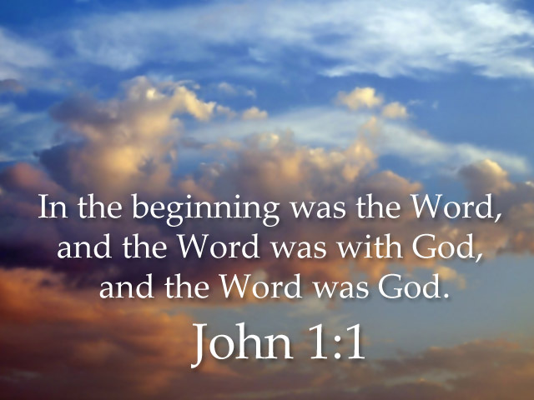

Pastor: Rev. Larry Myers
Elder on Call: Deb Crum
Minister of Music: Erma Martin
Choir Director: Jon Crum
Greeters: Brian & Mieke Heffern

Polk Presbyterian Church
P.O. Box 1027
Polk, PA 16342

CHURCH OFFICE: 814-437-3153

Pastor Larry Myers 412-417-5737
flyfisher@windstream.net

SESSION MEMBERS:

Conrad Houk 814-671-2774
Cindy Swendsen 814-374-4041

Brian Heffern 814-671-2774

Dave Perry 770-687-9202
Colleen Scurry 814-437-6069
Deb Crum 724-679-9867

IF YOU ARE IN NEED OF ASSISTANCE
PLEASE CONTACT:

FINANCIAL SECRETARY:
Robin Russell 814-437-7038
rrussell@pa.rr.com

SECRETARY:

Anna Aumiller 814-437-3611
aaumiller@neo.rr.com

CLERK OF SESSION:
Wendy Bellin 814-673-9826

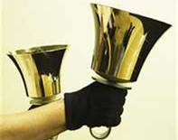
Polk Presbyterian Church
Calendar of Events
January 2020

Sunday School at 8:30am

Children Sunday School at 8:30am

Bible Study on Wed at 6:30pm

Assisted hearing devices are now available. They are in the secretary's office on the file cabinet. Please mark your name on the box.

Jan 11 9am-3pm: Officer's Training. Open to anyone.

Jan 12 - Reports for Congregational Meeting are due to the church office.

Jan 17 - Movie night.

Jan 26 - Congregational Meeting after worship service.

Truly Free Skate every Sunday from 4:30 to 6:30pm at Skate Capital in Seneca, PA. Community churches are sponsoring the skate night with free admission and skate rental.

Home Communion: If you know anyone who would like to receive communion at home, please let Pastor Larry know who they are.

Lay Speakers: Looking for volunteers to speak at the beginning of the service in the same capacity as Jon Crum does now. If you would like to volunteer, please let Pastor Larry know.

Men's Association are welcoming projects for the elderly or persons who are unable to do projects like painting, lawn mowing, etc. Please let one of the men know if there is anyone in the community that needs this kind of help.

Food Drive: Please place food items in box in the vestibule hallway and it will be taken to the Salvation Army.

Millie Nolan
1380 School Rd
Stoneboro, PA 16153

Trevor Wood Zack Stryffeler
The University of Akron St Bonaventure University
Honors Complex 656 3261 West State Road
PO Box 1350 PO Box 213
Akron, OH 44309 St Bonaventure, NY 14778

John & Pam Vickers Jenn & Marty Gilliland
211 Crawford Ave. 238 W. Washington St.
Polk, PA 16342 Harrisville, PA 16038
(814) 346-0010 (Land line)
AB Clayton Karns
Dave Burgoyne 321 TRS-FLT 131 (Dorm 2C1)
PO Box 874 1320 Truemper Street
Wheatley, Ontario Canada NOP2PO Lackland, TX 78236-6431
(Must be in plain wh business envelop, no packages or cards)

NEWS OF INTEREST

Pennies From Heaven: the monies collected help send children to the camp of their choice (mostly Seneca Hills). Your donations are appreciated and well spent. Other charities are often contributed to as worthy causes from Pennies From Heaven also.

PRAISES AND PRAYER

Please pray for God’s guidance in the future of our church. Please pray for the peace of the world. Pray for the leaders of our country as they earnestly seek peaceful solutions to the problems and crises around the globe. Please pray for our military and police forces and their safety throughout each day. Pray for our public school system. Pray for the mental health of people everywhere. Pray for our mission to Ghana. Pray for all the Christian's who are being persecuted in the world.
Would you like to know what our church has been up to? On the bulletin board in the entryway are the minutes and financial ledgers for each month. Please feel free to copy them and if you have a question, ask any session member or the pastor. We think this is the best way to keep everyone informed.

REMEMBER TO PRAY FOR OUR MEMBERS

AND FRIENDS AT HOME or HOSPITALS:

Jenn & Marty Gilliland, Mieke Heffern, Susan Hammond, the unspoken request, Skip Davison, Ken Timblin, Judy Krizon, Olivia Foster, Jan Sanners, Robin's mom Betty, Millie Nolan, Bud Bieler, Ron Mitchell, Brianna, Pat Kelly, Denny Martin, Jackie & Scott Ghering, Donna Clayton, Alexandra Stanford, Gregg Townsend, Dottie Dillin, Meryl, Deb BoyerPolk Center, Jan Heffern, Mark Knox and family, Isaac & Marci (motorcycle victims), Dawn, Sandy, Susan Martin, the family of Adam Gregory, Junior, Vicki, Deb Snyder, Tim Rustling, Benson, John & Mabel Sherman, Larry Willyoung, the family of Peg Myers during this time of their loss

