NEWS OF INTEREST

Pennies From Heaven: the monies collected help send children to the camp of their choice (mostly Seneca Hills). Your donations are appreciated and well spent. Other charities are often contributed to as worthy causes from Pennies From Heaven also.

PRAISES AND PRAYER

Please pray for God’s guidance in the future of our church. Please pray for the peace of the world. Pray for the leaders of our country as they earnestly seek peaceful solutions to the problems and crises around the globe. Please pray for our military and police forces and their safety throughout each day. Pray for our public school system. Pray for the mental health of people everywhere. Pray for our mission to Ghana. Pray for all the Christian's who are being persecuted in the world.

Would you like to know what our church has been up to? On the bulletin board in the entryway are the minutes and financial ledgers for each month. Please feel free to copy them and if you have a question, ask any session member or the pastor. We think this is the best way to keep everyone informed.

REMEMBER TO PRAY
FOR OUR MEMBERS AND FRIENDS AT HOME or HOSPITALS

Jenn & Marty Gilliland, Mieke Heffern, Susan Hammond, the unspoken request, Skip and Nancy Davison, Ken Timblin, Judy Krizon, Olivia Foster, Jan Sanners, Robin's mom Betty, Millie & Bill Nolan, Gregg Townsend, Dottie Dillin, Polk Center, Mark Knox, Sandy, Erma, Harry Daye, Virginia Heister, Deb Boyer, Sally & Doug Bell, Amy Zemanski, Lincoln, Dick & Nancy Kerr, Junior & Bonnie, Vicki, Deb Snyder, Dick McNany, Keith Reynolds, Teri and Gary Chisholm, Jewell, John and Chuck Karns, Chance, Aubrielle & family, Emma, Megan, Dewayne Doutt, Rick Vaxily, Barb & Bryan Chisholm, Dave Owen, Conrad Houk, Nancy & Tom Westcoat, June Mawhinney, victims of the storms and all those affected by the Coronavirus, for first responders, hospital staff, the military staff, at-home children, elderly and at-risk persons, the overdose & suicide epidemic, wildfires and firefighters

Polk Presbyterian Church
P.O. Box 1027
Polk, PA 16342
polkpresbyterianchurch.com

CHURCH OFFICE: 814-437-3153

Pastor Larry Myers 412-417-5737
flyfisher@windstream.net

SESSION MEMBERS:

Conrad Houk 814-374-4143
Cindy Swendsen 814-374-4041

Brian Heffern 814-671-2774

Dave Perry 770-687-9202
Colleen Scurry 814-437-6069
Deb Crum 724-679-9867

IF YOU ARE IN NEED OF ASSISTANCE
PLEASE CONTACT:

FINANCIAL SECRETARY:
Robin Russell 814-437-7038
rrussell@pa.rr.com

SECRETARY:

Anna Aumiller 814-437-3611
aaumiller@neo.rr.com

CLERK OF SESSION:
Wendy Bellin 814-673-9826

Millie & Bill Nolan Karns, Clayton M.
1380 School Rd 5350 Berger Street
Stoneboro, PA 16153 Stop #1360
Moody AFB, GA 31699

Tyler Wood Gracie Stryffeler
c/o Room 718 c/o Room 206
117 University Plaza 117 University Plaza
Youngstown, OH 44502-1208 Youngstown, OH 44502-1208

Dave Burgoyne Jenn & Marty Gilliland
c/o Amy Zemanski 238 W. Washington St.
200 McClelland Avenue Harrisville, PA 16038
Polk, PA 16342

Trevor Wood Zach Stryffeler
369 Sherman St. PO Box 213
Akron, OH 44311 3261 W. State Road
St. Bonaventure, NY 14778

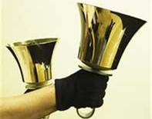
Polk Presbyterian Church
Calendar of Events
October 2020

Sunday School at 8:30am

Children Sunday School at 8:30am

Bible Study on Wednesdays at 6:30pm : at the church & via Zoom https://us04web.zoom.us/j/559705244 Meeting ID: 559 705 244

Assisted hearing devices are now available. They are in the secretary's office on the file cabinet. Please mark your name on the box.

Oct 4 - World Communion Sunday

Youth for Christ - there is a prayer calendar in the vestabule.

Lakeview Area Helping Hands Center is asking for any help.

Donations to the building fund are welcome. Put the donation into an envelop marked Building Donation and drop into collection plate.

Home Communion: If you know anyone who would like to receive communion at home, please let Pastor Larry know who they are.

Lay Speakers: Looking for volunteers to speak at the beginning of the service in the same capacity as Jon Crum does now. If you would like to volunteer, please let Pastor Larry know.

Men's Association are welcoming projects for the elderly or persons who are unable to do projects like painting, lawn mowing, etc. Please let one of the men know if there is anyone in the community that needs this kind of help.

Food Drive: Please place food items in box in the vestibule hallway and it will be taken to the Salvation Army.



Polk Presbyterian Church

October 11, 2020

19th Sunday after Pentecost

*Introit This Is the Day # 118
This is the day, this is the day that the Lord has made, that the Lord has made. We will rejoice, we will rejoice and be glad in it, and be glad in it. This is the day that the Lord has made, we will rejoice and be glad in it. This is the day, this is the day that the Lord has made.

Time for meditation and reflection.

CALL TO WORSHIP Psalm 106:1-4
(L) Praise the Lord! O give thanks to the Lord, for he is good; for his steadfast love endures forever.
(P) Who can utter the mighty doings of the Lord, or declare all his praise?
(L) Happy are those who observe justice, and who do righteousness at all times.
(P) Remember me, O Lord, when you show favor to your people; help me when you deliver them.
(Purple Booklet)
*Praise Hymn Now Is the Time to Worship #117
Come, now is the time to worship. Come, now is the time to give your heart. Come, just as you are to worship. Come, just as you are before your God. Come.

One day, every tongue will confess You are God. One day, every knee will bow. Still, the greatest treasure remains for those who gladly choose you now.

Come, now is the time to worship. Come, now is the time to give your heart. Come, just as you are to worship. Come, just as you are before your God. Come.

PRAYER OF CONFESSION
Almighty God, forgive us when we accept the divine invitation to attend the great wedding feast of the Lamb of God but refuse to take seriously the gifts of grace, mercy, faith, and love. Show mercy to your wayward children who dare to come into the presence of the Lord wearing our filthy rags of sin. Have compassion upon us when we fail to invite others to the joyful feast. In the name of the risen Christ, we pray. Amen.

ASSURANCE OF PARDON 1 Peter 1:3-5
(L) Blessed be the God and Father of our Lord Jesus Christ! By his great mercy, God has given us a new birth into a living hope through the resurrection of Jesus Christ from the dead,
(P) And into an inheritance that is imperishable, undefiled, and unfading, kept in heaven for you, who are being protected by the power of God through faith for a salvation ready to be revealed in the last time.

*Gloria Patri # 42

SPECIAL is Tate Daye on the Keyboard

CHILDREN'S CHAT

MOMENTS FOR MISSI0N

PRAYERS OF THE PEOPLE Joys and concerns:

Happy Birthday: Jon Crum

Happy Anniversary: Scott & Lisa Heffern

Presbytery Prayers: Port Allegany, Commissioned Pastor Garen Smith; Rev. Bill Mills, HR

THE LORDS PRAYER
Our Father, who art in heaven, hallowed be Thy name, Thy kingdom come, Thy will be done, on earth as it is in heaven. Give us this day our daily bread; and forgive us our debts, as we forgive our debtors; and lead us not into temptation, but deliver us from evil. For Thine is the kingdom, and the power, and the glory, forever. Amen.

*HYMN OF PREPARATION Are You Washed in the Blood? # 308

RETURNING THANKS TO GOD
*THE DOXOLOGY #39
*THE PRAYER OF DEDICATION

SCRIPTURE READING: Matthew 22:1-14
﻿﻿
(P) Thanks be to God

SERMON "Are We Dressed for the Banquet?"

*AFFIRMATION OF FAITH Westminister Confession of Faith 6.064
All those whom God has predestinated unto life, and those only, he is pleased, in his appointed and accepted time, effectually to call, by his Word and Spirit, out of that state of sin and death in which they are by nature, to grace and salvation by Jesus Christ: enlightening their minds, spiritually and savingly, to understand the things of God, taking away their heart of stone, and giving unto them an heart of flesh; renewing their wills, and by his almighty power determining them to that which is good; and effectually drawing them to Jesus Christ; yet so as they come most freely, being made willing by his grace. Amen.

*CLOSING HYMN Just as I Am # 306

*THE BENEDICTION

*Our Response Here I Am Lord # 54
Here I am, Lord. Is it I, Lord? I have heard you calling in the night. I will go, Lord, if you lead me. I will hold your people in my heart.

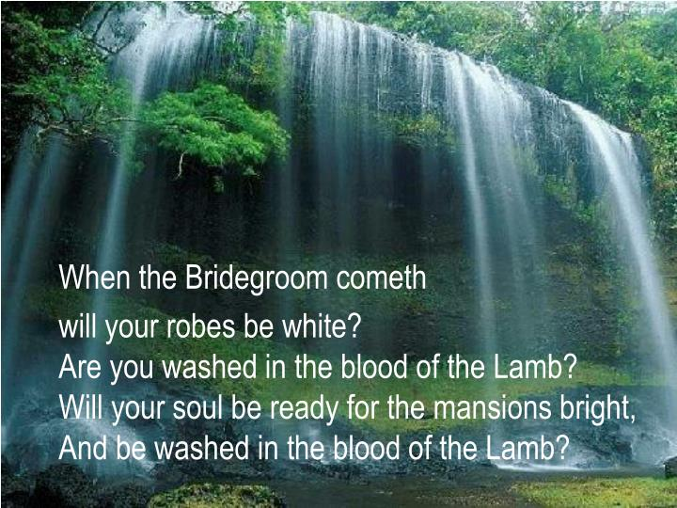

Pastor: Rev. Larry Myers
Elder on Call: Dave Perry
Music: Deb Myers
Greeters: Jeff & Julie Karns

