Polk Presbyterian Church

22nd Sunday after Pentecost

November 10, 2019



THE PRELUDE
THE WELCOMING AND ANNOUNCEMENTS

*The Introit “We Gather Together” # 13
We gather together to ask the Lord’s blessing-He chastens and hastens His will to make known; the wicked oppressing now cease from distressing: sing praises to His name-He forgets not His own.

Time for meditation and reflection.

CALL TO WORSHIP Psalm 145:17-21
(L) The Lord is near to all who call on him, to all who call on him in truth.
(P) He fulfills the desire of all who fear him; he also hears their cry, and saves them.
(L) The Lord watches over all who love him, but all the wicked he will destroy.
(P) My mouth will speak the praise of the Lord,
(A) And all flesh will bless his holy name forever and ever.

Purple Booklet
*Praise Hymn Jesus, We Crown You with Praise # 218

PRAYER OF CONFESSION
Father God, too often, we approach you insincerely. We confess that we focus on things that don’t matter. We come to you merely when we need your hand of blessing. We are distracted by insignificant and trivial questions of religion while we fail to truly seek out a relationship with you. Forgive us for our selfishness and self-centered approach towards seeking you. Forgive us for our lack of gratitude for the glory of who you are and the grace and mercy you offer us. Turn our hearts towards you. Help us to appreciate the life we have been given in your Son, Jesus Christ. It is in his name we pray. AMEN.

ASSURANCE OF PARDON Psalm 98:6-9
(L) With trumpets and the sound of the horn make a joyful noise before the King, the LORD.
(P) Let the sea roar, and all that fills it; the world and those who live in it.
(L) Let the floods clap their hands; let the hills sing together for joy at the presence of the LORD,
(P) For he is coming to judge the earth.
(A) He will judge the world with righteousness, and the peoples with equity.

*Gloria Patri # 42

SPECIAL by the Choir - Heaven Came Down

CHILDREN'S CHAT

MOMENTS FOR MISSI0N

PRAYERS OF THE PEOPLE Joys and concerns:

Happy Birthday: Heather Embach, Matthew Sybert

Presbytery Prayers: Cochranton; Rev. Hal Kelley, HR

THE LORDS PRAYER
Our Father, who art in heaven, hallowed be Thy name, Thy kingdom come, Thy will be done, on earth as it is in heaven. Give us this day our daily bread; and forgive us our debts, as we forgive our debtors; and lead us not into temptation, but deliver us from evil. For Thine is the kingdom, and the power, and the glory, forever. Amen.

*HYMN OF PREPARATION
In The Garden # 541

RETURNING THANKS TO GOD
*THE DOXOLOGY # 39
*THE PRAYER OF DEDICATION

SCRIPTURE READING: Haggai 1:15B-2:9 OT PG 878
Luke 20:27-38 NT PG 84
(P) Thanks be to God

SERMON "I Am With You - That's What Matters"

*AFFIRMATION OF FAITH The Larger Catechism 7.212
Q. 102. What is the sum of the four Commandments which contain our duty to God?
A. The sum of the four Commandments containing our duty to God is, to love the Lord our God with all our heart, and with all our soul, and with all our strength, and with all our mind.

*CLOSING HYMN
Sweet, Sweet Spirit # 89

*THE BENEDICTION

*Our Response “Count Your Blessings” # 430
Count your blessings-name them one by one; count your blessings-see what God hath done; count your blessings-name them one by one; count your many blessings-see what God hath done.

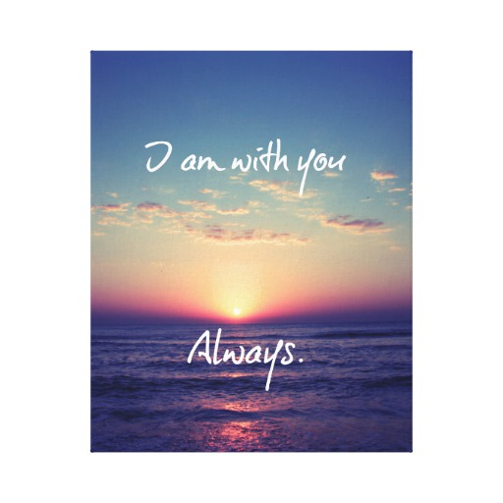

Guest Speaker: Jon Crum
Elder on Call: Brian Heffern
Minister of Music: Erma Martin
Choir Director: Jon Crum
Greeters: Janet Heister

Polk Presbyterian Church
P.O. Box 1027
Polk, PA 16342

CHURCH OFFICE: 814-437-3153

Pastor Larry Myers 412-417-5737
flyfisher@windstream.net

SESSION MEMBERS:

Cindy Swendsen 814-374-4041

Brian Heffern 814-437-0928

Dave Perry 770-687-9202
Colleen Scurry 814-437-6069
Deb Crum 724-679-9867

IF YOU ARE IN NEED OF ASSISTANCE
PLEASE CONTACT:

FINANCIAL SECRETARY:
Robin Russell 814-437-7038
rrussell@pa.rr.com

SECRETARY:

Anna Aumiller 814-437-3611
aaumiller@neo.rr.com

CLERK OF SESSION:
Jennifer Gilliland 724-372-3537

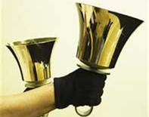
Polk Presbyterian Church
Calendar of Events
November 2019

Sunday School at 8:30am

Children Sunday School at 8:30am

Bible Study on Wed at 6:30pm

Assisted hearing devices are now available. They are in the secretary's office on the file cabinet. Please mark your name on the box.

Nov 17: Linger-Longer Luncheon honoring the Veteran's will follow worship service.

Nov 24th at 11am: Combined service with East Grove and Polk UM at Polk Presbyterian celebrating Thanksgiving.

Truly Free Skate every Sunday from 4:30 to 6:30pm at Skate Capital in Seneca, PA. Community churches are sponsoring the skate night with free admission and skate rental.

Young Presbyterian Scholars Program. There is a $19,000/year scholarship available for an outstanding young adult to attend Westminster College. The congregation can nominate qualifying high school seniors. Information is in the vestibule.

Labors of Love: Fundraising goal is $50,000 to improve heathcare delivery and services in Wapuli, Bladjai and Dambai in Ghana, West Africa. See insert.
There is a prayer box at Main Street Market for local community concerns. Mustard Seed Ministries works on projects of need for the local community for repairing homes and other donated works such as beds for those who need them. Deb Adams will be checking the prayer box.

Home Communion: If you know anyone who would like to receive communion at home, please let Pastor Larry know who they are.

Lay Speakers: Looking for volunteers to speak at the beginning of the service in the same capacity as Jon Crum does now. If you would like to volunteer, please let Pastor Larry know.

Men's Association are welcoming projects for the elderly or persons who are unable to do projects like painting, lawn mowing, etc. Please let one of the men know if there is anyone in the community that needs this kind of help.

Food Drive: Please place food items in box in the vestibule hallway and it will be taken to the Salvation Army.

Margaret (Peg) Myers Millie Nolan
Fair Oaks of Pittsburgh 1380 School Rd
2200 W. Liberty Ave, Rm 208A Stoneboro, PA 16153
Pittsburgh, PA 15211

Trevor Wood Zack Stryffeler
The University of Akron St Bonaventure University
Honors Complex 656 3261 West State Road
PO Box 1350 PO Box 213
Akron, OH 44309 St Bonaventure, NY 14778

John & Pam Vickers Jenn & Marty Gilliland
211 Crawford Ave. 238 W. Washington St.
Polk, PA 16342 Harrisville, PA 16038
(814) 346-0010 (Land line)
Hospital Address:
Room 601
Allegheny General Hospital
320 E. North St.
Pittsburgh, PA 15212

NEWS OF INTEREST

Pennies From Heaven: the monies collected help send children to the camp of their choice (mostly Seneca Hills). Your donations are appreciated and well spent. Other charities are often contributed to as worthy causes from Pennies From Heaven also.

PRAISES AND PRAYER

Please pray for God’s guidance in the future of our church. Please pray for the peace of the world. Pray for the leaders of our country as they earnestly seek peaceful solutions to the problems and crises around the globe. Please pray for our military and police forces and their safety throughout each day. Pray for our public school system. Pray for the mental health of people everywhere. Pray for our mission to Ghana. Pray for all the Christian's who are being persecuted in the world.

Would you like to know what our church has been up to? On the bulletin board in the entryway are the minutes and financial ledgers for each month. Please feel free to copy them and if you have a question, ask any session member or the pastor. We think this is the best way to keep everyone informed.

REMEMBER TO PRAY FOR OUR MEMBERS

AND FRIENDS AT HOME or HOSPITALS:

Jenn & Marty Gilliland, Mieke Heffern, Susan Hammond, the unspoken request, Skip Davison, Ken Timblin, Judy Krizon, Olivia Foster, Jan Sanners, Robin's mom Betty, Millie Nolan, Bud Bieler, Ron Mitchell, Brianna, Pat Kelly, Denny Martin, Jackie & Scott Ghering, Keith Feltonberger, Donna Clayton, Alexandra Stanford, Gregg Townsend, Dottie Dillin, Meryl, Deb Boyer, the breakdown of our American families, Polk Center, Jan Heffern, Mark Knox and family, Isaac & Marci (motorcycle victims), Dawn, Sandy

