NEWS OF INTEREST

Pennies From Heaven: the monies collected help send children to the camp of their choice (mostly Seneca Hills). Your donations are appreciated and well spent. Other charities are often contributed to as worthy causes from Pennies From Heaven also.

PRAISES AND PRAYER

Please pray for God’s guidance in the future of our church. Please pray for the peace of the world. Pray for the leaders of our country as they earnestly seek peaceful solutions to the problems and crises around the globe. Please pray for our military and police forces and their safety throughout each day. Pray for our public school system. Pray for the mental health of people everywhere. Pray for our mission to Ghana. Pray for all the Christian's who are being persecuted in the world.

Would you like to know what our church has been up to? On the bulletin board in the entryway are the minutes and financial ledgers for each month. Please feel free to copy them and if you have a question, ask any session member or the pastor. We think this is the best way to keep everyone informed.

REMEMBER TO PRAY
FOR OUR MEMBERS AND FRIENDS AT HOME or HOSPITALS

Jenn & Marty Gilliland, Mieke Heffern, Susan Hammond, the unspoken request, Skip and Nancy Davison, Ken Timblin, Judy Krizon, Olivia Foster, Jan Sanners, Robin's mom Betty, Millie & Bill Nolan, Gregg Townsend, Dottie Dillin, Polk Center, Mark Knox, Sandy, Erma, Harry Daye, Virginia Heister, Deb Boyer, Sally & Doug Bell, Amy Zemanski, Lincoln, Dick & Nancy Kerr, Junior & Bonnie, Vicki, Deb Snyder, Dick McNany, Keith Reynolds, Teri and Gary Chisholm, Jewell, John and Chuck Karns, Chance, Aubrielle & family, Emma, Megan, Dewayne Doutt, Rick Vaxily, Barb & Bryan Chisholm, Dave Owen, Conrad Houk, Nancy & Tom Westcoat, June Mawhinney, Pat Karns, Lincoln, Dennis Martin, Bill Foster, Barb Reaker, Tim Vickers, Michelle Gregory, Emmalene, Dave Allman, Dawson, William Reilly, Floyd Russell, Harper, Pam Bottomley, Sue & John Smith victims of the storms and all those affected by the Coronavirus, for first responders, hospital staff, the military staff, at-home children, elderly and at-risk persons, the overdose & suicide epidemic, wildfires and firefighters

Polk Presbyterian Church
P.O. Box 1027
Polk, PA 16342
polkpresbyterianchurch.com

CHURCH OFFICE: 814-437-3153

Pastor Larry Myers 412-417-5737
flyfisher@windstream.net

SESSION MEMBERS:

Conrad Houk 814-374-4143
Cindy Swendsen 814-374-4041

Brian Heffern 814-671-2774

Dave Perry 770-687-9202
Colleen Scurry 814-437-6069
Deb Crum 724-679-9867

IF YOU ARE IN NEED OF ASSISTANCE
PLEASE CONTACT:

FINANCIAL SECRETARY:
Robin Russell 814-437-7038
rrussell@pa.rr.com

SECRETARY:

Anna Aumiller 814-437-3611
aaumiller@neo.rr.com

CLERK OF SESSION:
Wendy Bellin 814-673-9826

Millie & Bill Nolan Karns, Clayton M.
1380 School Rd 5350 Berger Street
Stoneboro, PA 16153 Stop #1360
Moody AFB, GA 31699

Tyler Wood Gracie Stryffeler
c/o Room 718 c/o Room 206
117 University Plaza 117 University Plaza
Youngstown, OH 44502-1208 Youngstown, OH 44502-1208

Dave Burgoyne Jenn & Marty Gilliland
c/o Amy Zemanski 238 W. Washington St.
200 McClelland Avenue Harrisville, PA 16038
Polk, PA 16342

Trevor Wood Zach Stryffeler
369 Sherman St. PO Box 213
Akron, OH 44311 3261 W. State Road
St. Bonaventure, NY 14778

Greetings,
It has been brought to the attention of the Presbytery that Stated Clerk Rev Greg Gillespie's email has been hacked. If you received a message from reverendgreggillispie@gmail.com please disregard. Do not respond to the email and do not purchase or send gift cards.
Thank you
Have a blessed day
The Presbytery of Lake Erie Staff

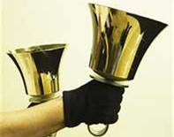
Polk Presbyterian Church
Calendar of Events
November 2020

Sunday School at 8:30am

Children Sunday School at 8:30am

Bible Study on Wednesdays at 6:30pm : at the church & via Zoom https://us04web.zoom.us/j/559705244 Meeting ID: 559 705 244 The passcode is 202020

Assisted hearing devices are now available. They are in the secretary's office on the file cabinet. Please mark your name on the box.

Greeting cards are being sent to some of our stay-at-home members during this time of Covid. Please sign the cards with any message you'd like to cheer these folks up with.

Nov 22 - Thanksgiving Service

Dec 6 - Communion Service

Heifer International - We are collecting until Dec 13th. You and your family can be part of a tradition of giving and receiving gifts that help those in need.

Lakeview Area Helping Hands Center is asking for any help.

Donations to the building fund are welcome. Put the donation into an envelop marked Building Donation and drop into collection plate.

Home Communion: If you know anyone who would like to receive communion at home, please let Pastor Larry know who they are.

Lay Speakers: Looking for volunteers to speak at the beginning of the service in the same capacity as Jon Crum does now. If you would like to volunteer, please let Pastor Larry know.

Men's Association are welcoming projects for the elderly or persons who are unable to do projects like painting, lawn mowing, etc. Please let one of the men know if there is anyone in the community that needs this kind of help.

Food Drive: Please place food items in box in the vestibule hallway and it will be taken to the Salvation Army.

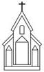

Polk Presbyterian Church

November 22, 2020
25th Sunday after Pentecost
Christ the King Sunday

*Introit Holy Ground # 129
We are standing on holy ground,
And I know that there are angels all around.
Let us praise Jesus now.
We are standing in His presence on holy ground.

Time for meditation and reflection.

CALL TO WORSHIP Psalm 100:1-4
(L) Make a joyful noise to the Lord, all the earth.
(P) Worship the Lord with gladness; come into his presence with singing.
(L) Know that the Lord is God.
(P) It is he that made us, and we are his; we are his people, and the sheep of his pasture.
(L) Enter his gates with thanksgiving, and his courts with praise.
(P) Give thanks to him, bless his name.

*Praise Hymn His Name Is Wonderful # 65
His name is Wonderful, His name is Wonderful, His name is Wonderful, Jesus, my Lord. He is the mighty King, Master of everything, His name is Wonderful, Jesus, my Lord. He’s the great Shepherd, the Rock of all ages, Almighty God is He; bow down before Him, love and adore Him, His name is Wonderful, Jesus my Lord.

PRAYER OF CONFESSION
Almighty God, in love you spread amazing gifts before us, more than we need or deserve. You feed, heal, teach, and save us. We confess that we always want more while we never share as freely as you give. We resent what we lack, and are jealous of our neighbor’s good fortune. We misuse what you intended for joy. Holy God, forgive our stubborn greed, and our destructiveness. In your vast mercy, help us to take such pleasure in your goodness that we will always be in a spirit of thanksgiving through Jesus Christ, our Lord. Amen.

ASSURANCE OF PARDON Colossian 3:14-17
(L) Clothe yourselves with love, which binds everything together in perfect harmony.
(P) Let the peace of Christ rule in your hearts, to which indeed you were called in the one body. And be thankful.
(L) Let the word of Christ dwell in you richly; teach and admonish one another in all wisdom; and with gratitude in your hearts sing psalms, hymns, and spiritual songs to God.
(P) And whatever you do, in word or deed, do everything in the name of the Lord Jesus, giving thanks to God the Father through him.

*Gloria Patri # 42

SPECIAL Psalm 23 - Read by Regina

CHILDREN'S CHAT

MOMENTS FOR MISSI0N

PRAYERS OF THE PEOPLE Joys and concerns:

Happy Birthday: Robin Russell, Gail Banks, Larry Myers, Amelia Sybert

Presbytery Prayers: Cooperstown, Commissioned Pastor, Diane Whitman; Teaching Elder Ronee Christy, Moderator of the Coordinating Committee

THE LORDS PRAYER
Our Father, who art in heaven, hallowed be Thy name, Thy kingdom come, Thy will be done, on earth as it is in heaven. Give us this day our daily bread; and forgive us our debts, as we forgive our debtors; and lead us not into temptation, but deliver us from evil. For Thine is the kingdom, and the power, and the glory, forever. Amen.

HYMN OF PREPARATION All Hail the Power of Jesus' Name 240

RETURNING THANKS TO GOD
*THE DOXOLOGY #39
*THE PRAYER OF DEDICATION

SCRIPTURE READING: Ezekiel 34:11-16, 20-24
Matthew 25:31-46
(P) Thanks be to God

SERMON "Embracing Christ's Kingship"

*AFFIRMATION OF FAITH THE NICENE CREED
We believe in one God, the Father, the Almighty, maker of heaven and earth, of all that is seen and unseen. We believe in one Lord, Jesus Christ, the only Son of God, eternally begotten of the Father, God from God, Light from Light, true God from true God, begotten, not made, of one Being with the Father; through him all things were made. For us and for our salvation he come down from heaven, was incarnate of the Holy Spirit and the Virgin Mary and became truly human. For our sake he was crucified under Pontius Pilate; he suffered death and was buried. On the third day; he rose again in accordance with the Scriptures; he ascended into heaven and is seated at the right hand of the Father. He will come again in glory to judge the living and the dead, and his kingdom will have no end.
We believe in the Holy Spirit, the Lord, the giver of life, who proceeds from the Father and the Son, who with the Father and the Son is worshiped and glorified, who has spoken through the prophets. We believe in one holy catholic and apostolic church. We acknowledge one baptism for the forgiveness of sins. We look forward to the resurrection of the dead, and the life of the world to come. Amen.

*CLOSING HYMN Crown Him with Many Crowns # 243

*THE BENEDICTION

*Our Response Thank You Lord # 268
Thank you, Lord, for saving my soul, Thank you, Lord, for making me whole; thank you, Lord for giving to me Thy great salvation so rich and free.

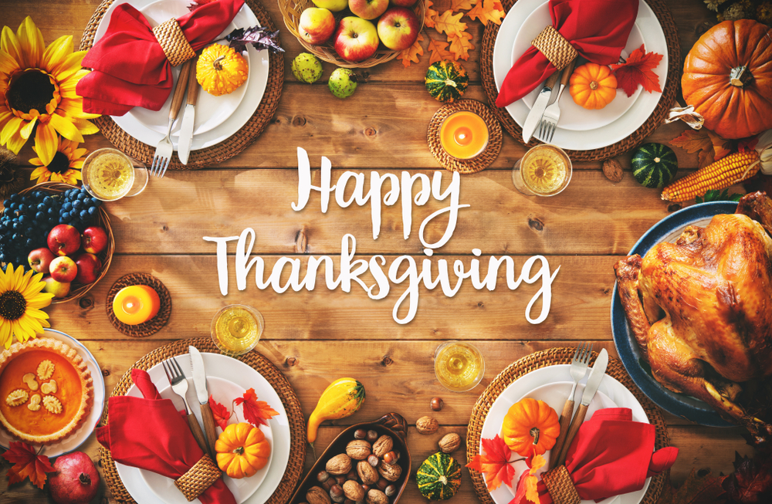

Pastor: Rev. Larry Myers
Elder on Call: Dave Perry
Music: Debbie Myers
Greeters: John and Pam Vickers

