Polk Presbyterian Church

November 24, 2019

Christ the King Sunday



*The Introit “We Gather Together” # 13
We gather together to ask the Lord’s blessing-He chastens and hastens His will to make known; the wicked oppressing now cease from distressing: sing praises to His name-He forgets not His own.

Time for meditation and reflection.

CALL TO WORSHIP Luke 1:68-79
(L) “Blessed be the Lord God of Israel, for he has looked favorably on his people and redeemed them.
(P) He has raised up a mighty savior for us in the house of his servant David, as he spoke through the mouth of his holy prophets from of old, that we would be saved from our enemies and from the hand of all who hate us.
(L) Thus he has shown the mercy promised to our ancestors, and has remembered his holy covenant, the oath that he swore to our ancestor Abraham, to grant us ﻿ that we, being rescued from the hands of our enemies, might serve him without fear, in holiness and righteousness before him all our days.
(P) By the tender mercy of our God, the dawn from on high will break upon us, to give light to those who sit in darkness and in the shadow of death, to guide our feet into the way of peace.”

Purple Booklet
*Praise Hymn Give Thanks # 13

PRAYER OF CONFESSION
Righteous God, you have crowned Jesus Christ as Lord of all. We confess that we have not bowed before him, and are slow to acknowledge his rule. We give allegiance to the powers of this world, and fail to be governed by justice and love. Merciful Creator, forgive us of our trespasses. Raise us to acclaim our Redeemer as ruler of all, that we may be loyal ambassadors, obeying the commands of our Lord Jesus Christ. We pray these things in the name of the living and glorified Christ. Amen.

ASSURANCE OF PARDON John 3:16-18
(L) For God so loved the world that he gave his only Son, so that everyone who believes in him may not perish but may have eternal life.
(P) Indeed, God did not send the Son into the world to condemn the world, but in order that the world might be saved through him.
(L) Those who believe in him are not condemned;
(P) but those who do not believe are condemned already, because they have not believed in the name of the only Son of God.
*Gloria Patri # 042
SPECIAL by the Choir - We Are So Blessed Medley

CHILDREN'S CHAT

MOMENTS FOR MISSI0N

PRAYERS OF THE PEOPLE Joys and concerns:

Happy Birthday: Gail Banks, Larry Myers

Presbytery Prayers: Cooperstown, Commissioned Pastor Diane Whitman; Commissioned Pastor Tim Olsen, Moderator of the Coordination Committee

THE LORDS PRAYER
Our Father, who art in heaven, hallowed be Thy name, Thy kingdom come, Thy will be done, on earth as it is in heaven. Give us this day our daily bread; and forgive us our debts, as we forgive our debtors; and lead us not into temptation, but deliver us from evil. For Thine is the kingdom, and the power, and the glory, forever. Amen.

*HYMN OF PREPARATION
Crown Him with Many Crowns # 243

RETURNING THANKS TO GOD
*THE DOXOLOGY # 39
*THE PRAYER OF DEDICATION

SCRIPTURE READING: Jeremiah 23:1-6 OT PG 725
Luke 23:33-43 NT PG 89
(P) Thanks be to God

SERMON "Recognizing Christ as the King"

*Affirmation of Faith The Apostles’ Creed
I believe in God, the Father Almighty, maker of heaven and earth.And in Jesus Christ, His only begotten Son, our Lord. Who was conceived by the Holy Spirit, born of the Virgin Mary, suffered under Pontius Pilate, was crucified, dead and buried; he descended into hell. The third day, He rose again from the dead; He ascended into heaven, and sitteth at the right hand of God, the Father Almighty, from thence he will come again to judge the quick and the dead.
I believe in the Holy Spirit, the holy catholic church, the communion of saints, the forgiveness of sins, the resurrection of the body, and the life everlasting. Amen.

*CLOSING HYMN
We've a Story to Tell # 502

*THE BENEDICTION

*Our Response “Count Your Blessings” # 430
Count your blessings-name them one by one; count your blessings-see what God hath done; count your blessings-name them one by one; count your many blessings-see what God hath done.

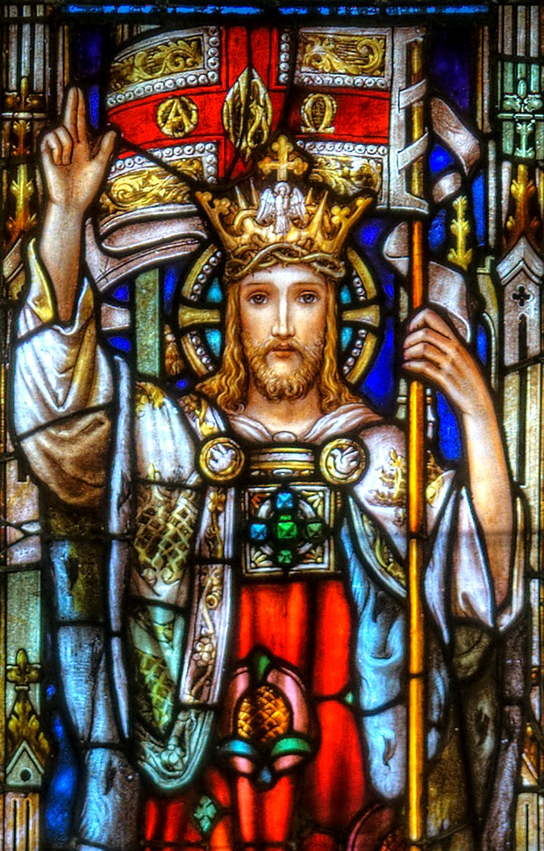

Speaker: Rev. Larry Myers
Elder on Call: Colleen Scurry
Minister of Music: Erma Martin
Choir Director: Jon Crum
Greeter: Janet Heister

Polk Presbyterian Church
P.O. Box 1027
Polk, PA 16342

CHURCH OFFICE: 814-437-3153

Pastor Larry Myers 412-417-5737
flyfisher@windstream.net

SESSION MEMBERS:

Cindy Swendsen 814-374-4041

Brian Heffern 814-437-0928

Dave Perry 770-687-9202
Colleen Scurry 814-437-6069
Deb Crum 724-679-9867

IF YOU ARE IN NEED OF ASSISTANCE
PLEASE CONTACT:

FINANCIAL SECRETARY:
Robin Russell 814-437-7038
rrussell@pa.rr.com

SECRETARY:

Anna Aumiller 814-437-3611
aaumiller@neo.rr.com

CLERK OF SESSION:
Jennifer Gilliland 724-372-3537


Polk Presbyterian Church
Calendar of Events
November 2019

Sunday School at 8:30am

Children Sunday School at 8:30am

Bible Study on Wed at 6:30pm

Assisted hearing devices are now available. They are in the secretary's office on the file cabinet. Please mark your name on the box.

Nov 24th at 11am: Combined service with East Grove and Polk UM at Polk Presbyterian celebrating Thanksgiving. A combined luncheon will follow worship service. There is a tureen sign-up sheet in the vestibule (turkey and gravy, potatoes, cranberry sauce and beverages are being provided).

Nov 28 (Thanksgiving Day) from 12 to 3: The Country Grub Restaurant is offering a Thanksgiving dinner free to those who want to come. Pass the word that people who can't make Thanksgiving dinner are very welcome to go to the Country Grub to enjoy dinner (sponsored by Country Grub).

Nov 30 at 10am: Hanging of the Greens. All are welcome.

Dec 1 - Communion Sunday.

Dec 7 from 9am to 3pm at Galloway UM Church in Franklin sponsored by Utica Presbyterian Church. Regular sale: 9 to 12; half off: 12 to 1; closed for lunch: 1-2; free toys: 2-3pm. Toy donations accepted Dec 5 from 4 to 8 and Dec 6 from 12 to 8. Volunteers are needed--see information in vestibule for more information. There is a clothes closet downstairs.

Dec 14 at 10am is the date and time for the Christmas party at Sugar Valley Lodge in Polk. There will be a sign-up sheet and a list of items that are wanted by the residents put into the vestibule soon. All are welcome.

There are envelopes at the end of each pew. Donations to go to Seneca Hills projects are being taken up for roof projects, etc. Our church is going to match donations up to $1000 total.

Glade Run Foundation would like donations to aid in their specialized schools. The offer alternative schooling for children with Autism and other emotional/behavioral health issues. There is further information in the vestibule.

Truly Free Skate every Sunday from 4:30 to 6:30pm at Skate Capital in Seneca, PA. Community churches are sponsoring the skate night with free admission and skate rental.

Labors of Love: Fundraising goal is $50,000 to improve heathcare delivery and services in Wapuli, Bladjai and Dambai in Ghana, West Africa. See insert.
There is a prayer box at Main Street Market for local community concerns.

Mustard Seed Ministries works on projects of need for the local community for repairing homes and other donated works such as beds for those who need them. Deb Adams will be checking the prayer box. MSM is looking for additional members to add to their group. Contact Randy Powell, President of MSM at pastorpowell@hotmail.com

Home Communion: If you know anyone who would like to receive communion at home, please let Pastor Larry know who they are.

Lay Speakers: Looking for volunteers to speak at the beginning of the service in the same capacity as Jon Crum does now. If you would like to volunteer, please let Pastor Larry know.

Men's Association are welcoming projects for the elderly or persons who are unable to do projects like painting, lawn mowing, etc. Please let one of the men know if there is anyone in the community that needs this kind of help.

Food Drive: Please place food items in box in the vestibule hallway and it will be taken to the Salvation Army.

Margaret (Peg) Myers Millie Nolan
Fair Oaks of Pittsburgh 1380 School Rd
2200 W. Liberty Ave, Rm 208A Stoneboro, PA 16153
Pittsburgh, PA 15211

Trevor Wood Zack Stryffeler
The University of Akron St Bonaventure University
Honors Complex 656 3261 West State Road
PO Box 1350 PO Box 213
Akron, OH 44309 St Bonaventure, NY 14778

John & Pam Vickers Jenn & Marty Gilliland
211 Crawford Ave. 238 W. Washington St.
Polk, PA 16342 Harrisville, PA 16038
(814) 346-0010 (Land line)

NEWS OF INTEREST

Pennies From Heaven: the monies collected help send children to the camp of their choice (mostly Seneca Hills). Your donations are appreciated and well spent. Other charities are often contributed to as worthy causes from Pennies From Heaven also.

PRAISES AND PRAYER

Please pray for God’s guidance in the future of our church. Please pray for the peace of the world. Pray for the leaders of our country as they earnestly seek peaceful solutions to the problems and crises around the globe. Please pray for our military and police forces and their safety throughout each day. Pray for our public school system. Pray for the mental health of people everywhere. Pray for our mission to Ghana. Pray for all the Christian's who are being persecuted in the world.
Would you like to know what our church has been up to? On the bulletin board in the entryway are the minutes and financial ledgers for each month. Please feel free to copy them and if you have a question, ask any session member or the pastor. We think this is the best way to keep everyone informed.

REMEMBER TO PRAY FOR OUR MEMBERS

AND FRIENDS AT HOME or HOSPITALS:

Jenn & Marty Gilliland, Mieke Heffern, Susan Hammond, the unspoken request, Skip Davison, Ken Timblin, Judy Krizon, Olivia Foster, Jan Sanners, Robin's mom Betty, Millie Nolan, Bud Bieler, Ron Mitchell, Brianna, Pat Kelly, Denny Martin, Jackie & Scott Ghering, Keith Feltenberger family during this time of their loss, Donna Clayton, Alexandra Stanford, Gregg Townsend, Dottie Dillin, Meryl, Deb Boyer, the breakdown of our American families, Polk Center, Jan Heffern, Mark Knox and family, Isaac & Marci (motorcycle victims), Dawn, Sandy, Susan Martin, Promise Keepers, the family of Adam Gregory, Junior, Vicki, Kay Case family and the Dana Mack family during this time of their loss

