NEWS OF INTEREST

Pennies From Heaven: the monies collected help send children to the camp of their choice (mostly Seneca Hills). Your donations are appreciated and well spent. Other charities are often contributed to as worthy causes from Pennies From Heaven also.

PRAISES AND PRAYER

Please pray for God’s guidance in the future of our church. Please pray for the peace of the world. Pray for the leaders of our country as they earnestly seek peaceful solutions to the problems and crises around the globe. Please pray for our military and police forces and their safety throughout each day. Pray for our public school system. Pray for the mental health of people everywhere. Pray for our mission to Ghana. Pray for all the Christian's who are being persecuted in the world.

Would you like to know what our church has been up to? On the bulletin board in the entryway are the minutes and financial ledgers for each month. Please feel free to copy them and if you have a question, ask any session member or the pastor. We think this is the best way to keep everyone informed.

REMEMBER TO PRAY
FOR OUR MEMBERS AND FRIENDS AT HOME or HOSPITALS

Jenn & Marty Gilliland, Mieke Heffern, Susan Hammond, the unspoken request, Skip and Nancy Davison, Ken Timblin, Judy Krizon, Olivia Foster, Jan Sanners, Robin's mom Betty, Millie & Bill Nolan, Gregg Townsend, Dottie Dillin, Polk Center, Mark Knox, Sandy, Erma, Harry Daye, Virginia Heister, Deb Boyer, Sally & Doug Bell, Amy Zemanski, Lincoln, Dick & Nancy Kerr, Junior & Bonnie, Vicki, Deb Snyder, Dick McNany, Keith Reynolds, Teri and Gary Chisholm, Jewell, John and Chuck Karns, Chance, Aubrielle & family, Emma, Megan, Dewayne Doutt, Rick Vaxily, Barb & Bryan Chisholm, Dave Owen, Conrad Houk, Nancy & Tom Westcoat, June Mawhinney, Pat Karns, Lincoln, Dennis Martin, Bill Foster, Barb Reaker, Tim Vickers, Michelle Gregory, Emmalene, Dave Allman, Dawson, William Reilly, Floyd Russell, Harper, Pam Bottomley, Sue & John Smith victims of the storms and all those affected by the Coronavirus, for first responders, hospital staff, the military staff, at-home children, elderly and at-risk persons, the overdose & suicide epidemic, wildfires and firefighters

Polk Presbyterian Church
P.O. Box 1027
Polk, PA 16342
polkpresbyterianchurch.com

CHURCH OFFICE: 814-437-3153

Pastor Larry Myers 412-417-5737
flyfisher@windstream.net

SESSION MEMBERS:

Conrad Houk 814-374-4143
Cindy Swendsen 814-374-4041

Brian Heffern 814-671-2774

Dave Perry 770-687-9202
Colleen Scurry 814-437-6069
Deb Crum 724-679-9867

IF YOU ARE IN NEED OF ASSISTANCE
PLEASE CONTACT:

FINANCIAL SECRETARY:
Robin Russell 814-437-7038
rrussell@pa.rr.com

SECRETARY:

Anna Aumiller 814-437-3611
aaumiller@neo.rr.com

CLERK OF SESSION:
Wendy Bellin 814-673-9826

Millie & Bill Nolan Karns, Clayton M.
1380 School Rd 5350 Berger Street
Stoneboro, PA 16153 Stop #1360
Moody AFB, GA 31699

Tyler Wood Gracie Stryffeler
c/o Room 718 c/o Room 206
117 University Plaza 117 University Plaza
Youngstown, OH 44502-1208 Youngstown, OH 44502-1208

Dave Burgoyne Jenn & Marty Gilliland
c/o Amy Zemanski 238 W. Washington St.
200 McClelland Avenue Harrisville, PA 16038
Polk, PA 16342

Trevor Wood Zach Stryffeler
369 Sherman St. PO Box 213
Akron, OH 44311 3261 W. State Road
St. Bonaventure, NY 14778

Greetings,
It has been brought to the attention of the Presbytery that Stated Clerk Rev Greg Gillespie's email has been hacked. If you received a message from reverendgreggillispie@gmail.com please disregard.

Do not respond to the email and do not purchase or send gift cards.
Thank you
Have a blessed day
The Presbytery of Lake Erie Staff

Food Drive: Please place food items in box in the vestibule hallway and it will be taken to the Salvation Army.

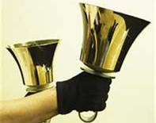
Polk Presbyterian Church
Calendar of Events
November 2020

Sunday School at 8:30am

Children Sunday School at 8:30am

Bible Study on Wednesdays at 6:30pm : at the church & via Zoom https://us04web.zoom.us/j/559705244 Meeting ID: 559 705 244 The passcode is 202020

Assisted hearing devices are now available. They are in the secretary's office on the file cabinet. Please mark your name on the box.

Greeting cards are being sent to some of our stay-at-home members during this time of Covid. Please sign the cards with any message you'd like to cheer these folks up with.

Dec 1 is Giving Tuesday

Dec 1 at 5:00pm - Session Meeting via Zoom

Notice* Community Services of Venango County does have some utility assistance still available.

Dec 6 - Communion Service

Dec 13 -Heifer International - We are collecting until Dec 13th. You and your family can be part of a tradition of giving and receiving gifts that help those in need.

Dec 24 at 7pm- Christmas Eve Service

Lakeview Area Helping Hands Center is asking for any help.

Donations to the building fund are welcome. Put the donation into an envelop marked Building Donation and drop into collection plate.

Home Communion: If you know anyone who would like to receive communion at home, please let Pastor Larry know who they are.

Lay Speakers: Looking for volunteers to speak at the beginning of the service in the same capacity as Jon Crum does now. If you would like to volunteer, please let Pastor Larry know.

Men's Association are welcoming projects for the elderly or persons who are unable to do projects like painting, lawn mowing, etc. Please let one of the men know if there is anyone in the community that needs this kind of help.
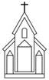

Polk Presbyterian Church

November 29, 2020
First Sunday of Advent

*Introit Holy Ground # 129
We are standing on holy ground,
And I know that there are angels all around.
Let us praise Jesus now.
We are standing in His presence on holy ground.

Time for meditation and reflection.

CALL TO WORSHIP Psalm 80:1-4
(L) Give ear, O Shepheerd of Israel, you who lead Joseph like a flock!
(P) You who are enthroned upon the cherubim, shine forth before Ephraim and Benjamin and Manasseh.
(L) Stir up your might, and come to save us!
(P) Restore us, O God; let your face shine, that we may be saved.

*Praise Hymn Solid Rock # 340
My hope is built on nothing less than Jesus' blood and righteousness; I dare not trust the sweetest frame, but wholly lean on Jesus' name. On Christ, the solid Rock, I stand---all other ground is sinking sand, all other ground is sinking sand.

PRAYER OF CONFESSION
Forgive us Lord when we are drawn into the secular glitter of this holiday season and we become complacent about our responsibilities to the Kingdom of God. Have mercy when we fail to live the Christian life but call out to our Lord to rescue us from our earthly predicaments. Help us to keep vigilant in our watching for the return of our Lord, in our call to service, and in our walk of faith. Heavenly Father, instill within us the hope of your presence among us, of your promise of salvation, and of your unending love. In the name of our risen and long-awaited Lord, we humbly pray. Amen.

ASSURANCE OF PARDON Titus 2:11-14
(L) For the grace of God has appeared, bringing salvatioon to all,
(P) Training us to renounce impiety and worldly passions, and in the present age to live lives that are self-controlled, upright, and godly,
(L) While we wait for the blessed hope and the manifestation of the glory of our great God and Savior, Jesus Christ.
(P) He who gave himself for us that he might redeem us from all iniquity and purify for himself a people of his own who are zealous for good deeds.

*Gloria Patri # 42

SPECIAL The First Advent Reading

CHILDREN'S CHAT

MOMENTS FOR MISSI0N

PRAYERS OF THE PEOPLE Joys and concerns:

Happy Birthday: Eddie Krizon, Deb Crum

Presbytery Prayers: Eastminster, Erie, Rev. Steve Morse, Temporary Supply Pastor; Rev. Emily Rodgers Bissett, Valid Minister, Presbyterian Church, Canada

THE LORDS PRAYER
Our Father, who art in heaven, hallowed be Thy name, Thy kingdom come, Thy will be done, on earth as it is in heaven. Give us this day our daily bread; and forgive us our debts, as we forgive our debtors; and lead us not into temptation, but deliver us from evil. For Thine is the kingdom, and the power, and the glory, forever. Amen.

HYMN OF PREPARATION O Come, O Come, Emmanuel 171
O come, O come, Emmanuel, and ransom captive Israel,
That mourns in lonely exile here until the Son of God appear.
Rejoice! rejoice! Emmanuel shall come to thee, O Israel.

O come, O come, Thou rod of Jesse, free Thine own from Satan's tyranny;
From depths of hel Thy people save and give them victory o'er the grave.
Rejoice! rejoice! Emmanuel shall come to thee, O Israel.

O come, Thou Dayspring, come and cheer our spirits by Thine advent here;
O drive away the shades of night and pierce the clouds and bring us light.
Rejoice! rejoice! Emmanuel shall come to thee, O Israel.

O come, Thou Key of David, come and open wide our heavenly home
Where all Thy saints with Thee shall dwell---O come, O come, Emmanuel!
Rejoice! rejoice! Emmanuel shall come to thee, O Israel.

RETURNING THANKS TO GOD
*THE DOXOLOGY #39
*THE PRAYER OF DEDICATION

SCRIPTURE READING: Isaiah 64:1-9
Mark 13:24-37
(P) Thanks be to God

SERMON "Keep Awake"

*Affirmation of Faith The Apostles’ Creed
I believe in God, the Father Almighty, maker of heaven and earth. And in Jesus Christ, His only begotten Son, our Lord. Who was conceived by the Holy Spirit, born of the Virgin Mary, suffered under Pontius Pilate, was crucified, dead and buried; he descended into hell. The third day, He rose again from the dead; He ascended into heaven, and sitteth at the right hand of God, the Father Almighty, from thence he will come again to judge the quick and the dead.
I believe in the Holy Spirit, the holy catholic church, the communion of saints, the forgiveness of sins, the resurrection of the body, and the life everlasting. Amen.

*CLOSING HYMN Come, Thou Long-Expected Jesus # 172
Come, Thou long expected Jesus, born to set Thy people free;
From our fears and sins release us, Let us find our rest in Thee.
Israel's strength and consolation, hope of all the earth Thou art;
Dear desire of every nation, joy of every longing heart.

Born Thy people to deliver, born a child and yet a King,
Born to reign in us forever---now Thy gracious Kingdom bring.
By Thine own eternal Spirit rule in all our hearts alone;
By Thine all sufficient merit raise us to Thy glorious throne.

*THE BENEDICTION

*Our Response Thank You Lord # 268
Thank you, Lord, for saving my soul, Thank you, Lord, for making me whole; thank you, Lord for giving to me Thy great salvation so rich and free.

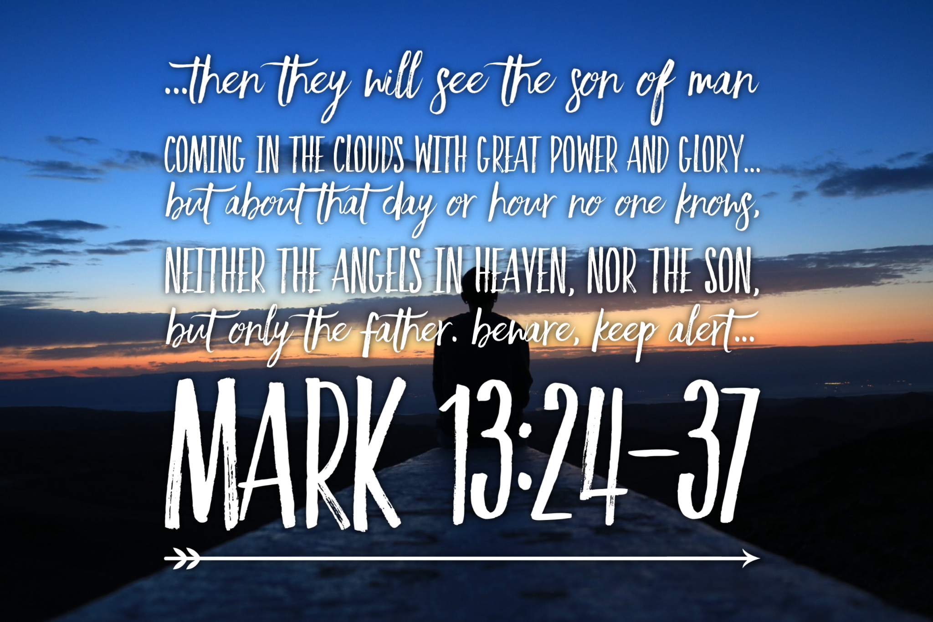

Pastor: Rev. Larry Myers
Elder on Call: Colleen Scurry
Music: Debbie Myers

