NEWS OF INTEREST

Pennies From Heaven: the monies collected help send children to the camp of their choice (mostly Seneca Hills). Your donations are appreciated and well spent. Other charities are often contributed to as worthy causes from Pennies From Heaven also.

PRAISES AND PRAYER

Please pray for God’s guidance in the future of our church. Please pray for the peace of the world. Pray for the leaders of our country as they earnestly seek peaceful solutions to the problems and crises around the globe. Please pray for our military and police forces and their safety throughout each day. Pray for our public school system. Pray for the mental health of people everywhere. Pray for our mission to Ghana. Pray for all the Christian's who are being persecuted in the world.

Would you like to know what our church has been up to? On the bulletin board in the entryway are the minutes and financial ledgers for each month. Please feel free to copy them and if you have a question, ask any session member or the pastor. We think this is the best way to keep everyone informed.

REMEMBER TO PRAY
FOR OUR MEMBERS AND FRIENDS AT HOME or HOSPITALS

Jenn & Marty Gilliland, Mieke Heffern, Susan Hammond, the unspoken request, Skip and Nancy Davison, Ken Timblin, Judy Krizon, Olivia Foster, Jan Sanners, Robin's mom Betty, Millie & Bill Nolan, Gregg Townsend, Dottie Dillin, Polk Center, Mark Knox, Sandy, Erma, Harry Daye, Virginia Heister, Deb Boyer, Sally & Doug Bell, Amy Zemanski, Lincoln, Dick & Nancy Kerr, Junior & Bonnie, Vicki, Deb Snyder, Dick McNany, Keith Reynolds, Teri and Gary Chisholm, Jewell, John and Chuck Karns, Chance, Aubrielle & family, Emma, Megan, Dewayne Doutt, Rick Vaxily, Barb & Bryan Chisholm, Dave Owen, Conrad Houk, Nancy & Tom Westcoat, June Mawhinney, Pat Karns, Lincoln, Dennis Martin, Bill Foster, Barb Reaker, Tim Vickers, Michelle Gregory, Emmalene, Dave Allman, Dawson, William Reilly, Floyd Russell, Harper, Pam Bottomley, victims of the storms and all those affected by the Coronavirus, for first responders, hospital staff, the military staff, at-home children, elderly and at-risk persons, the overdose & suicide epidemic, wildfires and firefighters

Polk Presbyterian Church
P.O. Box 1027
Polk, PA 16342
polkpresbyterianchurch.com

CHURCH OFFICE: 814-437-3153

Pastor Larry Myers 412-417-5737
flyfisher@windstream.net

SESSION MEMBERS:

Conrad Houk 814-374-4143
Cindy Swendsen 814-374-4041

Brian Heffern 814-671-2774

Dave Perry 770-687-9202
Colleen Scurry 814-437-6069
Deb Crum 724-679-9867

IF YOU ARE IN NEED OF ASSISTANCE
PLEASE CONTACT:

FINANCIAL SECRETARY:
Robin Russell 814-437-7038
rrussell@pa.rr.com

SECRETARY:

Anna Aumiller 814-437-3611
aaumiller@neo.rr.com

CLERK OF SESSION:
Wendy Bellin 814-673-9826

Millie & Bill Nolan Karns, Clayton M.
1380 School Rd 5350 Berger Street
Stoneboro, PA 16153 Stop #1360
Moody AFB, GA 31699

Tyler Wood Gracie Stryffeler
c/o Room 718 c/o Room 206
117 University Plaza 117 University Plaza
Youngstown, OH 44502-1208 Youngstown, OH 44502-1208

Dave Burgoyne Jenn & Marty Gilliland
c/o Amy Zemanski 238 W. Washington St.
200 McClelland Avenue Harrisville, PA 16038
Polk, PA 16342

Trevor Wood Zach Stryffeler
369 Sherman St. PO Box 213
Akron, OH 44311 3261 W. State Road
St. Bonaventure, NY 14778


Polk Presbyterian Church
Calendar of Events
November 2020

Sunday School at 8:30am

Children Sunday School at 8:30am

Bible Study on Wednesdays at 6:30pm : at the church & via Zoom https://us04web.zoom.us/j/559705244 Meeting ID: 559 705 244 The passcode is 202020

Assisted hearing devices are now available. They are in the secretary's office on the file cabinet. Please mark your name on the box.

Greeting cards are being sent to some of our stay-at-home members during this time of Covid. Please sign the cards with any message you'd like to cheer these folks up with.

Nov 8 - Congregational Meeting following worship service.

Nov 19 at 6:30 - Session Meeting

Lakeview Area Helping Hands Center is asking for any help.

Donations to the building fund are welcome. Put the donation into an envelop marked Building Donation and drop into collection plate.

Home Communion: If you know anyone who would like to receive communion at home, please let Pastor Larry know who they are.

Lay Speakers: Looking for volunteers to speak at the beginning of the service in the same capacity as Jon Crum does now. If you would like to volunteer, please let Pastor Larry know.

Men's Association are welcoming projects for the elderly or persons who are unable to do projects like painting, lawn mowing, etc. Please let one of the men know if there is anyone in the community that needs this kind of help.

Food Drive: Please place food items in box in the vestibule hallway and it will be taken to the Salvation Army.



Polk Presbyterian Church

November 8, 2020
23rd Sunday after Pentecost
Caregiver Sunday

*Introit Holy Ground # 129
We are standing on holy ground,
And I know that there are angels all around.
Let us praise Jesus now.
We are standing in His presence on holy ground.

Time for meditation and reflection.

CALL TO WORSHIP Psalm 78:1-5
(L) Give ear, O my people, to my teaching; incline your ears to the words of my mouth.
(P) I will open my mouth in a parable; I will utter dark sayings from of old, things that we have heard and known, that our ancestors have told us.
(L) We will not hide them from their children; we will tell to the coming generation the glorious deeds of the Lord, and his might, and the wonders that he has done.
(P) He established a decree in Jacob, and appointed a law in Israel, which he commanded our ancestors to teach to their children.

*Praise Hymn "Yes, Lord, Yes" #103
Yes, Lord, yes! to Your will and to Your way.
Yes, Lord, yes! I will trust You and obey.
When Your Spirit speaks to me,
With my whole heart I'll agree
And my answer wil be yes. Lord, yes!

PRAYER OF CONFESSION
Compassionate Creator, forgive us when we fail to realize we were known before conception, loved before birth, and formed in the image of God. Have mercy when we fail to believe through faith in the blood of our Redeemer, our sin debt has been paid in full. Show us compassion, as we do not trust the Sustainer to prepare us for service to the Kingdom of God and the second coming of Christ. Help us to accept unmerited grace, embrace our call to ministry, and make constant preparation for encountering our Lord, in whose name we pray. Amen.

ASSURANCE OF PARDON 1 Peter 1:3-5
(L) Our heavenly Father has given us a new birth into a living hope through the resurrection of Jesus Christ from the dead,
(P) And into an inheritance that is imperishable, undefiled, unfading, and kept in heaven for you,
(A) You who are being protected by the power of God through faith for a salvation ready to be revealed in the last time. Come quickly Lord Jesus.

*Gloria Patri # 42

SPECIAL by Deb and Jon What If It Were Today

CHILDREN'S CHAT

MOMENTS FOR MISSI0N

PRAYERS OF THE PEOPLE Joys and concerns:

Happy Birthday: Matthew Sybert

Presbytery Prayers: Rev. Lee Beckes, HR and Rev. Hal Kelley, HR

THE LORDS PRAYER
Our Father, who art in heaven, hallowed be Thy name, Thy kingdom come, Thy will be done, on earth as it is in heaven. Give us this day our daily bread; and forgive us our debts, as we forgive our debtors; and lead us not into temptation, but deliver us from evil. For Thine is the kingdom, and the power, and the glory, forever. Amen.

HYMN OF PREPARATION I'll Fly Away 256

RETURNING THANKS TO GOD
*THE DOXOLOGY #39
*THE PRAYER OF DEDICATION

SCRIPTURE READING: Matthew 25:1-13
(P) Thanks be to God

SERMON "Are We Truly Prepared?"

*Affirmation of Faith The Confession of 1967 9.32
The life, death, resurrection, ascension, and promised coming of Jesus Christ has set the pattern for the church’s mission. His life as man involves the church in the common life of men. His service to men commits the church to work for every form of human well-being. His suffering makes the church sensitive to all the sufferings of humankind so that it sees the face of Christ in the faces of human beings in every kind of need. His crucifixion discloses to the church God’s judgment on man’s inhumanity to man and the awful consequences of its own complicity in injustice. In the power of the risen Christ and the hope of his coming, the church sees the promise of God’s renewal of man's life in society and of God's victory over all wrong. Amen.

*CLOSING HYMN I Have Decided to Follow Jesus # 454

*THE BENEDICTION

*Our Response Thank You Lord # 268
Thank you, Lord, for saving my soul, Thank you, Lord, for making me whole; thank you, Lord for giving to me Thy great salvation so rich and free.

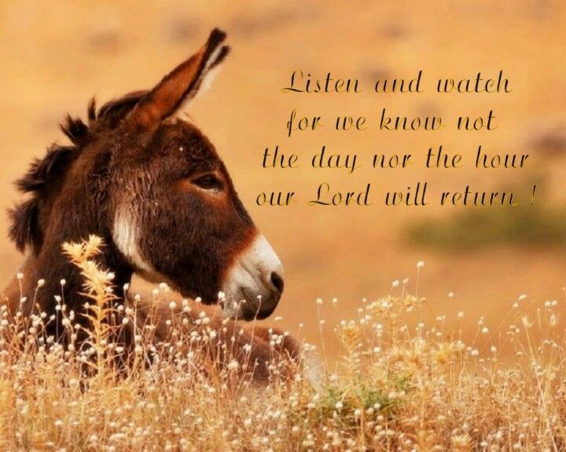

Pastor: Rev. Larry Myers
Elder on Call: Cindy Swendsen
Music: Debbie Myers
Greeters: John and Pam Vickers

