NEWS OF INTEREST

Pennies From Heaven: the monies collected help send children to the camp of their choice (mostly Seneca Hills). Your donations are appreciated and well spent. Other charities are often contributed to as worthy causes from Pennies From Heaven also.

PRAISES AND PRAYER

Please pray for God’s guidance in the future of our church. Please pray for the peace of the world. Pray for the leaders of our country as they earnestly seek peaceful solutions to the problems and crises around the globe. Please pray for our military and police forces and their safety throughout each day. Pray for our public school system. Pray for the mental health of people everywhere. Pray for our mission to Ghana. Pray for all the Christian's who are being persecuted in the world.

Would you like to know what our church has been up to? On the bulletin board in the entryway are the minutes and financial ledgers for each month. Please feel free to copy them and if you have a question, ask any session member or the pastor. We think this is the best way to keep everyone informed.

REMEMBER TO PRAY
FOR OUR MEMBERS AND FRIENDS AT HOME or HOSPITALS

Jen & Marty Gilliland, Mieke Heffern, Susan Hammond, the unspoken request, Ken Timblin, Olivia Foster, Jan Sanners, Robin's mom Betty, Millie & Bill Nolan, Gregg Townsend, Dottie Dillin, Polk Center, Mark Knox, Sandy, Erma, Harry Daye, Virginia Heister, Deb Boyer, Dick & Nancy Kerr, Bonnie, Vicki, Deb Snyder, Dick McNany, Keith Reynolds, Teri and Gary Chisholm, Jewell, John and Chuck Karns, Emma, Megan, Dewayne Doutt, Rick Vaxily, Barb & Bryan Chisholm, Conrad Houk, Nancy & Tom Westcoat, June Mawhinney, Pat Karns, Dennis Martin, Bill Foster, Barb Reaker, Tim Vickers, Michelle Gregory, Dave Allman, Dawson, William Reilly, Harper, Pam Bottomley, Chris Gannon, victims of the storms and all those affected by the Coronavirus, for first responders, hospital staff, the military staff, at-home children, elderly and at-risk persons, the overdose & suicide epidemic, wildfires and firefighters, the family of Jan Heffern during this time of their loss

Polk Presbyterian Church
P.O. Box 1027
Polk, PA 16342
polkpresbyterianchurch.com

CHURCH OFFICE: 814-437-3153

Pastor Larry Myers 412-417-5737
flyfisher@windstream.net

SESSION MEMBERS:

Conrad Houk 814-374-4143
Regina Allman 814-425-1850

Brian Heffern 814-671-2774

Jeff Karns 814-676-5096
Colleen Scurry 814-437-6069 or
814-208-3080
Deb Crum 724-679-9867

IF YOU ARE IN NEED OF ASSISTANCE
PLEASE CONTACT:

FINANCIAL SECRETARY:
Robin Russell 814-437-7038
rrussell@pa.rr.com

SECRETARY:

Anna Aumiller 814-437-3611
aaumiller@neo.rr.com

CLERK OF SESSION:
Wendy Bellin 814-673-9826

Millie & Bill Nolan Karns, Clayton M.
1380 School Rd 5350 Berger Street
Stoneboro, PA 16153 Stop #1360
Moody AFB, GA 31699

Tyler Wood Gracie Stryffeler
c/o Room 718 c/o Room 206
117 University Plaza 117 University Plaza
Youngstown, OH 44502-1208 Youngstown, OH 44502-1208

Dave Burgoyne Jenn & Marty Gilliland
c/o Amy Zemanski 238 W. Washington St.
200 McClelland Avenue Harrisville, PA 16038
Polk, PA 16342

Trevor Wood Zach Stryffeler
369 Sherman St. PO Box 213
Akron, OH 44311 3261 W. State Road
St. Bonaventure, NY 14778
Wendy Bellin
5272 Georgetown Rd
Franklin, PA 16323

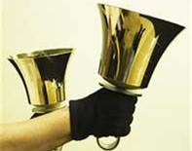
Polk Presbyterian Church
Calendar of Events
February 2021

Sunday School at 8:30am

Children Sunday School at 8:30am

Bible Study on Wednesdays at 6:30pm : at the church & via Zoom https://us04web.zoom.us/j/559705244 Meeting ID: 559 705 244 The passcode is 202020

Assisted hearing devices are now available. They are in the secretary's office on the file cabinet. Please mark your name on the box.

Greeting cards are being sent to some of our stay-at-home members during this time of Covid. Please sign the cards with any message you'd like to cheer these folks up with.

Donations to the building fund are welcome. Put the donation into an envelop marked Building Donation and drop into collection plate.

Home Communion: If you know anyone who would like to receive communion at home, please let Pastor Larry know who they are.

Lay Speakers: Looking for volunteers to speak at the beginning of the service in the same capacity as Jon Crum does now. If you would like to volunteer, please let Pastor Larry know.

Men's Association are welcoming projects for the elderly or persons who are unable to do projects like painting, lawn mowing, etc. Please let one of the men know if there is anyone in the community that needs this kind of help.

Food Drive: Please place food items in box in the vestibule hallway and it will be taken to the Salvation Army.

Feb 24 at 10am - Blanket making group with Pam Vickers.

Mar 7 - Communion Sunday

Mar 11 at 6:30pm - Session Meeting

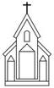

Polk Presbyterian Church

February 21, 2021
1st Sunday in Lent

*The Introit “O How He Loves You and Me” #214
O how He loves you and me, O how He loves you and me;
He gave His life what more could He give? O how He loves you, O how He loves me, O how He loves you and me.

Time for meditation and reflection.

CALL TO WORSHIP Psalm 25:1-5
(L) To you, O Lord, we lift up our souls. Make us to know your ways, O Lord; teach us your paths.
(P) Lead us in your truth, and teach us, for you are the God of our salvation.

*Praise Hymn Take My Life #11 (Purple)
1. Holiness, holiness is what I long for,
Holiness is what I need.
Holiness, holiness is what Your want from me.

(chorus) Take my heart and form it,
Take my mind transform it,
Take my will conform it to Yours, to Yours, O Lord.

2. Faithfulness, faithfulness is what I long for,
Faithfulness is what I need.
Faithfulness, faithfulness is what You want from me.

3. Righteousness, righteousness is what I long for,
Righteousness is what I need.
Righteousness, righteousness is what You want from me.

4. Purity, purity is what I long for,
Purity is what I need.
Purity, purity is what You want from me.

PRAYER OF CONFESSION
Faithful heavenly Father, have mercy upon us when we act like spoiled and disobedient children, instead of faithful disciples of Christ. Help us to embrace the new covenant, the gift of unmerited grace, our spiritual rebirth, and our Lord’s death that paid our sin debt. Allow the Holy Spirit to convict us of our trespasses, lead us to repentance, and guide us to the path of righteousness. In the name of Jesus, the Christ, we pray. Amen.

ASSURANCE OF PARDON John 3:5-6
(L) Jesus said, “Very truly, I tell you, no one can enter the kingdom of God without being born of water and Spirit.
(P) What is born of flesh is flesh, and what is born of the Spirit is spirit."
(A) If we confess our sin, he who is faithful and just will cleanse us of all unrighteousness. Thanks be to God.

*Gloria Patri # 42

SPECIAL a Reading: The Soul That Suffers With Longing To
See God read by David Allman

CHILDREN'S CHAT

MOMENTS FOR MISSI0N

PRAYERS OF THE PEOPLE Joys and concerns:

Happy Birthday: Xena Allman, Trevor Wood

Presbytery Prayers: Nickleville and Emlenton, Rev. darrell Knopp, Temporary Supply Pastor; Rev. Gary Larson, HR,
Rev. Jim Rimmer, HR

THE LORDS PRAYER
Our Father, who art in heaven, hallowed be Thy name, Thy kingdom come, Thy will be done, on earth as it is in heaven. Give us this day our daily bread; and forgive us our debts, as we forgive our debtors; and lead us not into temptation, but deliver us from evil. For Thine is the kingdom, and the power, and the glory, forever. Amen.

HYMN OF PREPARATION Jesus Walked This Lonesome Valley # 202

RETURNING THANKS TO GOD
*THE DOXOLOGY # 39
*THE PRAYER OF DEDICATION

SCRIPTURE READING: Genesis 9:8-17
Mark 1:9-15
1 Peter 3:18-22
(P) Thanks be to God

SERMON "A Covenant of Grace"

Westminster Confession of Faith 6.038, 6.039
The first covenant made with man was a covenant of works, wherein life was promised to Adam, and in him to
his posterity, upon condition of perfect and personal obedience.
Man, by his Fall, having made himself incapable of life
by that covenant, the Lord was pleased to make a second, commonly called the covenant of grace: wherein he freely offered unto sinners, life and salvation by Jesus Christ, requiring of them faith in him, that they may be saved, and promising to give unto all those that are ordained unto life,
his Holy Spirit, to make them willing and able to believe.

*CLOSING HYMN Are You Washed in the Blood # 308

*THE BENEDICTION

*Our Response “For God So Loved the World” #164
For God so loved the world He gave His only Son to die on Calv’ry’s tree, from sin to set me free; some day He’s coming back---what glory that will be: wonderful His love to me!

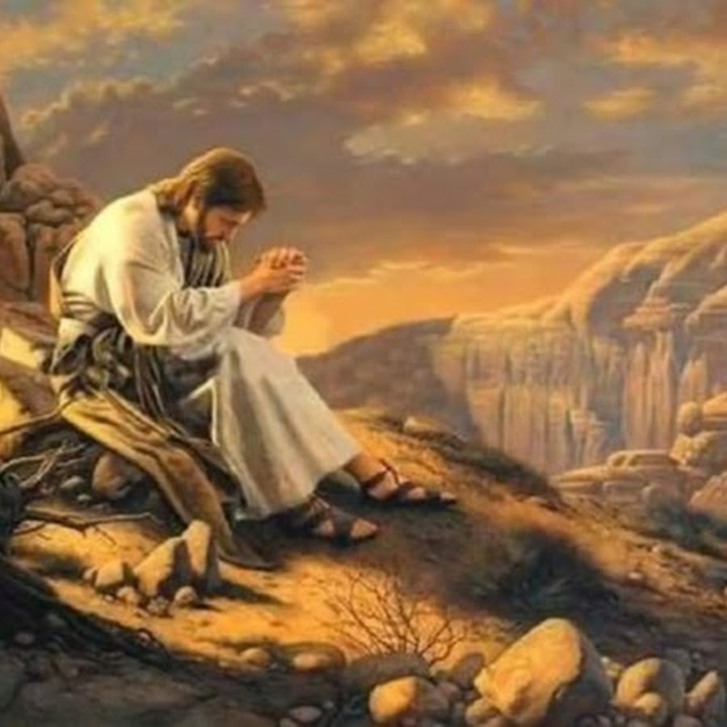

Pastor: Rev. Larry Myers
Elder on Call: Deb Crum
Music: Debbie Myers

