NEWS OF INTEREST

Pennies From Heaven: the monies collected help send children to the camp of their choice (mostly Seneca Hills). Your donations are appreciated and well spent. Other charities are often contributed to as worthy causes from Pennies From Heaven also.

PRAISES AND PRAYER

Please pray for God’s guidance in the future of our church. Please pray for the peace of the world. Pray for the leaders of our country as they earnestly seek peaceful solutions to the problems and crises around the globe. Please pray for our military and police forces and their safety throughout each day. Pray for our public school system. Pray for the mental health of people everywhere. Pray for our mission to Ghana. Pray for all the Christian's who are being persecuted in the world.

Would you like to know what our church has been up to? On the bulletin board in the entryway are the minutes and financial ledgers for each month. Please feel free to copy them and if you have a question, ask any session member or the pastor. We think this is the best way to keep everyone informed.

REMEMBER TO PRAY
FOR OUR MEMBERS AND FRIENDS AT HOME or HOSPITALS

Jen & Marty Gilliland, Mieke Heffern, Susan Hammond, the unspoken request, Ken Timblin, Olivia Foster, Jan Sanners, Robin's mom Betty, Millie & Bill Nolan, Gregg Townsend, Dottie Dillin, Polk Center, Mark Knox, Sandy, Erma, Harry Daye, Virginia Heister, Deb Boyer, Dick & Nancy Kerr, Bonnie, Vicki, Deb Snyder, Dick McNany, Keith Reynolds, Teri and Gary Chisholm, Jewell, John and Chuck Karns, Emma, Megan, Dewayne Doutt, Rick Vaxily, Barb & Bryan Chisholm, Conrad Houk, Nancy & Tom Westcoat, June Mawhinney, Pat Karns, Dennis Martin, Bill Foster, Barb Reaker, Tim Vickers, Michelle Gregory, Dave Allman, Dawson, William Reilly, Harper, Pam Bottomley, Chris Gannon, victims of the storms and all those affected by the Coronavirus, for first responders, hospital staff, the military staff, at-home children, elderly and at-risk persons, the overdose & suicide epidemic, wildfires and firefighters

Polk Presbyterian Church
P.O. Box 1027
Polk, PA 16342
polkpresbyterianchurch.com

CHURCH OFFICE: 814-437-3153

Pastor Larry Myers 412-417-5737
flyfisher@windstream.net

SESSION MEMBERS:

Conrad Houk 814-374-4143
Regina Allman 814-425-1850

Brian Heffern 814-671-2774

Jeff Karns 814-676-5096
Colleen Scurry 814-437-6069 or
814-208-3080
Deb Crum 724-679-9867

IF YOU ARE IN NEED OF ASSISTANCE
PLEASE CONTACT:

FINANCIAL SECRETARY:
Robin Russell 814-437-7038
rrussell@pa.rr.com

SECRETARY:

Anna Aumiller 814-437-3611
aaumiller@neo.rr.com

CLERK OF SESSION:
Wendy Bellin 814-673-9826

Millie & Bill Nolan Karns, Clayton M.
1380 School Rd 5350 Berger Street
Stoneboro, PA 16153 Stop #1360
Moody AFB, GA 31699

Tyler Wood Gracie Stryffeler
c/o Room 718 c/o Room 206
117 University Plaza 117 University Plaza
Youngstown, OH 44502-1208 Youngstown, OH 44502-1208

Dave Burgoyne Jenn & Marty Gilliland
c/o Amy Zemanski 238 W. Washington St.
200 McClelland Avenue Harrisville, PA 16038
Polk, PA 16342

Trevor Wood Zach Stryffeler
369 Sherman St. PO Box 213
Akron, OH 44311 3261 W. State Road
St. Bonaventure, NY 14778
Wendy Bellin
5272 Georgetown Rd
Franklin, PA 16323


Polk Presbyterian Church
Calendar of Events
February 2021

Sunday School at 8:30am

Children Sunday School at 8:30am

Bible Study on Wednesdays at 6:30pm : at the church & via Zoom https://us04web.zoom.us/j/559705244 Meeting ID: 559 705 244 The passcode is 202020

Assisted hearing devices are now available. They are in the secretary's office on the file cabinet. Please mark your name on the box.

Donations to the building fund are welcome. Put the donation into an envelop marked Building Donation and drop into collection plate.

Home Communion: If you know anyone who would like to receive communion at home, please let Pastor Larry know who they are.

Lay Speakers: Looking for volunteers to speak at the beginning of the service in the same capacity as Jon Crum does now. If you would like to volunteer, please let Pastor Larry know.

Men's Association are welcoming projects for the elderly or persons who are unable to do projects like painting, lawn mowing, etc. Please let one of the men know if there is anyone in the community that needs this kind of help.

Food Drive: Please place food items in box in the vestibule hallway and it will be taken to the Salvation Army.

Mar 7 - Communion Sunday

Mar 11 at 6:30pm - Session Meeting

Employment Opportunity: the local homeless shelter has 4 part-time positions available. Shifts available: 4pm to Midnite and Midnite to 7am, weekends. Pays $9.00 per hour. If interested, call 814/493-8791.

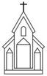

Polk Presbyterian Church

February 28, 2021
2nd Sunday in Lent

*The Introit “O How He Loves You and Me” #214
O how He loves you and me, O how He loves you and me;
He gave His life what more could He give? O how He loves you, O how He loves me, O how He loves you and me.

Time for meditation and reflection.

CALL TO WORSHIP Psalm 22:22-28
(L) I will tell of God's name to my brothers and sister; in the midst of the congregation, I will praise my God.
(P) You who fear the Lord, praise him! All the offspring of Jacob, glorify the Lord; stand in awe of him, all you, offspring of Israel!
(L) All the ends of the earth shall remember and turn to the Lord; and all the families of the nations shall worship before Almighty God.
(P) For dominion belongs to the Lord, and he rules over the nations.

*Praise Hymn The Solid Rock #340 (Hymnal)
My hope is built on nothing less than Jesus' blood and righteousness; I dare not trust the sweetest frame, but wholly lean on Jesus' name. On Christ, the solid Rock, I stand---all other ground is sinking sand, all other ground is sinking sand.

PRAYER OF CONFESSION
Heavenly Creator, all too often we find ourselves as stumbling blocks to the gospel message by setting our minds on human desires, fearing to act like faithful Christians, and unwilling to witness to others. Forgive our sinfulness, fear, doubt, shame, and guilt. Empower us to put on the righteousness of Christ, deny ourselves, pick up our crosses, embrace our faith, and follow our Lord’s example. In the name of Jesus, the Christ, we pray. Amen.

ASSURANCE OF PARDON John 3:16-18
(L) "For God so loved the world that he gave his only Son, so that everyone who believes in him may not perish but may have eternal life.
(P) Indeed, God did not send the Son into the world to condemn the world, but in order that the world might be saved through him.
(L) Those who believe in Jesus Christ are not condemned but have eternal life.
(P) Those who do not believe are condemned already, because they have not believed in the name of the only Son of God.” Thanks be to God. Amen.

*Gloria Patri # 42

SPECIAL a Congregational Hymn
Beneath the Cross of Jesus #407 (Hymnal)
Beneath the cross of Jesus I fain would take my stand, the shadow of a mighty Rock within a weary land; a home within the wilderness, a rest upon the way, from the burning of the noontide heat and the burden of the day.

Upon the cross of Jesus mine eye at times can see the very dying form of One who suffered there for me: and from my stricken heart with tears two wonders I confess, the wonders of redeeming love and my unworthiness.

I take, O cross, thy shadow for my abiding place: I ask no other sunshine than the sunshine of his face; content to let the world go by, to know no gain nor loss; my sinful self my only shame, my glory all the cross.

CHILDREN'S CHAT

MOMENTS FOR MISSI0N

PRAYERS OF THE PEOPLE Joys and concerns:

Happy Birthday: Scott Heffern

Presbytery Prayers: Erie, Belle Valley and Ellmwood Avenue, Rev. Dave Edmunds, Temporary Supply Pastor; Marsha MacKinnon, Presbytery Webmaster

THE LORDS PRAYER
Our Father, who art in heaven, hallowed be Thy name, Thy kingdom come, Thy will be done, on earth as it is in heaven. Give us this day our daily bread; and forgive us our debts, as we forgive our debtors; and lead us not into temptation, but deliver us from evil. For Thine is the kingdom, and the power, and the glory, forever. Amen.

HYMN OF PREPARATION My Faith Looks Up to Thee # 383

RETURNING THANKS TO GOD
*THE DOXOLOGY # 39
*THE PRAYER OF DEDICATION

SCRIPTURE READING: Genesis 17:1-7, 15-16
Mark 8:31-38
Romans 4:13-25
(P) Thanks be to God

SERMON "Faith and Righteousness"

Affirmation of Faith The Heidelberg Confession 4.021
Q 21: What is true faith?
A. It is not only a certain knowledge by which I accept as true all that God has revealed to us in his Word, but also a wholehearted trust which the Holy Spirit creates in me through the gospel, that, not only to others, but to me also God has given forgiveness of sins, everlasting righteousness and salvation, out of sheer grace solely for the sake of Christ's saving work.

*CLOSING HYMN O Master, Let Me Walk with Thee # 357

*THE BENEDICTION

*Our Response “For God So Loved the World” #164
For God so loved the world He gave His only Son to die on Calv’ry’s tree, from sin to set me free; some day He’s coming back---what glory that will be: wonderful His love to me!

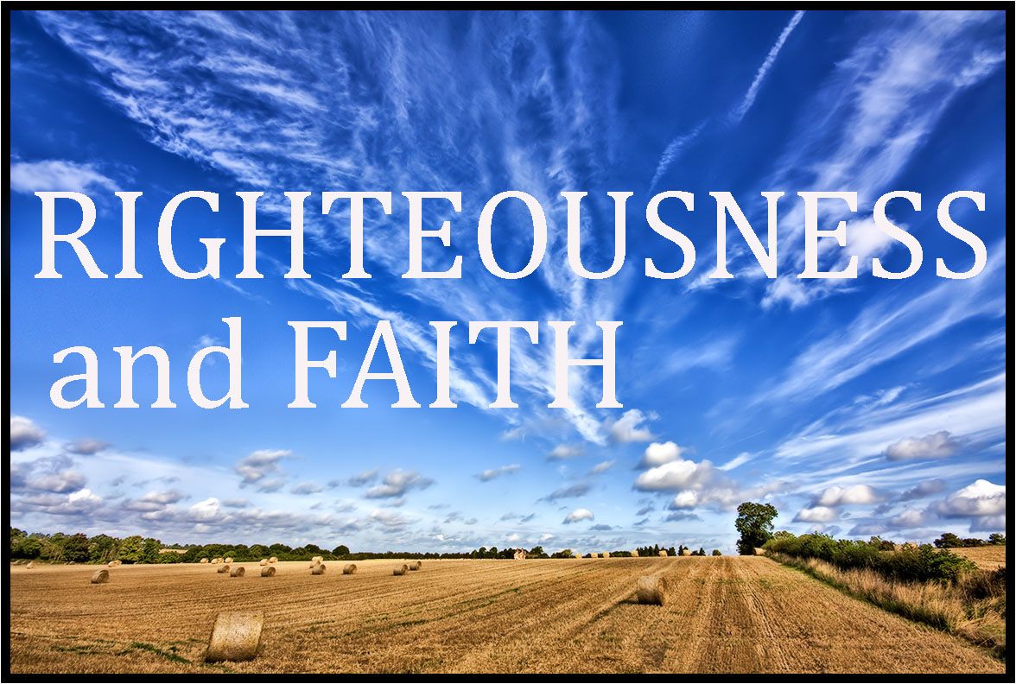

Pastor: Rev. Larry Myers
Elder on Call: Conrad Houk
Music: Debbie Myers

