Polk Presbyterian Church

March 1, 2020

1st Sunday in Lent



*The Introit O How He Loves You and Me #214
O how He loves you and me, O how He loves you and me; He gave His life what more could He give? O how He loves you, O how He loves me, O how He loves you and me.

Time for meditation and reflection.

CALL TO WORSHIP Psalm 32:1-2, 10-11
(L) Happy are those whose transgression is forgiven, whose sin is covered.
(P) Happy are those to whom the Lord imputes no iniquity, and in whose spirit there is no deceit.
(L) Many are the torments of the wicked, but steadfast love surrounds those who trust in the Lord.
(P) Be glad in the Lord and rejoice, O righteous, and shout for joy, all you upright in heart.

*Praise Hymn He's Still Workin' on Me #1818666
He's still workin' on me to make me what I ought to be; it took Him just a week to make the moon and stars, the sun and the earth and Jupiter and Mars. How loving and patient He must be! He's still workin' on me!

PRAYER OF CONFESSION Hebrews 4:14-16
Merciful heavenly Father, we confess the sin that seems ever before us and our inability to resist the power of darkness. Forgive our weakness in the hour of temptation and our stubborn pride that thinks we can live for ourselves. Yet we boldly approach the throne of grace seeking divine mercy and grace because we realize we have a Redeemer who was tested in every respect, as we are tempted, but Jesus did not sin. Forgive our weakness, as we put our faith in the faithfulness of our Lord, Jesus Christ. Amen.

ASSURANCE OF PARDON Romans 5:18, 21
(L) For just as by the one man’s disobedience the many were made sinners, so by the one man’s obedience the many will be made righteous.
(P) So that, just as sin exercised dominion in death, so grace might also exercise dominion through justification leading to eternal life in Jesus Christ our Lord. Amen.

*Gloria Patri # 42

SPECIAL by the Choir - I Believe in a Hill Called Mt. Calvary

CHILDREN'S CHAT

MOMENTS FOR MISSI0N

PRAYERS OF THE PEOPLE Joys and concerns:

Presbytery Prayers: Erie, Belle Valley and Elmwood Avenue, Rev. Dave Edmunds, Temp. Supply Pastor; Marsha MacKinnon, Presbytery Webmaster

THE LORDS PRAYER
Our Father, who art in heaven, hallowed be Thy name, Thy kingdom come, Thy will be done, on earth as it is in heaven. Give us this day our daily bread; and forgive us our debts, as we forgive our debtors; and lead us not into temptation, but deliver us from evil. For Thine is the kingdom, and the power, and the glory, forever. Amen.

*HYMN OF PREPARATION
Jesus Walked This Lonesome Valley # 202

RETURNING THANKS TO GOD
*THE DOXOLOGY # 39
*THE PRAYER OF DEDICATION

SCRIPTURE READING: Genesis 2:15-17, 3:1-7 OT PG 2
Matthew 4:1-11 NT PG 3
(P) Thanks be to God

SERMON "Where Is Our Focus?"

Affirmation of Faith The Heidelberg Confession 4.127
Q. 127. What does the sixth petition mean?
A. "And lead us not into temptation, but deliver us from evil.” That is: since we are so weak that we cannot stand by ourselves for one moment, and besides, since our sworn enemies, the devil, the world, and our own sin, ceaselessly assail us, Lord be pleased to preserve and strengthen us through the power of the Holy Spirit so that we may stand firm against them, and not be defeated in this spiritual warfare, until at last we obtain complete victory. Amen.

INVITATION TO THE LORD'S SUPPER
Let Us Break Bread Together #162

*CLOSING HYMN
I Need Thee Every Hour # 382

*THE BENEDICTION

*Our Response God Be With You # 105
God be with you till we meet again, by His counsels guide, uphold you, with His sheep securely fold you, God be with you till we meet again.

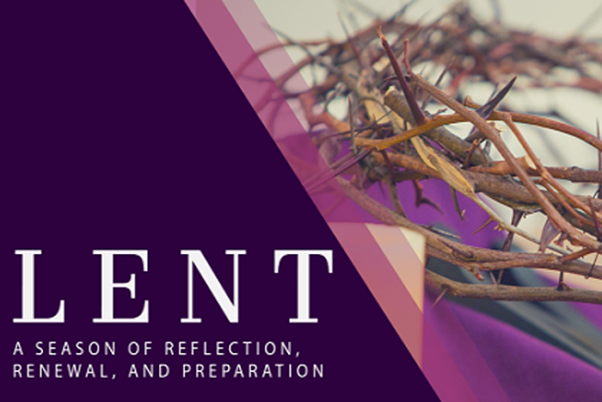

Pastor: Rev. Larry Myers
Elder on Call: Cindy Swendsen
Minister of Music: Erma Martin
Choir Director: Jon Crum
Greeters: Ernie & Gail Banks

Polk Presbyterian Church
P.O. Box 1027
Polk, PA 16342

CHURCH OFFICE: 814-437-3153

Pastor Larry Myers 412-417-5737
flyfisher@windstream.net

SESSION MEMBERS:

Conrad Houk 814-374-4143
Cindy Swendsen 814-374-4041

Brian Heffern 814-671-2774

Dave Perry 770-687-9202
Colleen Scurry 814-437-6069
Deb Crum 724-679-9867

IF YOU ARE IN NEED OF ASSISTANCE
PLEASE CONTACT:

FINANCIAL SECRETARY:
Robin Russell 814-437-7038
rrussell@pa.rr.com

SECRETARY:

Anna Aumiller 814-437-3611
aaumiller@neo.rr.com

CLERK OF SESSION:
Wendy Bellin 814-673-9826


Polk Presbyterian Church
Calendar of Events
March 2020

Sunday School at 8:30am

Children Sunday School at 8:30am

Bible Study on Wednesdays at 6:30pm

Assisted hearing devices are now available. They are in the secretary's office on the file cabinet. Please mark your name on the box.

Donations for Easter egg hunt can be left in the vestibule. Shawnee will be picking up the candy and any donations.

Mar 1 - Communion Sunday.

Mar 8 - Daylight Savings Time begins.

Mar 12 at 6:30pm - Session Meeting

Mar 15 - Fundraiser for Hog Heaven by the Karns family for after worship service.

Mar 20 - Movie Night. Snack and mingle with others starting at 6pm. The movie starts at 7pm.

March 21 "A Night Under the Stars": Franklin Junior/Senior High is having a free formal dance for disabled students. They are collecting donations for this event; contact Emily Bartlett at 814/432-2121. Also gently used items like formal wear for boys and girls, jewelry, shoes and new makeup are other items that can be donated.

Mar 29 - Fundraiser for the upcoming mission trips by Regina Allman and Cindy Swendsen is a luncheon after the worship service.

Truly Free Skate every Sunday from 4:30 to 6:30pm at Skate Capital in Seneca, PA. Community churches are sponsoring the skate night with free admission and skate rental.

Home Communion: If you know anyone who would like to receive communion at home, please let Pastor Larry know who they are.

Lay Speakers: Looking for volunteers to speak at the beginning of the service in the same capacity as Jon Crum does now. If you would like to volunteer, please let Pastor Larry know.

Men's Association are welcoming projects for the elderly or persons who are unable to do projects like painting, lawn mowing, etc. Please let one of the men know if there is anyone in the community that needs this kind of help.

Food Drive: Please place food items in box in the vestibule hallway and it will be taken to the Salvation Army.

Millie & Bill Nolan Karns, Clayton M.
1380 School Rd USAF
Stoneboro, PA 16153 230 Chevalier Avenue
Pensacola, FL 32508

Trevor Wood Zack Stryffeler
The University of Akron St Bonaventure University
Honors Complex 656 3261 West State Road
PO Box 1350 PO Box 213
Akron, OH 44309 St Bonaventure, NY 14778

Dave Burgoyne Jenn & Marty Gilliland
PO Box 874 238 W. Washington St.
Polk, PA 16342 Harrisville, PA 16038
Wheatley, Ontario Canada NOP2PO)

NEWS OF INTEREST

Pennies From Heaven: the monies collected help send children to the camp of their choice (mostly Seneca Hills). Your donations are appreciated and well spent. Other charities are often contributed to as worthy causes from Pennies From Heaven also.

PRAISES AND PRAYER

Please pray for God’s guidance in the future of our church. Please pray for the peace of the world. Pray for the leaders of our country as they earnestly seek peaceful solutions to the problems and crises around the globe. Please pray for our military and police forces and their safety throughout each day. Pray for our public school system. Pray for the mental health of people everywhere. Pray for our mission to Ghana. Pray for all the Christian's who are being persecuted in the world.

Would you like to know what our church has been up to? On the bulletin board in the entryway are the minutes and financial ledgers for each month. Please feel free to copy them and if you have a question, ask any session member or the pastor. We think this is the best way to keep everyone informed.

REMEMBER TO PRAY
FOR OUR MEMBERS AND FRIENDS AT HOME or HOSPITALS:

J Jenn & Marty Gilliland, Mieke Heffern, Susan Hammond, the unspoken request, Skip Davison, Ken Timblin, Judy Krizon, Olivia Foster, Jan Sanners, Robin's mom Betty, Millie & Bill Nolan, Denny Martin, Jackie & Scott Ghering, Donna Clayton, Alexandra Stanford, Gregg Townsend, Dottie Dillin, Polk Center, Mark Knox, Sandy, Susan Martin, the family of Adam Gregory, Junior, Vicki, Deb Snyder, Rick Doutt, Jim Hesson, Dick McNany, the Methodist Church, the Shannon Peterson family, Dave Perry, Nancy, Pat Embach, Keith Reynolds, Teri and Gary Chisholm, Floyd Russell, Jewell, Ginny, Meryl, the family of Joe Toy during this time of their loss

