NEWS OF INTEREST

Pennies From Heaven: the monies collected help send children to the camp of their choice (mostly Seneca Hills). Your donations are appreciated and well spent. Other charities are often contributed to as worthy causes from Pennies From Heaven also.

PRAISES AND PRAYER

Please pray for God’s guidance in the future of our church. Please pray for the peace of the world. Pray for the leaders of our country as they earnestly seek peaceful solutions to the problems and crises around the globe. Please pray for our military and police forces and their safety throughout each day. Pray for our public school system. Pray for the mental health of people everywhere. Pray for our mission to Ghana. Pray for all the Christian's who are being persecuted in the world.

Would you like to know what our church has been up to? On the bulletin board in the entryway are the minutes and financial ledgers for each month. Please feel free to copy them and if you have a question, ask any session member or the pastor. We think this is the best way to keep everyone informed.

REMEMBER TO PRAY
FOR OUR MEMBERS AND FRIENDS AT HOME or HOSPITALS

Jen & Marty Gilliland, Mieke Heffern, Susan Hammond, the unspoken request, Ken Timblin, Olivia Foster, Jan Sanners, Robin's mom Betty, Millie & Bill Nolan, Gregg Townsend, Dottie Dillin, Polk Center, Mark Knox, Sandy, Erma, Harry Daye, Virginia Heister, Deb Boyer, Dick & Nancy Kerr, Bonnie, Vicki, Deb Snyder, Dick McNany, Keith Reynolds, Teri and Gary Chisholm, Jewell, John and Chuck Karns, Emma, Megan, Dewayne Doutt, Rick Vaxily, Barb & Bryan Chisholm, Conrad Houk, Nancy & Tom Westcoat, June Mawhinney, Pat Karns, Dennis Martin, Bill Foster, Barb Reaker, Tim Vickers, Michelle Gregory, Dave Allman, Dawson, William Reilly, Harper, Pam Bottomley, Chris Gannon, victims of the storms and all those affected by the Coronavirus, for first responders, hospital staff, the military staff, at-home children, elderly and at-risk persons, the overdose & suicide epidemic, wildfires and firefighters

Polk Presbyterian Church
P.O. Box 1027
Polk, PA 16342
polkpresbyterianchurch.com

CHURCH OFFICE: 814-437-3153

Pastor Larry Myers 412-417-5737
flyfisher@windstream.net

SESSION MEMBERS:

Conrad Houk 814-374-4143
Regina Allman 814-425-1850

Brian Heffern 814-671-2774

Jeff Karns 814-676-5096
Colleen Scurry 814-437-6069 or
814-208-3080
Deb Crum 724-679-9867

IF YOU ARE IN NEED OF ASSISTANCE
PLEASE CONTACT:

FINANCIAL SECRETARY:
Robin Russell 814-437-7038
rrussell@pa.rr.com

SECRETARY:

Anna Aumiller 814-437-3611
aaumiller@neo.rr.com

CLERK OF SESSION:
Wendy Bellin 814-673-9826

Millie & Bill Nolan Karns, Clayton M.
1380 School Rd 5350 Berger Street
Stoneboro, PA 16153 Stop #1360
Moody AFB, GA 31699

Tyler Wood Gracie Stryffeler
c/o Room 718 c/o Room 206
117 University Plaza 117 University Plaza
Youngstown, OH 44502-1208 Youngstown, OH 44502-1208

Dave Burgoyne Jenn & Marty Gilliland
c/o Amy Zemanski 238 W. Washington St.
200 McClelland Avenue Harrisville, PA 16038
Polk, PA 16342

Trevor Wood Zach Stryffeler
369 Sherman St. PO Box 213
Akron, OH 44311 3261 W. State Road
St. Bonaventure, NY 14778
Wendy Bellin
5272 Georgetown Rd
Franklin, PA 16323

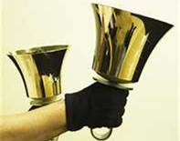
Polk Presbyterian Church
Calendar of Events
March 2021

Sunday School at 8:30am

Children Sunday School at 8:30am

Bible Study on Wednesdays at 6:30pm : at the church & via Zoom https://us04web.zoom.us/j/559705244 Meeting ID: 559 705 244 The passcode is 202020

Assisted hearing devices are now available. They are in the secretary's office on the file cabinet. Please mark your name on the box.

Donations to the building fund are welcome. Put the donation into an envelop marked Building Donation and drop into collection plate.

Home Communion: If you know anyone who would like to receive communion at home, please let Pastor Larry know who they are.

Lay Speakers: Looking for volunteers to speak at the beginning of the service in the same capacity as Jon Crum does now. If you would like to volunteer, please let Pastor Larry know.

Men's Association are welcoming projects for the elderly or persons who are unable to do projects like painting, lawn mowing, etc. Please let one of the men know if there is anyone in the community that needs this kind of help.

Food Drive: Please place food items in box in the vestibule hallway and it will be taken to the Salvation Army.

Mar 7 - Communion Sunday

Mar 11 at 6:30pm - Session Meeting

2021 A Year for Caring - Items will be taken to the Franklin Salvation Army. Please continue to bring items and place them in the blue bin in the vestibule.

Employment Opportunity: the local homeless shelter has 4 part-time positions available. Shifts available: 4pm to Midnite and Midnite to 7am, weekends. Pays $9.00 per hour. If interested, call 814/493-8791.



Polk Presbyterian Church

March 7, 2021
3rd Sunday in Lent

*The Introit Open My Eyes #119 Hymnal
Open my eyes, that I may see glimpses of truth Thou has for me;
Place in my hands the wonderful key that shall unclasp and set me free. Silently now I wait for Thee, Ready, my God, Thy will to see;
Open my eyes---illumine me, Spirit divine!

Time for meditation and reflection.

CALL TO WORSHIP Psalm 19:7-10
(L) The law of the Lord is perfect, reviving the soul; the decrees of the Lord are sure, making the wise simple;
(P) the precepts of the Lord are right, rejoicing the heart; the commandment of the Lord is clear, enlightening the eyes.
(L) More to be desired are commandments that gold, even much fine gold.
(P) sweeter also than honey and drippings of the honeycomb.

*Praise Hymn Only a Sinner 295 (vv 1, 2) Hymnal
Naught have I gotten but what I received,
Grace bestowed it since I have believed;
Boasting excluded, pride I abase---
I'm only a sinner saved by grace!
Only a sinner saved by grace! Only a sinner saved by grace! This is my story, to God be the glory---I'm only a sinner saved by graced!

Once I was foolish and sin ruled my heart,
Causing my footsteps from God to depart;
Jesus has found me, happy my case---
I now am a sinner saved by grace! Only a sinner saved by grace! Only a sinner saved by grace! This is my story, to God be the glory---I'm only a sinner saved by graced!

PRAYER OF CONFESSION
Merciful and Almighty God, how easily we are led astray from the path of righteousness. All too often we find ourselves deep in the muck and mire of sinfulness. Forgive us when we become like the money changers of old, worshipping our religious rituals instead of praising the God of salvation. Purge our hearts of all evil darkness, as our Lord purged the Temple of false idols. Create in us clean hearts that seek to follow the living and risen Christ, in whose name we humbly pray. Amen.

ASSURANCE OF PARDON 1 Peter 2:24-25
(L) Jesus Christ bore our sins in his body on the cross, so that, free from sin, we might live for righteousness; by his wounds we have been healed.
(P) We were going astray like sheep, but now we have returned to the shepherd and the guardian of our souls.
(A) This saying is sure and worthy of acceptance, that Christ Jesus came into the world to save sinners. Thanks be to God. Amen.

*Gloria Patri # 42

SPECIAL a guitar solo by Tate Daye Amazing Grace

CHILDREN'S CHAT

MOMENTS FOR MISSI0N

PRAYERS OF THE PEOPLE Joys and concerns:

Happy Birthday: Cindy Swendsen, Jackie Ghering, Ryan Sullivan, Eric Dilley

Presbytery Prayers: Tidioute and Irvine, Commissioned Pastor Dennis Ledebur; Rev. Seth Agidi, Moderator of General Assembly, Evangelical Presbyterian Church, Ghana

THE LORDS PRAYER
Our Father, who art in heaven, hallowed be Thy name, Thy kingdom come, Thy will be done, on earth as it is in heaven. Give us this day our daily bread; and forgive us our debts, as we forgive our debtors; and lead us not into temptation, but deliver us from evil. For Thine is the kingdom, and the power, and the glory, forever. Amen.

HYMN OF PREPARATION Be Thou My Vision # 339

RETURNING THANKS TO GOD
*THE DOXOLOGY # 39
*THE PRAYER OF DEDICATION

SCRIPTURE READING: Exodus 20:1-17
John 2:13-22
(P) Thanks be to God

SERMON "Spring Cleaning"

AFFIRMATION OF FAITH The Heidelberg Catechism 4.114, 4.115
Q. 114 But can those converted to God obey these (Ten) commandments perfectly?

A. No. In this life even the holiest have only a small beginning of this obedience. Nevertheless, with all seriousness of purpose, they do begin to live according to all, not only some, of God's commandments.

Q. 115 Since no one in this life can obey the Ten Commandments perfectly, why does God want them preached so pointedly?

A. First, so that the longer we live the more we may come to know our sinfulness and the more eagerly look to Christ for forgiveness of sins and righteousness. Second, so that, we may never stop striving, and never stop praying to God for the grace of the Holy Spirit, to be renewed more and more after God’s image, until after this life we reach our goal: perfection.

INVITATION TO THE LORD'S SUPPER
Let Us Break Bread Together # 162

*CLOSING HYMN Blest Be the Tie That Binds # 135

*THE BENEDICTION

*Our Response 'Tis So Sweet to Trust in Jesus 324 (chorus)
Jesus, Jesus, how I trust Him! How I've proven Him o'er and o'er! Jesus, Jesus, precious Jesus! O for grace to trust Him more!

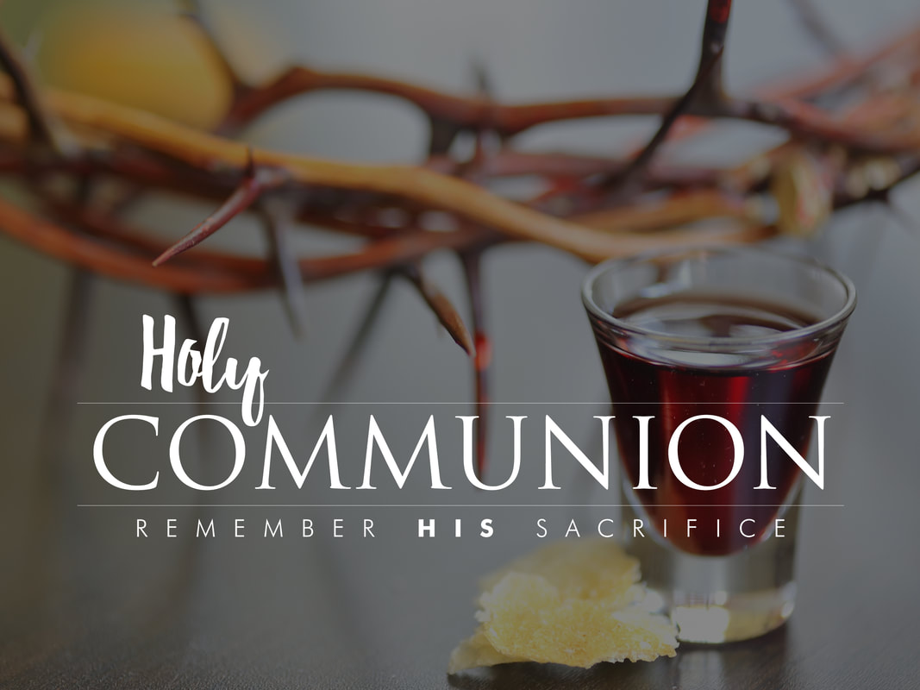

Pastor: Rev. Larry Myers
Elder on Call: Deb Crum
Music: Debbie Myers
Greeters: Ernie & Gail Banks

