NEWS OF INTEREST

Pennies From Heaven: the monies collected help send children to the camp of their choice (mostly Seneca Hills). Your donations are appreciated and well spent. Other charities are often contributed to as worthy causes from Pennies From Heaven also.

PRAISES AND PRAYER

Please pray for God’s guidance in the future of our church. Please pray for the peace of the world. Pray for the leaders of our country as they earnestly seek peaceful solutions to the problems and crises around the globe. Please pray for our military and police forces and their safety throughout each day. Pray for our public school system. Pray for the mental health of people everywhere. Pray for our mission to Ghana. Pray for all the Christian's who are being persecuted in the world.

Would you like to know what our church has been up to? On the bulletin board in the entryway are the minutes and financial ledgers for each month. Please feel free to copy them and if you have a question, ask any session member or the pastor. We think this is the best way to keep everyone informed.

REMEMBER TO PRAY
FOR OUR MEMBERS AND FRIENDS AT HOME or HOSPITALS

Jen & Marty Gilliland, Mieke Heffern, Susan Hammond, the unspoken request, Olivia Foster, Jan Sanners, Robin's mom Betty, Millie & Bill Nolan, Gregg Townsend, Dottie Dillin, Polk Center, Mark Knox, Sandy, Erma, Harry Daye, Dewayne Doutt,Virginia Heister, Bonnie, Vicki, Dick McNany, Teri and Gary Chisholm, Jewell, Emma, Megan, Rick Vaxily, Conrad Houk, Barb Reaker, Tim Vickers, Michelle Gregory, Dave Allman, William Reilly, Harper, Pam Bottomley, Chris Gannon, Shelly, Suzette Miller's father, Ed Krizon, Clay & Heather, Dan Perry, Wendy, John Karns, Richard, the Huff family, Adam Heeter, Shelly Bell, victims of the storms and all those affected by the Coronavirus, for first responders, hospital staff, the military staff, at-home children, elderly and at-risk persons, the overdose & suicide epidemic, natural disasters, our homeless brothers & sisters

Polk Presbyterian Church
P.O. Box 1027
Polk, PA 16342
polkpresbyterianchurch.com

CHURCH OFFICE: 814-437-3153

Pastor Larry Myers 412-417-5737
flyfisher@windstream.net

SESSION MEMBERS:

Conrad Houk 814-374-4143
Regina Allman 814-425-1850

Brian Heffern 814-671-2774

Jeff Karns 814-428-2754
Colleen Scurry 814-437-6069 or
814-208-3080
Deb Crum 724-679-9867

IF YOU ARE IN NEED OF ASSISTANCE
PLEASE CONTACT:

FINANCIAL SECRETARY:
Robin Russell 814-437-7038
rrussell@pa.rr.com

SECRETARY:

Anna Aumiller 814-437-3611
aaumiller@neo.rr.com

CLERK OF SESSION:
Wendy Bellin 814-673-9826

Millie & Bill Nolan Karns, Clayton M.
1380 School Rd 5350 Berger Street
Stoneboro, PA 16153 Stop #1360
Moody AFB, GA 31699

Tyler Wood Gracie Stryffeler
c/o Room 718 c/o Room 206
117 University Plaza 117 University Plaza
Youngstown, OH 44502-1208 Youngstown, OH 44502-1208

Dave Burgoyne Jenn & Marty Gilliland
c/o Amy Zemanski 238 W. Washington St.
200 McClelland Avenue Harrisville, PA 16038
Polk, PA 16342

Trevor Wood Zach Stryffeler
369 Sherman St. PO Box 213
Akron, OH 44311 3261 W. State Road
St. Bonaventure, NY 14778
Wendy Bellin
5272 Georgetown Rd
Franklin, PA 16323

Upcoming dates & activities:

May 2 - Communion Sunday

May 5 at 6pm - Mother's Day Banquet

May 6 - National Day of Prayer

May 13 at 6:30 - Session Meeting

May 23 at 11am - Pentecost Linger-longer Luncheon

May 31 - Memorial Day

June 10 at 6:30 - Session Meeting

June 16 at 6pm - Father's Day Banquet

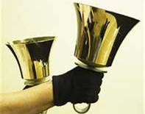
Polk Presbyterian Church
Calendar of Events
April 2021

Sunday School at 8:30am

Children Sunday School at 8:30am

Bible Study on Wednesdays at 6:30pm : at the church & via Zoom Psalms

https://us04web.zoom.us/j/559705244 Meeting ID: 559 705 244 The passcode is 202020

Assisted hearing devices are now available. They are in the secretary's office on the file cabinet. Please mark your name on the box.

Donations to the building fund are welcome. Put the donation into an envelop marked Building Donation and drop into collection plate.

Home Communion: If you know anyone who would like to receive communion at home, please let Pastor Larry know who they are.

Lay Speakers: Looking for volunteers to speak at the beginning of the service in the same capacity as Jon Crum does now. If you would like to volunteer, please let Pastor Larry know.

Men's Association are welcoming projects for the elderly or persons who are unable to do projects like painting, lawn mowing, etc. Please let one of the men know if there is anyone in the community that needs this kind of help.

Food Drive: Please place food items in box in the vestibule hallway and it will be taken to the Salvation Army.

Seneca Hills: If you know anyone that wants to go to the camps, please let an Elder know who it is so we can give them assistance.

May 1 7am - 4pm - the scheduled work day for Seneca Hills. More info to come.

Church Yard Sale: will be held in the church parking lot. Plan to donate 10% of your profit to the charity of your choice. Hot dogs and cookies will be available. More info to come.

2021 A Year for Caring - Items will be taken to the Franklin Salvation Army. Please continue to bring items and place them in the blue bin in the vestibule.

Employment Opportunity: the local homeless shelter has 4 part-time positions available. Shifts available: 4pm to Midnite and Midnite to 7am, weekends. Pays $9.00 per hour. If interested, call 814/493-8791.



Polk Presbyterian Church

April 18, 2021
3rd Sunday of Easter

*The Introit: “He Is Lord” # 234
He is Lord, He is Lord! He is risen from the dead and He is Lord! Every knee shall bow, every tongue confess that Jesus Christ is Lord.

Time for meditation and reflection.

CALL TO WORSHIP 2 Timothy 3:15-17
(L) From childhood you have known the sacred writings that are able to instruct you for salvation through faith in Christ Jesus.
(P) All scripture is inspired by God and is useful for teaching, for reproof, for correction, and for training in righteousness,
(L) So that everyone who belongs to God may be proficient, equipped for every good work.

*Praise Hymn Open My Eyes #119 Hymnal
Open my eyes, that I may see glimpses of truth Thou has for me;
Place in my hands the wonderful key
That shall unclasp and set me free.
Silently now I wait for Thee,
Ready, my God, Thy will to see;
Open my eyes---illumine me, Spirit divine!

PRAYER OF CONFESSION
Loving and Merciful God, forgive our lack of faith that allows the evil one to plant fear, doubt, and confusion in our minds and hearts. Through the gifts of grace, mercy, love, and faith, may we have the courage to embrace the resurrected Christ, believe the gospel messages, repent of our evil natures, and seek forgiveness of our sins. Allow the Word of God to transform our lives such that we are empowered to boldly proclaim repentance and forgiveness of sins to lost souls through Jesus the Christ, in whose name we humbly pray. Amen.

ASSURANCE OF PARDON Colossians 3:15-17
(L) And let the peace of Christ rule in your hearts, to which indeed you were called in the one body. And be thankful.
(P) Let the word of Christ dwell in you richly; teach and admonish one another in all wisdom; and with gratitude in your hearts sing psalms, hymns, and spiritual songs to God.
(L) And whatever you do, in word or deed, do everything in the name of the Lord Jesus, giving thanks to God the Father through him.

*Gloria Patri #42

SPECIAL a congregational hymn sing:
Leaning on the Everlasting Arms # 363
What a fellowship, what a joy divine,
Leaning on the everlasting arms;
What a blessedness, what a peace is mine,
Leaning on the everlasting arms.
Leaning, leaning, safe and secure from all alarms;
Leaning, leaning, leaning on the everlasting arms.

O how sweet to walk in this pilgrim way,
Leaning on the everlasting arms;
O how bright the path grows from day to day,
Leaning on the everlasting arms.
Leaning, leaning, safe and secure from all alarms;
Leaning, leaning, leaning on the everlasting arms.

What have I to dread, what have I to fear,
Leaning on the everlasting arms?
I have blessed peace with my Lord so near,
Leaning on the everlasting arms.
Leaning, leaning, safe and secure from all alarms;
Leaning, leaning, leaning on the everlasting arms.

CHILDREN'S CHAT

MOMENTS FOR MISSI0N

PRAYERS OF THE PEOPLE Joys and concerns:

Happy Birthday: John Vicker

Presbytery Prayers: Utica, Commissioned Pastor Tina Kaye; Rev. Susan Speakman, Moderator of the Coordinating Committee

THE LORDS PRAYER
Our Father, who art in heaven, hallowed be Thy name, Thy kingdom come, Thy will be done, on earth as it is in heaven. Give us this day our daily bread; and forgive us our debts, as we forgive our debtors; and lead us not into temptation, but deliver us from evil. For Thine is the kingdom, and the power, and the glory, forever. Amen.

HYMN OF PREPARATION The Day of Resurrection # 230

RETURNING THANKS TO GOD
*THE DOXOLOGY # 39
*THE PRAYER OF DEDICATION

SCRIPTURE READING: Psalm 4
Luke 24:36b-48
(P) Thanks be to God

SERMON "Guess Who Came to Dinner"

*Affirmation of Faith The Confession of 1967 9.21, 9.23
The reconciling work of Jesus was the supreme crisis in the life of mankind. His cross and resurrection become personal crisis and present hope for men when the gospel is proclaimed and believed. In this experience the Spirit brings God’s forgiveness to men, moves them to respond in faith, repentance, and obedience, and initiates the new life in Christ.
The new life does not release a human being from conflict with unbelief, pride, lust, and fear. They still have to struggle with disheartening difficulties and problems. Nevertheless, as they mature in love and faithfulness in their lives with Christ, they live in freedom and good cheer, bearing witness on good days and evil days, confident that the new life is pleasing to God and helpful to others.

*CLOSING HYMN He Lives # 550

*THE BENEDICTION

*Our Response Because He Lives # 238
Because He lives I can face tomorrow, because He lives all fear is gone; because I know He holds the future and life is worth the living – just because He lives.

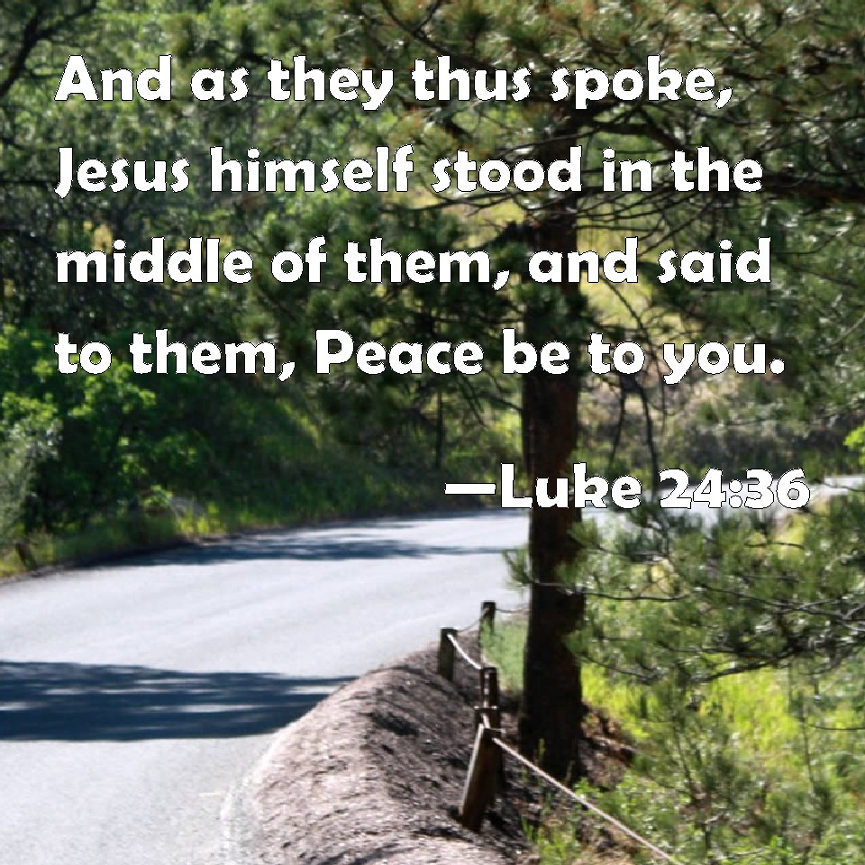

Pastor: Rev. Larry Myers
Elder on Call: Deb Crum
Music: Debbie Myers
Greeters: Colleen Scurry

