Good Friday Service
Polk Presbyterian Church
April 2, 2021

Gather in Silence

Lighting of Christ Candles

The Call to Worship: Philippians 2:8
(L) Blessed be the name of the Lord our God,
(P) Who redeems us from sin and death.
(L) For us and for salvation, Christ became obedient unto death, even death on a cross.
(P) Blessed be the name of the Lord.

Prayer of Meditation: Psalm 22:1-19
(L) My God, my God, why have you forsaken me? Why are you so far from helping me, from the words of my groaning?
(P) O my God, I cry by day, but you do not answer; and by night, but find no rest.
(L) Yet you are holy, enthroned on the praises of Israel.
(P) In you our ancestors trusted; they trusted, and you delivered them.
(L) To you they cried, and were saved; in you they trusted, and were not put to shame.
(P) But I am a worm, and not human; scorned by others and despised by the people.
(L) All who see me mock at me; they make mouths at me; they shake their heads;
(P) Commit your cause to the LORD; let him deliver---let him rescue the one in whom he delights!
(L) Yet it was you who took me from the womb; you kept me safe on my mother's breast.
(P) On you I was cast from my birth, and since my mother bore me you have been my God.
(L) Do not be far from me, for trouble is near and there is no one to help.
(P) Many bulls encircle me, strong bulls of Bashan surround me; they open wide their mouths at me, like a ravening and roaring lion.
(L) I am poured out like water, and all my bones are out of joint; my heart is like wax; it is melted within my breast; my mouth is dried up like a potsherd, and my tongue sticks to my jaws; you lay me in the dust of death.
(P) For dogs are all around me; a company of evildoers encircles me.
(L) My hands and feet have shriveled; I can count all my bones.
(P) They stare and gloat over me; they divide my clothes amoung themselves, and for my clothing they cast lots.
(A) But you, O LORD, do not be far away! O my help, come quickly to my aid!

*Hymn of Praise Beneath the Cross of Jesus 407

The Procession of Sorrow from The Cross by C.H. Spurgeon read by David Allman

Prayer of Illumination:

Old Testament: Isaiah 52:13--53:12

Homily

Time of Reflection

The Pastoral Prayer

The Lord's Prayer

*Closing Hymn Were You There # 228

The Light of Christ goes before us.

Depart in Silence

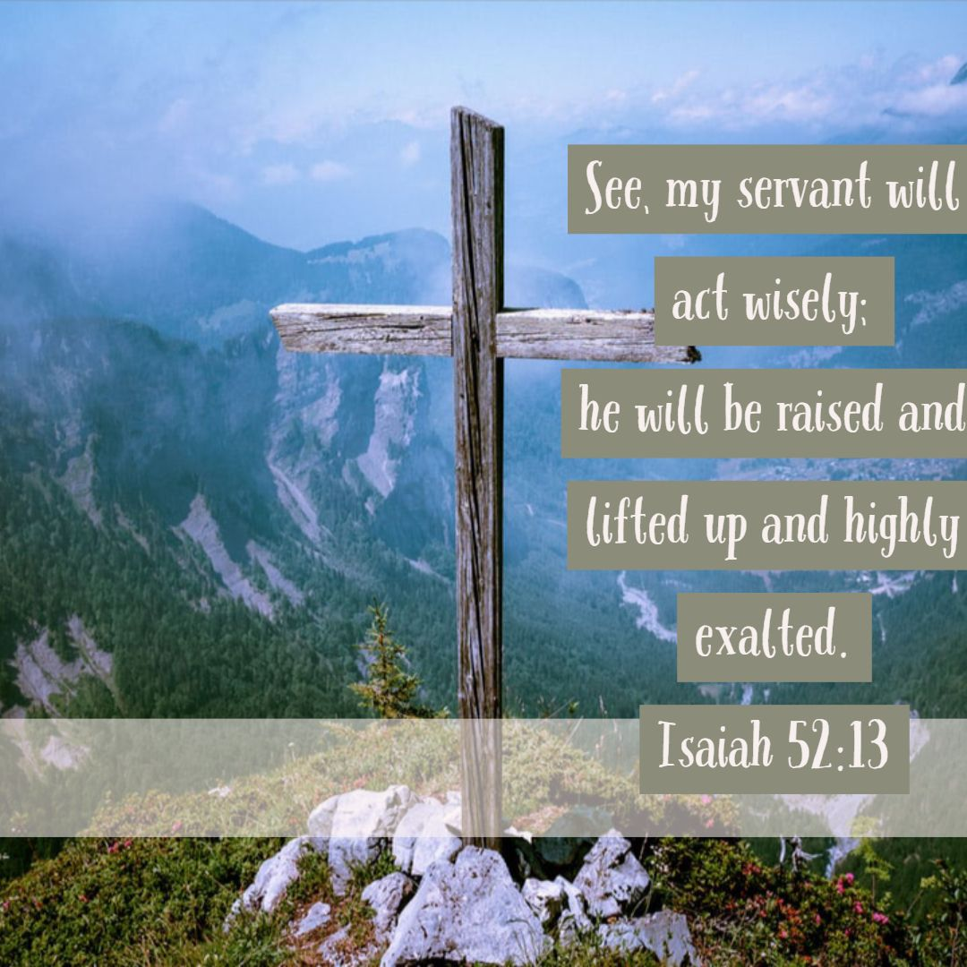

Pastor: Rev. Larry Myers
Minister of Music: Debbie Myers

