

Polk Presbyterian Church

April 4, 2021
Easter Sunrise Sunday

*The Introit: “He Is Lord” # 234
He is Lord, He is Lord! He is risen from the dead and He is Lord! Every knee shall bow, every tongue confess that Jesus Christ is Lord.

Time for meditation and reflection.

CALL TO WORSHIP Luke 24:34, Matt. 28:5-6
(L) Alleluia! Christ is risen!
(P) The Lords is risen indeed! Alleluia!
(L) "Do not be afraid; I know you are looking for Jesus who was crucified. He is not here, he has been raised, as he said."
(P) Alleluia! Christ is risen!
(L) Alleluia! Christ our Passover Lamb is sacrificed for us;
(P) Therefore, let us keep the feast. Alleluia!

*Praise Hymn Shine, Jesus, Shine #120 (Purple)
1. Lord, the light of Your love is shining, In the midst of the darkness shining; Jesus, Light of the world, shine upon us, Set us free by the truth You now bring us; Shine on me. Shine on me.

Chorus:
Shine, Jesus, shine, fill this land with the Father's glory; Blaze, Spirit, blaze, set our hearts on fire.
Flow, river, flow, flood the nations with grace and mercy; Send forth Your Word, Lord, and let there be light.

2. Lord, I come to Your awesome presence, From the shadows into Your radiance; By the blood I may enter Your brightness; Search me, try me, consume all my darkness; Shine on me. Shine on me.

3. As we gaze on Your kingly brightness, So our faces display Your likeness, Ever changing from glory to glory; Mirrored here, may our lives tell Your story; Shine on me. Shine on me.

PRAYER OF CONFESSION BCW
Almighty God, in raising Jesus from the grave, you shattered the power of sin and death. We confess that we remain captive to doubt and fear, bound by the ways that lead to death. We overlook the poor and the hungry and pass by those who mourn. We are deaf to the cries of the oppressed and indifferent to the calls for peace. We despise the weak and abuse the good earth you created. God of mercy, forgive us, help us to change our lives, and make us new creatures. Empower us to know the joy of abundant life given in Jesus the Christ, our risen Lord. Amen.

ASSURANCE OF PARDON Romans 8:34, 2 Cor. 5:17
(L) Hear the Good News! Who is in a position to condemn? Only Christ, and Christ died for us, Christ rose for us, Christ reigns in power for us, Christ prays for us.
(P) Anyone who is in Christ is a new creation. The old life has gone; a new life has begun. Fear not, know that we are forgiven and be at peace. Amen.

*Gloria Patri #42

CHILDREN'S CHAT

MOMENTS FOR MISSI0N

PRAYERS OF THE PEOPLE Joys and concerns:

Happy Birthday: Erma Martin, Ella McCall, Julie Motter

Presbytery Prayers: Linesville & Franklin, Rocky Grove, Rev. Rachel Johns, Temporary Supply Pastor; Rev. Emmanuel Amey, Stated Clerk, Evangeline Presbyterian Church, Ghana

THE LORDS PRAYER
Our Father, who art in heaven, hallowed be Thy name, Thy kingdom come, Thy will be done, on earth as it is in heaven. Give us this day our daily bread; and forgive us our debts, as we forgive our debtors; and lead us not into temptation, but deliver us from evil. For Thine is the kingdom, and the power, and the glory, forever. Amen.

HYMN OF PREPARATION The Day of Resurrection #230

RETURNING THANKS TO GOD
*THE DOXOLOGY # 39
*THE PRAYER OF DEDICATION

PRAYER OF ILLUMINATION
Merciful God as we come into this sanctuary on this special day, bind us into one body of faith in Jesus Christ. May the Holy Spirit enlighten each of with the true meaning of the empty tomb, the glorified and resurrected Christ, and how these mysteries transform our lives. Allow the Word of God that is read, preached, and written upon our hearts, to nurture us in the same manner as the spring rains water the earth. May we experience again on this Easter morning the living, risen, and glorified Christ, in whose name we pray. Amen.

SCRIPTURE READING: John 20:1-18
(P) Thanks be to God

SERMON "Easter Faith"

*Affirmation of Faith The Apostles’ Creed
I believe in God, the Father Almighty, maker of heaven and earth. And in Jesus Christ, His only begotten Son, our Lord. Who was conceived by the Holy Ghost, born of the Virgin Mary, suffered under Pontius Pilate, was crucified, dead and buried; he descended into hell. The third day, He rose again from the dead; He ascended into heaven, and sitteth at the right hand of God, the Father Almighty, from thence he will come again to judge the quick and the dead.
I believe in the Holy Ghost, the holy catholic church, the communion of saints, the forgiveness of sins, the resurrection of the body, and the life everlasting. Amen.

*CLOSING HYMN Christ Arose # 232

*THE BENEDICTION

*Our Response Because He Lives # 238
Because He lives I can face tomorrow, because He lives all fear is gone; because I know He holds the future and life is worth the living – just because He lives.

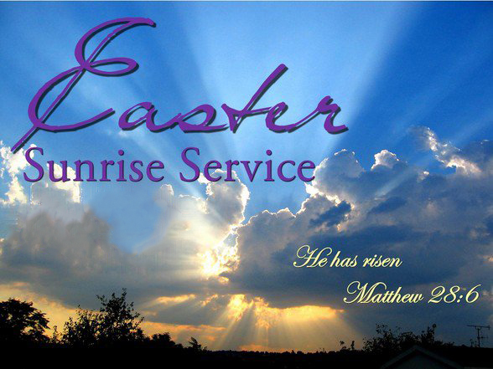

Pastor: Rev. Larry Myers
Elder on Call: Jeff Karns
Music: Debbie Myers

