NEWS OF INTEREST

Pennies From Heaven: the monies collected help send children to the camp of their choice (mostly Seneca Hills). Your donations are appreciated and well spent. Other charities are often contributed to as worthy causes from Pennies From Heaven also.

PRAISES AND PRAYER

Please pray for God’s guidance in the future of our church. Please pray for the peace of the world. Pray for the leaders of our country as they earnestly seek peaceful solutions to the problems and crises around the globe. Please pray for our military and police forces and their safety throughout each day. Pray for our public school system. Pray for the mental health of people everywhere. Pray for our mission to Ghana. Pray for all the Christian's who are being persecuted in the world.

Would you like to know what our church has been up to? On the bulletin board in the entryway are the minutes and financial ledgers for each month. Please feel free to copy them and if you have a question, ask any session member or the pastor. We think this is the best way to keep everyone informed.

REMEMBER TO PRAY
FOR OUR MEMBERS AND FRIENDS AT HOME or HOSPITALS

Jen & Marty Gilliland & stepdad John, Susan Hammond, the unspoken request, Olivia Foster, Jan Sanners, Robin's mom Betty, Millie & Bill Nolan, Gregg Townsend, Dottie Dillin, Polk Center, Mark Knox, Sandy, Erma, Harry Daye, Dewayne Doutt,Virginia Heister, Bonnie, Vicki, Dick McNany, Rick Vaxily, Conrad Houk, Barb Reaker, Tim Vickers, Michelle Gregory, Dave Allman, William Reilly, Harper, Pam Bottomley, Chris Gannon, Suzette Miller's father and mother, Ed Krizon, Zach, Clay & Heather, John Karns, Richard, the Huff family, Adam Heeter, Shelly Bell; Cathi, Dan, Huck, & Karen Miller; Caitlyn, Eddie, Mickey, Deb Watkins, Calgary church, victims of the storms and all those affected by the Coronavirus, for first responders, hospital staff, the military staff, at-home children, elderly and at-risk persons, the overdose & suicide epidemic, natural disasters, our homeless brothers & sisters, Israel, the Mieke Heffern family during this time of their loss

Polk Presbyterian Church
P.O. Box 1027
Polk, PA 16342
polkpresbyterianchurch.com

CHURCH OFFICE: 814-437-3153

Pastor Larry Myers 412-417-5737
flyfisher@windstream.net

SESSION MEMBERS:

Conrad Houk 814-374-4143
Regina Allman 814-425-1850

Brian Heffern 814-671-2774

Jeff Karns 814-428-2754
Colleen Scurry 814-437-6069 or
814-208-3080
Deb Crum 724-679-9867

IF YOU ARE IN NEED OF ASSISTANCE
PLEASE CONTACT:

FINANCIAL SECRETARY:
Robin Russell 814-437-7038
rrussell@pa.rr.com

SECRETARY:

Anna Aumiller 814-437-3611
aaumiller@neo.rr.com

CLERK OF SESSION:
Wendy Bellin 814-673-9826

Millie & Bill Nolan Karns, Clayton M.
1380 School Street 5350 Berger Street
Stoneboro, PA 16153 Stop #1360
Moody AFB, GA 31699

Tyler Wood Gracie Stryffeler
c/o Room 718 c/o Room 206
117 University Plaza 117 University Plaza
Youngstown, OH 44502-1208 Youngstown, OH 44502-1208

Dave Burgoyne Jenn & Marty Gilliland
5928 Bluewater Line 238 W. Washington St.
Lot #19 Harrisville, PA 16038
Wallaceburg, Ontario, Canada N8A4K9

Trevor Wood Zach Stryffeler
369 Sherman St. PO Box 213
Akron, OH 44311 3261 W. State Road
St. Bonaventure, NY 14778

Wendy Bellin Erma Martin
5272 Georgetown Rd c/o Denise Ezell
Franklin, PA 16323 189 Fowler Street
Lynchburg, VA 24502
(814) 673-5951

Upcoming dates & activities:

June 12 - 8am-3pm Mission Madness Parking Lot Sale

June 16 at 6pm - Father's Day Banquet (sign up in vestibule)

July 10 at 3pm - Celebration of Life for Jan Heffern

July 17 - 23 VBS from 6-8pm. Volunteers needed.


Polk Presbyterian Church
Calendar of Events
June 2021

Sunday School at 8:30am

Children Sunday School at 8:30am

Bible Study on Wednesdays at 6:30pm : at the church & via Zoom

https://us04web.zoom.us/j/559705244 Meeting ID: 559 705 244 The passcode is 202020

Assisted hearing devices are now available. They are in the secretary's office on the file cabinet. Please mark your name on the box.

Home Communion: If you know anyone who would like to receive communion at home, please let Pastor Larry know who they are.

Lay Speakers: Looking for volunteers to speak at the beginning of the service in the same capacity as Jon Crum does now. If you would like to volunteer, please let Pastor Larry know.

Food Drive: Please place food items in box in the vestibule hallway and it will be taken to the Salvation Army.

Seneca Hills: If you know anyone that wants to go to the camps, please let an Elder know who it is so we can give them assistance.

Kairos - Goodwill baskets are being made. It will take $8500 to supply the items to be placed in the baskets for ~$4.50/resident. As the prison will only allow their suppliers to be used, money is the only gift we can make. Please mark your donation for "Kairos" when placed in the collection.

June 12: Mission Madness Community Yard Sale: will be held in the church parking lot. Plan to donate 10% of your profit to the charity of your choice. Hot dogs and cookies will be available. There is a sign-up sheet in the vestibule: how many tables will you need? Also there is a volunteer sheet for helping set up the tables, cooks, cookies, etc.

2021 A Year for Caring - Items will be taken to the Franklin Salvation Army. Please continue to bring items and place them in the blue bin in the vestibule. So far: 1275 items have been collected.

There is a bible reading aide in the back left corner of our Library and is available to help if you want to study the bible at home.

ABC Baby Bottle Boomerang: Donations may be put in the big baby bottle in the vestibule. Deadline is Aug 3, 2021.



Polk Presbyterian Church

June 6, 2021
2nd Sunday after Pentecost

*The Introit: Awesome God # 15
Our God is an awesome God, He reigns from heaven above with wisdom, pow’r and love, our God is an awesome God.

Time for meditation and reflection.

CALL TO WORSHIP Psalm 138:1-3, 8
(L) I give you thanks, O Lord, with my whole heart; before the gods I sing your praise.
(P) I bow down toward your holy temple and give thanks to your name for your steadfast love and your faithfulness; for you have exalted your name and your word above everything.
(L) On the day I called, you answered me, you increased my strength of soul.
(P) The LORD will fulfill his purpose for me; your steadfast love, O LORD, endures forever.
Purple Booklet
*Praise Hymn All Hail King Jesus # 99
All hail King Jesus. All hail Emmanuel,
King of Kings, Lord of Lords, bright Morning Star.
And throughtout eternity, I'll sing His praises,
And I'll reign with Him throughout eternity.

PRAYER OF CONFESSION
Almighty God, we humbly stand before the throne of grace recognizing our own sin, our sinful natures, and our rebellion against your authority. We confess our foolish vanity, our selfish desires, and thoughtless actions. We have fallen short in our callings, feared to go where we are sent, and missed opportunities to share the gospel message. But you are a loving, compassionate heavenly Father who gives second chances. Enable us to recognize the Holy Spirit’s conviction, direction, and guidance. Empower us to become faithful disciples of Jesus Christ, in whose name we humbly pray. Amen.

ASSURANCE OF PARDON Romans 8:9-13
(L) But you are not in the flesh; you are in the Spirit, since the Spirit of God dwells in you. Anyone who does not have the Spirit of Christ does not belong to him.
(P) But if Christ is in you, though the body is dead because of sin, the Spirit is life because of righteousness.
(L) If the Spirit of him who raised Jesus from the dead dwells in you, he who raised Christ from the dead will give life to your mortal bodies also through his Spirit that dwells in you.
(P) For if you live according to the flesh, you will die; but if by the Spirit you put to death the deeds of the body, you will live. Amen.

*Gloria Patri #42

SPECIAL by Jon and Deb - Crown Him with Many Crowns

CHILDREN'S CHAT

MOMENTS FOR MISSI0N

PRAYERS OF THE PEOPLE Joys and concerns:

Happy Birthday: Teri Chisholm, Gracie Stryffeler

Happy Anniversary: John & Pam Vickers, Marty & Jen Gilliland

Presbytery Prayers: Watson Run and North Shenango, Greg VanderVeen, preaching; Bimbilla District, Upper Northern Presbyter, 27 Congregations

THE LORDS PRAYER
Our Father, who art in heaven, hallowed be Thy name, Thy kingdom come, Thy will be done, on earth as it is in heaven. Give us this day our daily bread; and forgive us our debts, as we forgive our debtors; and lead us not into temptation, but deliver us from evil. For Thine is the kingdom, and the power, and the glory, forever. Amen.

HYMN OF PREPARATION He's Everything to Me #549

RETURNING THANKS TO GOD
*THE DOXOLOGY # 39
*THE PRAYER OF DEDICATION

SCRIPTURE READING: 1 Samuel 8:4-20
Mark 3:19b-35
(P) Thanks be to God

SERMON "Give Us a King!"

*Affirmation of Faith Confession of 1967 9.53
God's redeeming work in Jesus Christ embraces the whole of man's life: social and cultural, economic and political, scientific and technological, individual and corporate. It includes man's natural environment as exploited and despoiled by sin. It is the will of God that his purpose for human life shall be fulfilled under the rule of Christ and all evil be banished from His creation.

INVITATION TO THE LORD'S SUPPER
Let Us Break Bread Together # 162

*CLOSING HYMN The Family of God #138

*THE BENEDICTION

*Our Response Yes, Lord, Yes # 103
Yes, Lord, yes! to Your will and to Your way.
Yes, Lord, yes! I will trust You and obey.
When Your Spirit speaks to me,
With my whole heart I'll agree
And my answer will be yes. Lord, yes!

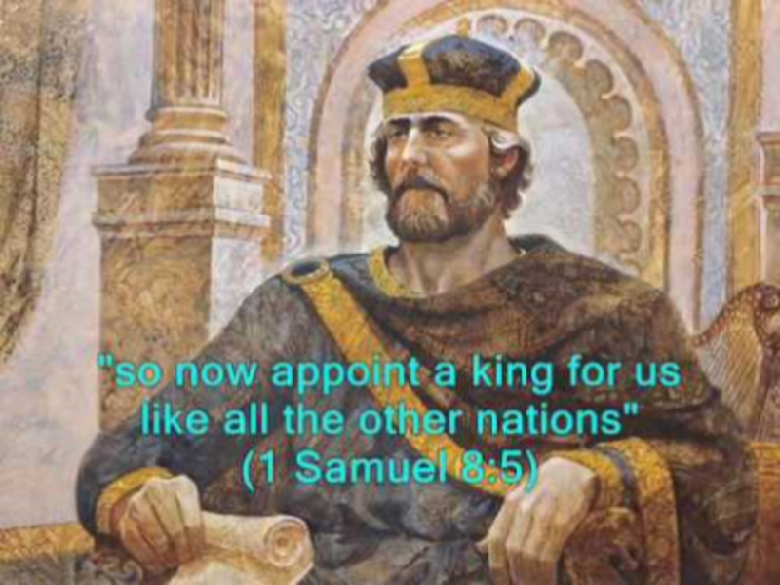

Pastor: Rev. Larry Myers
Elder on Call: Conrad Houk
Music: Debbie Myers
Greeters: John & Anna Aumiller

