**NEWS OF INTEREST**

**Pennies From Heaven:** the monies collected help send children to the camp of their choice (mostly Seneca Hills). Your donations are appreciated and well spent. Other charities are often contributed to as worthy causes from Pennies From Heaven also.

**PRAISES AND PRAYER**

*Please pray for God’s guidance in the future of our church. Please pray for the peace of the world. Pray for the leaders of our country as they earnestly seek peaceful solutions to the problems and crises around the globe. Please pray for our military and police forces and their safety throughout each day. Pray for our public school system. Pray for the mental health of people everywhere. Pray for our mission to Ghana. Pray for all the Christian's who are being persecuted in the world.*

Would you like to know what our church has been up to? On the bulletin board in the entryway are the minutes and financial ledgers for each month. Please feel free to copy them and if you have a question, ask any session member or the pastor. We think this is the best way to keep everyone informed.

**REMEMBER TO PRAY**

**FOR OUR MEMBERS AND FRIENDS AT HOME or HOSPITALS**

Jen & Marty Gilliland, Dottie Dillin, Bonnie, Nancy Davison,

Lisa’s cousin Bonnie, Rudy Liebmann, Mary Vickers,

David Shearer, Alberta Swendson, Pat Karns, Joe Karns,

Lisa & Scott Heffern, Kathleen Raecke, Brian Hudson

Joanie Bottomley, Teri Chisholm, Mike Peterson family,

John & Pam Vickers

**Polk Presbyterian Church**

**P.O. Box 1027**

**Polk, PA 16342**

**polkpresbyterianchurch**.**com**

**CHURCH OFFICE: 814-437-3153**

**Pastor Larry Myers 412-417-5737**

**flyfisher@windstream.net**

**SESSION MEMBERS:**

**Gary Chisholm 724-376-3731**

**Scott Heffern 814-673-8667**

**Pam Bottomley 814-671-4998**

**Judy Krizon 814-432-4189**

**Alan Wood 814-671-0873**

**John Vickers 814-227-8562**

**IF YOU ARE IN NEED OF ASSISTANCE**

**PLEASE CONTACT:**

**FINANCIAL SECRETARY:**

**Scott Heffern 814-673-8667**

**scottheffern@yahoo.com**

**SECRETARY:**

**Pam Bottomley 814-671-4998**

**psbtweety@yahoo.com**

**CLERK OF SESSION**:

**Cindy Swendsen 814-671-6100**

**swendsen1@verizon.net**

**Rudy Liebmann**

**Clarion Nursing & Rehab**

**999 Heidrick St.**

**Clarion, PA 16214**

**Upcoming dates & activities:**

**3/5     Kids Club Program at PUMC (3-5:00 pm**

**Every Wednesday afternoon thru April 9th)**

**3/7      World Day of Prayer**

**3/9      Daylight Savings Time begins**

**3/12 Genesis Bible Study 6:30 pm**

**3/13 Prayer Blankets 9 am**

**3/13 Session Meeting 6:30 pm ?**

**3/17     St. Patrick’s Day**

**3/19 Genesis Bible Study 6:30 pm**

**3/22 Craft Day 10 am Sign up in the Narthex**

**3/23 VARHA Potato Bar Fund Raiser 10:45 am**

**3/26 Genesis Bible Study 6:30 pm**



**Polk Presbyterian Church**

**Calendar of Events**

**March 2025**

**Sunday School** **at 8:30am**

**Children Sunday School at 8:30am**

**Bible Study on Wednesdays at 6:30pm at the church & via Zoom**

<https://us04web.zoom.us/j/559705244> **Meeting ID 559 705 244**

**The passcode is 202020**

**Prayer Blankets will be done on the 2nd Thursday of the month at 9:00 am**

**Per Capita for 2025: $35**

**March Mission: VARHA Riding Stable**

**Kid’s Club: March 5th thru April 9th – Polk United Methodist Church (on Wednesday’s) 3 pm – 5 pm.**

**Lynn Harriger from Nazarene church in Franklin is collecting grocery bags to make Mercy Mats. Amy Zemanski will see that Lynn gets any donations.**

**Save your Poptabs for a hospital in Pittsburgh. There is a container in the Narthex.**

**Lay Reader: We are in search of another Lay Reader. We would like to have 3 in the rotation. If you are interested, please contact Pastor Myers.**



### **Polk Presbyterian Church,**

### **March 5, 2025**

**Ash Wednesday**

### **Enter Silently and Reverently**

### **Lighting of Candles**

### 

**CALL TO WORSHIP:         Joel 2:12-17**

**L:**“Repent and return to God,” says the prophet.

**P: We know the confession and repentance will be our focus.**

**L:**“God is gracious and merciful,” says the prophet.

**P: As our faults come home to us, we need God’s mercy.**

**L:**“God is slow to anger, and abounding in steadfast love,” says the prophet.

**P: We come as a faithful people before you, O God.  We are ready for the Lenten time of reflection.**

**Invocation**

**Scripture**

**Joel 2:1-2,12-17**

**Matthew 6:1-6,16-21**

**Homily**

**Invitation to the Observance of the Lenten Discipline**

**Psalm 51      (Read Responsively)**

**L:**Have mercy on me, O God, according to your steadfast love; according to your abundant mercy blot out my transgressions.

**P: Wash me thoroughly from my iniquity, and cleanse me from my sin.**

**L:**For I know my transgressions, and my sin is ever before me.

**P: Against you, you alone, have I sinned, and done what is evil in your sight, so that you are justified in your sentence and blameless when you pass judgment.**

**L:**Indeed, I was born guilty, a sinner when my mother conceived me.

**P: You desire truth in the inward being;﻿ therefore, teach me wisdom in my secret heart.**

**L:**Purge me with hyssop, and I shall be clean; wash me, and I shall be whiter than snow.

**P: Let me hear joy and gladness; let the bones that you have crushed rejoice.**

**L:**Hide your face from my sins, and blot out all my iniquities.

**P: Create in me a clean heart, O God, and put a new and right﻿﻿ spirit within me.**

**L:** Do not cast me away from your presence, and do not take your holy spirit from me.

**P: Restore to me the joy of your salvation, and sustain in me a willing﻿ spirit.**

**PRAYER OF CONFESSION   BCW**

**Gracious God, our sins are too heavy to carry, too real to hide, and too deep to undo.  Forgive what our lips tremble to name, what our hearts can no longer bear, and what has become for us a consuming fire of judgment.  Set us free from a past that we cannot change.  Open to us a future in which we can be changed.  Grant us grace to grow more and more into the likeness and image of our Lord and Savior Jesus the Christ, in whose name we humbly pray.  Amen.**

**Assurance of Pardon**

**Imposition of Ashes         (Read Responsively)**

**L:** Accomplish in us, O God, the work of your salvation,

**P: That we may show forth your glory in the world.**

**L:** By the cross and passion of our Savior,

**P: Bring us with all your saints to the joy of Christ’s resurrection.**

**Thanksgiving Over the Ashes**

**Imposition of Ashes**

**“Remember that you are dust, and to dust you shall return”       Gen. 3:19**

**Individual Spiritual Offerings**

**Prayer of Dedication**

**Commissioning and Benediction**

**Exit Silently and Reverently**

**Light goes out before us**

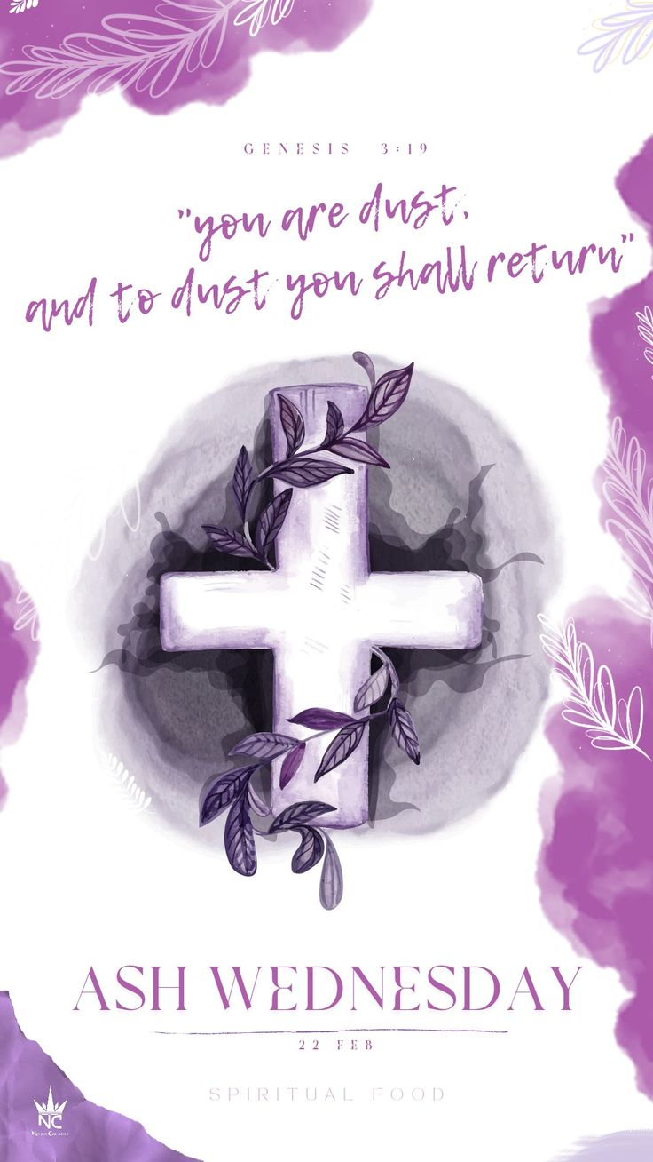

Pastor: Larry Myers