Polk Presbyterian Church

July 5, 2020

5th Suday after Pentecost



*The Introit “Majesty” Purple Booklet 8
So exalt, lift up on high the name of Jesus. Magnify, come glorify Christ Jesus, the King. Majesty, worship His majesty--Jesus who died, now glorified, King of all kings.

Time for meditation and reflection.

CALL TO WORSHIP Psalm 145:8-9, 13-14
(L) The LORD is gracious and merciful, slow to anger and abounding in steadfast love.
(P) The LORD is good to all, and his compassion is over all that he has made.
(L) The LORD is faithful in all his words, and gracious in all his deeds.
(P) The LORD upholds all who are falling, and raises up all who are bowed down.

*Praise Hymn Come, Now Is the Time to Worship 117
Come, now is the time to worship. Come, now is the time to give your heart. Come, just as you are to worship. Come, just as you are before your God. Come.

One day, every tongue will confess You are God. One day, every knee will bow. Still, the greatest treasure remains for those who gladly choose you now.

Come, now is the time to worship. Come, now is the time to give your heart. Come, just as you are to worship. Come, just as you are before your God. Come.

PRAYER OF CONFESSION
Immanuel, “God with Us”, have mercy upon your wayward children who fail to keep your commandments. Forgive us when we allow sin to enslave us during times we are engaged in the spiritual battle of good and evil, which rages inside our hearts. Help us to embrace our Lord’s yoke of grace that permits us to enter the very presence of God. Grant us the gifts of grace, mercy, love, and faith that enable us to embrace Christian unity, forgiveness, and peace in Christ Jesus, our Lord. Amen.

ASSURANCE OF PARDON Romans 7:21-8:2
(L) So I find it to be a law that when I want to do what is good, evil lies close at hand.
(P) For I delight in the law of God in my inmost self, but I see in my members another law at war with the law of my mind, making me captive to the law of sin that dwells in my members.
(L) Wretched man that I am! Who will rescue me from this body of death?
(P) There is therefore now no condemnation for those who are in Christ Jesus.
(A) For the law of the Spirit of life in Christ Jesus has set you free from the law of sin and of death. Praise the Lord!

*Gloria Patri # 42

SPECIAL by Tate Daye on the keyboard

CHILDREN'S CHAT

MOMENTS FOR MISSI0N

PRAYERS OF THE PEOPLE Joys and concerns:

Happy Birthday: Janet Heister, Alisha Eakin

Presbytery Prayers: Girard, Rev. Nicola Vitiello, Pastor; Katiejeli District Upper Northern Presbytery, 9 Congregations

THE LORDS PRAYER
Our Father, who art in heaven, hallowed be Thy name, Thy kingdom come, Thy will be done, on earth as it is in heaven. Give us this day our daily bread; and forgive us our debts, as we forgive our debtors; and lead us not into temptation, but deliver us from evil. For Thine is the kingdom, and the power, and the glory, forever. Amen.

*HYMN OF PREPARATION Reach Out to Jesus #427
Is your burden heavy as you bear it all alone? Does the road you travel harbor danger yet unknown? Are you growing weary in the struggle of it all? Jesus will help you when on His name you call. He is always there hearing every prayer, faithful and true, walking by our side---in His love we hide all the day through; when you get discouraged just remember what to do---reach out to Jesus, He's reaching out to you.

Is the life you're living filled with sorrow and despair? Does the future press you with its worry and its care? Are you tired and friendless, have you almost lost your way? Jesus will help you---just come to Him today. He is always there hearing every prayer, faithful and true, walking by our side---in His love we hide all the day through; when you get discouraged just remember what to do---reach out to Jesus, He's reaching out to you.

RETURNING THANKS TO GOD
*THE DOXOLOGY # 39
*THE PRAYER OF DEDICATION

SCRIPTURE READING: Matthew 11:25-30
^{﻿﻿25﻿} At that time Jesus said, “I thank you, Father, Lord of heaven and earth, because you have hidden these things from the wise and the intelligent and have revealed them to infants; ^{﻿26﻿} yes, Father, for such was your gracious will. ^{﻿27﻿} All things have been handed over to me by my Father; and no one knows the Son except the Father, and no one knows the Father except the Son and anyone to whom the Son chooses to reveal him.
^{﻿28﻿} “Come to me, all you that are weary and are carrying heavy burdens, and I will give you rest. ^{﻿29﻿} Take my yoke upon you, and learn from me; for I am gentle and humble in heart, and you will find rest for your souls. ^{﻿30﻿} For my yoke is easy, and my burden is light.”

(P) Thanks be to God

SERMON "Come, Take, Learn"

*Affirmation of Faith The Confession of 1967 9.08
In Jesus of Nazareth true humanity was realized once for all. Jesus, a Palestinian Jew, lived among his own people and shared their needs, temptations, joys, and sorrows. He expressed the love of God in word and deed and became a brother to all kinds of sinful men. But his complete obedience led him into conflict with his people. His life and teaching judged their goodness, religious aspirations, and national hopes. Many rejected him and demanded his death. In giving himself freely for them he took upon himself the judgment under which all men stand convicted. God raised him from the dead, vindicating him as Messiah and Lord. The victim of sin became victor, and won the victory over sin and death for all men. Amen.

INVITATION TO THE LORD'S SUPPER
Let Us Break Bread Together # 162

Let us break bread together on our knees, let us break bread together on our knees, when I fall on my knees, with my face to the rising sun, O Lord, have mercy on me.

Let us drink the cup together on our knees, let us drink the cup together on our knees, when I fall on my knees, with my face to the rising sun, O Lord, have mercy on me.

Let us praise God together on our knees, let us praise God together on our knees, when I fall on my knees, with my face to the rising sun, O Lord, have mercy on me.

*CLOSING HYMN Precious Lord, Take My Hand #374
Precious Lord, take my hand, lead me on, help me stand---I am tired, I am weak, I am worn; thru the storm, thru the night, lead me on to the light---take my hand, precious Lord, lead me home.

When my way grows drear, precious Lord, linger near---when my life is almost gone; hear my cry, hear my call, hold my hand lest I fall---take my hand, precious Lord, lead me home.

*THE BENEDICTION

*Our Response We Will Glorify #67
We will glorify the King of Kings; we will glorify the Lamb. We will glorify the Lord of Lords, who is the great I AM.

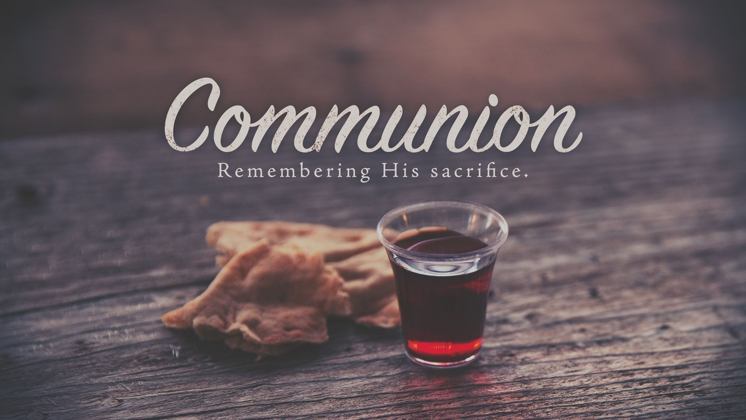

Pastor: Rev. Larry Myers
Elder on Call: Conrad Houk
Music: Deb Myers
Greeters: Janet Heister

Polk Presbyterian Church
P.O. Box 1027
Polk, PA 16342

CHURCH OFFICE: 814-437-3153

Pastor Larry Myers 412-417-5737
flyfisher@windstream.net

SESSION MEMBERS:

Conrad Houk 814-374-4143
Cindy Swendsen 814-374-4041

Brian Heffern 814-671-2774

Dave Perry 770-687-9202
Colleen Scurry 814-437-6069
Deb Crum 724-679-9867

IF YOU ARE IN NEED OF ASSISTANCE
PLEASE CONTACT:

FINANCIAL SECRETARY:
Robin Russell 814-437-7038
rrussell@pa.rr.com

SECRETARY:

Anna Aumiller 814-437-3611
aaumiller@neo.rr.com

CLERK OF SESSION:
Wendy Bellin 814-673-9826


Polk Presbyterian Church
Calendar of Events
July 2020

Sunday School at 8:30am

Children Sunday School at 8:30am

Bible Study on Wednesdays at 6:30pm : at the church & via Zoom https://us04web.zoom.us/j/559705244 Meeting ID: 559 705 244

Assisted hearing devices are now available. They are in the secretary's office on the file cabinet. Please mark your name on the box.

July 5 at 11:15am - Polk United Methodist Church is celebrating the 4th of July on the Village Green. All are invited, but there will be no communion and no food due to Covid-19. Bring a lawn chair.

July 9 at 6:30pm - Session Meeting

July 12th - Trevor Wood is preaching during worship

July 12th - Open Graduation Party for Tate Daye at his home from 4 to 7 pm. Invitation is in the vestibule.

July 19th - Hot dog picnic follow worship here at the church. Meat and beverage will be provided. Please bring a covered dish to share.

July 26th - Distribution of scholarships during worship service.

August 16th - Blessing of backpacks.

Donations to the building fund are welcome. Put the donation into an envelop marked Building Donation and drop into collection plate.

Tithing and other monies to the church, can be sent to Robin Russell at 727 Main St, Polk, PA 16342.

Home Communion: If you know anyone who would like to receive communion at home, please let Pastor Larry know who they are.

Lay Speakers: Looking for volunteers to speak at the beginning of the service in the same capacity as Jon Crum does now. If you would like to volunteer, please let Pastor Larry know.

Men's Association are welcoming projects for the elderly or persons who are unable to do projects like painting, lawn mowing, etc. Please let one of the men know if there is anyone in the community that needs this kind of help.

Food Drive: Please place food items in box in the vestibule hallway and it will be taken to the Salvation Army.

Millie & Bill Nolan Karns, Clayton M.
1380 School Rd USAF
Stoneboro, PA 16153 230 Chevalier Avenue
Pensacola, FL 32508

Trevor Wood Zack Stryffeler
The University of Akron St Bonaventure University
Honors Complex 656 3261 West State Road
PO Box 1350 PO Box 213
Akron, OH 44309 St Bonaventure, NY 14778

Dave Burgoyne Jenn & Marty Gilliland
c/o Amy Zemanski 238 W. Washington St.
200 McClelland Avenue Harrisville, PA 16038
Polk, PA 16342

NEWS OF INTEREST

Pennies From Heaven: the monies collected help send children to the camp of their choice (mostly Seneca Hills). Your donations are appreciated and well spent. Other charities are often contributed to as worthy causes from Pennies From Heaven also.

PRAISES AND PRAYER

Please pray for God’s guidance in the future of our church. Please pray for the peace of the world. Pray for the leaders of our country as they earnestly seek peaceful solutions to the problems and crises around the globe. Please pray for our military and police forces and their safety throughout each day. Pray for our public school system. Pray for the mental health of people everywhere. Pray for our mission to Ghana. Pray for all the Christian's who are being persecuted in the world.

Would you like to know what our church has been up to? On the bulletin board in the entryway are the minutes and financial ledgers for each month. Please feel free to copy them and if you have a question, ask any session member or the pastor. We think this is the best way to keep everyone informed.

REMEMBER TO PRAY
FOR OUR MEMBERS AND FRIENDS AT HOME or HOSPITALS

Jenn & Marty Gilliland, Mieke Heffern, Susan Hammond, the unspoken request, Skip and Nancy Davison, Ken Timblin, Judy Krizon, Olivia Foster, Jan Sanners, Robin's mom Betty, Millie & Bill Nolan, Gregg Townsend, Dottie Dillin, Polk Center, Mark Knox, Sandy, Junior & Bonnie, Vicki, Deb Snyder, Rick Doutt, Jim Hesson, Dick McNany, Dave Perry, Keith Reynolds, Teri and Gary Chisholm, Floyd Russell, Jewell, Ginny, Meryl, John and Chuck Karns, Chance, Aubrielle & family, Nicky, Hudson, Darius, Katlin, June, Carey, Anna, Emma, Megan, Cheryl Adams, Dewayne Doutt, Rick Vaxily, Barb & Bryan Chisholm, Valerie, Neil Buckley, victims of the storms and all those affected by the Coronavirus, for first responders, hospital staff, the military staff, at-home children, elderly and at-risk persons.

