Dave Burgoyne Jenn & Marty Gilliland
c/o Amy Zemanski 238 W. Washington St.
200 McClelland Avenue Harrisville, PA 16038
Polk, PA 16342

NEWS OF INTEREST

Pennies From Heaven: the monies collected help send children to the camp of their choice (mostly Seneca Hills). Your donations are appreciated and well spent. Other charities are often contributed to as worthy causes from Pennies From Heaven also.

PRAISES AND PRAYER

Please pray for God’s guidance in the future of our church. Please pray for the peace of the world. Pray for the leaders of our country as they earnestly seek peaceful solutions to the problems and crises around the globe. Please pray for our military and police forces and their safety throughout each day. Pray for our public school system. Pray for the mental health of people everywhere. Pray for our mission to Ghana. Pray for all the Christian's who are being persecuted in the world.

Would you like to know what our church has been up to? On the bulletin board in the entryway are the minutes and financial ledgers for each month. Please feel free to copy them and if you have a question, ask any session member or the pastor. We think this is the best way to keep everyone informed.

REMEMBER TO PRAY
FOR OUR MEMBERS AND FRIENDS AT HOME or HOSPITALS

Jenn & Marty Gilliland, Mieke Heffern, Susan Hammond, the unspoken request, Skip and Nancy Davison, Ken Timblin, Judy Krizon, Olivia Foster, Jan Sanners, Robin's mom Betty, Millie & Bill Nolan, Gregg Townsend, Dottie Dillin, Polk Center, Mark Knox, Sandy, Junior & Bonnie, Vicki, Deb Snyder, Rick Doutt, Jim Hesson, Dick McNany, Dave Perry, Keith Reynolds, Teri and Gary Chisholm, Jewell, Ginny, Meryl, John and Chuck Karns, Chance, Aubrielle & family, Nicky, June, Cheryl Adams, Dewayne Doutt, Rick Vaxily, Barb & Bryan Chisholm, Neil Buckley, victims of the storms and all those affected by the Coronavirus, for first responders, hospital staff, the military staff, at-home children, elderly and at-risk persons.

Polk Presbyterian Church
P.O. Box 1027
Polk, PA 16342
polkpresbyterianchurch.com

CHURCH OFFICE: 814-437-3153

Pastor Larry Myers 412-417-5737
flyfisher@windstream.net

SESSION MEMBERS:

Conrad Houk 814-374-4143
Cindy Swendsen 814-374-4041

Brian Heffern 814-671-2774

Dave Perry 770-687-9202
Colleen Scurry 814-437-6069
Deb Crum 724-679-9867

IF YOU ARE IN NEED OF ASSISTANCE
PLEASE CONTACT:

FINANCIAL SECRETARY:
Robin Russell 814-437-7038
rrussell@pa.rr.com

SECRETARY:

Anna Aumiller 814-437-3611
aaumiller@neo.rr.com

CLERK OF SESSION:
Wendy Bellin 814-673-9826


Polk Presbyterian Church
Calendar of Events
August 2020

Sunday School at 8:30am

Children Sunday School at 8:30am

Bible Study on Wednesdays at 6:30pm : at the church & via Zoom https://us04web.zoom.us/j/559705244 Meeting ID: 559 705 244

Assisted hearing devices are now available. They are in the secretary's office on the file cabinet. Please mark your name on the box.

August 20th at 6:30 - Session Meeting

August 16th - Blessing of backpacks.

Donations to the building fund are welcome. Put the donation into an envelop marked Building Donation and drop into collection plate.

Home Communion: If you know anyone who would like to receive communion at home, please let Pastor Larry know who they are.

Lay Speakers: Looking for volunteers to speak at the beginning of the service in the same capacity as Jon Crum does now. If you would like to volunteer, please let Pastor Larry know.

Men's Association are welcoming projects for the elderly or persons who are unable to do projects like painting, lawn mowing, etc. Please let one of the men know if there is anyone in the community that needs this kind of help.

Food Drive: Please place food items in box in the vestibule hallway and it will be taken to the Salvation Army.

Millie & Bill Nolan Karns, Clayton M.
1380 School Rd 5350 Berger Street
Stoneboro, PA 16153 Stop #1360
Moody AFB, GA 31699

Trevor Wood Zack Stryffeler
The University of Akron St Bonaventure University
Honors Complex 656 3261 West State Road
PO Box 1350 PO Box 213
Akron, OH 44309 St Bonaventure, NY 14778

Polk Presbyterian Church

August 16, 2020

11th Sunday after Pentecost



Father, I Adore You #45
Father, I adore You, lay my life before You---How I love You!
Jesus, I adore You, lay my life before You---How I love You!
Spirit, I adore You, lay my life before You---How I love You!

Time for meditation and reflection.

CALL TO WORSHIP Psalm 133
(L) How very good and pleasant it is when kindred live together in unity!
(P) It is like the precious oil on the head, running down upon the beard, on the beard of Aaron, running down over the collar of his robes.
(L) It is like the dew of Hermon, which falls on the mountains of Zion.
(P) For there the LORD ordained his blessing, life forevermore.

*Praise Hymn "They'll Know We Are Christians by Our Love"
We are one in the Spirit, we are one in the Lord, we are one in the Spirit, we are one in the Lord, and we pray that all unity may one day be restored: and they'll know we are Christians by our love, by our love, yes, they'll know we are Christians by our love.

We will work with each other, we will work side by side, we will work with each other, we will work side by side, and we'll guard each man's dignity and save each man's pride: and they'll know we are Christians by our love, by our love, yes, they'll know we are Christians by our love.

PRAYER OF CONFESSION
Holy God, forgive us when we erect human boundaries that segregate, prideful attitudes that disconnect, and isolating walls that detach ourselves from neighbors. Enable the Holy Spirit to soften our hardened hearts, convict us of sin, lead us to repentance, increase our faith, and guide our path into loving kindness. May we follow the examples of Joseph, Paul, and Jesus who reached across restrictions in order to enact God’s plan of salvation. In the name of the risen Christ we pray. Amen

ASSURANCE OF PARDON Corinthians 2:11-14
(L) In him also you were circumcised with a spiritual circumcision, by putting off the body of the flesh in the circumcision of Christ;
(P) When you were buried with Christ in baptism, you were also raised with him through faith in the power of God, who raised our Lord from the dead.
(L) And when you were dead in trespasses, God made you alive together with him, when he forgave us all our trespasses, erasing the record that stood against us with its legal demands.
(P) He set this aside, nailing it to the cross.

*Gloria Patri # 42

SPECIAL by Debbie and Jon The Family of God

CHILDREN'S CHAT

MOMENTS FOR MISSI0N Blessing of the Backpacks

PRAYERS OF THE PEOPLE Joys and concerns:

Happy Birthday: Denny Adams

Presbytery Prayers: Adamsville, Rev. Harry Johns, Temporary Supply Pastor; Coordinating Committee of the Presbytery of Lake Erie

THE LORDS PRAYER
Our Father, who art in heaven, hallowed be Thy name, Thy kingdom come, Thy will be done, on earth as it is in heaven. Give us this day our daily bread; and forgive us our debts, as we forgive our debtors; and lead us not into temptation, but deliver us from evil. For Thine is the kingdom, and the power, and the glory, forever. Amen.

*HYMN OF PREPARATION We've a Story to Tell # 502

RETURNING THANKS TO GOD
*THE DOXOLOGY # 39
*THE PRAYER OF DEDICATION

SCRIPTURE READING: Matthew 15:21-28
Romans 11:1–2a, 29–32
﻿﻿
(P) Thanks be to God

SERMON "Crumbs from the Master's Table"

AFFIRMATION OF FAITH The Second Helvetic Confession 5.129
THE TWO PEOPLES: Generally, two peoples are usually counted, namely, the Israelites and Gentiles, or those who have been gathered from among Jews and Gentiles into the Church. There are also two Testaments, the Old and the New. THE SAME CHURCH FOR THE OLD AND THE NEW PEOPLE. Yet from all these people there was and is one fellowship, one salvation in the one Messiah; in whom, as members of one body under one Head, all united together in the same faith, partaking also of the same spiritual food and drink. Yet here we acknowledge a diversity of times, and a diversity in the signs of the promised and delivered Christ; and that now the ceremonies being abolished, the light shines unto us more clearly, and blessings are given to us more abundantly, and a fuller liberty.

*CLOSING HYMN In Christ There Is No East or West 509

*THE BENEDICTION

*Our Response Go Light Your World #39
Carry your candle, run to the darkness, seek out the hopeless, confused and torn. Hold out your candle for all to see it,
take your candle, and go light your world,
take your candle, and go light your world.

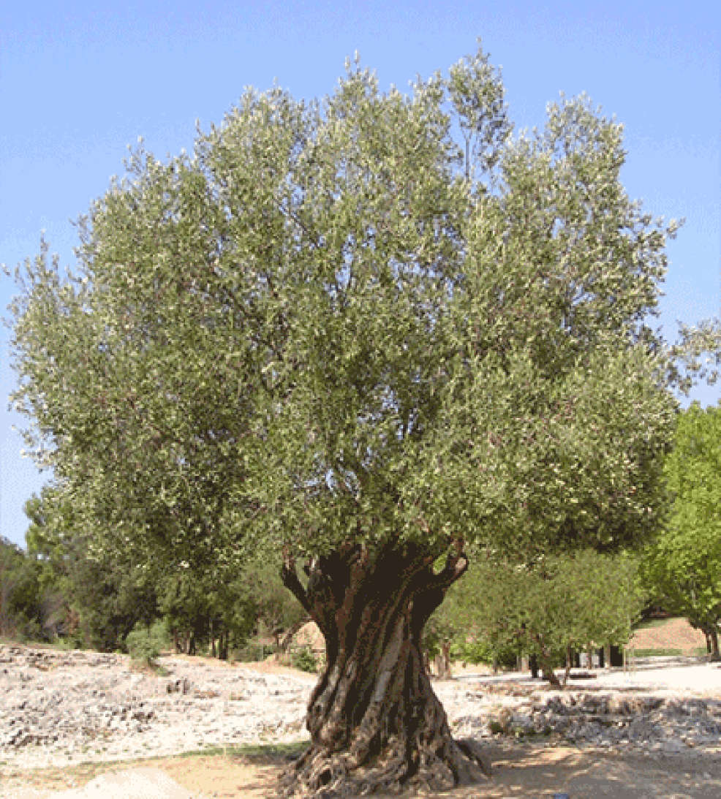

Pastor: Rev. Larry Myers
Elder on Call: Conrad Houk
Music: Deb Myers
Greeters: Skip & Nancy Davison

