Dave Burgoyne Jenn & Marty Gilliland
c/o Amy Zemanski 238 W. Washington St.
200 McClelland Avenue Harrisville, PA 16038
Polk, PA 16342

NEWS OF INTEREST

Pennies From Heaven: the monies collected help send children to the camp of their choice (mostly Seneca Hills). Your donations are appreciated and well spent. Other charities are often contributed to as worthy causes from Pennies From Heaven also.

PRAISES AND PRAYER

Please pray for God’s guidance in the future of our church. Please pray for the peace of the world. Pray for the leaders of our country as they earnestly seek peaceful solutions to the problems and crises around the globe. Please pray for our military and police forces and their safety throughout each day. Pray for our public school system. Pray for the mental health of people everywhere. Pray for our mission to Ghana. Pray for all the Christian's who are being persecuted in the world.

Would you like to know what our church has been up to? On the bulletin board in the entryway are the minutes and financial ledgers for each month. Please feel free to copy them and if you have a question, ask any session member or the pastor. We think this is the best way to keep everyone informed.

REMEMBER TO PRAY
FOR OUR MEMBERS AND FRIENDS AT HOME or HOSPITALS

Jenn & Marty Gilliland, Mieke Heffern, Susan Hammond, the unspoken request, Skip and Nancy Davison, Ken Timblin, Judy Krizon, Olivia Foster, Jan Sanners, Robin's mom Betty, Millie & Bill Nolan, Gregg Townsend, Dottie Dillin, Polk Center, Mark Knox, Sandy, Junior & Bonnie, Vicki, Deb Snyder, Rick Doutt, Jim Hesson, Dick McNany, Dave Perry, Keith Reynolds, Teri and Gary Chisholm, Jewell, Ginny, Meryl, John and Chuck Karns, Chance, Aubrielle & family, Nicky, June, Cheryl Adams, Dewayne Doutt, Rick Vaxily, Barb & Bryan Chisholm, Neil Buckley, victims of the storms and all those affected by the Coronavirus, for first responders, hospital staff, the military staff, at-home children, elderly and at-risk persons.

Polk Presbyterian Church
P.O. Box 1027
Polk, PA 16342
polkpresbyterianchurch.com

CHURCH OFFICE: 814-437-3153

Pastor Larry Myers 412-417-5737
flyfisher@windstream.net

SESSION MEMBERS:

Conrad Houk 814-374-4143
Cindy Swendsen 814-374-4041

Brian Heffern 814-671-2774

Dave Perry 770-687-9202
Colleen Scurry 814-437-6069
Deb Crum 724-679-9867

IF YOU ARE IN NEED OF ASSISTANCE
PLEASE CONTACT:

FINANCIAL SECRETARY:
Robin Russell 814-437-7038
rrussell@pa.rr.com

SECRETARY:

Anna Aumiller 814-437-3611
aaumiller@neo.rr.com

CLERK OF SESSION:
Wendy Bellin 814-673-9826


Polk Presbyterian Church
Calendar of Events
August 2020

Sunday School at 8:30am

Children Sunday School at 8:30am

Bible Study on Wednesdays at 6:30pm : at the church & via Zoom https://us04web.zoom.us/j/559705244 Meeting ID: 559 705 244

Assisted hearing devices are now available. They are in the secretary's office on the file cabinet. Please mark your name on the box.

August 20th at 6:30 - Session Meeting

September 6 - Communion Sunday

September 7 - Labor Day

Donations to the building fund are welcome. Put the donation into an envelop marked Building Donation and drop into collection plate.

Home Communion: If you know anyone who would like to receive communion at home, please let Pastor Larry know who they are.

Lay Speakers: Looking for volunteers to speak at the beginning of the service in the same capacity as Jon Crum does now. If you would like to volunteer, please let Pastor Larry know.

Men's Association are welcoming projects for the elderly or persons who are unable to do projects like painting, lawn mowing, etc. Please let one of the men know if there is anyone in the community that needs this kind of help.

Food Drive: Please place food items in box in the vestibule hallway and it will be taken to the Salvation Army.

Millie & Bill Nolan Karns, Clayton M.
1380 School Rd 5350 Berger Street
Stoneboro, PA 16153 Stop #1360
Moody AFB, GA 31699

Tyler Wood Gracie Stryffeler
c/o Room 718 c/o Room 206
117 University Plaza 117 University Plaza
Youngstown, OH 44502-1208 Youngstown, OH 44502-1208

Polk Presbyterian Church

August 23, 2020

12th Sunday after Pentecost

Public Education Sunday

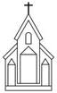

Father, I Adore You #45
Father, I adore You, lay my life before You---How I love You!
Jesus, I adore You, lay my life before You---How I love You!
Spirit, I adore You, lay my life before You---How I love You!

Time for meditation and reflection.

CALL TO WORSHIP Psalm 124:1-3, 8
(L) If it had not been the Lord who was on our side —let Israel now say—
(P) if it had not been the Lord who was on our side, when our enemies attacked us,
(L) then they would have swallowed us up alive, when their anger was kindled against us;
(P) Our help is in the name of the Lord, who made heaven and earth.

*Praise Hymn "The Solid Rock" # 340
My hope is built on nothing less than Jesus' blood and righteousness; I dare not trust the sweetest frame, but wholly lean on Jesus' name. On Christ, the solid Rock, I stand---all other ground is sinking sand, all other ground is sinking sand.

PRAYER OF CONFESSION
Forgive us Lord when we allow the glitter of this world to distract our attention from our Christian calling. Have mercy upon us when we fail to align ourselves with the will of God. Enable us to recognize Jesus the Christ as the Lord of our lives, give ourselves as a holy living sacrifice, and use our spiritual gifts to enhance the Kingdom of God. Empower us to humbly serve the body of Christ that is blessed with the keys of the Kingdom. We make this prayer in the name of the risen and glorified Christ. Amen.

ASSURANCE OF PARDON 1 Peter 2:4-5, 9-10
(L) Come to him, a living stone, though rejected by mortals yet chosen and precious in God’s sight.
(P) Like living stones, let yourselves be built into a spiritual house, to be a holy priesthood, to offer spiritual sacrifices acceptable to God through Jesus Christ.
(L) But you are a chosen race, a royal priesthood, a holy nation, God’s own people, in order that you may proclaim the mighty acts of him who called you out of darkness into his marvelous light.
(P) Once you were not a people, but now you are God’s people; once you had not received mercy, but now you have received mercy.

*Gloria Patri # 42

SPECIAL a solo by Debbie Myers

CHILDREN'S CHAT

MOMENTS FOR MISSI0N

PRAYERS OF THE PEOPLE Joys and concerns:

Happy Birthday: Dave Allman

Happy Anniversary: Conrad & Sandy Houk

Presbytery Prayers: Garland, Commissioned Pastor Tim Olsen; Children of Lake Erie Pastors

THE LORDS PRAYER
Our Father, who art in heaven, hallowed be Thy name, Thy kingdom come, Thy will be done, on earth as it is in heaven. Give us this day our daily bread; and forgive us our debts, as we forgive our debtors; and lead us not into temptation, but deliver us from evil. For Thine is the kingdom, and the power, and the glory, forever. Amen.

*HYMN OF PREPARATION The Church's One Foundation #131

RETURNING THANKS TO GOD
*THE DOXOLOGY # 39
*THE PRAYER OF DEDICATION

SCRIPTURE READING: Matthew 16:13-20
Romans 12:1-2
﻿﻿
(P) Thanks be to God

SERMON "What's in a Name?"

*Affirmation of Faith The Apostles’ Creed
I believe in God, the Father Almighty, maker of heaven and earth. And in Jesus Christ, His only begotten Son, our Lord. Who was conceived by the Holy Spirit, born of the Virgin Mary, suffered under Pontius Pilate, was crucified, dead and buried; he descended into hell. The third day, He rose again from the dead; He ascended into heaven, and sitteth at the right hand of God, the Father Almighty, from thence he will come again to judge the quick and the dead.
I believe in the Holy Spirit, the holy catholic church, the communion of saints, the forgiveness of sins, the resurrection of the body, and the life everlasting. Amen.

*CLOSING HYMN He's Everything to Me 549

*THE BENEDICTION

*Our Response Go Light Your World #39
Carry your candle, run to the darkness, seek out the hopeless, confused and torn. Hold out your candle for all to see it,
take your candle, and go light your world,
take your candle, and go light your world.

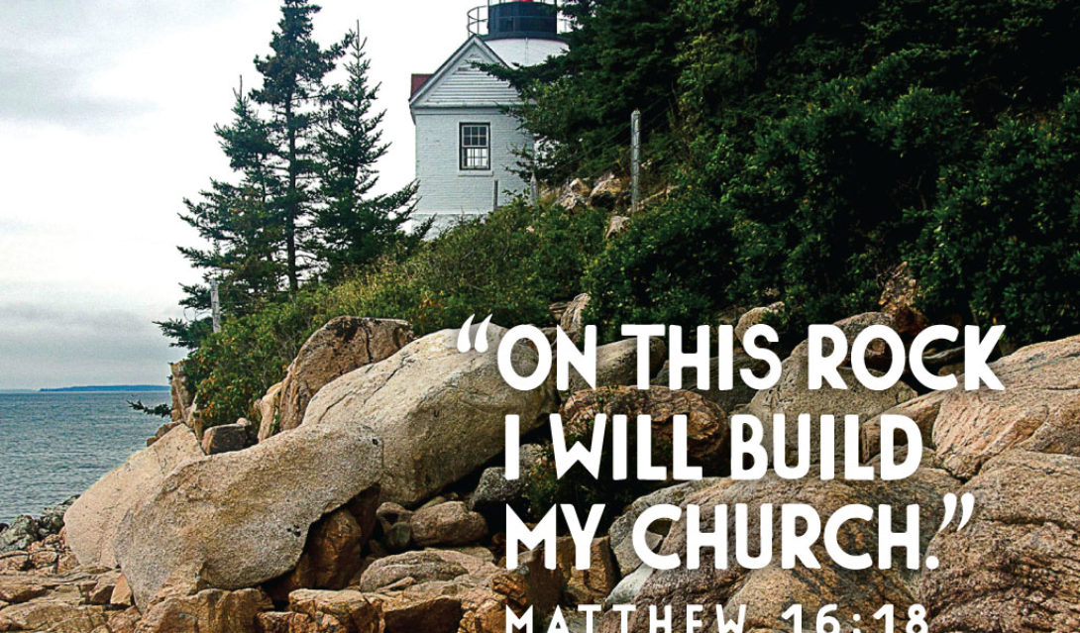

Pastor: Rev. Larry Myers
Elder on Call: Cindy Swendsen
Music: Deb Myers
Greeters: Skip & Nancy Davison

