NEWS OF INTEREST

Pennies From Heaven: the monies collected help send children to the camp of their choice (mostly Seneca Hills). Your donations are appreciated and well spent. Other charities are often contributed to as worthy causes from Pennies From Heaven also.

PRAISES AND PRAYER

Please pray for God’s guidance in the future of our church. Please pray for the peace of the world. Pray for the leaders of our country as they earnestly seek peaceful solutions to the problems and crises around the globe. Please pray for our military and police forces and their safety throughout each day. Pray for our public school system. Pray for the mental health of people everywhere. Pray for our mission to Ghana. Pray for all the Christian's who are being persecuted in the world.

Would you like to know what our church has been up to? On the bulletin board in the entryway are the minutes and financial ledgers for each month. Please feel free to copy them and if you have a question, ask any session member or the pastor. We think this is the best way to keep everyone informed.

REMEMBER TO PRAY
FOR OUR MEMBERS AND FRIENDS AT HOME or HOSPITALS

Jenn & Marty Gilliland, Mieke Heffern, Susan Hammond, the unspoken request, Skip and Nancy Davison, Ken Timblin, Judy Krizon, Olivia Foster, Jan Sanners, Robin's mom Betty, Millie & Bill Nolan, Gregg Townsend, Dottie Dillin, Polk Center, Mark Knox, Sandy, Erma, Harry Daye, Virginia Heister, Deb Boyer, Sally & Doug Bell, Amy Zemanski, Lincoln, Dick & Nancy Kerr, Junior & Bonnie, Vicki, Deb Snyder, Dick McNany, Dave Perry, Keith Reynolds, Teri and Gary Chisholm, Jewell, John and Chuck Karns, Chance, Aubrielle & family, Emma, Megan, Dewayne Doutt, Rick Vaxily, Barb & Bryan Chisholm, Dave Owen, Conrad Houk, Nancy & Tom Westcoat, victims of the storms and all those affected by the Coronavirus, for first responders, hospital staff, the military staff, at-home children, elderly and at-risk persons, the overdose & suicide epidemic, wildfires and firefighters

Polk Presbyterian Church
P.O. Box 1027
Polk, PA 16342
polkpresbyterianchurch.com

CHURCH OFFICE: 814-437-3153

Pastor Larry Myers 412-417-5737
flyfisher@windstream.net

SESSION MEMBERS:

Conrad Houk 814-374-4143
Cindy Swendsen 814-374-4041

Brian Heffern 814-671-2774

Dave Perry 770-687-9202
Colleen Scurry 814-437-6069
Deb Crum 724-679-9867

IF YOU ARE IN NEED OF ASSISTANCE
PLEASE CONTACT:

FINANCIAL SECRETARY:
Robin Russell 814-437-7038
rrussell@pa.rr.com

SECRETARY:

Anna Aumiller 814-437-3611
aaumiller@neo.rr.com

CLERK OF SESSION:
Wendy Bellin 814-673-9826

Millie & Bill Nolan Karns, Clayton M.
1380 School Rd 5350 Berger Street
Stoneboro, PA 16153 Stop #1360
Moody AFB, GA 31699

Tyler Wood Gracie Stryffeler
c/o Room 718 c/o Room 206
117 University Plaza 117 University Plaza
Youngstown, OH 44502-1208 Youngstown, OH 44502-1208

Dave Burgoyne Jenn & Marty Gilliland
c/o Amy Zemanski 238 W. Washington St.
200 McClelland Avenue Harrisville, PA 16038
Polk, PA 16342

Trevor Wood Zach Stryffeler
369 Sherman St. PO Box 213
Akron, OH 44311 3261 W. State Road
St. Bonaventure, NY 14778


Polk Presbyterian Church
Calendar of Events
September 2020

Sunday School at 8:30am

Children Sunday School at 8:30am

Bible Study on Wednesdays at 6:30pm : at the church & via Zoom https://us04web.zoom.us/j/559705244 Meeting ID: 559 705 244

Assisted hearing devices are now available. They are in the secretary's office on the file cabinet. Please mark your name on the box.

Contributions to the Underground Railroad will be taken until the end of September. Please make the check out to the church and notate that it is for the Underground Railroad.

Oct 3 - Seneca Hills Work Day - If you're interested in helping, please talk to Jon Crum or Dave Allman.

Oct 4 - World Communion Sunday

Youth for Christ - there is a prayer calendar in the vestabule.

Lakeview Area Helping Hands Center is asking for any help.

Donations to the building fund are welcome. Put the donation into an envelop marked Building Donation and drop into collection plate.

We are soliciting names in September for Elders for 2021.

Home Communion: If you know anyone who would like to receive communion at home, please let Pastor Larry know who they are.

Lay Speakers: Looking for volunteers to speak at the beginning of the service in the same capacity as Jon Crum does now. If you would like to volunteer, please let Pastor Larry know.

Men's Association are welcoming projects for the elderly or persons who are unable to do projects like painting, lawn mowing, etc. Please let one of the men know if there is anyone in the community that needs this kind of help.

Food Drive: Please place food items in box in the vestibule hallway and it will be taken to the Salvation Army.



Polk Presbyterian Church

September 27, 2020

17th Sunday after Pentecost
Evangelism Sunday

*Introit Lord, Be Glorified #33
In my life, Lord, be glorified, be glorified. In my life, Lord, be glorified today.
In my song, Lord, be glorified, be glorified. In my song, Lord, be glorified today.
In Your Church, Lord, be glorified, be glorified. In Your Church, Lord, be glorified today.

Time for meditation and reflection.

CALL TO WORSHIP Psalm 78:1-4
(L) Give ear, O my people, to my teaching; incline your ears to the words of my mouth.
(P) I will open my mouth in a parable; I will utter dark sayings from of old,
(L) Things that we have heard and known, that our ancestors have told us.
(P) We will not hide them from their children; we will tell to the coming generation the glorious deeds of the Lord, and his might, and the wonders that he has done.

*Praise Hymn Praise the Name of Jesus # 167
Praise the name of Jesus, Praise the name of Jesus.
He's my Rock, He's my Fortress,
He's my Deliverer; in Him will I trust.
Praise the name of Jesus.

PRAYER OF CONFESSION
Almighty God, make your presence known to us as we gather in worship this morning. Calm our anxious spirits, quiet our earthly distractions, and bind us together in and through Jesus Christ as we work out our own salvation in fear and trembling. Allow the light of your glory to shine through the darkness of our sin in order to illuminate the Word of God to our understanding. Allow the living Word to penetrate our hearts so that we fall on our knees at the name of Jesus and confess him as our Lord, Savior, and Redeemer. In name of the glorified Christ, we pray. Amen.

ASSURANCE OF PARDON Romans 10:9-10
(L) If you confess with your lips that Jesus is Lord and believe in your heart God raised him from the dead, you will be saved.
(P) For one believes with the heart and so is justified, and one confesses with the mouth and so is saved.

*Gloria Patri # 42

SPECIAL Congregational Hymn Sing

CHILDREN'S CHAT

MOMENTS FOR MISSI0N

PRAYERS OF THE PEOPLE Joys and concerns:

Happy Birthday: Amelia Sybert, Amy Zemanski

Presbytery Prayers: Fairview, Church of the Cross, Rev. Drew Himes, Pastor; Rev. Susan Speakman, HR, Rev. John Dyke, HR

THE LORDS PRAYER
Our Father, who art in heaven, hallowed be Thy name, Thy kingdom come, Thy will be done, on earth as it is in heaven. Give us this day our daily bread; and forgive us our debts, as we forgive our debtors; and lead us not into temptation, but deliver us from evil. For Thine is the kingdom, and the power, and the glory, forever. Amen.

*HYMN OF PREPARATION All Hail the Power # 240

RETURNING THANKS TO GOD
*THE DOXOLOGY #39
*THE PRAYER OF DEDICATION

SCRIPTURE READING: Matthew 21:23-32
﻿﻿
(P) Thanks be to God

SERMON "By Whose Authority"

AFFIRMATION OF FAITH Westminster Larger Catechism 7.186
Q. 76. What is repentance unto life?
A. Repentance unto life is a saving grace, wrought in the heart of a sinner by the Spirit and Word of God, whereby out of the sight and sense, not only of the danger, but also of the filthiness and odiousness of his sins, and upon the apprehension of God’s mercy in Christ to such as are penitent, he so grieves for, and hates his sins, as that he turns from them all to God, purposing and endeavoring constantly to walk with him in all the ways of new obedience. Amen.

*CLOSING HYMN He Is Lord # 234

*THE BENEDICTION

*Our Response How Great Thou Art #16 chorus only
Then sings my soul, my Savior God, to Thee:
How great Thou art, how great Thou art!
Then sings my soul, my Savior God, to Thee:
How great Thou art, how great Thou art!

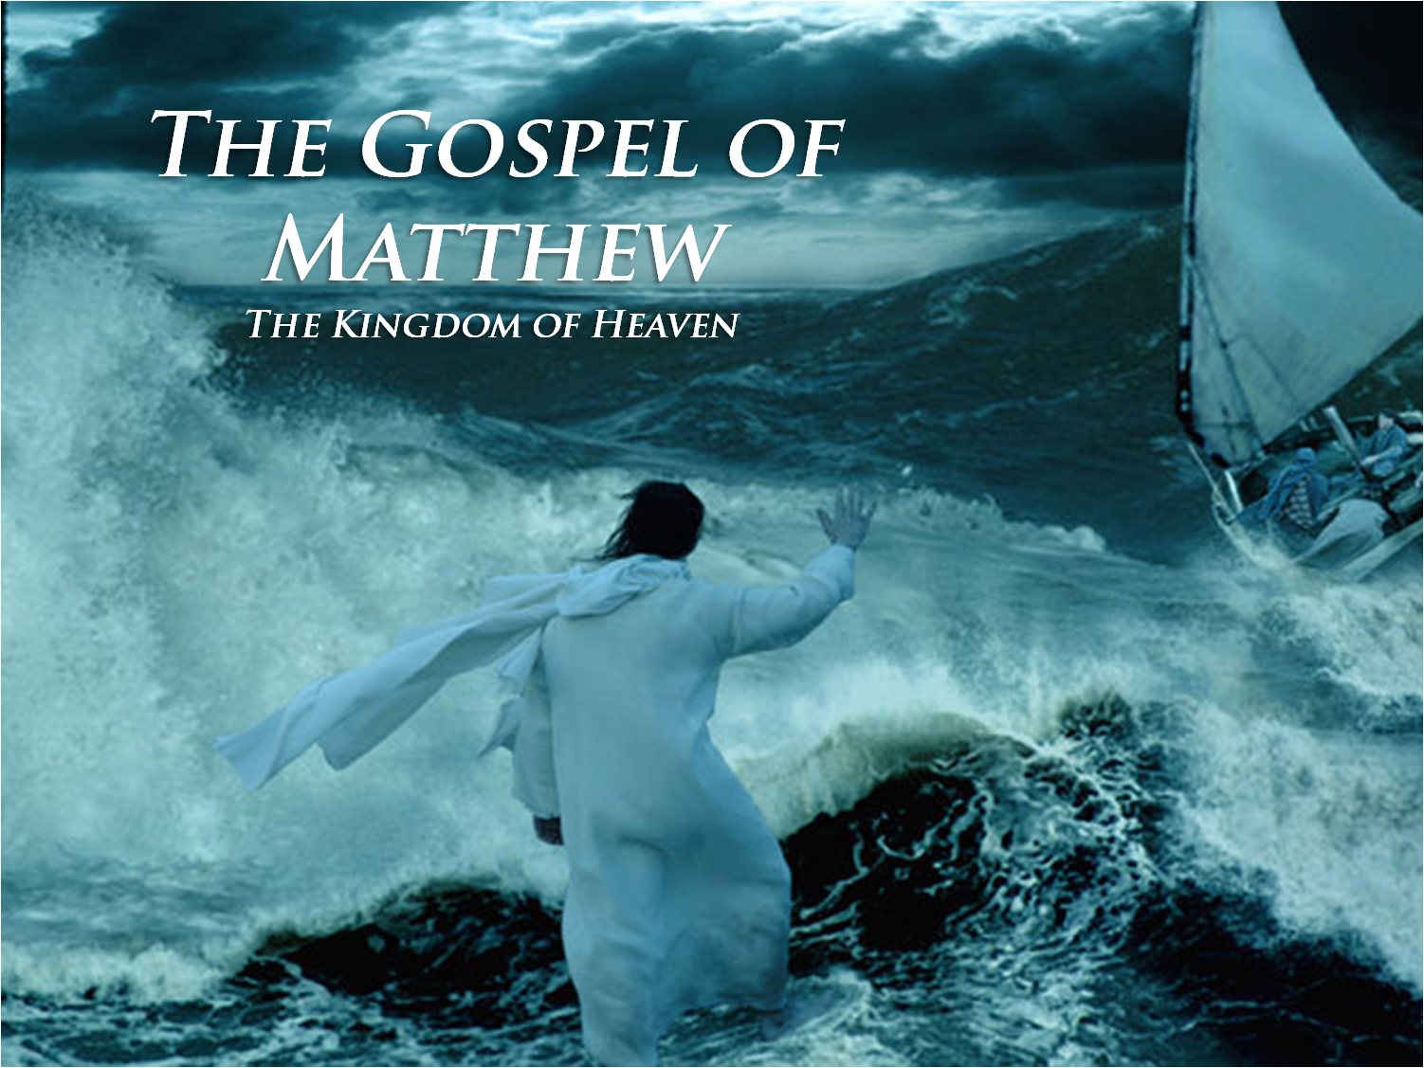

Pastor: Rev. Larry Myers
Elder on Call: Cindy Swendsen
Music: Deb Myers
Greeters: Ernie & Gail Banks

