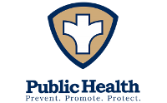
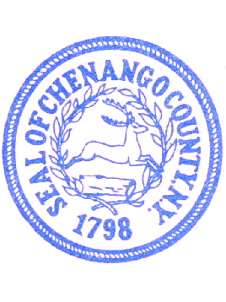
Department of Public Health
Chenango County

Chenango County Office Building,
5 Court Street, Norwich, New York 13815
https://www.chenangocountyny.gov

RABIES ALERT NOTICE

A raccoon found along State Highway 80 between Sherburne and Columbus was tested on October 21, 2025, by NYS Wadsworth Laboratories, and was found to have rabies. Residents and visitors in the area are advised to take the following precautions:
- Do not pick up or handle any stray or wild animal.
- Contact the Department of Environmental Conservation (607-371-7268), or the Chenango County Health Department (607-337-1673) to report animals which are behaving strangely or aggressively.
- Enjoy wildlife from a distance! Do not attempt to feed, approach, or touch wild animals.
- Teach children about the dangers of stray and wild animals.
- DO NOT kill healthy appearing animals merely due to this warning.
- Report any animal bites and/or scratches to your health care provider or the Chenango County Health Department.
- If your pet or livestock is behaving strangely contact your veterinarian immediately.
- Make sure all your dogs, cats, ferrets, and livestock are vaccinated against rabies.

If you are bitten or scratched by any animal: 1. Wash and rinse the wound thoroughly for several minutes. 2. Apply a disinfectant. 3. Seek medical attention immediately. 4. Report the bite/scratch to your health care provider or the Chenango County Health Department,
(607) 337-1673

