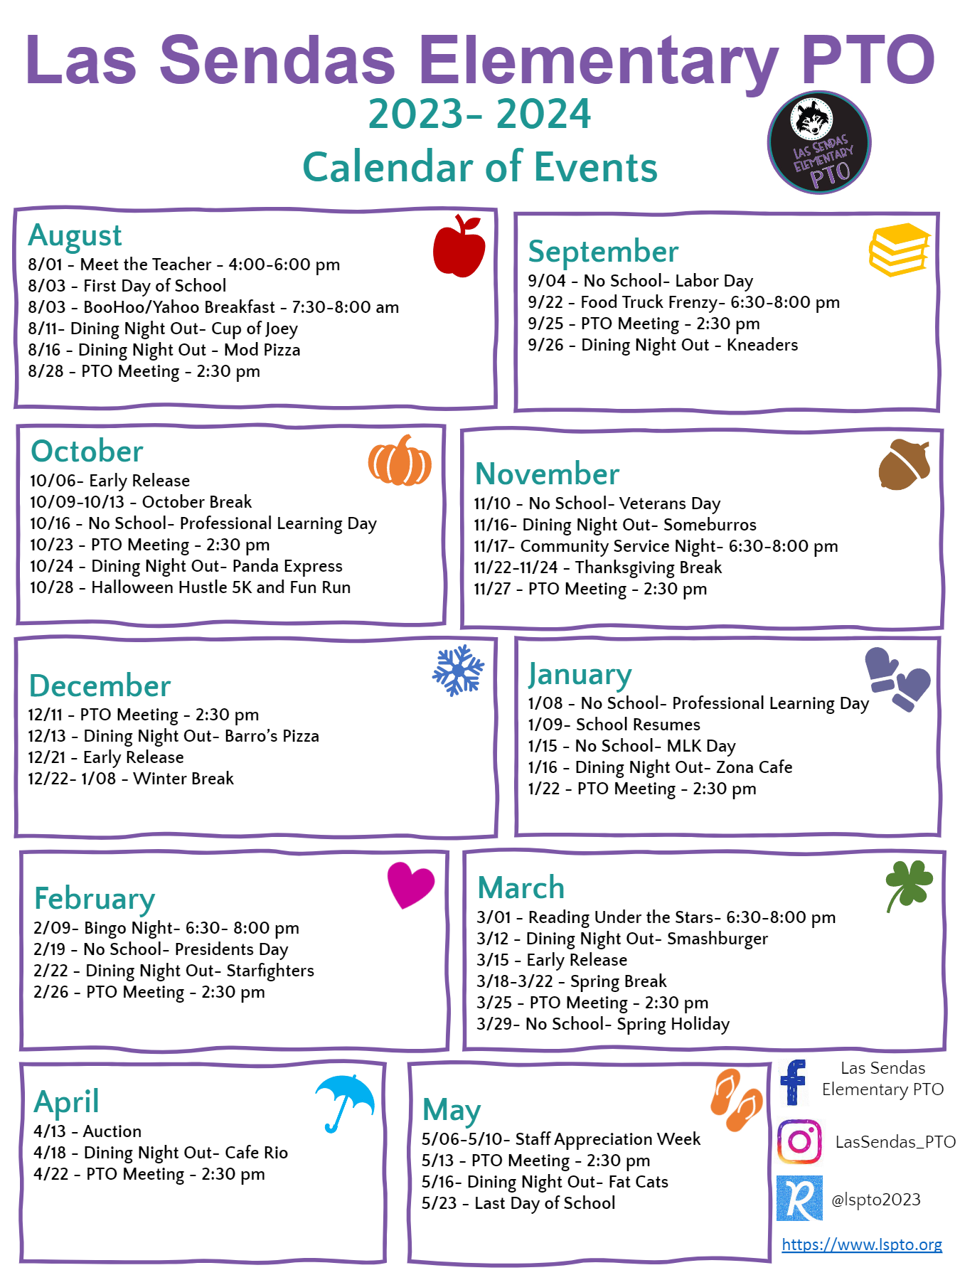
Las Sendas Elementary School
Parent Teacher Organization
3120 N. Red Mountain, Mesa, AZ 85207

Minutes-General Meeting
October 27, 2025
Meeting Called to Order at 2:34pm
Introduction/Roll Call
Present Absent
- Jennifer Berkshire – President
- Cindy Sroufe – Treasurer
- Abby Donahue – VP Fundraising
- Brittany Fawley – VP Communications
- Kaitlyn Rodgers – VP Events
- Donna Walkoz – Secretary
Approval of September 29, 2025 Meeting Minutes
- Motion made by Mrs. Arviso. Second by Ms. Sears. Motion passed.
Principal’s Report
Ms. Micela talked about the feeder school program and how the district is trying to strengthen the relationship between elementary schools, their middle school, and their high schools. She spoke about the first quarter assembly and what a success it was. The sensory walk is complete and she thanked the PTO for finishing the project she started 2 years ago.
Treasurer’s Report
Reviewed Budget - Operating Account Balance $75,880.00
Encumbered $10,901.87
Operating Account Balance after encumbered funds $64,978.13
- Motion made by Ms. Kitchell. Second by Mr. Campos. Motion passed.

Review of October:
- The collaboration with What’s Crackin Cafe for our trunk-or-treat was a giant success! There were so many families in attendance and we ended up with 12 cars from the school! Mr. Lorenzen’s class had three cars show up and they won the pizza party! It was nice having live music and the Sanderson sisters.
- Our float for the homecoming parade was enjoyed by everyone. Thank you again to the families who participated and thank you to the classes that provided candy for both events. There were a few expenses to make it happen. Motion to encumber $37.95 for the RMHS homecoming float.
- - Motion made by Ms. Sears. Second by Mrs. Arviso. Motion passed.
- For the love of teaching has been completed. We hope everyone is enjoying their new things. We will be saving $150 for Ms. Potter when she returns.
- The Sensory Path is complete! We hope you have all taken a walk down and we hope that your students are able to benefit from this project.

New Business
- Feed back about communication from parents.
  - There was discussion about how parents can receive the information from PTO in the newsletter from the office, the newsletter from their teachers, the PTO website, Facebook, Instagram, and the bulletin boards that are now outside the gates. PTO can not have a ParentSquare. The concern is that parents have ParentSquare fatigue and are not reading the newsletters. A suggestion was to have an image with the information so it is catchy for the parents to see. Another suggestion was to have the PTO provide exact verbiage to the office and the teachers so they can copy and paste directly into their newsletters.
- Fundraising Update:
  - DNOs: Panda raised $214.27. The next DNO is Chick-fil-a on November 18 from 4-8. Use code LSE25 when ordering through the app.
- Please make sure you are uploading your photos to Google Drive and sharing the drive with Khloe Jones.
- The next quarterly lunch will be November 19. The theme will be “comfort food” and lunch will be served in the staff lounge during normal lunch hours.
- Partnering with Student Council for a canned food drive/clothing drive to benefit Stevenson Elementary.
- The next event is our 5k turkey trot with the Las Sendas HOA, November 22 starting around 7:30. Registration will be posted to our website this week. There will be live music, a DJ, food trucks, and a 1 mile race for younger kids. Motion to encumber $250 for event expenses.
- - Motion made by Mrs. Wheeler. Second by Mrs. McKee. Motion passed.
- We are still waiting for the district to approve the water fountains.
- We purchased some bows and shoulder rests for the orchestra.
- One of our goals this year is to help pay for field trips. Motion to encumber $15,000 for this project.
- - Motion made by Mrs. Arviso. Second by Mr. Campos. Motion passed.
- As mentioned last month, we will be providing light snacks for conference weeks and testing weeks. We are working on getting donations, but to make sure it’s possible…Motion to encumber $250 for the year (roughly $50 per event).
- - Motion made by Mrs. McKee. Second by Mrs. Valencia. Motion passed.

Agenda Requests
Carrie Kitchell - Awards/medals for spelling bee. Motion to encumber $30
- Motion made by Mrs. Arviso. Second by Ms. Sears. Motion passed.

General Housekeeping
- Motion to unencumber ($820.58)
  - Trunk or Treat at What's Crackin' $210
  - Initiative (24-25) - Nature/Sensory Walk $28.06
  - For the love of teaching - $398.17
  - Movie Night - $ 184.35
- Motion made by Mr. Campos. Second by Mrs. Wheeler. Motion passed.

Upcoming Events
- 11/11/25 - Veteran’s Day, no school
- 11/18/25 - DNO Chick-fil-a, 4-8, use code LSE 25
- 11/22/25 - 5k with Las Sendas HOA
- 11/24/25 - PTO Meeting media center, 2:30
- 11/26-28/25 - Thanksgiving Holiday

Next PTO Meeting
- November 24, 2025
Motion to adjourn - 2:54pm
- Motion made by Mrs. Valencia. Second by Mrs. Kitchell. Motion passed.

