**SOJOURNER TRUTH MINISTRIES, INC.**



**501 High Street, Williamsport, Pennsylvania**

**(570) 323-1797**

**SPRING NEWSLETTER MARCH 2025**

***So much more than just a soup kitchen***

**A Note from Pastor Angelique**

A man with deep sorrows came before Dinner Table Church and wept (not quietly) throughout the brief service a few weeks ago. He was under the influence and extremely emotional. Married decades ago in the church, which is now STM, regrets and pain filled him. He asked for prayer and wanted to confess many things and ended up asking to dedicate his life to Jesus. Several days later he returned stating that he was telling everyone! He said people noticed a (good) change in him. The next Saturday he was back again, asking to sing/lead us all in Amazing Grace. I had the honor of standing by his side and singing along and we worshipped. With no music and no words before us, mostly a heart that had begun to heal, which filled in for lost words. What sweet music that was to God’s ears! That is what we do- we stand alongside people- some in their despair, some on the way up the very difficult path to overcome the next barrier they are facing.  
Thank you for encouragement, for prayers, for supporting this ministry. It truly makes a difference, one at a time!

**Exciting things are happening at STM!**

We welcome two new board members: Mary Beth Croll and Jim Redka. We also welcome Patty Beggs as our new Volunteer Social Service Assistant. She will be here on Wednesdays 10:30-12:30. We are excited to have them join us in ministry.

*The annual blessings for nonprofits through* ***RAISE THE REGION*** *is coming soon. The 2025 event begins at 6:00pm on March 12th and last through March 13th at 11:59p.m. This is* ***a 30-hour online fundraiser for******nonprofits.*** *We are asking you to consider donating to Sojourner Truth Ministries as we serve people who are food and/or financially struggling, including those who are homeless in these difficult times. Your donation will make a difference. Thank you.*

*Springtime blessings are right around the corner, and* ***YOU*** *are invited to be part of the movement to extend a blessing to others.*

**A BIT OF HISTORY:** Sojourner’s Cafe (now known as The Soup Kitchen) started in March of 2002 with a trial run by the T.U.F.F. group of youth headed up by Jim Sortman of Duboistown UMC. That meal served about 50 people. The cafe, on a regular basis, started on Saturday, April 16, 2002. The average attendance started with about 35-40 persons for each meal but quickly escalated to the preset 80-90. July 6, 2002, the cook served 142 people.

**Stepping Up**

Mary came to live in the House of Hope. She came to rededicate her life to Jesus shortly after that, followed by asking to be baptized, which was shortly before the Program had to close to restructure, as the funds had run out. Part of that program has been to work on overcoming barriers- from tending to basic medical and health needs to self-care, obtaining identification, etc, to more complex and ongoing challenges. Throughout the resident’s time, she is to serve somehow for the community.

Part of Mary's daily tasks throughout her duration at the House of Hope was to come and assist with making brown bag lunches for the Soup Kitchen at STM.

Following closure just after Thanksgiving, Mary continued to come and assist with the bag lunches, and Chef Dave began working with her to learn large scale food prep and helping with making the "meals for our masses". She continues to learn and hone skills and has had the opportunity and privilege to be trusted with the whole kitchen while Dave took a few days off. Mary is filled with gratitude to God and to STM for the opportunities and support she has received since late summer '24 and always has a smile and positive attitude. We are thankful to have her as a part of STM! Mary says, “I love to volunteer and give back.”

**Change of Plans**

Our friend Gerri started coming to Sojourner Truth Ministries (STM) last summer and quickly made friends and sits at the same table daily. This is a group I hear encouraging each other and sharing life, laughs and brotherly (sisterly) love. She had planned to move out of the area and was ready to go, and about that time there was a brief postponement. We had also given her a very meaningful going away card to wish her the best. As it turned out, she did not end up going, and turned a corner with a new commitment level, assisting to serve meals and to clear places daily, getting to know many others and sharing that great smile with all, as we have become second family.

**The Helping Friendly Table**

It began with Deb, a regular who has always been friendly. Deb was invited to assist us with the important job of tallying - 6 days a week she came and noted basic demographic info on each person who came through the doors for three months- not missing a day! Next it was Gerri who began helping, and most recently, Dale, who was a judge for a local Souper Bowl contest, and as we learned more about him, invited him to use some of his organizational skills to assist us in the food storage pantry area. Immediately and eagerly, he took on the task and has been reorganizing everything that comes in and fully enjoying the new displays of our stock. This Helping Friendly table is the first one a person would see coming into the dining room, and it is the first one I introduce newcomers to visit to feel more welcome and comfortable. Their attitude is contagious!

**Meals served in January 2025**

3104 meals (1949 hot meals, 1155 bag lunches),

6 emergency food care boxes which served 9 adults, 12 children and 2 seniors.

We could not have done this without our 91 volunteers for a total of 534 hours.

New volunteer, Dale, reorganizing our food pantry (he is doing a fantastic job!)

Thank you, Mary! Stepping in and up and running our kitchen while Chef Dave is enjoying vacation time.

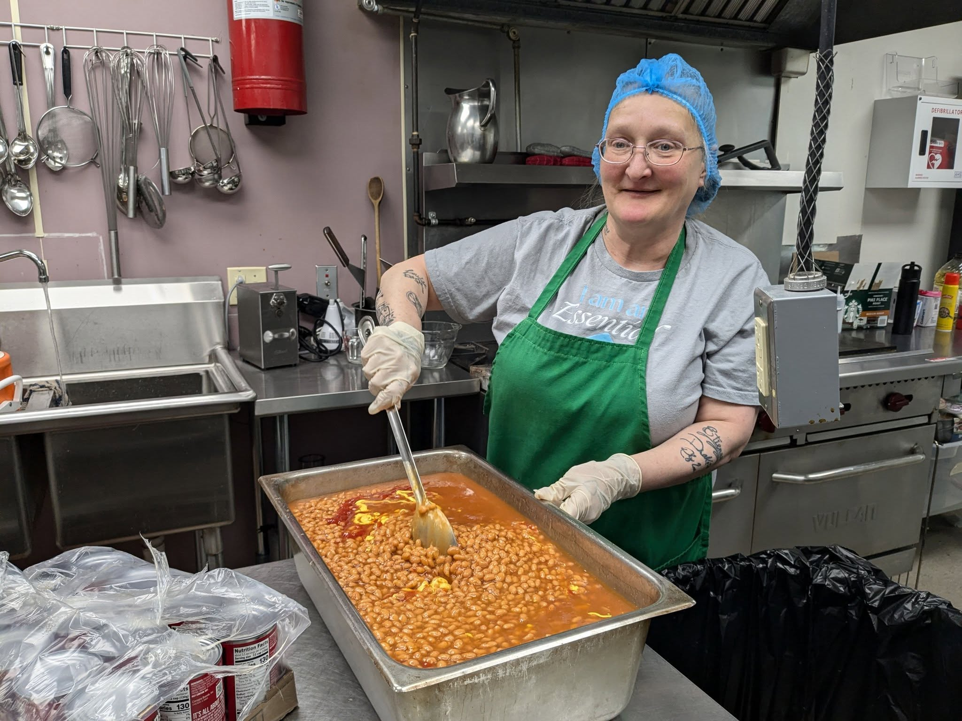

**Ways to donate:**

We are reaching out to you today to humbly invite you to celebrate the joy of serving our community. Your financial support, your gifts of time and talent are so important so STM can continue to reach out to those who may otherwise fall through the cracks. With ever growing needs your support matters. Will you give?

Go to website

to give

Online Visit our website and find the “Support us today! button.

[www.stmwilliamsport.org](http://www.stmwilliamsport.org) (QR codes included)

Mail: Checks can be sent to 501 High Street Williamsport PA 17701.

Please make checks payable to “Sojourner Truth Ministries, Inc.

In Person: Stop by to see how your gift is helping the community.

Go to pay pal

to give

Thank you for considering a donation to STM to make our community a better

place. If you have any questions, please do not hesitate to contact us.

**NEWSLETTER UPDATES:**  If you would like to have a newsletter sent to your email, please send your email to Wilma at [assistant4stm@gmail.com](mailto:assistant4stm@gmail.com) and we will add you to our newsletter email list.

**Volunteer**: We are always looking for volunteers, either to help us serve meals, help in the office, help with cleaning and organizing. Would you like to get involved?

There are GREAT opportunities to “P*lug in and make a difference. Let’s do the Lord’s work together.”* **Call Shawn for more details. 570-323-1797**

 

**Current Needs**

**Kitchen needs: We can always use lunch bags, snack bags, napkins, and individual sides of snacks, chips, breakfast bars, etc. to go along with the sandwiches. (We offer 45-50 take home lunch bags daily. Several sojourners take these bags to neighbors who are unable to get out.)**

**Office needs: stamps, thank you notes**

COMEDY MURDER MYSTERY DINNER/DESSERT THEATRE

Performed by the Paul Calvary Players

St. Paul-Calvary United Methodist Church

1427 Memorial Ave, Williamsport PA 17701

Dinner Theater Entrée prepared by Hillside Catering

Thursday April 24th, Friday April 25th, Saturday April 26th,

6:00pm Cost: $25 per ticket

Dessert Theater: Sunday April 27th

2:00pm Cost: $12.50 per ticket

For reservations call Faith Smith 570-419-3270

**DREAMS DELAYED BUT NOT DASHED**

Thank you for all your prayers, time, and financial support for our dreams. House of Hope is a ministry under the umbrella of Sojourner Truth Ministries, Inc. From the outset it has been a solid Christian program designed to help women in need to learn skills to come out of homelessness and move up the ladder to maintain a life that is independent.

Unfortunately, even after a full year of fervent prayer and constant discussions, we came to a point of financial crisis. Our Board of Directors had to make the painful decision to step back and reassess the timing for our dreams to be fulfilled.

 For now, House of Hope doors are closed. Prayers, plans, financial strategies, and God's continuing direction assure us that when we are financially on very solid ground and spiritually led, House of Hope will again open its doors to see our dreams being fulfilled.

We implore you to join us in fervent prayers in this endeavor as we listen carefully for the Spirit's guidance in moving forward.  --- Rev. Angelique Labadie-Cihanowyz

**SOJOURNER TRUTH**

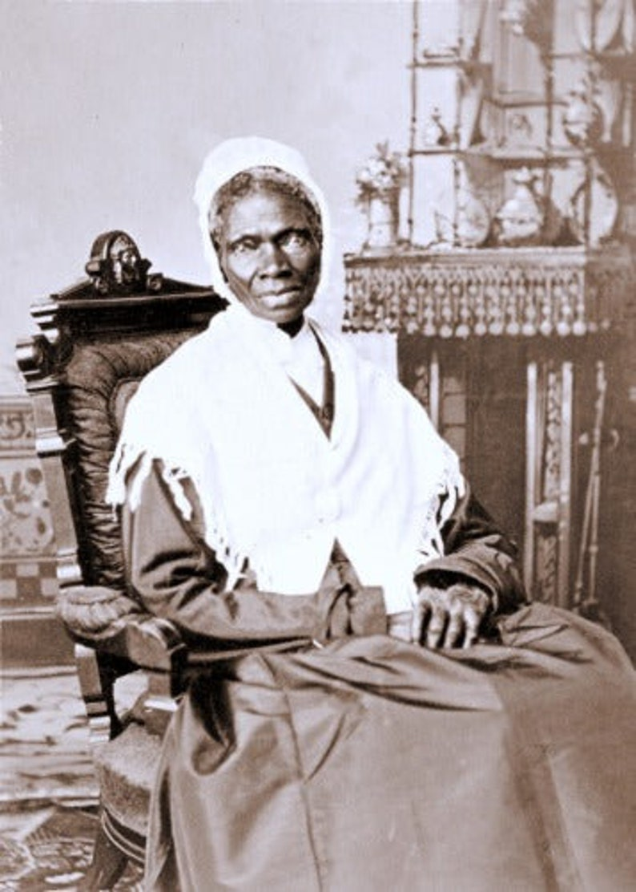

**OUR HISTORY**

Where did the name *“Sojourner Truth”* originate?

Sojourner Truth 1797 -1883

She was born into slavery as Isabella Baumfree. She attained her freedom in 1822.

She attributed her freedom to the *Truth* of the Gospel as revealed in the Person of

Jesus Christ.

She was a *Sojourner* because she became an itinerate methodist preacher

championing equality.

President Lincoln and President Grant sought her ministry and wisdom on the above subjects. She may be thought of as a minority among minorities who overcame the obstacles of her culture.

THE VISION

The ministry is named in her honor to help represent the intent to seek those that are disenfranchised and alienated by the traditional church. Included are those that are social-economically challenged and people of affluence. Many may not find our traditional Sunday settings inviting or friendly.

VISION STATEMENT

STM shall be a loving, spiritual and inclusive Christian mission.

MISSION STATEMENT

STM loves all people, creates community, builds character and equips us to be faithful disciples of Jesus Christ.

Contact us at: 501 High Street Williamsport PA 17701

Phone #570-323-1797

Email [sojournertruthministries@gmail.com](mailto:sojournertruthministries@gmail.com)

Website: [www.stmwilliamspor.org](http://www.stmwilliamspor.org)

Facebook - Sojourner Truth Ministries, Inc.

MONDAY – FRIDAY 11:30AM - 12:30PM  We serve a hot healthy lunch for dine in and brown bag to go with prayers and daily devotions SATURDAYS, join us at "Dinner Church" upstairs in the Sanctuary at 11:15AM.



**After School Kids, a ministry of Sojourner Truth Ministries**



Our Mission:

To bear witness to the gospel of Jesus Christ in Word and deed through an educational after school program for children.

When: Wednesday and Thursdays 3:30-5 during the school year (Many of our volunteers come either Wednesday or Thursday but are welcome for both!!)

What do we do: Each session includes a Bible Lesson, Homework help, Learning craft, group activity, prayer and a kid friendly meal. (Yep, it is a lot!)

Who are the children: Beautiful children, Kindergarten through 6th graders from the neighborhood, many of whom are experiencing difficult situations at home and at school.

Who is an “ASK” volunteer: A person who wants each child to know how much JESUS LOVES them wants to be in their lives, NO MATTER WHAT!!.

What Gifts do volunteers need? God will provide; He has something planned for each one of you!!!!!

**\*\*CLEARANCES REQUIRED**

ASK BENEFITS: Experience the presence of the Holy Spirit in YOUR life as you work side by side with other Christian Volunteers. Start to understand what these children are experiencing and how much they need to SEE the LOVE of JESUS in ACTION!

YOU are INVITED: Come and see, call/text me to ask questions, plan a visit.

Pat Burket 570 651 088

**Tutoring for Children at Sojourner Truth Ministries**

When: Mondays after school, 3:00-4:30

What: One on one work with a child under the guidance of qualified teachers

How: Currently 5 children in the program with a waiting list of children who need a volunteer

Who: Are YOU interested in this rewarding opportunity??

Call: Gale Weaver at 570 326 2952 to learn more!!!!!

**Non-Profit.org**

**U.S. Postage**

**PAID**

**Permit 269**

**Williamsport PA 17701**

**0**

SOJOURNER TRUTH MINISTRIES

501 High St.

Williamsport PA 17701

**Return Service Requested**



Place label here

*If we laugh and sing a little as we fight the good fight of freedom, it makes it all go easier. I will not allow my life’s light to be determined by the darkness around me.*

*--Sojourner Truth*