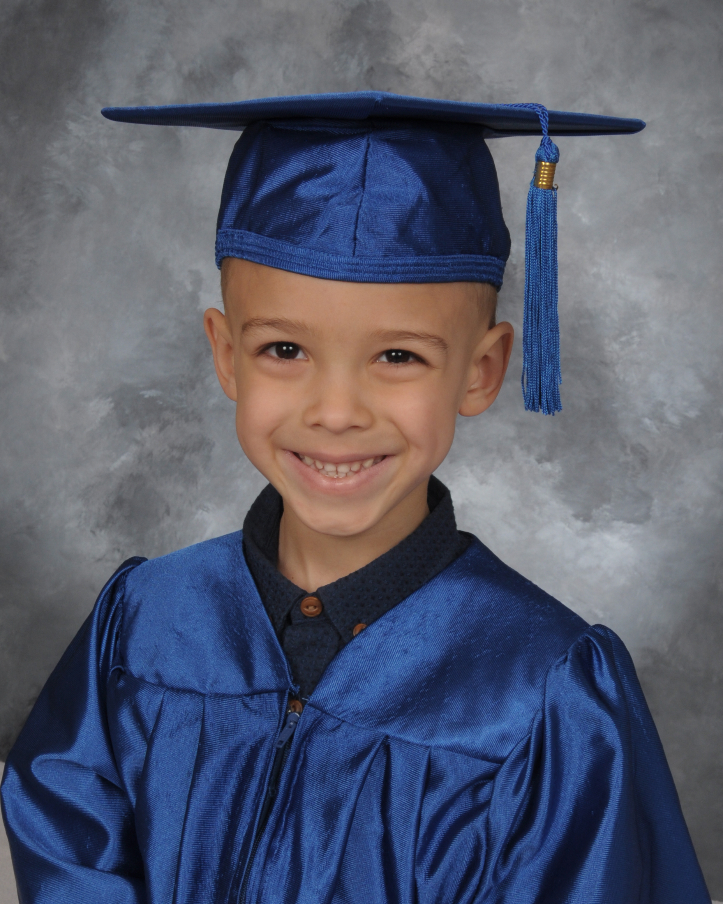

Photography by
Graduate Photo 413-245-7989
Coming to on
Student Name________________________________________________________________

Teacher___________________________________Grade/Class________________________

Package(s)_______________________Amount Enclosed $____________________________

*CASH--Money order make payable to
Shiers Photography
* No Personal Checks Thank you.
*One envelope per child.
MC/VISA/DISC slip inside envelope. Must be
filled out completely, then sealed inside envelope.

Cash, and money orders accepted. MC/VISA/DISC accepted All money due in school before picture day.
30 Day Money Back Guarantee on prints.
Package A
1 8x10
2 5x7’s
8 wallets
_________
$30.00
Package B

1 5x7
4 wallets
_________
$25.00
Package E $50 Digital (one) Image with permission. No refunds once email is sent. PLEASE write one email clearly below.

Email

Package D
5x7 Group photo only
____
$10
With the purchase of
Package A, B or E
you may “add on “magnets
4 for $15 8 for $20
Total $_________________

