Technology Education Name: ________________

Digital Photography Date: ______

Mr. English

**Portraits**

Directions:

Complete the following question using the internet or other resources. All responses should be in complete sentences unless otherwise noted.

1. What is the Key Focal Point in Portrait Photography? Explain.

2. Explain what these 6 Common Lighting styles for Portrait Photography look like. (It may be easiest to determine the direction of the light on the subject)

Butterfly Lighting-

Loop Lighting-

Rembrandt Lighting-

Split Lighting-

Broad Lighting

Short Lighting-

3. What is the Golden Ratio? (Can also draw a picture of it to answer this question)

4. Why is a Soft Box, one of the most common ways to light a subject for a Portrait?

5. Some of the first Portraits were made using the Daguerreotype, what is this process? (Explain how it works to take a picture)

6. Three-point Lighting is the most common way a Portrait Photographer will take Professional Portraits, label image with the correct lighting location. Draw in where the subject would sit.

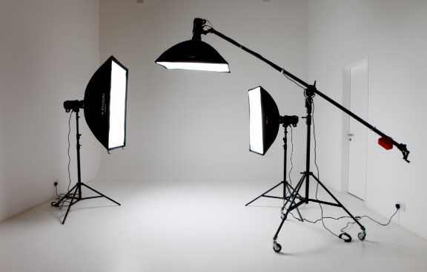

**Word Bank**

Key Light

Fill Light

Back Light

7. What is the difference between a Causal and Professional Portrait?

8. When were the first “Senior Portraits” taken? Why did this become a thing?

9. How does Bokeh make your Portrait pictures look more professional?

10. What is the difference between a Contemporary and Traditional Portrait?

11. What is one thing you would like to learn, have learned that you didn’t know before about Portrait Photography?