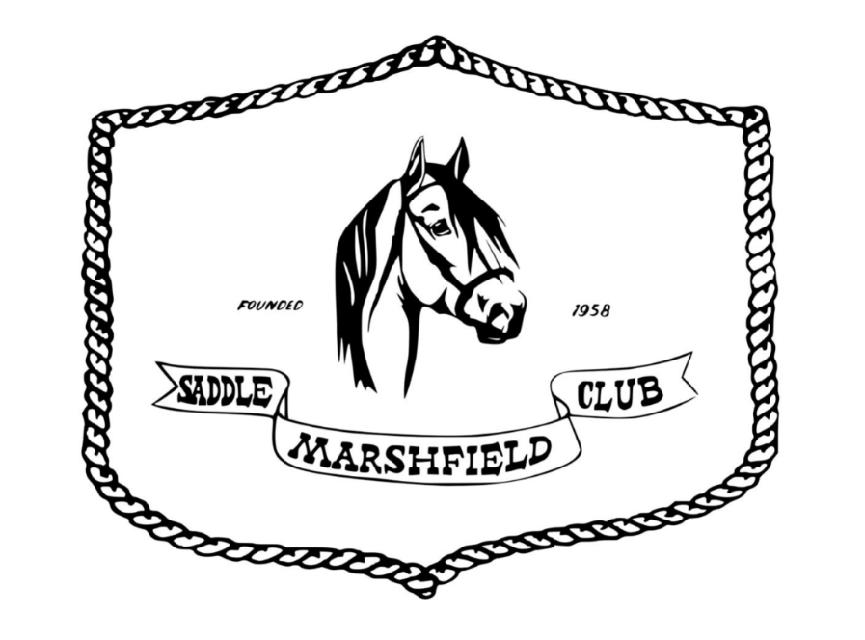

2024 Guidelines for Fun Shows & Events

Table of Contents

1) General Grounds Rules 2

2) Arena Etiquette Guidelines 3

3) General Event Rules 4

4) Judged Show Classes 5

5) Speed/timed Classes 7

General Ground Rules ~ The following guidelines have been decided upon for the safety and enjoyment of our shows and events. Please remember to follow them so that everyone stays safe & has a good time.

- NO Alcohol/Controlled Substances/Drugs Allowed on Saddle Club Grounds.

- Please DO NOT Litter - use trash cans.

- Dogs Must be on Leashes during any shows/events on Club Grounds.

- Remember when parking your horse trailer to leave room for you and your neighbor to tie your horses safely.

- Spectators please do not park amongst the horse trailers.

- Please keep in mind the safety of yourself and others as you ride and ALWAYS practice good horsemanship. Per show officials, dangerous animals may be asked to leave the grounds.

- Saddle Club Grounds are WALK Only unless in arenas or designated warm up areas.

- The Handlers and Riders of Stallions must be at least 18 years of age. Please manage your stallion responsibly. Per show officials, dangerous animals may be asked to leave the grounds.

- If your horse is known to kick, please tie a red ribbon in their tail to warn others.

- Please do NOT tie horses to arena panels or climb on arena fences.

- Remember there are children about and please watch your language.

- Please keep horses out of the following areas: cookshack, bleachers, signup table & announcer stand.

- Please use proper footwear when riding.

- Anyone caught abusing any animal or child, verbally or physically, may be ejected from the show without refund.

- Negative Coggins Required for all horses & Current Waiver is required to be on file for all riders/handlers.

- BE SAFE & HAVE FUN!!!
- ARENA ETIQUETTE RULES:

  - Slow horses keep to the Rail (outside).
  - Faster horses keep to the Inside.
  - Pass all riders/handlers with a wide berth – absolutely NO running up on anyone.
  - Please only ENTER/EXIT arena/warm-up at a WALK
  - Be Courteous to all horses/riders sharing the arena and always stay ALERT.

***Bullying of ANY kind will not be tolerated on Club Property and will be grounds for dismissal from competition and removal from Grounds. – Please treat everyone with RESPECT at ALL times.

- GENERAL CLASS RULES
  - DIVISIONS
    - Divisions will be determined annually by current committee approval.
    - There are 2 divisions in Judged classes and 5 Divisions in Timed events.
Judged Classes (ex. Halter & Rail classes)
      - 17 and Under
      - 18 & over
      - Combined Class will run as OPEN
Timed Events (ex. Barrels, Poles, Flag race) & Obstacle Trail
- PeeWee - 6 & under
- Green Horn – OPEN walk/trot division
- Youth – 7-12
- Teen – 13-17
- Adult – 18 & over
    - A competitor’s age group is determined by their age on January 1 of the show year.
  - MULTIPLE HORSES
    - Timed Events
      - All competitors will be permitted to compete on multiple horses.
      - Competitors are responsible for telling the secretaries they are riding multiple horses. Club secretaries will do their best to accommodate but are not responsible for separating runs on multiple horses.
    - Pleasure Events
      - A competitor may not show multiple horses in any event that all horses/riders are judged simultaneously.
  - DRESS CODE
    - All competitors are required to use proper footwear when riding.
    - Protective Head Gear – Protective headgear is allowed and encouraged in all classes. Riders will not be penalized for not wearing a Western or English hat if they are wearing protective headgear.
    - Tack – All tack should be appropriate to the competitor’s class, but no rider/handler will be penalized for quality.
    - Judged Events
      - Exhibitor Numbers – All riders in judged classes require Exhibitor numbers. Anyone who does not have their exhibitor number visibly displayed on his or her person, or their horse, will be disqualified from the class that they are in.
      - Show attire is encouraged but not required. No rider or horse will be penalized for not having show attire.
    - Speed Events – During competitions all riders must wear shoes with a riding heel, pants that reach ankle length, and a shirt that must be long enough to tuck into their jeans.
- POTENTIAL JUDGED SHOW CLASSES
  - The judge’s decision is final. Anyone caught harassing the judge in any form may be ejected from the show.
  - If a class requiring all entries in the arena at once has a small number of participants, the judge or their assistant may request the use of only one-half of the arena. The judge or show committee may also choose to split classes with significantly large entries if it is deemed unsafe to fit all entries in the arena at once.
  - HALTER CLASSES
    - A Halter class is defined as a class where the horse is judged based upon his conformation for their age and breed type.
      - Conformation is defined as the physical appearance due to the arrangement of muscle, bone, and other body tissues (in simple terms: “how the horse is built”)
    - Horse is to be led by competitor into arena to be judged.
      - The judge will decide what “patterns” the competitor will follow when bringing the horse into the ring. (Example: Often the judge will have the horses enter the arena at a walk, stop at the judge and have the horse trot away from him/her, where they will line up with other competitors to be further looked over by the judge.)
  - RIDE A BUCK
    - Each rider will enter the arena bareback; a dollar bill will be placed under one leg. The announcer or judge will then call out different requests of various speeds, turns and tasks. The rider who keeps the bill under their leg the longest will place first.
  - LEAD-LINE
    - The rider will be led into the arena on a horse at a walk, by a handler with appropriate skills to control the horse.
    - The rider may ride either English or Western.
      - Regardless of which riding style is preferred; the rider should have his/her feet in the stirrups (using Lil’ Buddies or similar if necessary) and should be holding the reins.
      - The rider may not be tied, buckled, or fastened to the saddle in any manner.
    - The leader should be leading with a lead rope – not the reins.
    - The judge may ask the rider to back their horse.
    - The judge may ask the rider simple questions regarding the horse they are riding or horses in general.
  - WALK-JOG/TROT
    - Competitor will walk and trot the horse in both directions, per judge’s instruction.
      - Judge may not ask riders to perform any gait faster than a trot.
      - The judge may ask the rider to back their horse.
    - Judging will be based 75% on the performance of the horse and 25% on the performance of the rider.
  - WALK/JOG/LOPE OR WALK/TROT/CANTER
    - Competitor will walk, jog/trot and lope/canter the horse in both directions, per judge’s instruction.
      - The horse should look pleasurable to ride, with his gaits being consistent and smooth, and he should take the correct leads at the lope/canter.
      - The rider should keep the horse in the correct gait, on the rail and under control at all times.
      - The judge may ask the rider to back their horse or extend/collect their gait.
    - Judging will be based 75% on the performance of the horse and 25% on the performance of the rider.
  - GAITED PLEASURE
    - This class is open to all breeds of GAITED horses, riding styles and ages of riders.
    - Judging will be based 75% on the performance of the horse and 25% on the performance of the rider.
    - Riders will be asked to perform a walk and “favorite” gait in both directions.
      - Favorite Gait may be any gait faster than a walk, including, but not limited to, a running walk or foxtrot.
      - Rider must be consistent with their favorite gait. This means that if a rider performs a foxtrot when their favorite gait is first called, they must perform a foxtrot every time favorite gait is called. The judge may not ask for any gait other than walk and favorite gait.
  - HORSEMANSHIP – WALK/JOG
    - Exhibitors will individually ride a predetermined pattern consisting of maneuvers such as walking & jogging in curved or straight lines, pivoting, backing and crossing ground poles or small jumps and be evaluated on their abilities to control the horse through the pattern.
    - Exhibitors may also be asked to show on the rail as a group at the judge’s discretion.
  - EGG & SPOON
    - This class is performed with one horse/rider team. The rider will carry an egg in a spoon and attempt to be the last one carrying their egg.
    - This is sometimes a timed event where the rider must carry the egg/spoon on their horse down to a barrel, around it and back at the fastest speed they can manage. However, if they drop their egg, they will receive a “no time”.
    - This can also be done as a pleasure class where all entries are in the arena at one time. The judge or announcer will have entries walk, trot, lope, take their feet out of their stirrups, or even put the egg/spoon in their mouth, until the last egg has fallen.

  - OBSTACLE TRAIL
    - Predetermined pattern with a minimum of 6 and no more than 12 obstacles. Judged based on exhibitors’ willingness and ease in negotiating the course, 75% on the performance of the horse and 25% on the performance of the rider.
    - Each obstacle is worth 5 points, scored as follows: 5 – Excellent, 4 – Very Good, 3 – Good, 2 – Nice Try, 1 – Needs work, 0 – Did not attempt/Did not complete.
    - Contestants get a total of 3 attempts at an obstacle, refusal at 3rd attempt is a 0 score and contestant must move on to the next pattern.
    - Patterns will be posted prior to the event.
    - Class will be held in a separate arena/area and will run simultaneously to events in main arena.

- POTENTIAL SPEED/TIMED CLASSES
  - TIMED EVENTS
    - All Timed Events are judged on a timer, with the fastest times winning.
    - All event patterns must be done correctly, or penalties may apply.
    - Riders may run in the gate; however, the gate will be closed once the rider has passed through it. The gate will remain closed until the rider has completed their pattern and has brought their horse to a stop. Under no circumstances may a rider run out the gate during a run.
    - Lead line riders may be led through any of the speed classes, some classes may offer a shorter, modified option.
    - STICK HORSE RACE
      - Format will be determined in relation to # of entries.
      - The event will be different at each show and may include, but not limited to, the use of poles, barrels, jumps and cones.
    - POLE BENDING

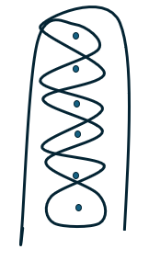

      - This event is set up with 6 poles in a line with 21 feet between each of them and 21 feet between the end pole and the timeline.
      - The competitor must cross the timer line and go all the way to the other end of the arena, beginning on either the left or right side of the poles. They will then turn around the end pole and weave through them until you get to the other end of the poles. Here you will turn around that end pole and weave back through the poles. At the end pole you will turn around it, coming out on the opposite side that you started on. The competitor will then race to the other end of the arena and cross the timeline.
      - If the competitor breaks the pattern (by going the wrong way around the pole) or crosses the timer line before completing the pattern, then they will receive a “no time”.
    - JUMPING FIGURE 8
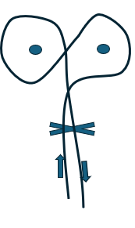
      - There will be a small jump and two barrels set in the arena.
      - Competitors must cross the time line, go over the jump, head to the right or left and figure 8 the barrels, go back over the jump and back across the time line
      - If the competitor breaks the pattern or crosses the timer line before completing the pattern, they will receive a “no time”.
    - FLAG RACE
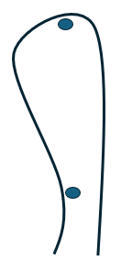

      - There will be two barrels set in s straight line in the arena. The far barrel (located 150 feet from the time line) will have a bucket with a flag in it and the closer barrel (located 50 feet from the time line) will be an open-ended barrel.
      - Competitors must cross time line, go to the farthest barrel, pick up the flag, go around the outside of the barrel and race towards the closer barrel.
      - Competitors must then toss the flag into the second barrel.
      - The competitor will receive a “no-time” if they drop the flag anywhere outside of the second barrel.

    - TURN AND BURN
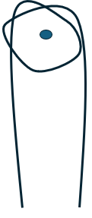
      - There will be a single barrel at the far end of the arena.
      - Competitors must cross the time line, head towards the barrel and circle all the way around the barrel (left or right) and head back, crossing the time line to complete the run
      - If the competitor breaks the pattern, does not completely circle the barrel or crosses the timer line before completing the pattern, they will receive a “no time”.
    - BARREL RACING
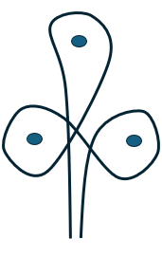
      - Three barrels will be set in a triangle shape.
      - The competitor must complete a cloverleaf pattern and re-cross the timeline.
      - Competitor completes the pattern by crossing the timeline and going to the first barrel (This can be either the left or right barrel) and make a turn all the way around the barrel. If the competitor goes to the right barrel first, they will go to the left side of the barrel. Then the competitor will cross the arena to the second barrel (the other bottom corner of the triangle). Go to the right side of the barrel and go all the way around that barrel, then go towards the third barrel (the point of the triangle). At the third barrel the competitor will again be on the right side and make another left-hand turn, come out of the turn facing the timeline and race “home”. NOTE: If the competitor starts with the left barrel all above directions will be opposite.
      - A 5-second penalty per barrel will be added for knocking over a barrel.
      - If the competitor breaks the pattern (by going the wrong way around the barrel) or crosses the timer line before completing the pattern, then they will receive a “no time”.

    - KEYHOLE
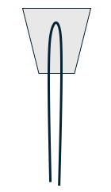
      - A Keyhole shape will be drawn/built in the arena.
      - Competitors will cross the time line heading towards the keyhole, enter the keyhole, turn around without crossing the lines of the keyhole and head back across the time line.
      - If the competitor breaks the pattern (by crossing the keyhole barrier lines) or crosses the timer line before completing the pattern, then they will receive a “no time”.

    - MUG RACE

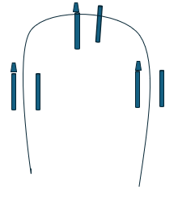

      - There will be 3 sets of (2) poles side by side around the arena.
      - Competitors must cross the time line, head to the poles on the right or left, stop at poles and move mug from one pole to the opposite side.
      - Then proceed to next set of poles and repeat, then to the final set and repeat before heading back across the timer line.
      - If the competitor breaks the pattern, drops a mug, or crosses the timer line before completing the pattern, they will receive a “no time”.

    - 4 FLAGS
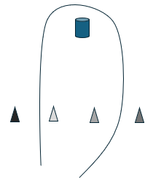
      - There will be 4 sets of colored flags set across the arena and one open topped barrel at the top end of the arena.
      - Competitors must cross the time line, then the announcer will call out a color, competitor must go to the flag of that color, grab the flag, ride to the end of the arena and place flag in the barrel, go all the way around the barrel and return to the start line.
      - If the competitor drops a flag, misses the barrel, does not go around the barrel or crosses the timer line before completing the pattern, they will receive a “no time”.

    - PANTY HOSE RACE
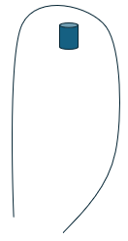
      - There will be a single barrel at the far end of the arena.
      - Competitors, in teams of two each holding an end of a pantyhose, must cross the time line, head towards the barrel and circle all the way around the barrel (left or right) and head back, crossing the time line to complete the run – both members of the team must go around the barrel and must keep hold of their pantyhose at all times.
      - If the competitors break the pattern, both riders do not completely circle the barrel, either rider drops the panty hose or either rider crosses the timer line before completing the pattern, they will receive a “no time”.

    - BARREL BACK THROUGH
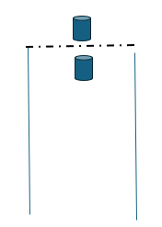
      - Two barrels will be side by side at the top end of the arena
      - Competitors will cross the time line heading towards the barrels, stop and back through the barrels before heading back across the time line.
      - If the competitor breaks the pattern, knocks a barrel over or crosses the timer line before completing the pattern, then they will receive a “no time”.

    - RING TOSS
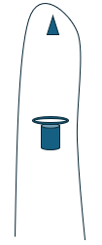
      - A hula hoop will be placed on a barrel and a cone will be placed at the top end of the arena
      - Competitors will cross the time line heading towards the hulahoop, pick up the hoop and ride towards the cone, tossing the hoop on the cone before heading back across the time line.
      - If the competitor breaks the pattern, misses the cone or crosses the timer line before completing the pattern, then they will receive a “no time”.

    - WALK/TROT/LEAD
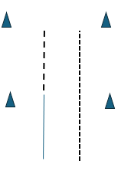
      - Mounted competitors will line up at the start line.
      - When the announcer says go, riders will WALK to first marker, pick up TROT and trot to second marker, stop and dismount. Then lead horse all the way back to start line.
      - If the competitor breaks into an incorrect gait, they must go back to the start line and begin again.
      - Class is not timed, places decided by who crosses finish line first.

