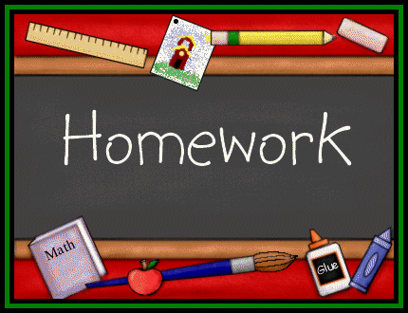
This Photo by Unknown Author is licensed under CC BY-SA-NC
Second Grade Homework Sheet
Mrs. Sigvardsen’s Class Week #5 Sept. 8-11
Verse: Psalm 8:3-4 When I consider thy heavens, the work of thy fingers, the moon and the stars which thou hast ordained; What is man that thou art mindful of him?
rock back think clock ask thank black desk bank pink check truck mask sink blank will dress you your says

Monday Thursday
Labor Day-No School Bible-write verse___
Reading- work pages__ (in class)
Spelling- write words 2x’s___Test Fri.
English- do work under Spelling Sentences___
Math-do sheet___
Heritage-study guide for Test___
Tuesday
Bible-write verse___ Friday
Reading-read p.102-107____ Spelling- write new list 2x’s ___
Spelling-write words 2x’s ___
English-do sheet___
Math-do sheet___
Heritage-study guide for Test Friday__
Wednesday
Bible- write verse___ *P.E. Thursday
Reading- read p. 108-113___
Sentence Writing-write 6 sentences using spelling words ____
Spelling-write words 2x ___
English-do sheet____
Math-do sheet___ Heritage-study guide for Test Fri. ___

2nd Grade Vocabulary Work Name _________________
- Green beans and carrots are _____________ foods.
- God gave us many different kinds or __________ of dogs.
- The police officer arrested the __________ in the bank robbery.
- The dog was trained by its ___________ to catch a ball.
- Police dogs __________ for people who are lost.

search breeds healthy handler suspect

- A ________ dog can help someone who is blind.
- A person with a _______________ may have difficulty doing things.
- Someone with __________ problems has difficulty moving.
- Many people with disabilities have ____________ trained service dogs to help them.

mobility disability guide adopted guide

*Draw a picture of a service dog helping someone with a disability.

Second Grade Spelling Sentences Name_______________
*Write 6 sentences using Spelling words. Remember to start with a capital letter and end your sentence with a . ! ?

_1______________________________________________________________________________________________

_2______________________________________________________________________________________________

_3______________________________________________________________________________________________

_4_____________________________________________________________________________________________

_5______________________________________________________________________________________________

_6______________________________________________________________________________________________

*Circle all the Nouns below:

cupcake fun grape Sammy wet God Bible

*Circle the Action words below:

jump apple write swim big run hop

*Circle the action part of the sentences below:

The dog buried his bone.

I worked on my homework.

She jumped in the pool.

He ate all his food.

They cleaned the yard.

Name ______________
Math
*Write Math Facts

Tuesday
4+8=12 ____________ ____________ ____________ ____________

4+9=13 ____________ ____________ ____________ ____________

5+2=7 ____________ ____________ ____________ ____________

Wednesday
5+3=8 ____________ ____________ ____________ _____________

5+4=9 ____________ ____________ ____________ _____________

5+6=11 ____________ ____________ ____________ _____________

Thursday

5+7=12 ____________ ____________ ____________ _____________

5+8=13 ____________ ____________ ____________ _____________

5+9=14 ____________ ____________ ____________ _____________

*Write numbers by 2’s to 100 below.

