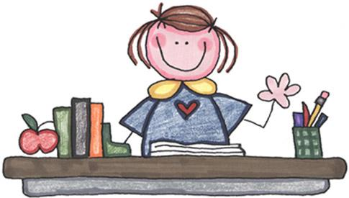 Mrs. Sigvardsens Class Week #5 Sept. 8-11
This Photo by Unknown Author is licensed under CC BY
First Grade Homework
Verse Psalm 8:3-4 When I consider thy heavens, the work of thy fingers, the moon and the stars, which thou hast ordained; What is man that thou art mindful of him?
*Spelling List 4
back bake lick like snack snake brick clock shake broke come I cone kick keep cake man bus sun the
*Monday *Thursday
Labor Day- No School Bible-study verse for test___
Reading-read p.117-126___HR-p.44-45
Spelling-write new words 2x’s ___(in class)
Phonics-do back of sheet___
Math-do sheet___
Heritage-study for Test on Friday___
*Tuesday
Bible-write verse ___ *Friday
Reading-read p.108-111___HR-p.40-41 Spelling-write new words 2x’s__(in class)
Phonics-do back of sheet___
Spelling-write words 2x’s___
Math-do sheet ___
Heritage-study guide for Test on Friday___
*Wednesday
Bible-write verse___
Reading-read p. 112-116___ HR-p. 42-43
Phonics-do back of sheet ___ P.E. Thursday
Spelling-write words 2x’s.___
Math-do sheet___
Heritage-study guide for Test on Friday___

First Grade Phonics Homework Work Name _______________
Monday
*Circle the rules/ mark vowels/ Read pr in pray gr in grin qu in queen
prize print plate praise prick prune
green grip grapes grasp grill grunt
queen quiz quack quick quote quill
Tuesday
dress shell block this path class pray flash
smell smile smoke clock thin drip smell math
scuff scale skip ask sky back bake dust

Wednesday-Fill in missing letters for spelling words./ Study
ba_ _ b _ k _ l _ _ k li _ _ sna _ _
sna _ e sna _ k bri _ _ c _ o c _ s_ ake
c _ n _ k _ _ p ki _ e t _ e c _ m _
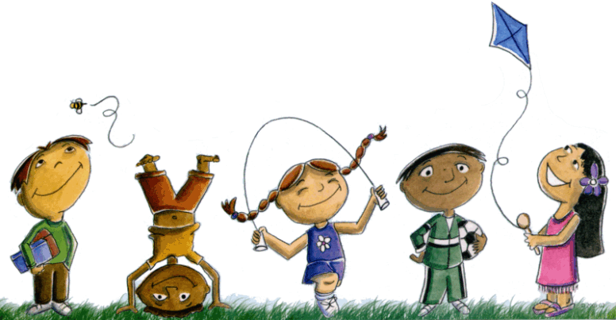
This Photo by Unknown Author is licensed under CC BY-NC-ND
First Grade Spelling Weekly Work
back bake lick like snack snake brick clock shake the broke come I cone kick keep cake man bus sun
Tuesday
Fill in missing letters in your spelling words above.
b ___ ck ba___e l __ ck li _e s_ac_ sn__ke
__ __ ick cl __ck __ __ ake th__ br _ k _
________________________________________________
Wednesday
*Write the spelling word for each picture.
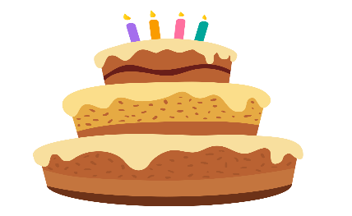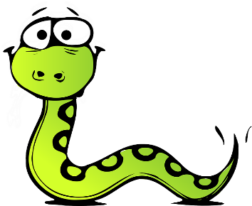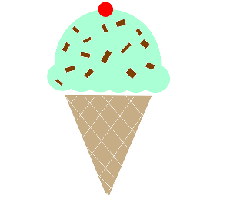
This Photo by Unknown Author is licensed under CC BY-SA
This Photo by Unknown Author is licensed under CC BY-NC
________________ _____________ __________ ___________
Wednesday
*Write these words
lick ____________ ______________ like _____________ _____________
snack____________ ______________ snake_____________ _____________

