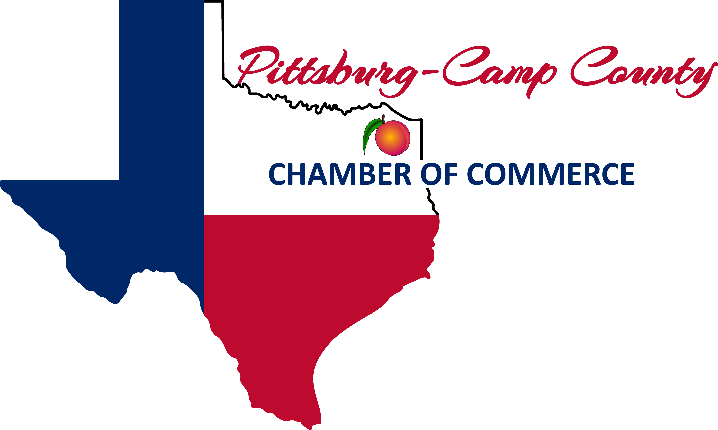

Pittsburg-Camp County Chamber of Commerce
202 Jefferson Street, Pittsburg, TX 75686
903.856.3442
info@pittsburgcampcountychamber.com

2022 Pioneer Days Sponsorship Opportunities

Trail Boss Sponsor - $5,000
Benefits include:
- Premium banner placement on main stage
- Frequent main stage mentions by emcee
- Logo prominently displayed on Pioneer Days poster
- Full color ad on back cover of Pioneer Days Festival Guide
- Mention as title sponsor on radio ads and promotional materials
- Logo on Pioneer Days Website & Pioneer Days Facebook Page
- Logo prominently displayed on Festival t-shirts
- Logo prominently displayed on sponsorship banner
- Two complimentary vendor booths at Festival
- One complimentary table (8 seats) at Leadership Luncheon
- Ten complimentary tickets to The Original Pinto Bean and Cornbread Cook-Off

Diamond Jubilee Sponsor - $2,500
Benefits include:
- Banner placement on main stage
- Frequent main stage mentions by emcee
- Logo on Pioneer Days poster
- Full color ad on inside cover of Pioneer Days Festival Guide
- Mention as a sponsor on radio ads and promotional materials
- Logo on Pioneer Days Website & Pioneer Days Facebook Page
- Logo on Festival t-shirts
- Logo displayed on sponsorship banner
- One complimentary vendor booth at Festival
- Four complimentary seats at Leadership Luncheon
- Eight complimentary tickets to The Original Pinto Bean & Cornbread Cook-Off

Gold Rush Sponsor - $1,000
Benefits include:
- Main stage mentions by emcee
- Logo on Pioneer Days poster
- Full page color ad in Pioneer Days Festival Guide
- Logo on Pioneer Days Website & Pioneer Days Facebook Page
- Logo on Festival t-shirts
- Logo displayed on sponsorship banner
- Half price vendor booth at Festival
- Two complimentary seats at Leadership Luncheon
- Six complimentary tickets to The Original Pinto Bean & Cornbread Cook-Off

Silver Spurs Sponsor - $500
Benefits include:
- Business name on Pioneer Days poster
- Half page color ad in Pioneer Days Festival Guide
- Business name on Chamber Website
- Business name on Pioneer Days Facebook Page
- Business name on Festival t-shirts
- Business name displayed on sponsorship banner
- Four complimentary tickets to The Original Pinto Bean & Cornbread Cook-Off

Chuck Wagon Sponsor - $300
Benefits include:
- Quarter page color ad in Pioneer Days Festival Guide
- Business name on Chamber Website
- Business name on Pioneer Days Facebook Page
- Business name displayed on sponsorship banner
- Two complimentary tickets to The Original Pinto Bean & Cornbread Cook-Off

❖                            
☑ Yes! I would love to be a sponsor for the 76th Anniversary
Pioneer Days Festival

I’ll be a……
❑ Trail Boss Sponsor  Diamond Jubilee Sponsor
❑ Gold Rush Sponsor  Silver Spurs Sponsor  Chuck Wagon Sponsor

Business Name: _____________________________________________________________________________
Contact: ________________________________________ Phone: ___________________________________
Address: __________________________________________________________________________________
Email: ____________________________________________________________________________________

