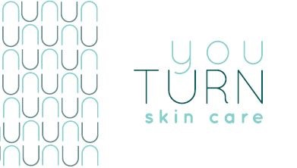
Cryoskin Slimming Before and After Instructions
Slimming Before
- For best results before slimming session do not eat sugar for minimum 2 hours. For best results 4-5 hours is recommended.
- Avoid exercise directly before a session. It will be harder to cool the body down and complete the slimming effectively.
- Before session try to avoid putting lotion or perfumes on the area that will be the focus of the Cryo session.
Slimming After
- If possible, avoid all kind of sugar or carbohydrates for 4 - 5 hours after the Cryo session. 2 hours is the minimum time recommended for best results.
- This applies to all kind of sugars (pasta, rice, bread, cereals...) and of course simple starches and sugars.
- For optimum results follow a Keto diet for minimum 72 hours post treatment.
- The cold weakens and retracts the adipocyte [fat storage cell]. Consuming sugar will return immediate energy to these cells, so the apoptosis [cell death] effect will be less efficient and can even be canceled.
- The lymphatic system takes 15 days to remove the cellular debris from the slimming naturally through the body. Results will improve over the 2 weeks following the session. Additional slimming sessions can be completed 2 weeks after a treatment.
- For best results, maintain the best possible diet and lifestyle to accompany the Treatment.
- It is crucial that you drink plenty of water to aid your kidneys and liver with the removal of these cells from your body. Recommended to drink at least 1.5 liters a day for the 15 day cycle.
- It is safe to exercise right after Cryo treatment. Good daily exercise also improves the elimination of the fat cells through the lymphatic system. At minimum try to increase your walking activity to help with lymphatic circulation.

